Working notes and log of progress
Composing Music 2 – Moving on with Composition
Alan Cook - Student no: 509958

Sunday 15 May 2016
As I get started
Finally making a start – see notes in reflective and listening logs for details of what I have concentrated on so far and for the reasons why it has taken me so long to get to grips with this new course since finishing the Composing Music 1 module – ‘Start Composing Music’ – at the beginning of February.
I have ordered and received the following books that are on the reference material list, or I already have them:
- Taylor, E (1989 reprinted). The AB Guide to Music Theory (Book 2). ABSRM.
- Kennedy, M and J (2005). Oxford Concise Dictionary of Music. OUP. (not the 2007 version)
- Schoenberg, A (1967). The fundamentals of Music Composition. Pearson Education.
- Whittall, A (2000). Musical Composition in the Twentieth-century. OUP.
- Tymoczko, D (2011). A Geometry of Music: Harmony and Counterpoint in the Extended Common Practice. OUP.
Am considering ordering:
- Potter, K (2002). Four Musical Minimalists. Cambridge UP. (NOTE: bought and received in July)
NOTE: I already have a copy of:
- Strickland, E (1993). Minimalism: Origins. Indiana UP.
Have tried to get hold of, but it is hugely expensive and I cannot find a second hand copy at present:
- Kennan and Grantham, (2002). The technique of orchestration. Pearson Education.
(NOTE: found on Amazon a new hardback copy at a much lower cost than previously, on 17 May, so I purchased and received it on 18 May)

Part one - Harmony with words
Notes from Taylor, E (1989 reprinted). The AB Guide to Music Theory (Book 2). ABSRM.
Chapter 15 – ‘Non- harmony notes’
P110
‘The first point to be explained is that the notes heard at any one moment do not always belong to the particular chord being used. Other, ‘non-harmony’, notes may be added as decorations of the melody, or of any part in the music which has a ‘melodic line’.
‘Non-harmony notes may be simply ornamental, but they can also be deeply expressive.’

Passing notes
‘…a link between two notes in a melodic line.’
Date: 31 May 2016
P111
‘Passing notes are found not only in the melody but also in the bass and in middle parts.’
P112
‘They are also used simultaneously in different parts of the music’
‘Most commonly … found in relatively weak positions rhythmically … also occur in relatively strong positions … when they are referred to as “accented passing notes”.’
‘Notice that a passing note always moves from and to a note which is next to it … “by step” ..’

Auxiliary notes
P113
‘An auxiliary note is a note which follows a harmony note by step, either above or below, but then returns to the same harmony note.’
P114
‘… it can be chromatically altered to make the interval a semitone …’

Anticipations
‘… the sounding of a note before the chord to which it belongs.’
‘… very common at cadences.’

Changing notes
P115
‘Two stepwise movements can also be used together … to produce patterns containing two non-harmony notes.’ (cf echapee where the melody moves one step in the opposite direction from the harmony and melodic progression)
‘Apart from the echapee, there is much confusion over the names given to the non-harmony notes … best to describe them all as changing notes.’

Appoggiaturas
P118
‘… it “leans” on the following note”
‘… essential points:…
- .. is a dissonant note …
- … followed by the note below or above it …(“resolution”)
- … in a more strongly accented position than its resolution …

Suspensions
P120
‘A harmony note may be delayed in moving to the next chord …’
P121
3 notes are involved:
- ‘the preparation (a harmony note)
- The suspension itself (note continued)
- The resolution (again a harmony note)’
‘The suspended note produces a discord. … The resolution is always a note below or above the suspension … Suspensions which resolve upwards are sometimes called
“retardations”’
P122
‘often used in the bass, and in the middle of the music … Two or even three suspensions may be used simultaneously … from a purely harmonic point of view, a suspension is virtually identical with one type of appoggiatura: an appoggiatura preceded by the same note.’
P123
‘Between the suspension and its resolution, another note – or other notes – may be inserted.’

Pedal points
P124
‘… a note which is sustained throughout changing harmonies … need not “belong” to each of the chords which it accompanies … often dissonant with them.’
P125
‘… may last for only two or three changes of chord, or they can be much longer … not restricted to the bass … top (inverted pedal) … in the middle (inner pedal) …’

Chapter 16 – ‘More about tonal harmony’
Counterpoint
P126
‘Normally the top line is a genuine melody, and to some extent the bass also will have a feeling of melodic shaping, but the inner parts are often rather dull….Often, however, the parts are designed to have an equal melodic interest, with independent rhythms. When this happens the music is described as counterpoint, or is said to be ‘contrapuntal’.’
‘Many pieces for keyboard include some passages which are contrapuntal and some which are not.’
(See two part Inventions and three part Sinfonias of JS Bach) ..’A characteristic of these two collections is that…individual parts are based on the same melodic ideas …’
P127
‘Counterpoint of this kind is described as ‘imitative’. … The most exact kind of imitative counterpoint is canon: two (or more) parts are the same, but starting after one another …’
P128
‘Not all counterpoint is imitative (cf Wagner – Prelude to Die Meistersingern)… whether imitative or not, music which is contrapuntal always has a harmonic basis as well. The individual parts combine to produce chords – or, at the very least, to imply chords very clearly.’
P129
‘… individual contrapuntal lines may be described as the “horizontal” aspect … chords … as the ‘vertical’ aspect of the music …’

Part-writing
‘Parallel motion tends to undermine counterpoint …less…independent of each other.’
‘… as long ago as the 15th century … became the convention to avoid using consecutive unisons, consecutive perfect octaves, and consecutive perfect 5ths. Also avoided were the compounds of these intervals, e.g. consecutive perfect 12ths and 15ths. … JS Bach, for instance, occasionally wrote perfect 5ths in his chorales when they resulted from the use of a non-harmony note.’
P130
‘Attitudes have varied, too, to consecutive 5ths and octaves produced by contrary motion …’
‘Conventions about the avoidance of consecutive 5ths and octaves (though note that these did relax in contrary motion music and octaves at perfect cadences) come under the general heading of what is called part-writing … refers to the ways in which contrapuntal parts are related to each other, and also the ways in which they are individually shaped to produce good melodic lines.’
Date: 9 July 2016
P130/1
‘When keyboard music is clearly not contrapuntal, the ordinary conventions about part-writing do not apply …’
P131
‘… the bass will make two-part counterpoint with any melody or melodic fragment above it …’
P132
‘… it should be mentioned that the convention of avoiding consecutive octaves does not extend to a whole passage performed in octaves: e.g. a melody ‘doubled’ an octave higher, or a bass doubled an octave lower. Such passages do not constitute two separate melodic lines: merely one which has been reinforced.’

Harmonic Rhythm
‘the rate at which the basic harmonies of a piece change is generally considerably slower than the rate of actual notes heard.’
P133
‘Usually, harmonic rhythm is not only slower but also simpler than any of the rhythms which are in fact being played. Nevertheless, it is of the greatest importance in the shaping of music: when chords change is as important as which chords are used.’
Note: quickening the harmonic rhythm can make the music more intense as it approaches a cadence

Second-inversion chords
‘Non-harmony notes do not destroy the effect of the basic chords in a piece or of the underlying harmonic rhythm which they produce.’
P135
‘Although other subsidiary chords can be produced by combinations of non-harmony notes, so called ‘second-inversion’ (⁶₄) chords are the most common. Indeed they originated as part of a double suspension’
‘⁶₄ chords produced by double appoggiaturas are a commonplace in music of the classical period, particularly at cadences. … It would be an exaggeration, however, to assert that all ⁶₄ chords are mere adjuncts of other chords.’

Extensions of the triad (7ths, 9ths etc.)
P136/7
‘… a triad on any degree of the scale may be extended by the addition of a 7th from the root. The most common occurrence of this – a 7th added to the dominant triad, forming the dominant 7th chord …The 7th chords on other degrees of the scale are collectively known as ‘secondary sevenths’. Like the dominant 7th, they take their individual names form the degrees of the scale on which they are based: e.g. a 7th chord on the 2nd degree of the scale (II⁷) is a ‘supertonic 7th’.
In all 7th chords, the 7th itself is resolved in the following chord, normally by moving one step down or, very occasionally, by staying where it is … The only standard exception to this is when the second inversion of a V⁷ occurs between I and Ib, and the 7th rises one step …’
‘What is popularly known as the added sixth chord is sometimes regarded as a type of secondary 7th chord. Originally, however, the term was used to describe a subdominant chord to which a 6th from the root has been added as a passing note …can form what is a truly independent chord … Nowadays this chord would also be described as an ‘added sixth’, as indeed would any chord consisting of a major or minor triad plus a 6th from the root. One such chord became a cliché in jazz and popular music; a 6th added to the final tonic chord’ (note: could also be labelled as VI⁷b but that says the author would be ‘absurd’)
‘Further extensions to the basic triad may be made by the addition of a 9th, 11th or 13th from the root …However, it is not always possible for all the notes of these chords to be included. Even 7th chords may lack a 3rd or a 5th …’
P138
‘This may be because of the demands of good part-writing, or simply because all four notes cannot be performed …’
‘The 5th from the root is the most likely note to be missing …’
P139
‘Very often, what may appear to be 9th, 11th and 13th chords are really nothing more than the result of adding appoggiaturas or other non-harmony notes to simpler versions of the same chord.’
‘Even harmonic progressions which include ‘true’ 9th, 11th and 13th chords often closely resemble simpler progressions decorated with non-harmony notes.’
P140
‘Thus it can often be a fine point whether to describe a chord as a V⁷ or as a more extended V chord.’

Modulation
‘Pieces vary rarely stay in the same key throughout … no change of key which occurs during apiece is truly permanent. Nevertheless, an important distinction has to be made between a brief visit to another key and one which is longer-lasting. When the listener feels that the music has really settled in a key, at least for the time being, the key is said to have been ‘established’. .. usually described as a modulation …’
P141
‘It is better to think of modulation as a process by which one key may lead to another. The most common process involves the use of a ‘pivot ‘chord … one which can be found both in the first key and in the second …’
‘Two keys may have more than one chord in common: consequently there may be not just one pivot chord but several … Instead of a complete chord, one or two notes may act as a pivot. A note of a chord in the first key becomes a note of a different chord in the second key …’
P144
‘The presence of a modulatory process leading towards a new key is no guarantee that the new key will be felt to be established – not even if there is a perfect cadence in the new key.
‘To give a genuine impression that the original tonic has been superseded by another usually takes a relatively long time. That is why a real key-change is rarely found in short pieces.
‘… music can modulate through keys without settling in any of them – even temporarily.’

Chapter 17 – ‘Chromatic Chords’
P145
‘A chromatic chord is a chord including at least one note which does not belong to the diatonic of the scale. … may be used in the process of modulation, or … for their expressive effect.’
Borrowed chords
‘Music in a major key may use chords ‘borrowed’ from the minor key with the same key-note … The chords most commonly borrowed I this way are the diminished chord on II, the minor chord on IV, and the major chord on the flattened V! (♭VI) …’
(Note: a ♭ or a ♯sign before a chord indicates that the root of the chord is lowered or raised a semitone.)
P147
‘It is much rarer for music in minor keys to use chords which have to be regarded as borrowings from the major. This is simply because minor keys themselves already provide many alternatives.’
‘However pieces in minor keys sometimes end with a major tonic chord. … known as a tierce de Picardie …’
‘A chromatic chord can act as a pivot chord in a modulation between two keys: a chord which is chromatic in the first key may be diatonic in the second, or vice versa; or it may be chromatic in both keys.’
(Note: the Oxford Concise Dictionary of Music defines diatonic as relating to the major and minor keys and that diatonic harmonies are made up of notes from the key prevailing at the moment. A chromatic scale is 12 ascending or descending semitones.)

Altered chords
Date: 12 July 2016
P149
‘Diatonic chords may be changed (e.g. from minor to major) by means of accidentals. When the accidentals produce notes which are chromatic, the chords themselves become chromatic.’
‘As well as the notes of the basic triads, diatonic 7ths are sometimes altered so as to produce chromatic 7ths … The chromatic notes often arise as the result of stepwise movement: i.e. they are often approached and/or left by step.’
P150
‘When the addition of a chromatic note or notes produces a major chord, the major chord often functions like a V chord in an ordinary V-I progression.’
Date: 15 July 2016
P151
‘Chords which function like dominants in this way are known collectively as secondary dominants. They can be found on other degrees of the scale apart from the supertonic … a ♯ added to the 3rd of VI transforms it into a secondary dominant leading to II.’
‘… a secondary dominant does not necessarily create any feeing of modulation. Indeed, it may do the exact opposite: it may strengthen the sense of the tonic key. This happens, for example, in the common cadential progression II-V-I when II is changed into a major chord, thus becoming a secondary dominant to the true dominant. Bach sometimes uses this approach to a perfect cadence in his chorales, where it gives a magnificent feeling of solidity and finality.’

The Neapolitan Sixth
P153
‘…owes its name to its popularity with composers in Naples during the 17th-18th centuries. It is the first inversion of a major chord on the flattened supertonic (♭IIb)
(so in C major the chord would be F, A♭, D♭. Is more common in minor keys)
P154
‘The flattened supertonic is less often used in root position.’
‘Both in root position and as a Neapolitan 6th, however, the flattened supertonic chord is the most common means of modulating down a semitone.’

The diminished seventh
P155
‘… three minor thirds on top of each other … named after its most striking interval, the diminished 7th between the top and bottom notes … contains two other dissonant intervals: two diminished 5ths …’ (Note: and each of these seeks a resolution)
‘The chord as a whole is most satisfyingly resolved , therefore, when the next chord resolves all the individual dissonances … it can be followed in other ways.
There is only one circumstance in which a chord consisting of three minor 3rds is a diatonic chord. This is when it occurs as a 7th chord on the leading note of a minor … A diminished 7th chord can also be used on the leading note in major keys, and indeed on many other notes in both major and minor keys. In all these situations, however, it is a chromatic chord.’
P156
‘… they can function like secondary dominants (without necessarily implying a modulation).’
P157
‘One characteristic of the diminished 7th chord has far-reaching consequences: when the inversions are spelt differently (changing enharmonically), they continue to consist of three minor 3rds on top of each other … In other words, the inversions are enharmonic equivalents of different diminished 7th chords …’
P158
‘Another way of showing this is to treat each of the notes of a diminished 7th chord in turn as an appoggiatura resolving down a semi-tone.’
‘In this way, the chord offers considerable scope for modulation. Used as a pivot, it can be approached in one key and left in another.’
P159
‘Because it so easily suggests uncertainty of key, and because of the dissonances it contains, the diminished 7th chord can have a very restless quality. This effect is heightened when several diminished 7ths follow each other in descending semitones …’
‘.. often used with great dramatic force in opera.’

The augmented sixth
P161
‘… occurs in three versions … have individual names. All of them include the interval of a major 3rd as well as the augmented 6th above the bass note … if only these three notes are used … the chord is known as an Italian Sixth. If an augmented 4th above the bass is {also} added … it becomes a French sixth; and of a perfect 5th above the bass is added … it is a German sixth.’
‘Being dissonant, the interval of the augmented 6th still expects a resolution. Normally the two notes open out to form an octave (or compound octave) … in which case the chord is commonly followed by V or Ic-V …’
P162
‘Augmented 6th chords are most frequently based on the minor 6th of the scale … But they are also sometimes used, both in major and in minor keys, on the minor 2nd (with corresponding resolutions on to I or IVc-I).’
P163
‘When the lower of the two notes forming the augmented 6th interval is in the bass, the chord is often described as being in the ‘root’ position’. ‘…convenient … illogical.’
P165
‘The scope for modulation is widened much further when takes account of the fact that the augmented 6th can be used not only on ♭VI but on other notes of the scale as well – e.g. on ♭II and on IV.’

Harmonic sequences
‘A sequence is a pattern of notes which is immediately repeated at a higher or lower pitch. There may be only one repetition, or several. Sequences may occur in a melodic line (‘melodic’ sequences) or in the chords used (‘harmonic’ sequences): the two can be used independently, although usually they are combined.’
P166
‘By far the most common kind of harmonic sequence is one in which each chord is followed by one whose root is a 4th higher or (which comes to the same thing) a 5th lower.’
‘A 7th may be added to alternate chords, or to every chord, without the basic progression being affected …’
P169
‘Even real sequences do not always modulate into the keys which they touch – not even temporarily.’

Notes on other matters:

I have now ordered (and received some of) the following books:

- Potter, K (2002). Four Musical Minimalists. Cambridge UP. (received)
- Glass, P (2015). Words Without Music – A Memoir. Faber and Faber. (received)
- Schwartz, KR. Minimalists (20th Century Composers). Phaidon Press 2008. (in transit)

- I think I am going to be studying minimalism amongst other things!

Music 2 – Part one - Harmony with words
Have now finished the ‘pre reading needed and have read pages 18 to 23 and listened to the music examples.
Project 1: Colouring Harmony
Some key notes as reminders:
Melodic lines can be:
- Prominent in the musical texture
- Hidden in the musical texture
- In similar motion
- In contrary motion
- In step by step (= conjunct) motion
- Or leaping around (= disjunct) motion
- In parallel motion with other melodies too
My first activity (task):
Compose a group of four contrasting short episodes that explore colourful ways of moving around the circle of pre-V, V and I chords

Rough working notes
Progression chosen: I - ♭IIb – V⁷ – VI – IIb (deliberately using major) – V – I in C major (for ease for the first one)

Friday 22 July ‘progress ‘report’

Have written first 3 bars of the first of the four contrasting short episodes and have taken today off work so that I can work on these further – aim is to finish them by tonight. They are on a culinary theme and I have decided they will be musical depictions of an Italian rustic meal! (I usually need a creative theme or external reference point to get me inspired and going)

Saturday 23 July

Have now finished the first of the four contrasting colourful pieces – not sure about it but I have at least managed to do it and have reengaged with Sibelius – I find it easy to lose my way around that software programme. My thoughts about it are:

- I like the Italian meal concept – it has got me going
- I have ended up writing a contrapuntal piece and now must try something that is more homophonic
- It sounds bright with some crunchy moments, and works to an extent
- Not sure if it meets the course instruction of ‘explore colourful ways of moving round the circle … of chords’
- I enjoyed writing bits of it although it became a slog in the end – I think that because I am having to work intermittently on this course there is a challenge for memory and continuity
- There are bits of similar and contrary motion at points, some uses of conjunct motion, some disjunct motion and one example of parallel motion
- I now face the puzzle of how to copy the music into this Word document – next learning task!

Task achieved – see next 2 pages

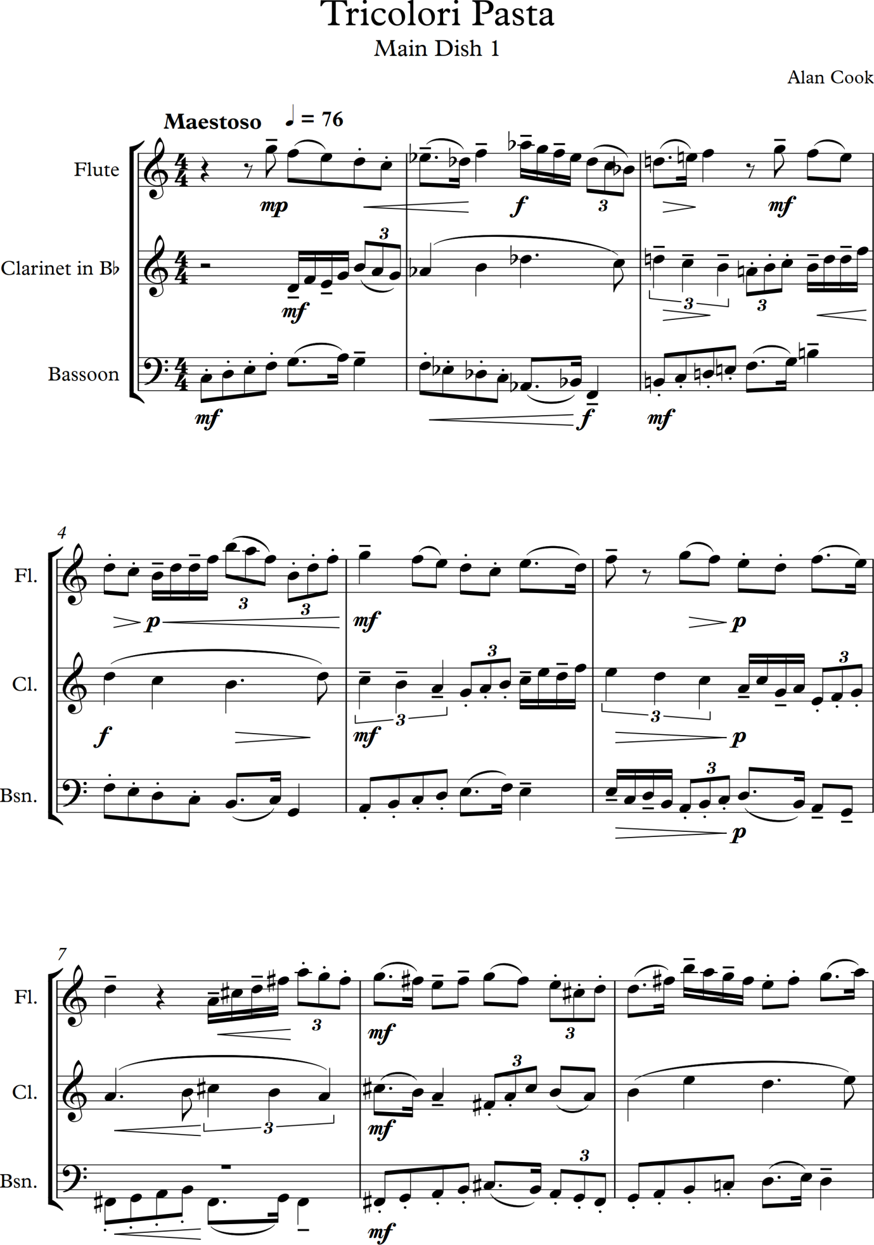

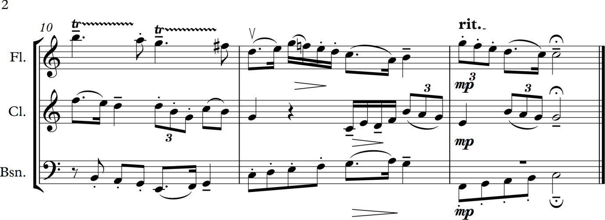

On to piece no 2 in my Italian meal sequence – however in researching Italian meal construction, unexpected on a music degree, I find that pasta is a second dish of a typical menu with antipasti first. So I will still call it ‘Dish 1’ but will now compose what should actually be the first piece which is an ‘antipasti’ – and I choose ‘ Prosciutto Dolce con Fichi Maturi’ (sweet ham with ripe figs). Thank you to Marcella Hazan, Prima Donna of Italian cookery, for her classic Italian cookbooks for inspiration here – and below is a quote from her, followed by three more from the same book, which I really like and use in my workshops on creativity:

The good Italian cook is an improviser, whose performance is each time a fresh response to the suggestions of an inner beat

Music and cooking are so much alike

Taste, like rhythm, may be described, but it does not exist until it is experienced

Each time you bring your ingredients together, your own hand falls with a different cadence. The objective … is not to achieve uniformity … It is to express the values of the materials at hand, and the unrepeatable intuitions of the moment of execution

(Hazan, 1983)

Chord sequence to be used (I may use it twice as I want a lengthy enough piece, will see what emerges from my compositional process) and in the key of C minor with a time signature of ³₄ (still have not worked out how to do fractions yet in Word):

I – IV⁷ - ♭VII⁷ – III⁷ – VI⁷ – II⁷ – V – I

This based on a passage from the third movement of Mozart’s Piano Sonata K .533 – I got the idea from the AB Guide to Music Theory II in the section on harmonic sequences (Taylor, 1991).

Monday 25 July

I have now finished my second of the colourful contrasting pieces – still on the Italian rustic meal theme – it is here:

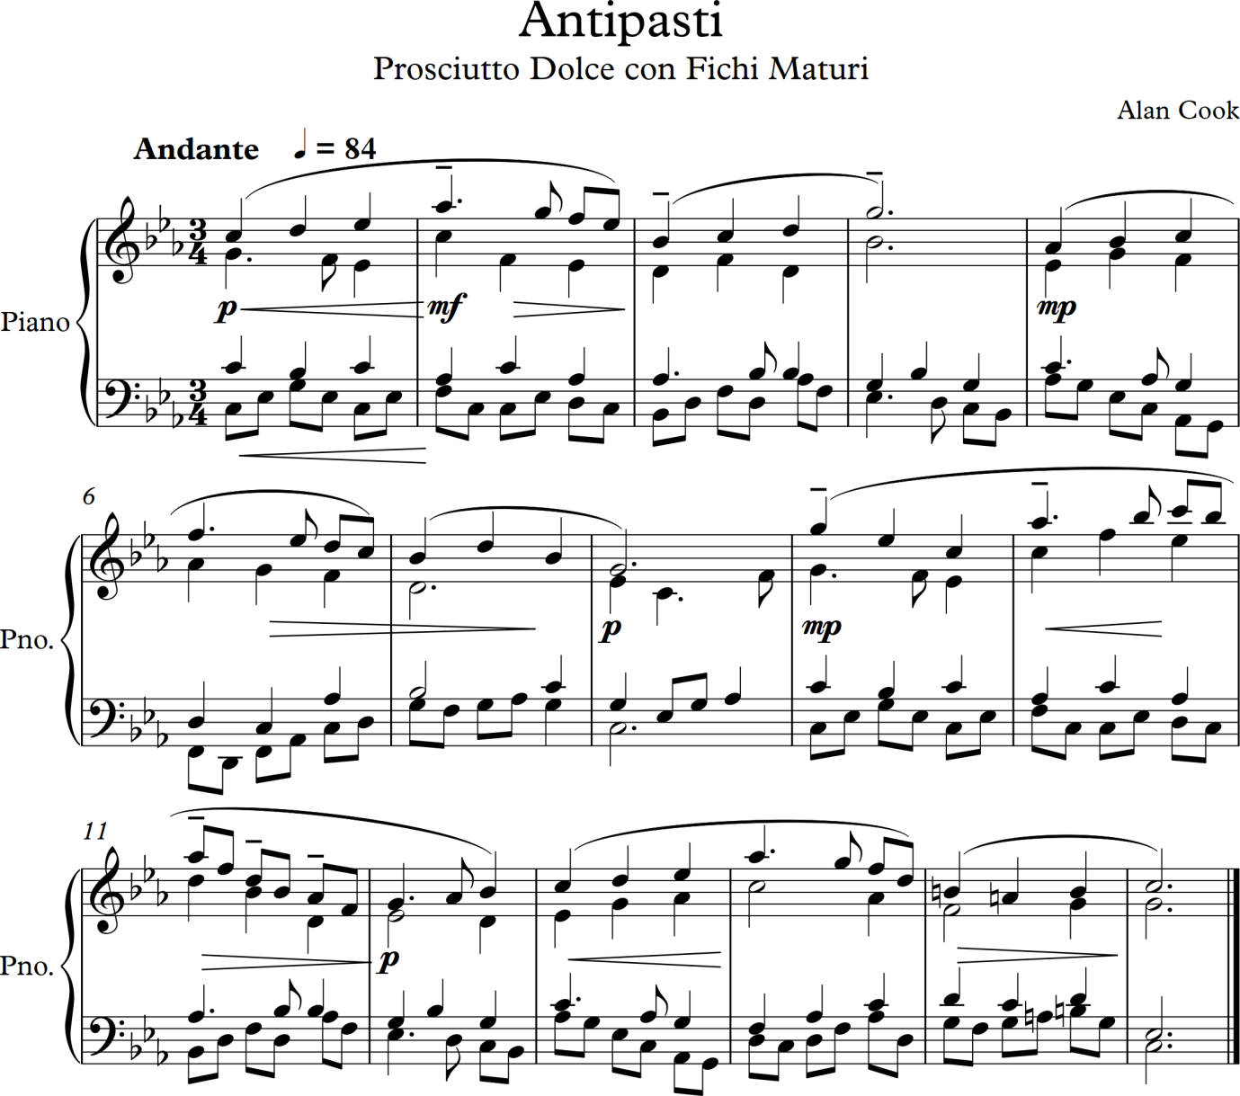

Some thoughts about it:
- It has a great tune to my ears, but I have a horrible sense that the start might be cribbed from somewhere else – I have so many random tunes floating about in my head that are pieces I have listened to and I hope I have not copied one
- It is a bit ‘Richard Clayderman’ (populist) in style, but I still like (love) the tune
- I do like the chord progression – thank you Mozart
- I feel I have overworked the arrangement as it is too busy – I cannot get away from loads of parts moving around and must try to be sparer in my musical texture. ‘Less is more’
- I feel I am not yet moving on from what I have written before in any significant way – but then I have only just started this second composition module
- It is quite conventional with its harmony – I have not added in many (if any) chromatic notes to spice it up – a challenge for the next ‘colourful piece’

A quote from the book I have started reading and studying:

Schoenberg was convinced that the student of composition must master thoroughly the traditional techniques and organisational methods, and possess a wide and intimate knowledge of musical literature if he wishes to solve the more difficult problems of contemporary music

(Schoenberg, 1967)

I have also ordered Schoenberg’s book ‘Structural Functions of Harmony’. (Has now arrived and I have started reading and studying it – 13/08/2016)

Saturday 13 August 2016

I am now working on Project 1, four contrasting pieces number 3. Here is a transcript of my current rough working notes:

So this piece is to be the third course in my rustic Italian meal – ‘I Secondi’ and is based on a traditional Tuscan dish – ‘Pollo alla Diavola’ (translated: chicken of, or like, the devil). This is described in Marcella Hazan’s first English cookery book as:

A tasty, peppery grilled chicken

(Hazan, 1980)

This dish is usually charcoal grilled chicken which has been marinated in pepper and lemon. And Hazan also writes about this second main course in Italian cookery on the same page:

The austerity of the second courses is the legacy of the hunter and the fisherman

(Hazan, 1980)

All this inspires me to try and write a piquant, sparer more astringent sounding piece that uses less notes but achieves a full sound that satisfies and has interesting colours in its sonics and musical textures.

Reminder of colourful ways of moving around with melodies and options I can use:
- Similar motion
- Contrary motion
- Step by step (conjunct)
- Leaping around (disjunct)
- Parallel motion
And also I can utilise interesting chromatic harmony addition which can lead to interesting sounds and sequences. I am struggling with what sequence of chords to now create and use. Derived from the Circle of Fifths? Or something more illogical that sounds good to me? Or some other schema?

Sunday 14 August 2016

I have now constructed more fully the piece and started working on it in Sibelius – have decided the following and created a structure to work within:

- The chord sequence I have designed (created) is I – VI – IIIb – IIb – IV - ♭VIIc – IIb⁷ – IV⁷ – V – I
(I did this working at my keyboard trying sounds and chords out and thinking about the circle of fifths but wanting to be more divergent and unusual, as always!)
- Key of F major
- Time signature of ⁵₈
(Again I am never straightforward and have cursed this complexity but am determined to continue with it now I have started)
- For a brass quartet of Cornet, Flugelhorn, Tenor Horn and Euphonium

I have created the first phrases of the cornet part and blocked in the chords – two bars of each – to check that I like the sound of them – I do. But writing a melody and an accompaniment is tricky – which first? Or both as I go so that it is intricately constructed? And what sort of harmonic accompaniment? I am trying to get away from polyphonic voices which would suit this grouping and is now so natural for me and move into something more homophonic which feels less interesting and is not flowing from me yet.

Saturday 20 August 2016

I am still working on the above piece – on to my third version – only a few bars in but I just cannot figure the accompaniment and default to polyphonic writing which I am trying to get away from. I think that creating the piece in ⁵₈ is responsible for this and that I am trying to ‘run before I can walk’. I like the top line – it sounds like a pastoral romance more in the style that Elgar wrote for the bassoon than what I initially had in mind. I shall listen to a recording and follow the score, which I have as I have been learning it on the euphonium and see if that offers any insight or ideas as at the moment I am stumped!

Some observations on the Elgar piece (Romance for Bassoon and Orchestra Op. 62):
- It is rhapsodic in nature and played with a great deal of rubato by most players
- Held notes (tenuto, riternello, lots of long pauses) are frequent and shape the musical phrase
- Elgar has lots of long notes when the harmony shifts underneath with faster bits in between – all beautifully interactive between soloist and accompaniment – so skilfully written!
- The music ebbs and flows wonderfully – but this is written carefully into the musical phrasing and notes
- It is homophonic but with a lot of movement in the parts – but all done so gracefully
- I have a phenomenal amount to learn!

Saturday 10 September 2016

I have now finished the piece described above. I have managed to make it mainly homophonic by layering up chords from the bass part and lowest instrument and varying the texture with rhythmic variations and the use of rests which I have not done so comprehensively before. Listening to a new recording I found online of a brass quartet that I downloaded (see Listening Log entry dates Sunday 14 August for details – copied below too) helped here hugely. I am aware that it sounds, in Sibelius software, rough and ready and could do with more work on the dynamics but I am leaving it as it is as this is an exercise in chordal progression and I need to get on with more of this part of the course – and I have another piece to write to complete the quartet. It is pasted on to the next two pages.

I will also record here that I have had a few weeks break from studying as I have been to Spain to work – major medical education conference in Barcelona for 5 days at which I was presenting, chairing the postgraduate committee and running a major preconference workshop on faculty development. Full on time the week before getting ready for this and also followed it with a 6 day stay in Montpellier with my ill stepmother. Now I am back I am intending to forge full speed ahead, although I also start a new job on Monday too! I took reading with me to Barcelona and France but it has not been possible to do anything due to the intense nature of both visits.

Copy of entry in Listening Log on 14 August describing recording of a brass quartet that helped me with my latest piece (Brass Quartet Volcano, 2013):
Listened to much of this recording in trying to figure out how to write interestingly for a Brass Quartet – this was the most interesting one I found on Spotify and which I have also purchased. Observed some interesting techniques including:
- Plain chordal accompaniments with a great tune above
- Chords being built up one note after another and in volume
- Tunes being repeated at different pitches across the instruments
- Harmony static in 2 instruments, melody in thirds in the other two
- Some polyphony for fast lively sections then calming down – much interplay of voices of instruments

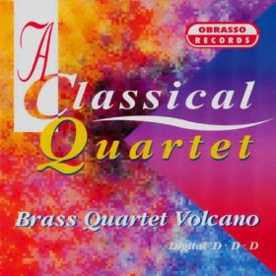

Now back to composing (see work log) my own piece for Brass Quartet – I am learning lots and probably forgetting even more!
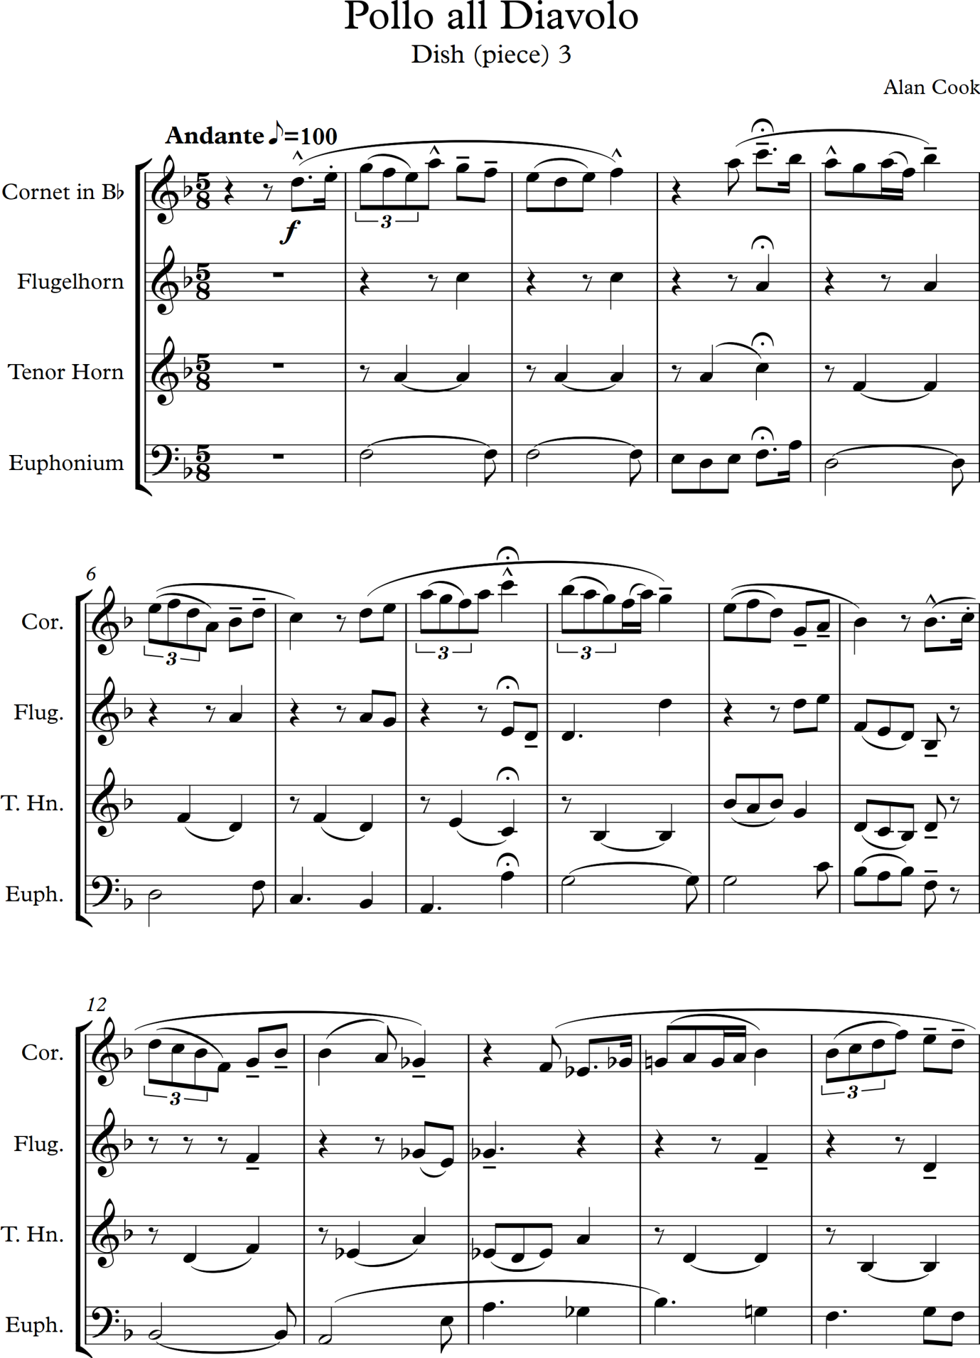

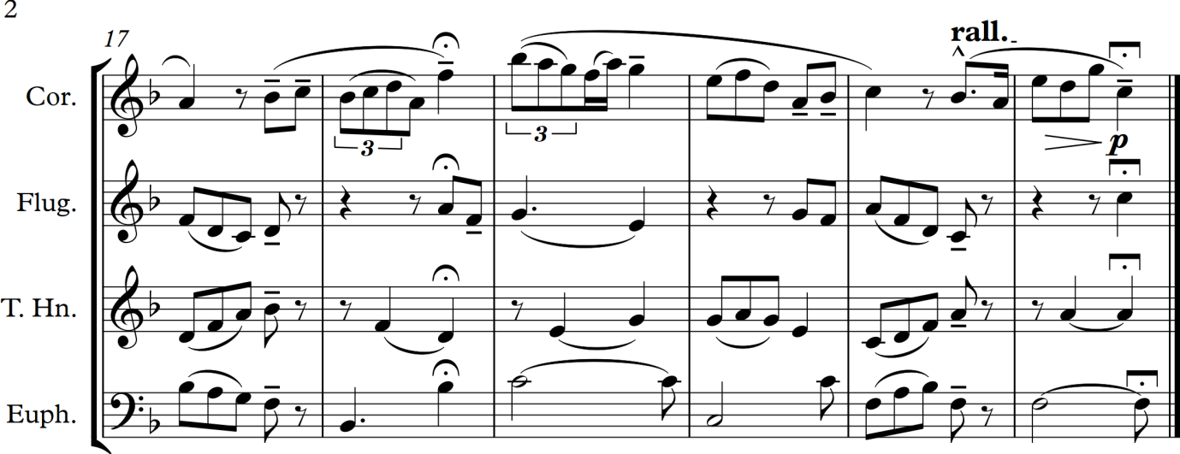

Now to the fourth piece which in my Italian meal concept needs to be a pudding – ‘Dolce’. For this I chose the wonderful ‘Torta di Verdure’ from Lucca an elegant little city in northern Tuscany for my inspiration. It is a great speciality of the area and is served daily at Puccini’s favourite café, the ‘Café di Simo’ with cups of frothy cappuccino. It is a sweet spinach pie that includes courgettes, spinach, raisins and orange peel in its ingredients – along with various spices and also parmesan cheese! Lots to transfer into sonic interest there!

Sunday 11 September 2016

And so to create and write the fourth piece of music. I have decided to write it for piano and flute and I wish it to be a sweet and piquant piece that it easy to listen to. I have decided on the following features:

- For flute and piano
- In time signature of ⁶₈
- In key of E minor, my all time favourite key
- For it to be bitter sweet I feel as well as pleasant to listen to with a few oddities at moments (after all it is inspired by a pudding with spinach and courgettes in it!)
- To follow this chord sequence:
I – IV – V – III – VI – II – VII – IV (V?) – III – IV – V – I (used V for the 8th chord as it sounded better when composing the piece)

Finished the piece at 6 pm – I created a simple accompaniment which I decided was all that the piece needed and I want to move on as the main emphasis is on the chord progression and moving around it in a colourful way – I could work more on the piano part I am sure. The score looks a bit untidy in the last bar and I need to think about how to tidy that up too to make it visually cleaner.

The score is on the next 2 pages of these notes:

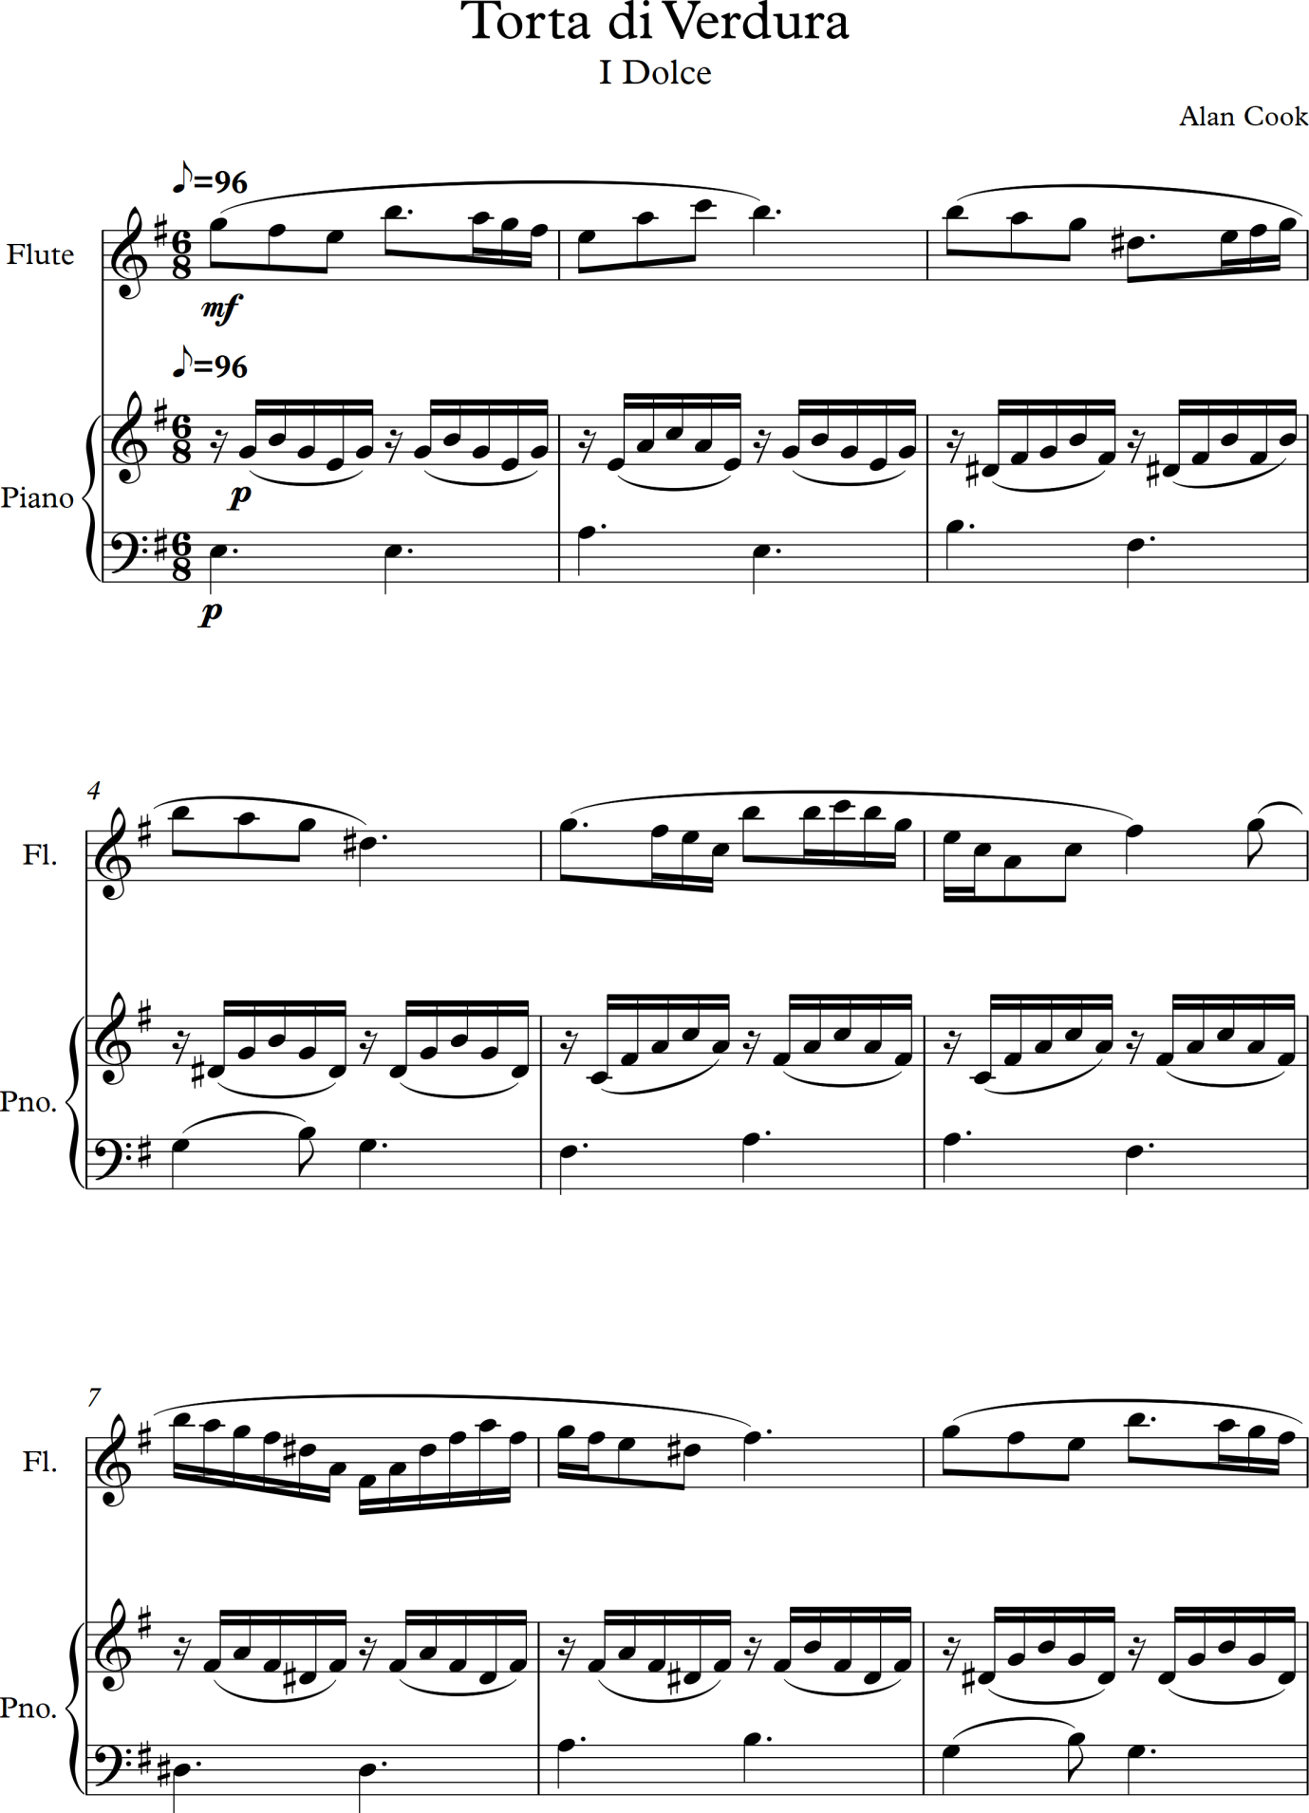

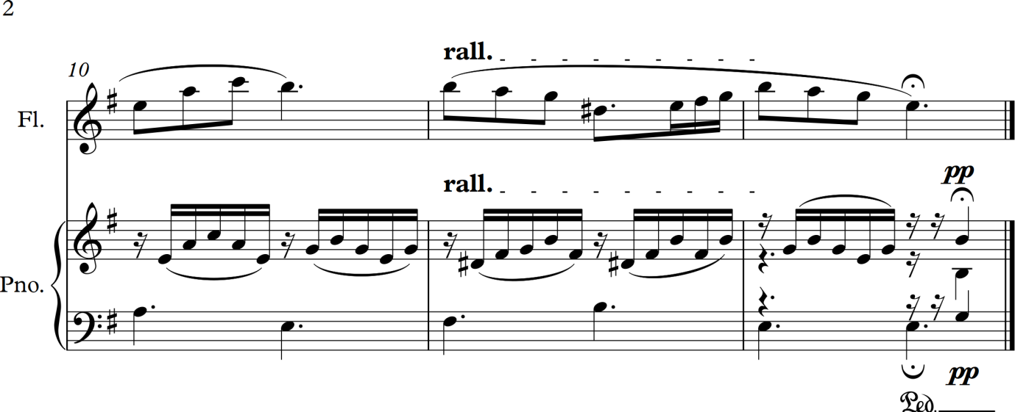

Sunday 25 September 2016

All assignments for ‘Music 1: Start Composing Music’ now sent off for formal university assessment! This has taken me two weeks to achieve as I have had to re print loads of notes, check grammar and references and remake CD discs of many files suitable for assessment. I had to buy a scanner for my computer as the one I had was not up to scanning notes from my learning logs – that task itself took up four full evenings after work. Now I shall forge on with the next part of Module 1 of ‘Composing 2’.

I must also note here that I realised a while back that of the four recent short compositions I have created that no. 2, the Antipasti, (which should be eaten first!) I have derived the first part of the melody from the popular song ‘Autumn Leaves’. This is probably because I have played an arrangement of it many times with a brass band and also have a jazz arrangement I often play at home. Originally it was a 1945 French song, ‘Les Feuilles Mortes’ (the dead leaves) the music having been composed by Hungarian-French composer Joseph Kosma and the lyrics by Jacques Prevert.

Am still in the Project 1 section ‘Colouring Harmony’ – so a few more notes and comments on the notes and exercises there:

- I used an excerpt from the third movement of Mozart’s Piano Sonata K .533 as the harmonic rhythmic basis for my first piece in this section so feel I have started in line with the ethos of this section!
- I absolutely love Jacques Loussier and have been familiar with his work since the age of 12 (nearly 50 years ago) as my secondary school music teacher was a huge admirer of him and regularly played his works to us and explained why he was so good. My mother started collecting his records and I have continued to do so all my life. I have all commercially available recordings of his Bach pieces and most of the rest too, including his own compositions. For this stage of study I have listened again to his arrangement of the Four Seasons by Vivaldi (Jacques Loussier Trio, 1997), and have noticed that the next exercise requires me to work with a small section of one of these, and a few of his classic Bach performances including his arrangements of the Prelude and Fugue no 1 in C major which he recorded many times – I stuck to two of them one from 1959 the other from 1985! (Jacques Loussier, 1959 & Jacques Loussier, 1985). I like how in the first section of these pieces he plays the prelude and fugue ‘straight’ and then jazzes them up but still sticks to the same harmonic structure.
- I have also collected quite a few recordings by the David Williams-Rees Trio over the last 20 years but these do not work so well for me – maybe less rhythmically interesting or just more down beat and chilled in a lounge sort of way that does not really work for me. I like cheesy lounge music so this is an unusual response from me. I will listen further and try to pin down why this is the case.

Saturday 1 October 2016

I have started on the next exercise - the first one in Project 2: Reviving Skeletons and am a bit stumped. I have worked out the chord progression except for the 3rd last chord which is F plus B♭ plus C which I cannot figure out. B♭ with an added C or something else – may be a bit advanced for me?

Wanted to meanwhile anticipate assignment 1 by stating that I have found the poem I want to compose the song and accompaniment for. It is by a twentieth century Welsh poet – RS Thomas:
The Moor
By RS Thomas
Original Language English
It was like a church to me.
I entered it on soft foot,
Breath held like a cap in the hand.
It was quiet.
What God was there made himself felt,
Not listened to, in clean colours
That brought a moistening of the eye,
In movement of the wind over grass.
There were no prayers said. But stillness
Of the heart's passions -- that was praise
Enough; and the mind's cession
Of its kingdom. I walked on,
Simple and poor, while the air crumbled
And broke on me generously as bread.
(Unknown, 2012)
I find this moving and can relate to it from my own experience. I can hear the sort of melody I would like to hear the words sung to and fragments of tunes in my head. I know the feel it must have. I can hear a dark and interesting and uplifting piano accompaniment that goes hand in hand with it to create this mystical, still and breathtaking atmosphere. I look forward to working on this.
The website it is from is a bit weird – I cannot find the author and there is a comment from a poem’s author on it that the website owner publishes poems without getting permission.
Further ideas (later in the day after working on a piece based on Vivaldi’s Four Seasons):
The song could be scored for high baritone or alto voice with viola and piano accompaniment. The piano is the countryside, the viola is God and the spirit of nature and the voice is the visitor to the moor, the person having the experience. The piece starts with a piano introduction and the viola steals in – deep, timeless, mysterious and utterly beautiful. The voice enters with trepidation and caution, entering a mysterious realm for the first time. The viola is silent at this point. Gradually as the voice expresses increasing response and wonder to the beauty in nature (gorgeous piano sounds at this point) the viola gradually steals in, then fades away, and then returns again more strongly. The voice and viola increasingly weave in and out of each other with the piano as a ravishing backdrop. A change happens as the voice becomes more muted and the viola takes on more significance but then breaks into shafts of increasingly fragmented sound (not sure how to express in words here what I can hear in my head – as Sibelius said, music expresses that which words cannot). Eventually the voice returns – stronger yet quieter and slowly quietens away leaving the piano to conclude with a calm, deep, somewhat dark and mysterious postlude that is utterly tranquil and yet leaves longing and a slight restlessness.

See my Listening Log for details of music I will be listening to as part of my studies towards creating this piece. (and see below for 7 Ocotber)

Another project I want to undertake: arranging for our music ensemble at work (Pizzazz!) the music from the song Happy Feet from the Paul Whiteman talkie film ‘The King of Jazz’ – music by Milton Ager and Jack Selig Yennen. I have found a version arranged for modern swing band by John Altman for the film ‘Shall we Dance’ (Shall we Dance, 2005) but can only find sheet music for a piano and voice version online – available from Presto Classical. I shall order that tomorrow and then have a go at arranging it for the ensemble.

Friday 7 October 2016

Pieces that I will listen to in preparation for my Assignment 1 vocal piece:

- Brahms – two songs with viola (for scoring and expression of deep feelings)
- Brahms – Alto Rhapsody (for vocal arrangement)
- Richard Strauss – Morgen (for hushed quietness and anticipation)
- Richard Strauss – Zueignung (for excitement and joy)
- Debussy songs – for composition and interplay between piano and voice
- Sibelius songs – because I love them and his way of composing
- Morten Lauridsen – video on composing a song (Dirait-On)
And more notes on the features of ‘The Moor’ as I hope to set it (and I must bring all these together in another folder)

- Will need some declamation of the text with fragments of melody
- There will be a build up to a large melodic phrase
- It may be repeated again later in the piece with more intensity OR recaptured in a more wistful manner (emotion recaptured)
- D minor? E minor? (need to also listen to relative major for brightness of sound)

Back to notes on Reviving Skeletons Project

I have worked on this for quite a few days now and hoped to finish the first piece today – alas am so tired that I have no energy and having difficulty concentrating – started work on some Deanery matters at 7 am and then on to music at 10 .45 am. It is now 16.20 pm and I am very tired. I have got half way through the piece and trying to decide where to take it now. I know I am tired as I keep hitting my desk in frustration and want to throw the computer keyboard out of the window! Also had a long conversation a couple of notes ago with a pianistic friend who had read somewhere that Beethoven and other great composers worked out the structures and ideas for their pieces thoroughly before committing notes to manuscript. I like the idea but am not musically gifted enough to do this – in that I cannot put on paper what I hear in my head without trying out the sounds I am creating – some of them I cannot translate into musical form yet. My rough working notes are scanned and on the next page.

Some thoughts about the composing of this piece so far and in general:
- I started with initial ideas and got these down – I wanted lots of rhythm and created my own that sounds strong to me – I have then altered slightly and copied over and over again like a click track – is this wrong/ Or lazy?
- The initial piano part I like and again I have kept copying and altering it slightly as I have built up the music – maybe this too is lazy, but it seems to work
- I am adding in the instruments one by one and have managed to get them all in but no vocals – am not sure where to go now, but it is interesting experimenting
- Am I doing the right thing copying on bits I have written and re-using? I have also been putting melodies sort of upside down and then adjusting them to suit the tessitura of the instruments
- I think I have enough musical material in terms of themes and am now trying to work it all and use it in an interesting way
- I find this challenging and keep reminding myself that this is only an exercise and that I am learning lots as I go
- My key changes are unsophisticated and the piece lurches from one key to the next with little preparation – I have SO MUCH to learn!
- My progress is slow but then I do have an awful lot on and have had a stonking cold and sinusitis – these conditions are not known for helping creativity and focus!
- Despite 4.5 hours work on music today I have only achieved four more bars of music
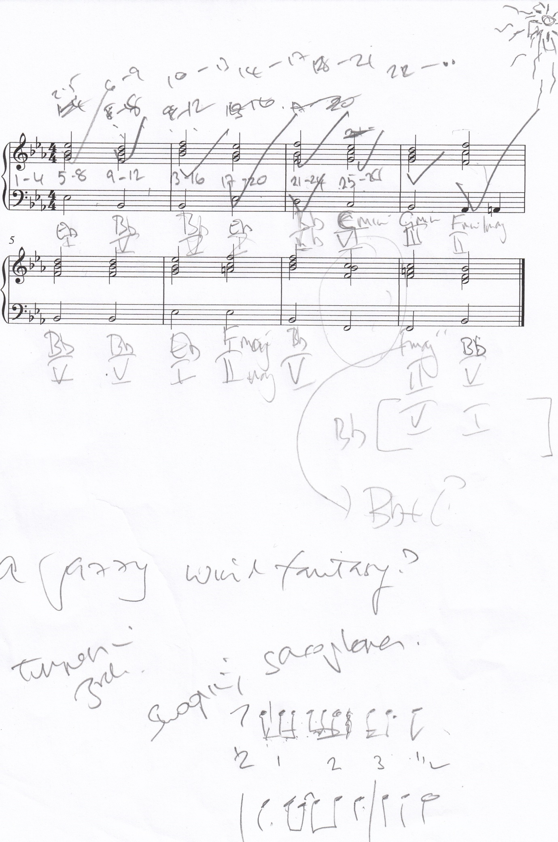
Rough working notes for Reviving Skeletons Exercise 1 based on a Vivaldi chord progression
Saturday 8 October 2016

Have started thinking about how to extend the piece I am working on for another 8 bars to keep up with the harmonic rhythm I have established based on the Largo from Winter from Vivaldi’s Four Seasons and have been trying out a new percussion accompaniment – see immediately below.

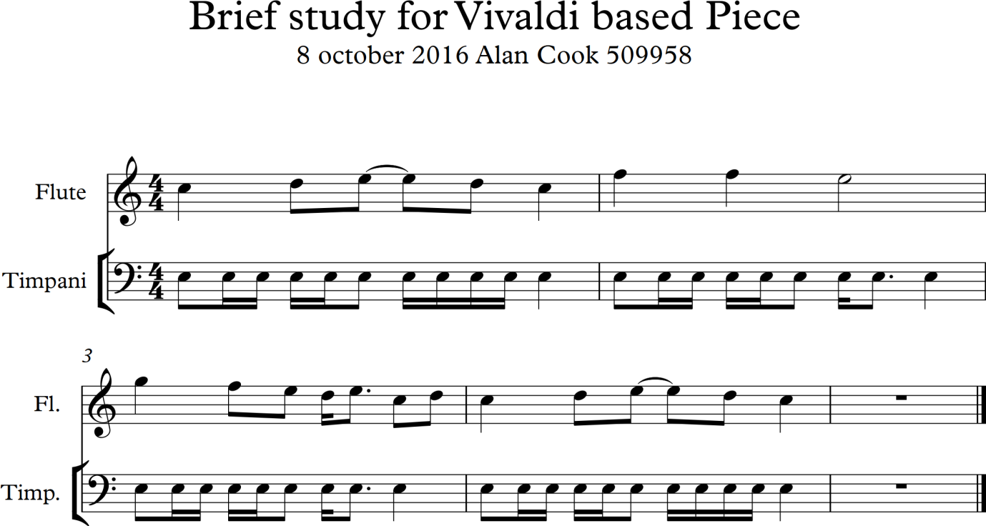

I have listened to the piece so far and it is building up in intensity and impetus and I have to know work out where to take it – the danger is that I throw everything in and make it a block of sound which will not do. I was also reflecting earlier this morning on the need to create dissonance as well as consonance and that if I stick to just the triad of the scales that will be very dull indeed.

Sunday 9 October 2016

It is 4.45 pm and I have finally after weeks finished the first practical exercise in Project 2 – and have loads more to do before composing Assignment 1 which is supposed to be in next Saturday. I have already had an extension (or two) so am very worried about this. I found the piece challenging to create and am still not happy with it but need to move on – the manuscript is copied on the next 18 pages below. Some reflections on this composition:
- I cannot believe I stretched 8 bars to 68! Quite an achievement in working material – although I have been using and reusing phrases and bits of the material over and over
- There is a limitation to sticking to simple chord progressions and listening to it I think it needs to vary more to compensate for this
- I need to learn more about orchestration as I have been struggling to make the music interesting and need to learn this art – also more dynamics are needed in the piece – all too loud
- I also need to work out how to make rhythms more syncopated and Latin in feel

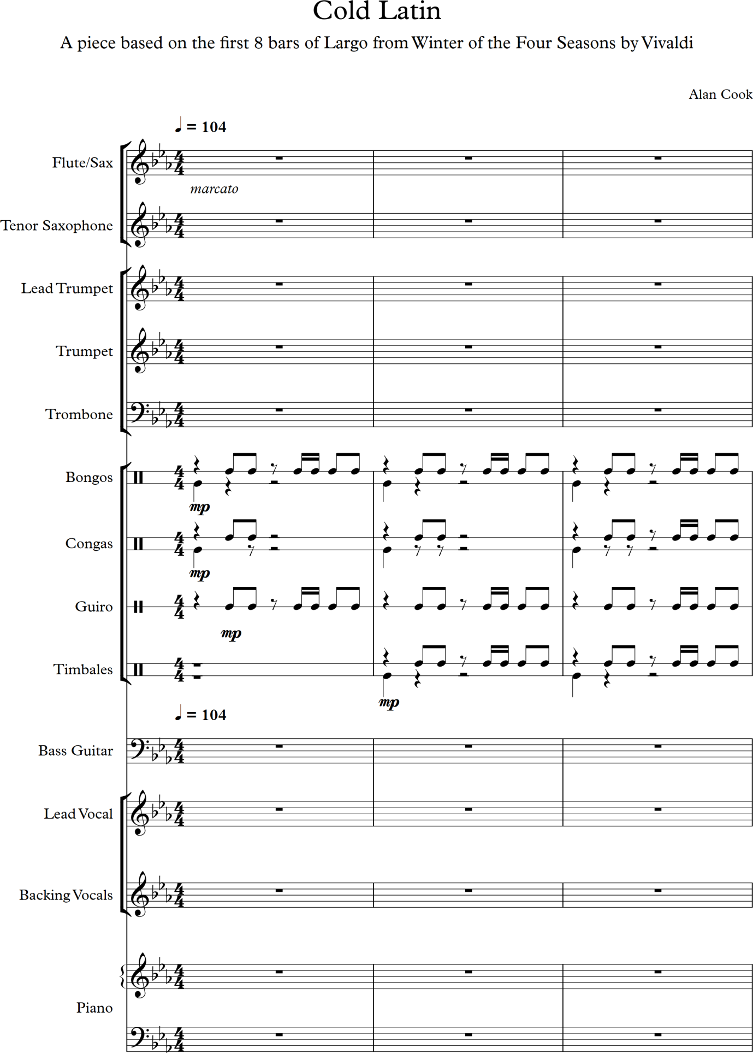

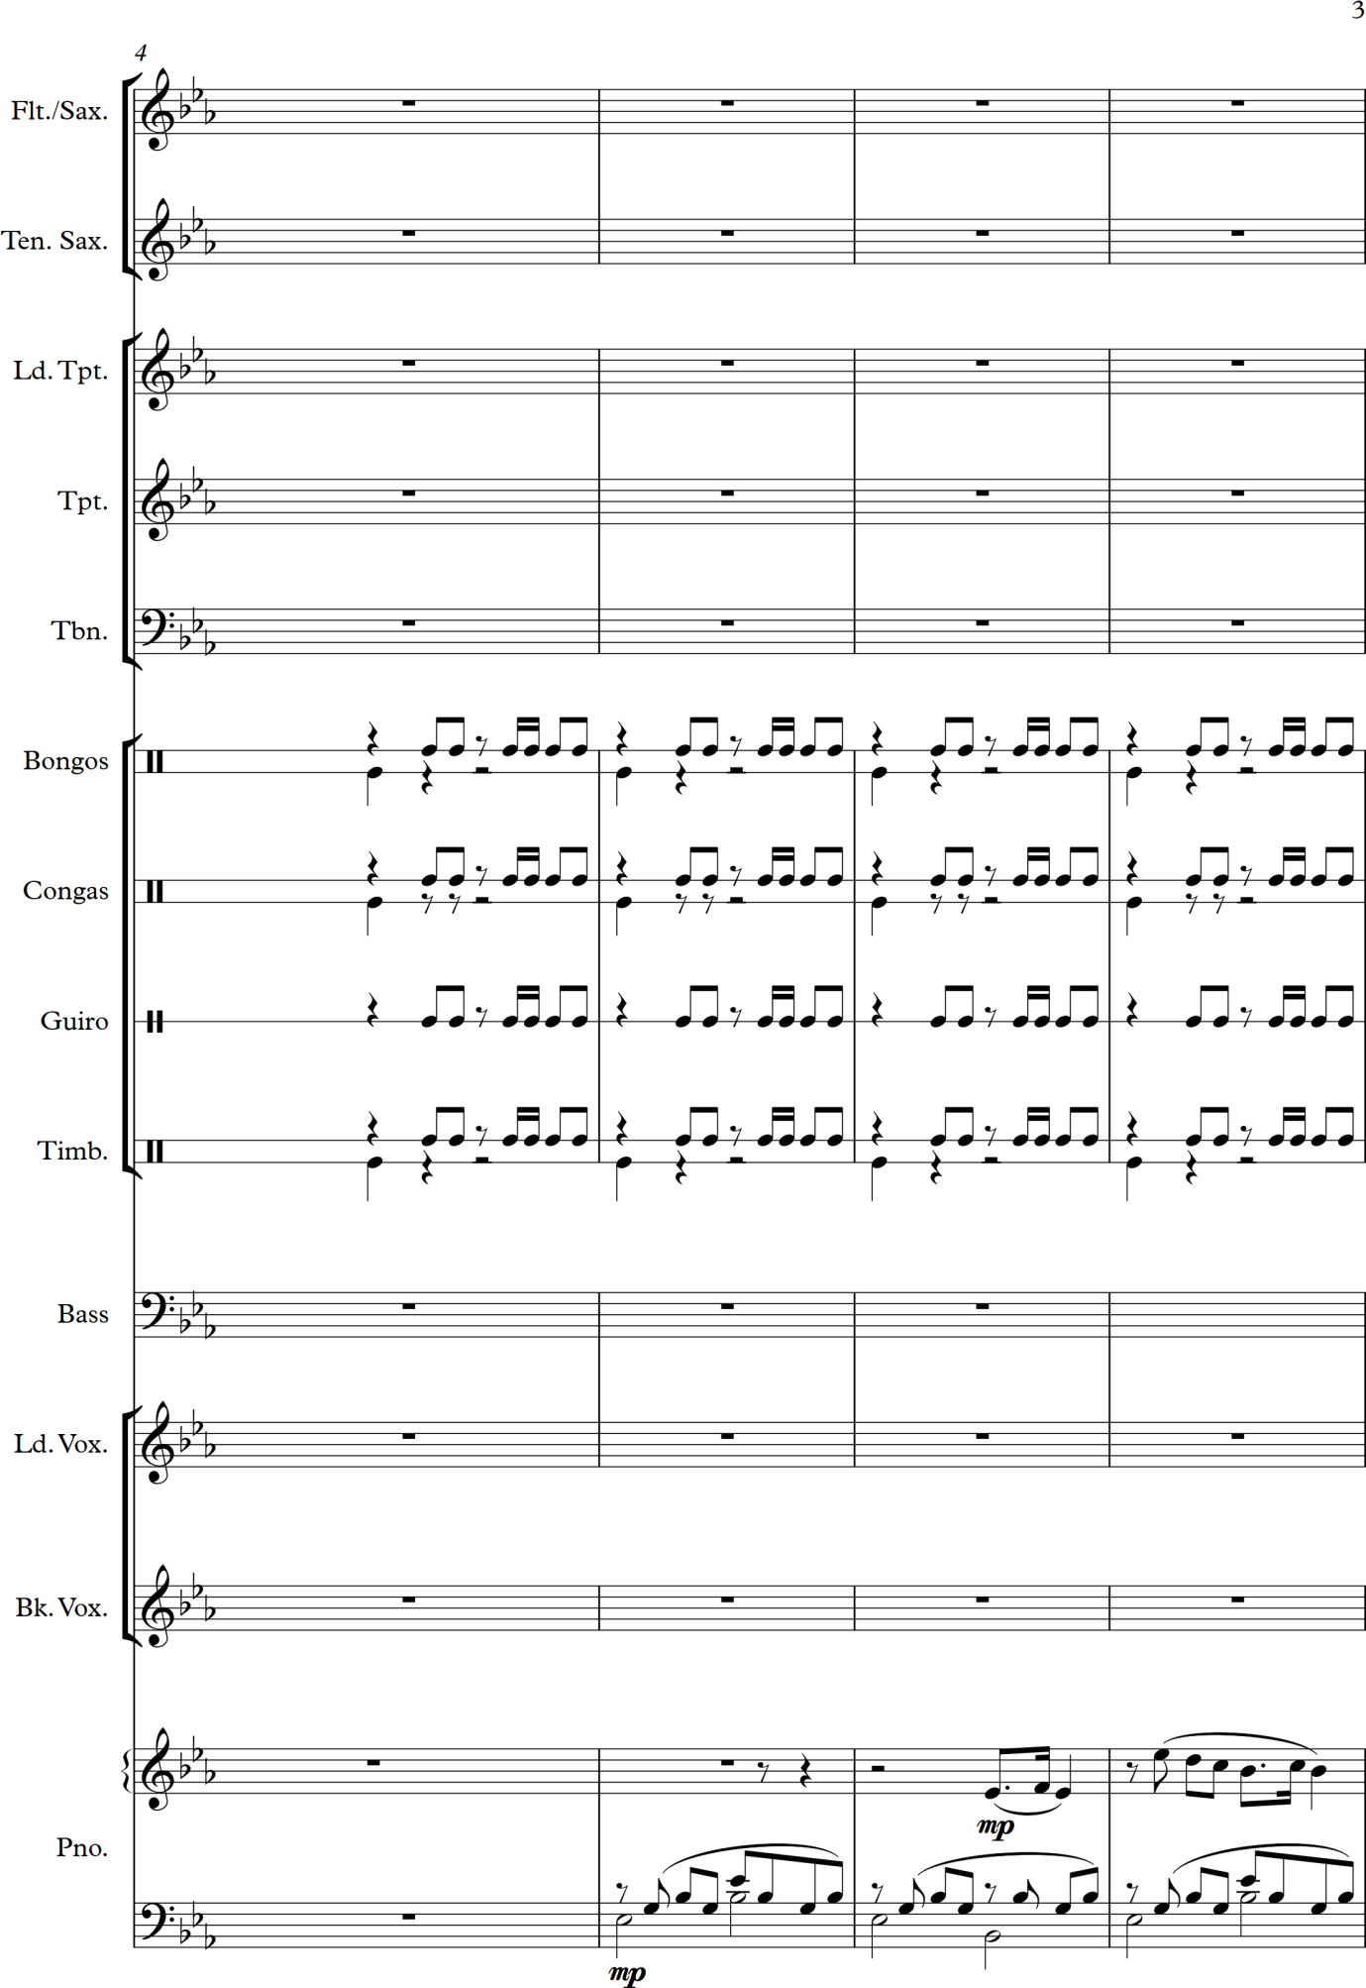

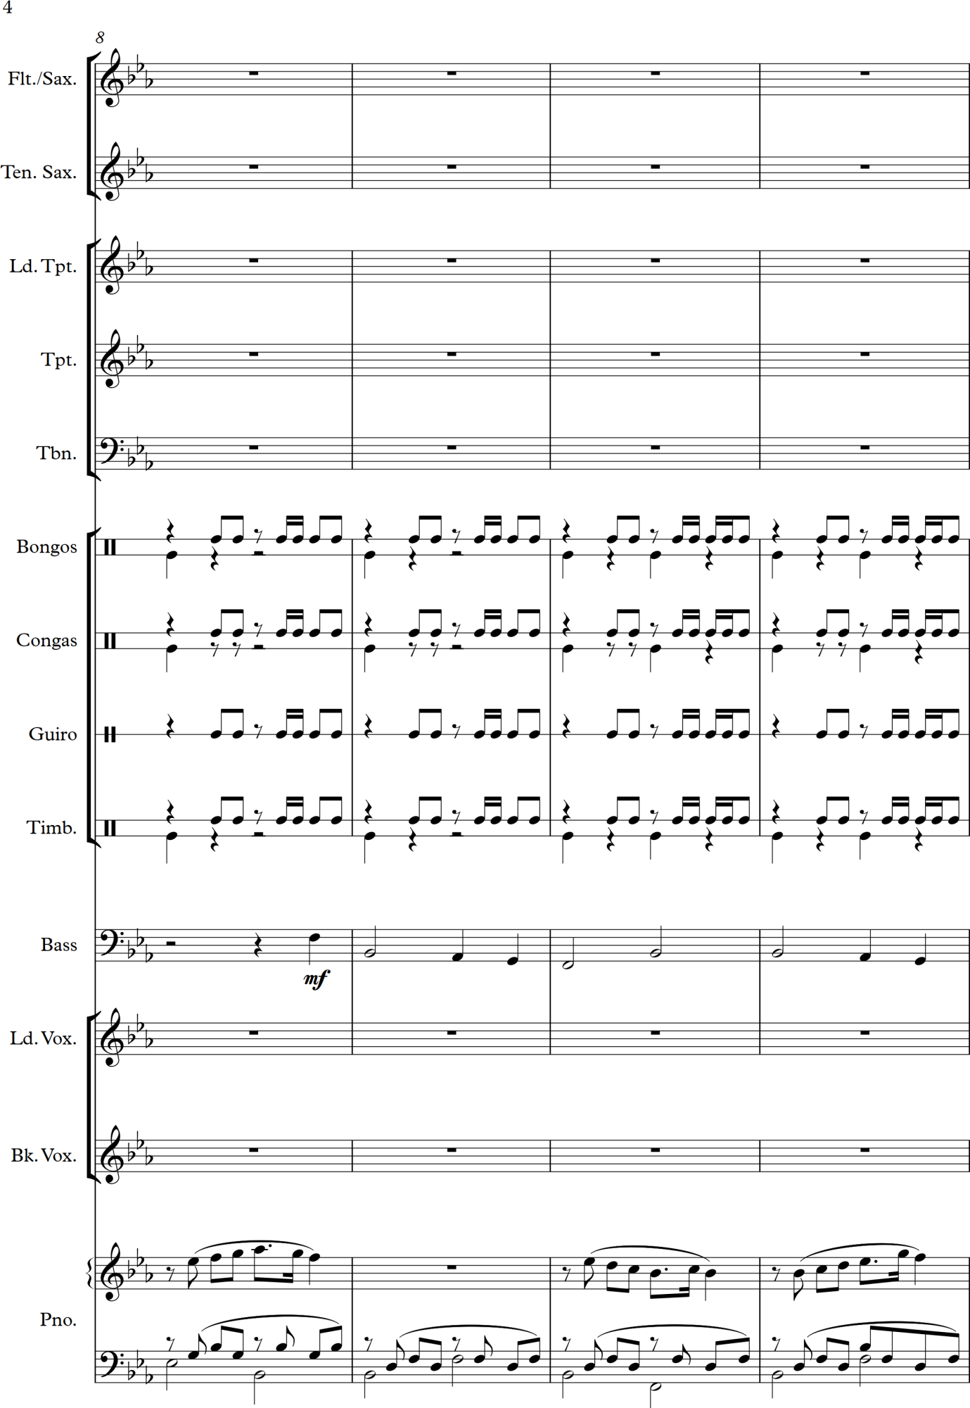

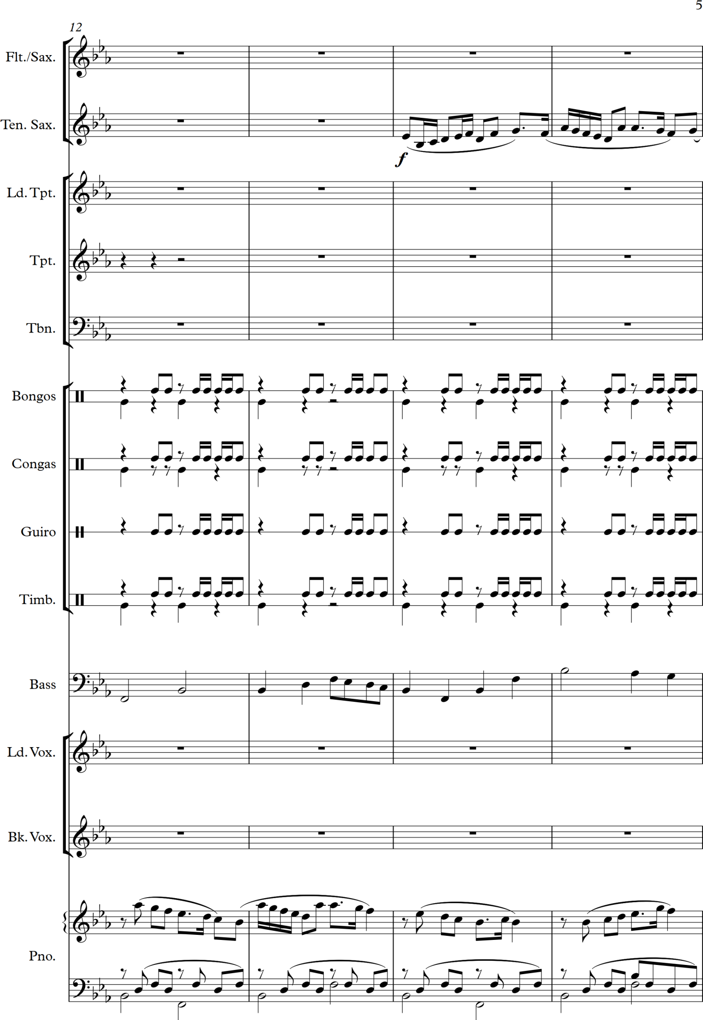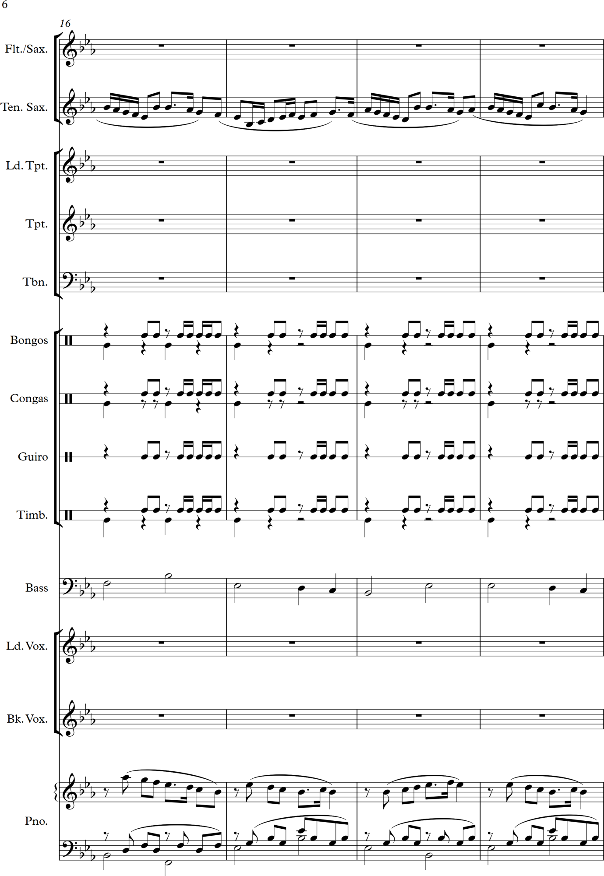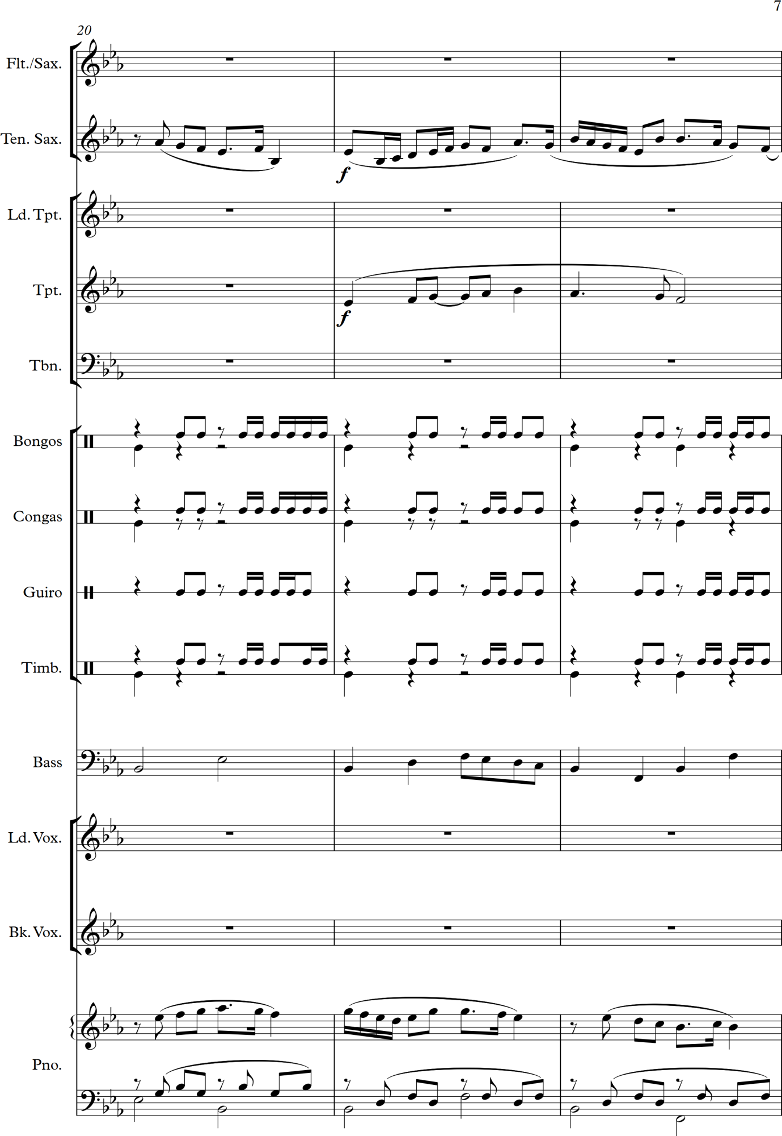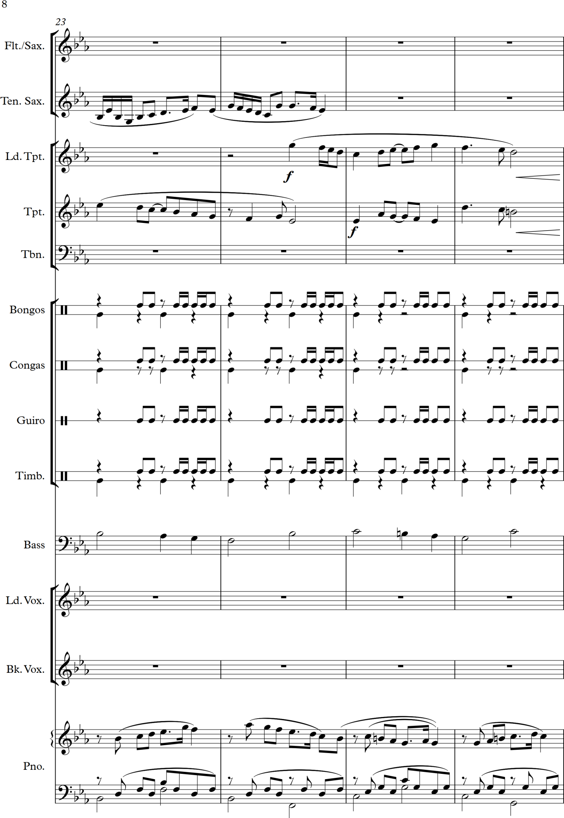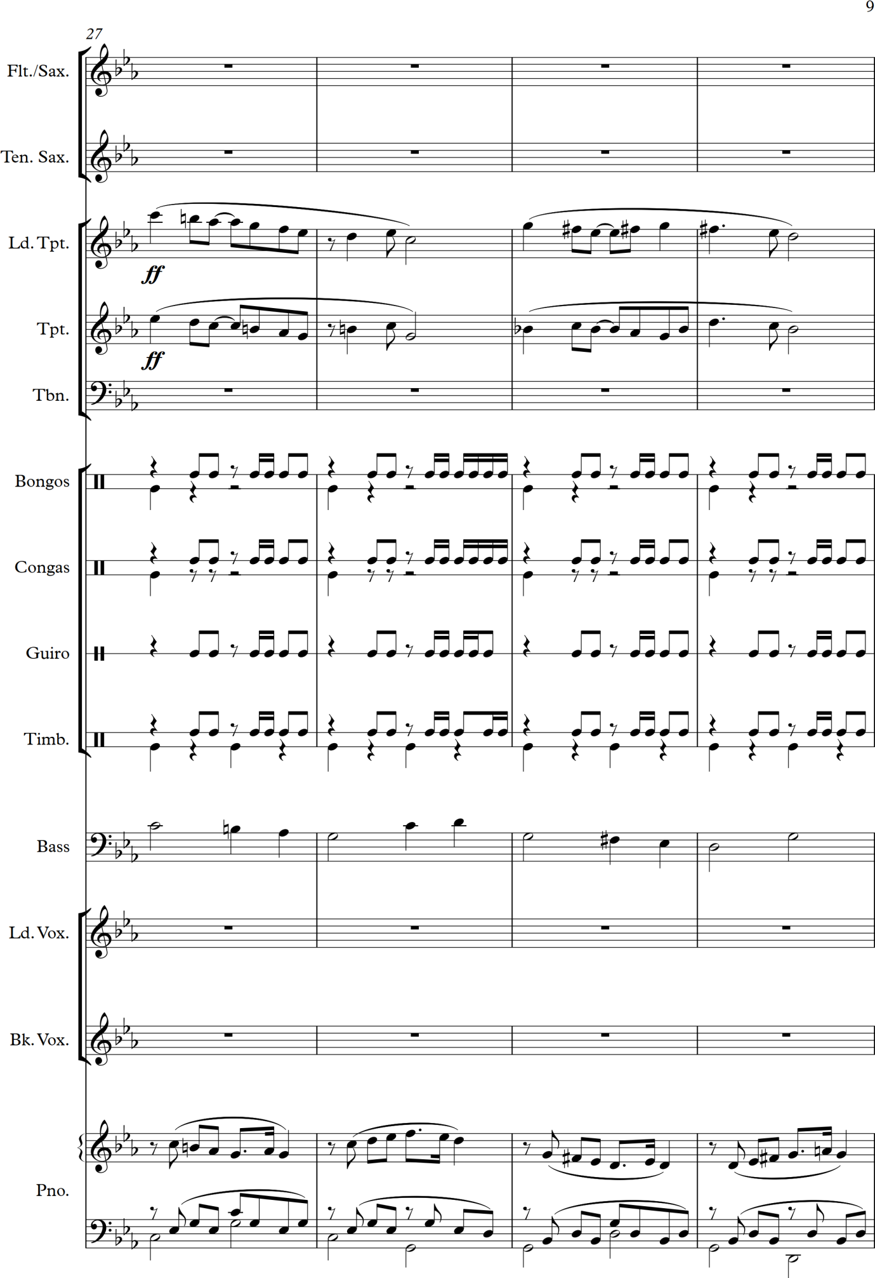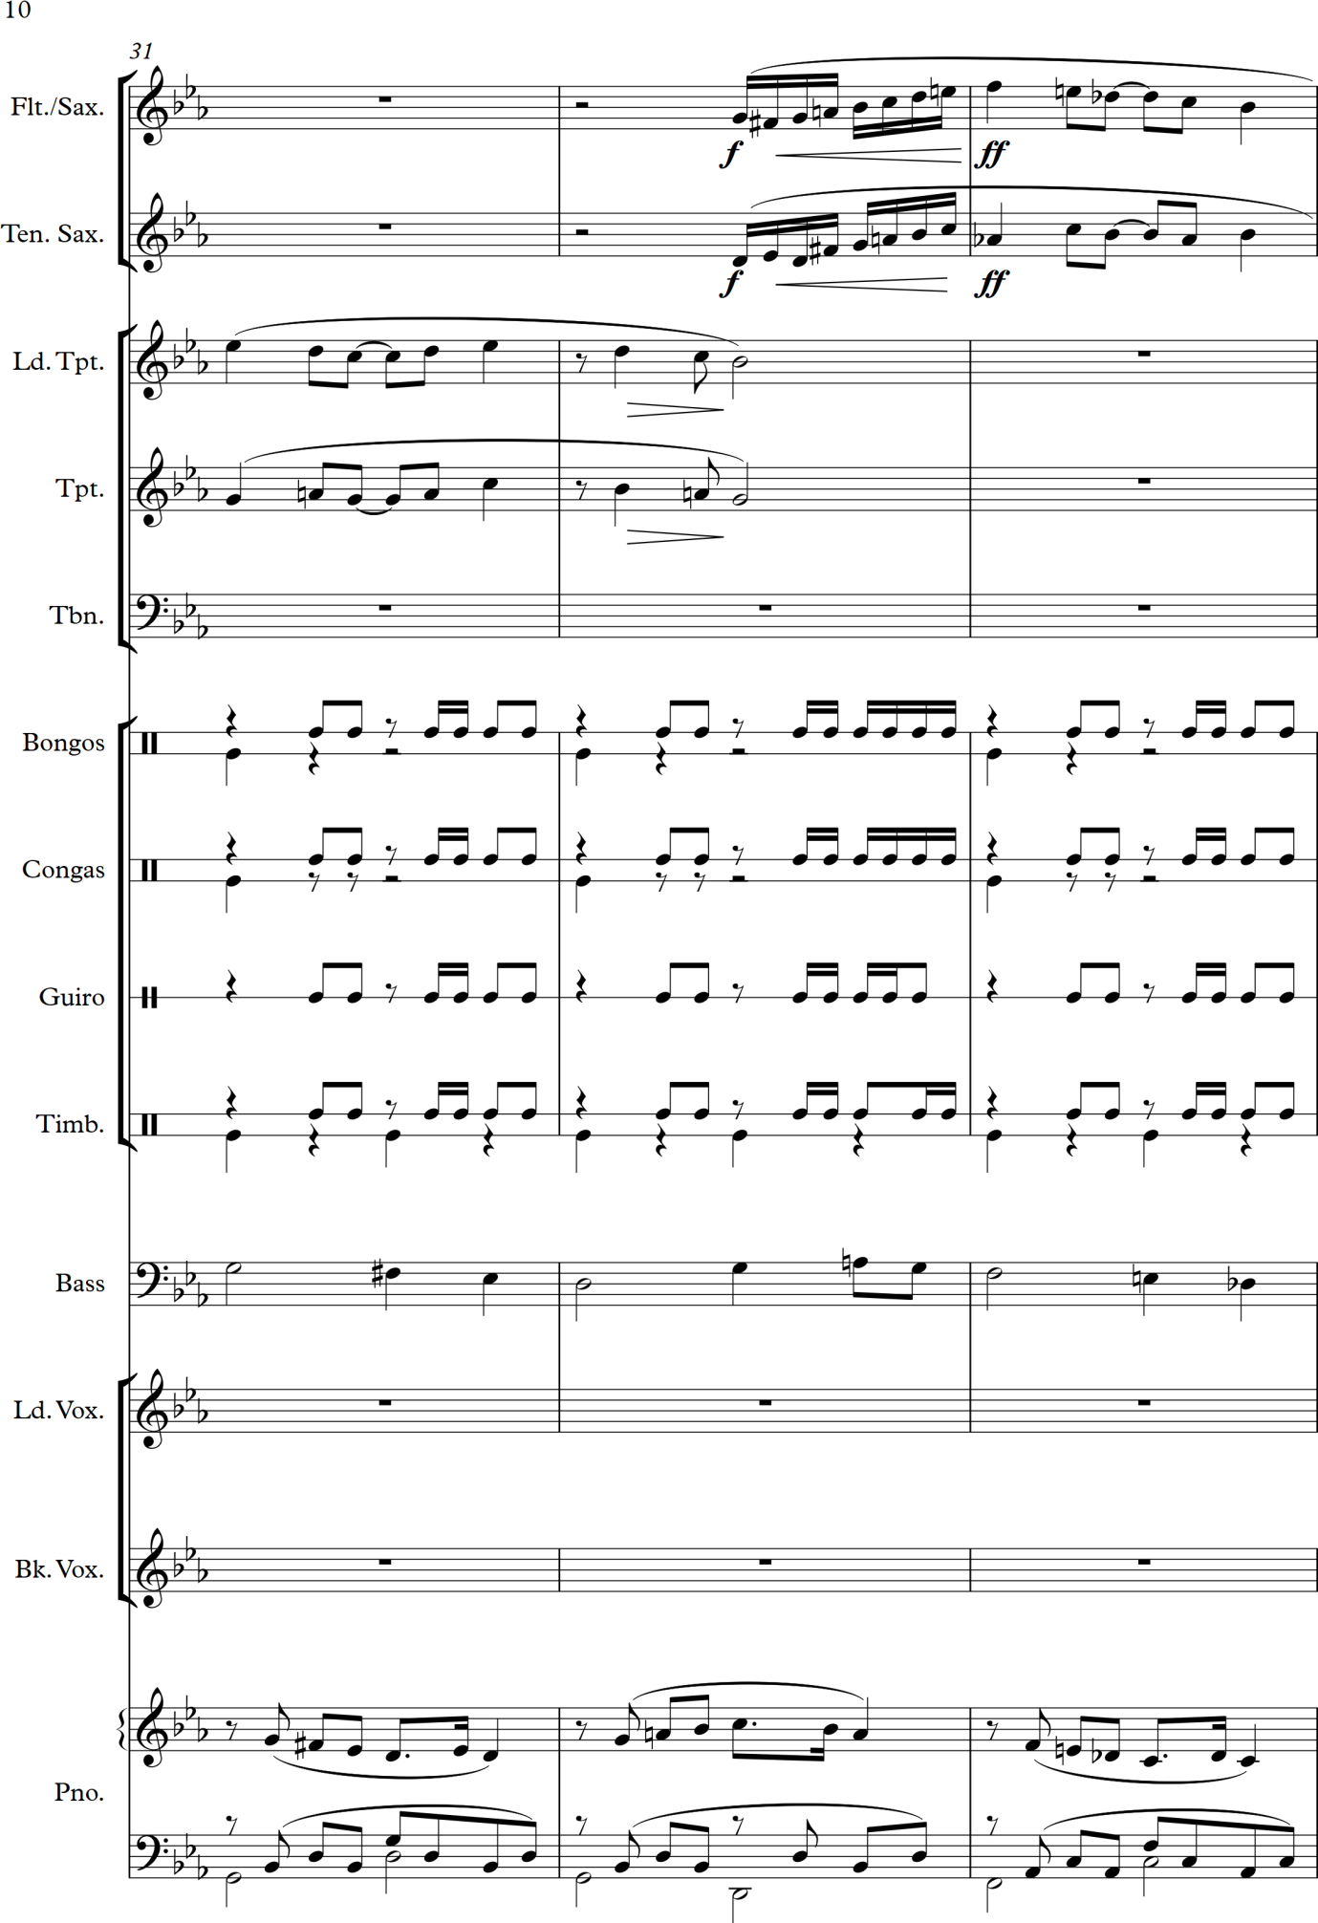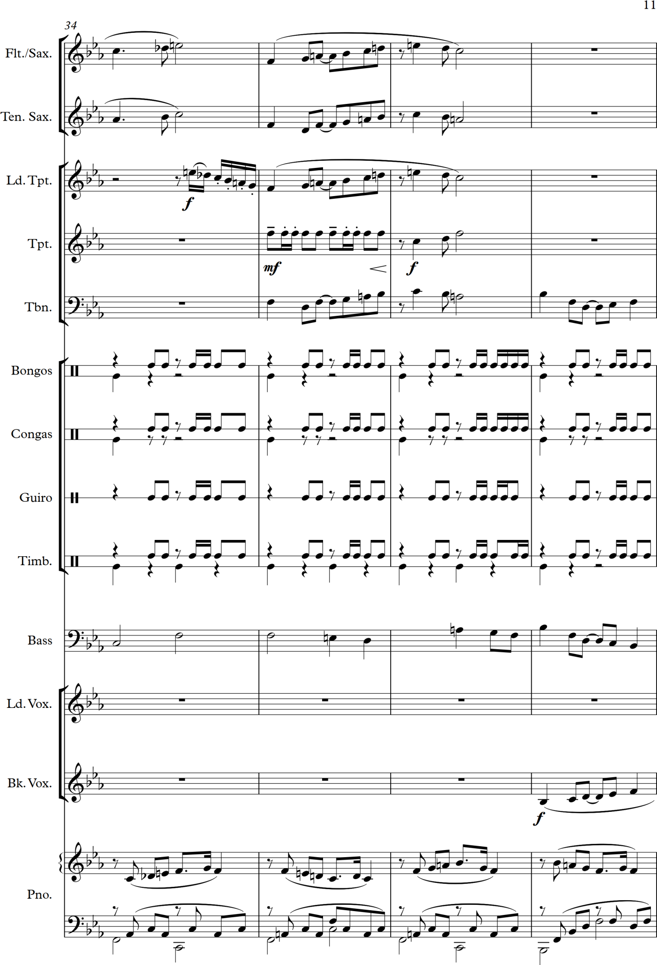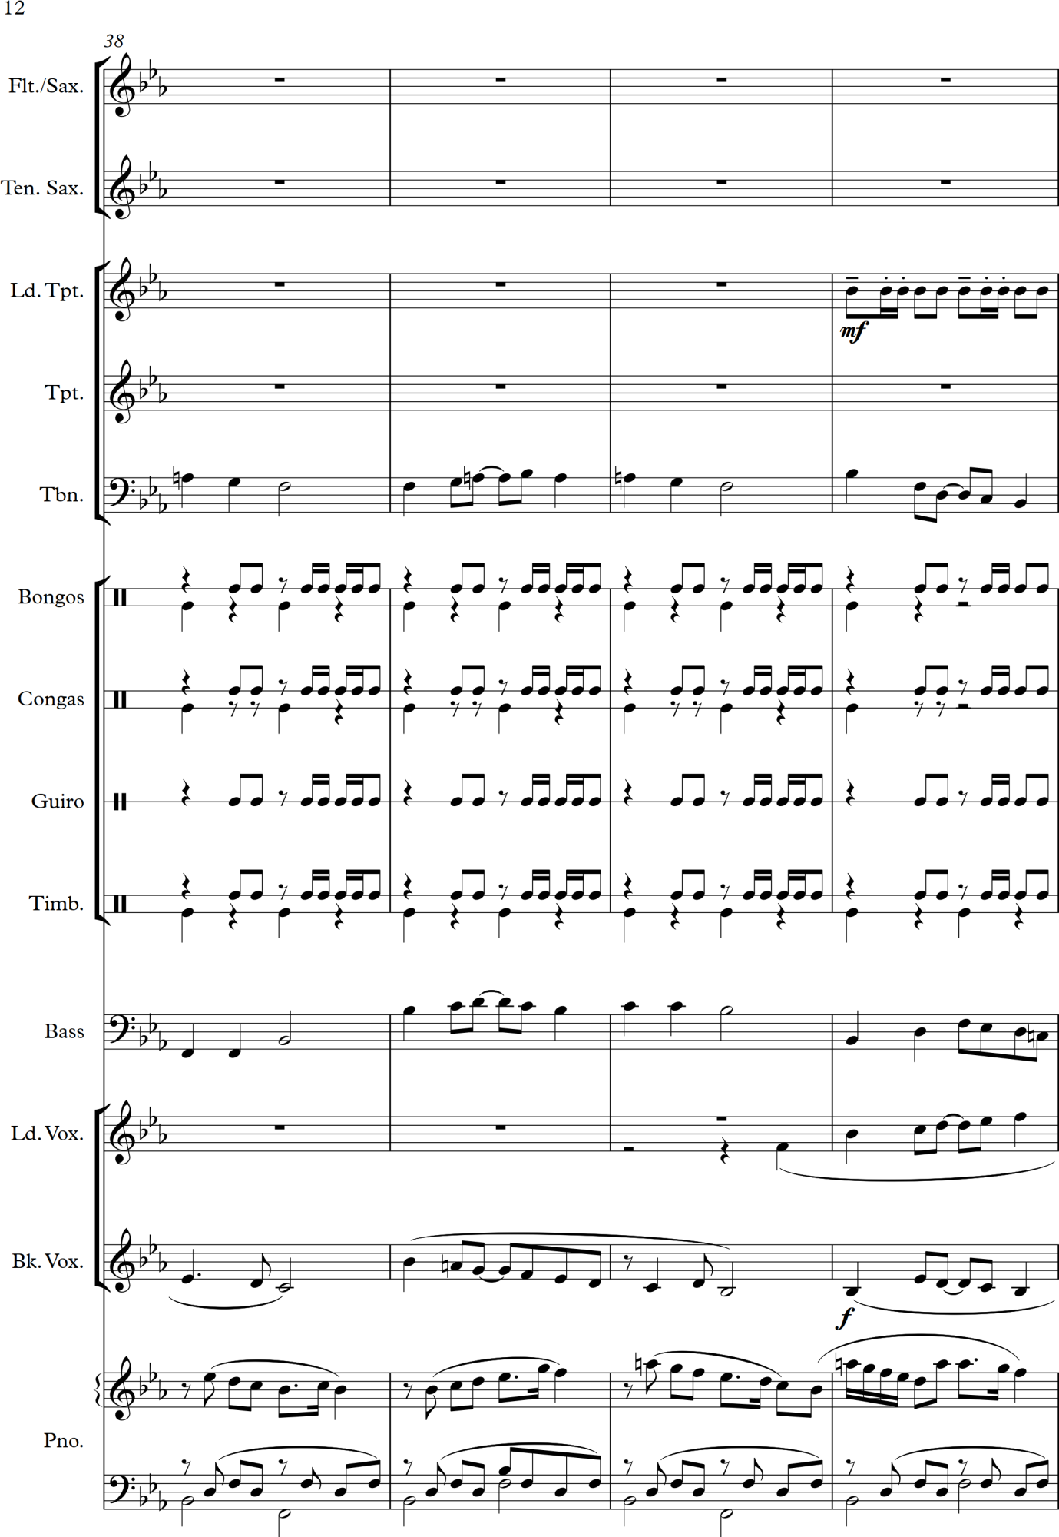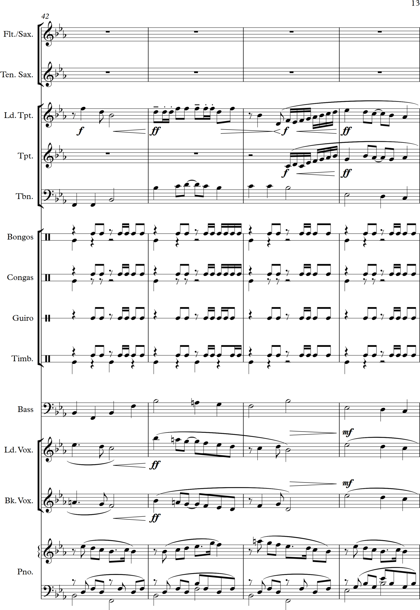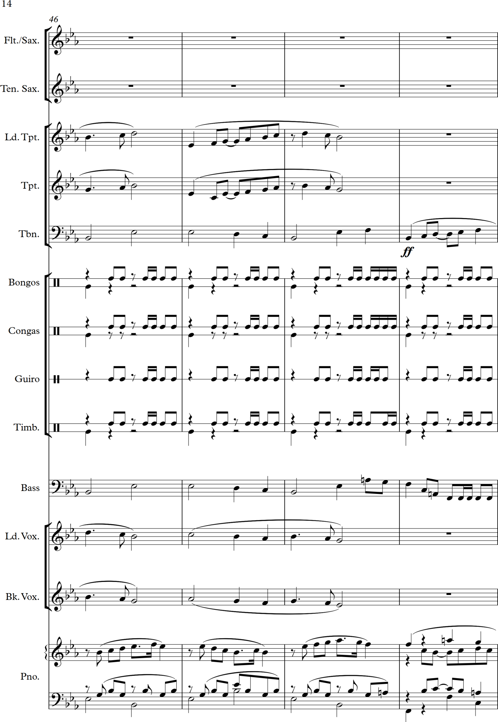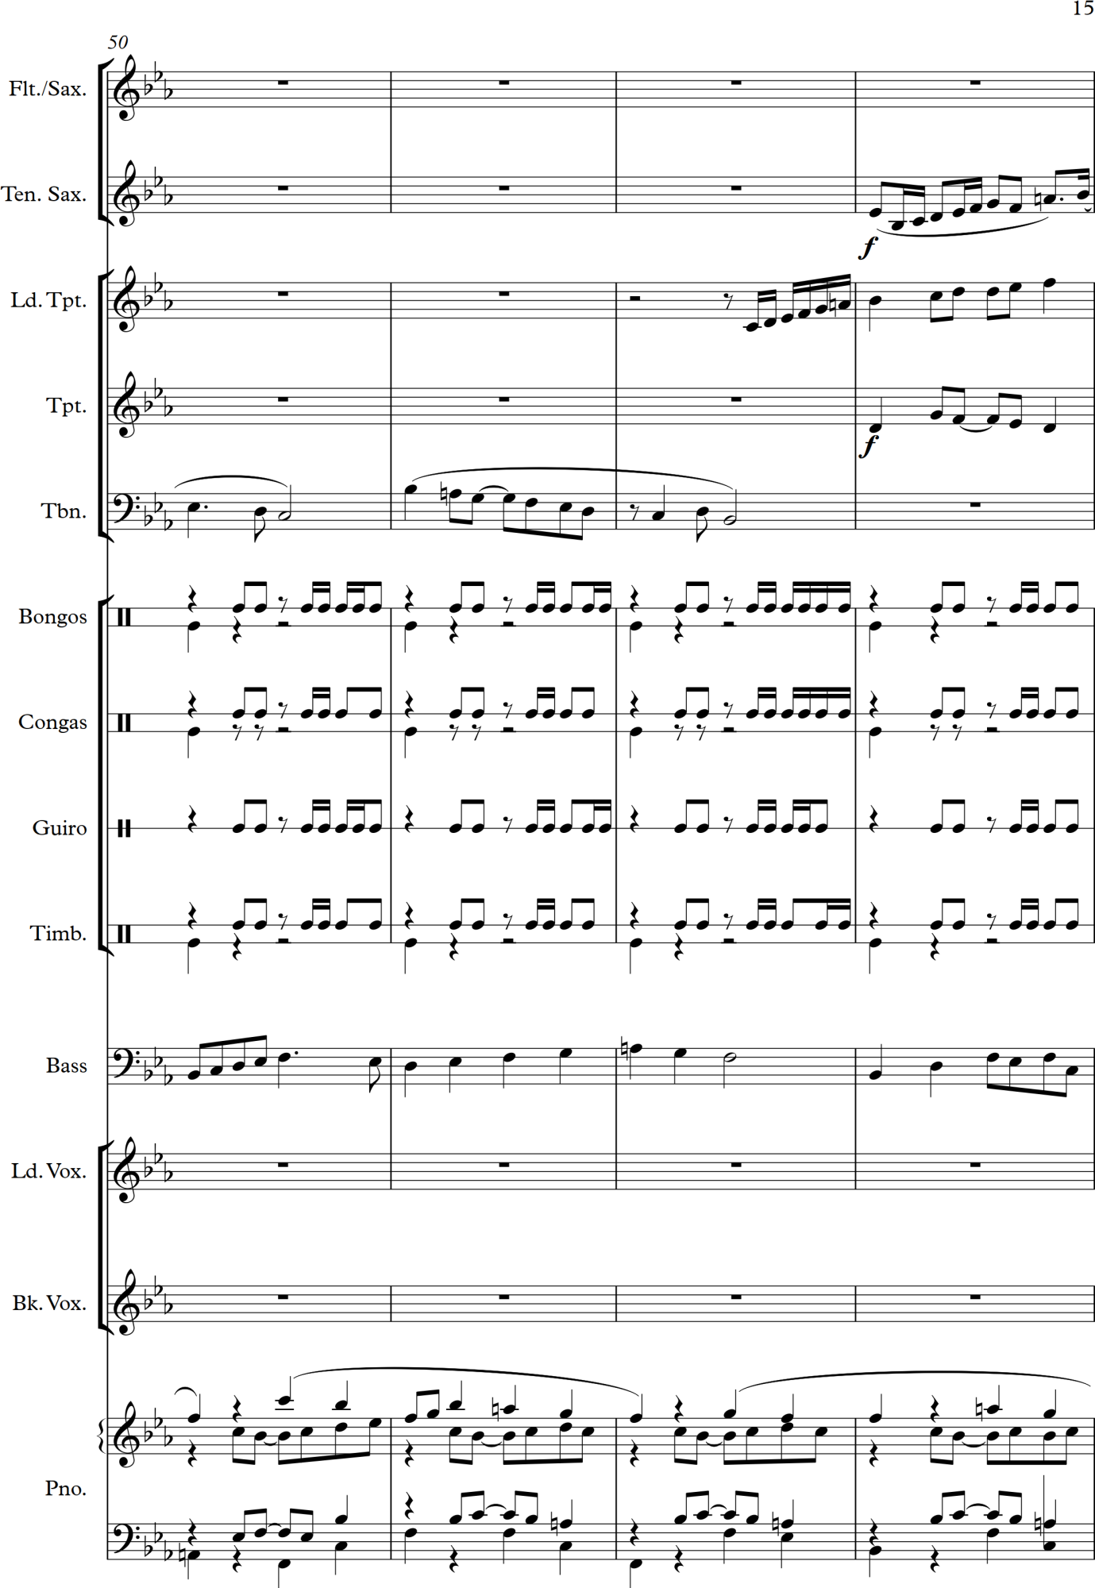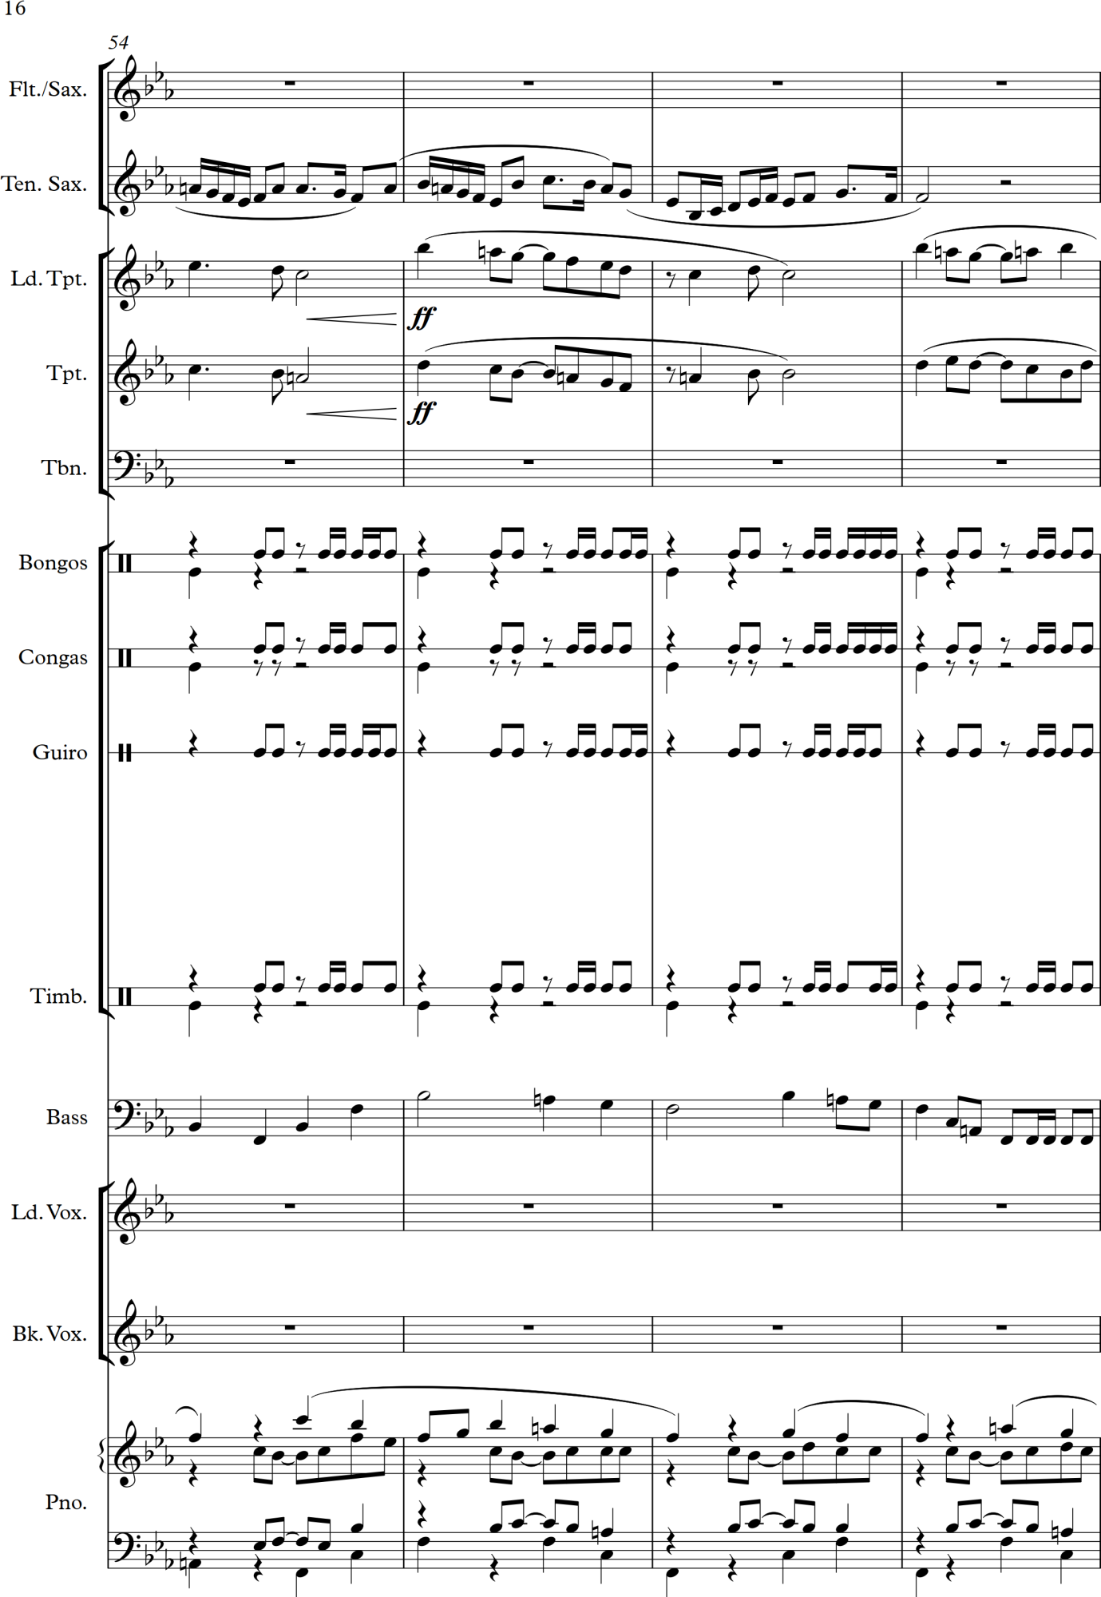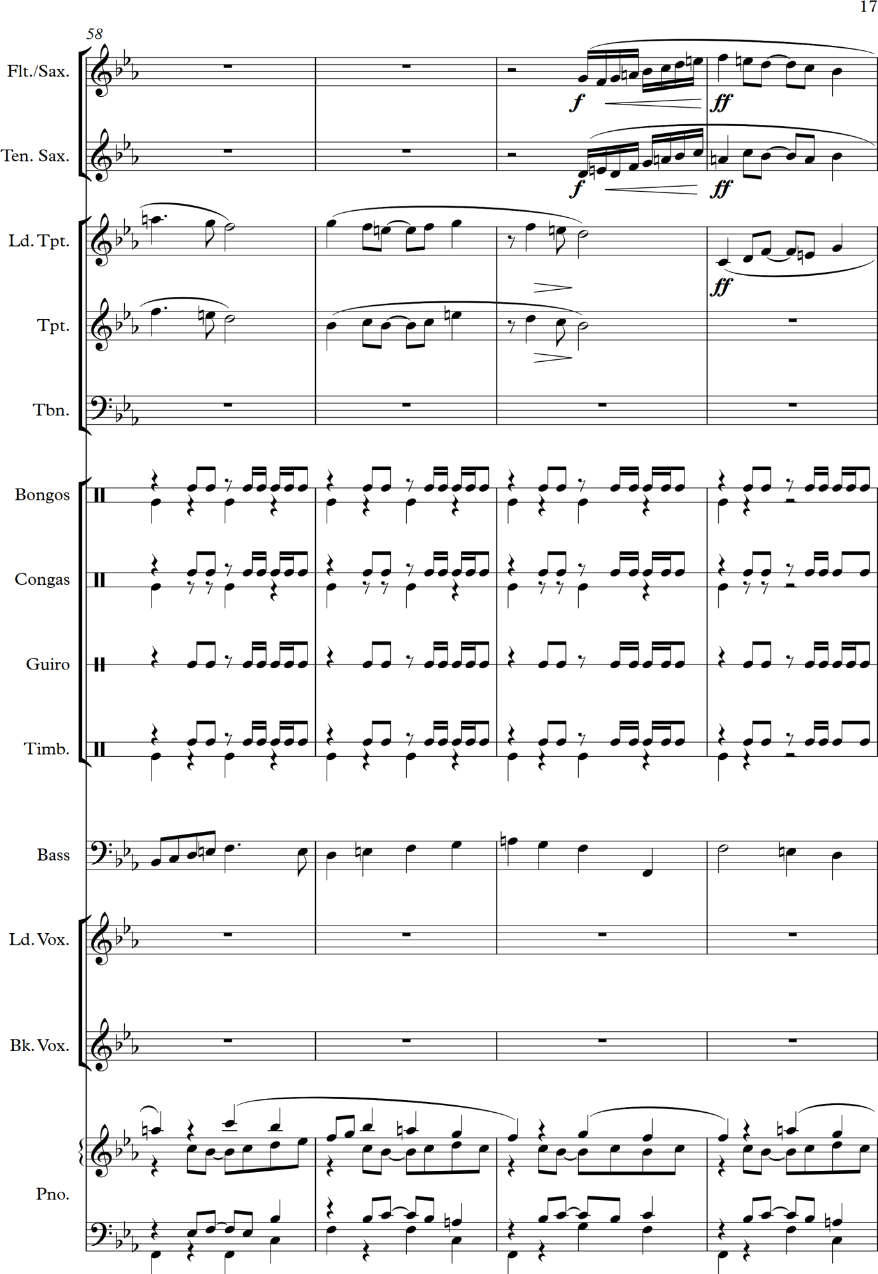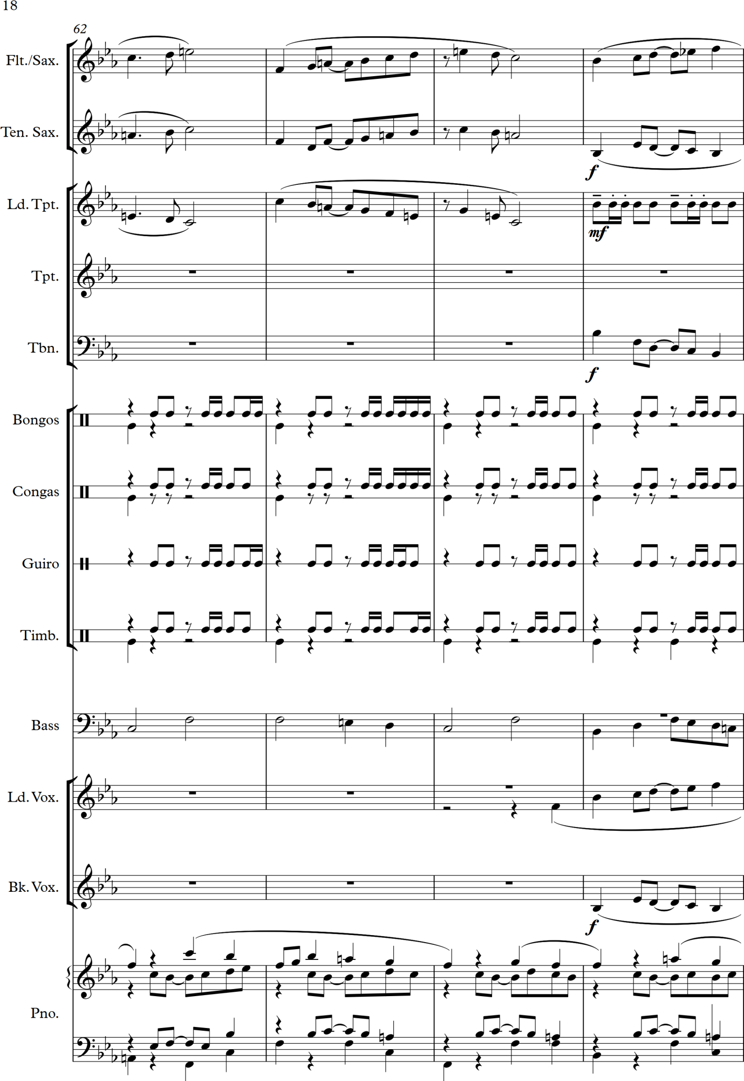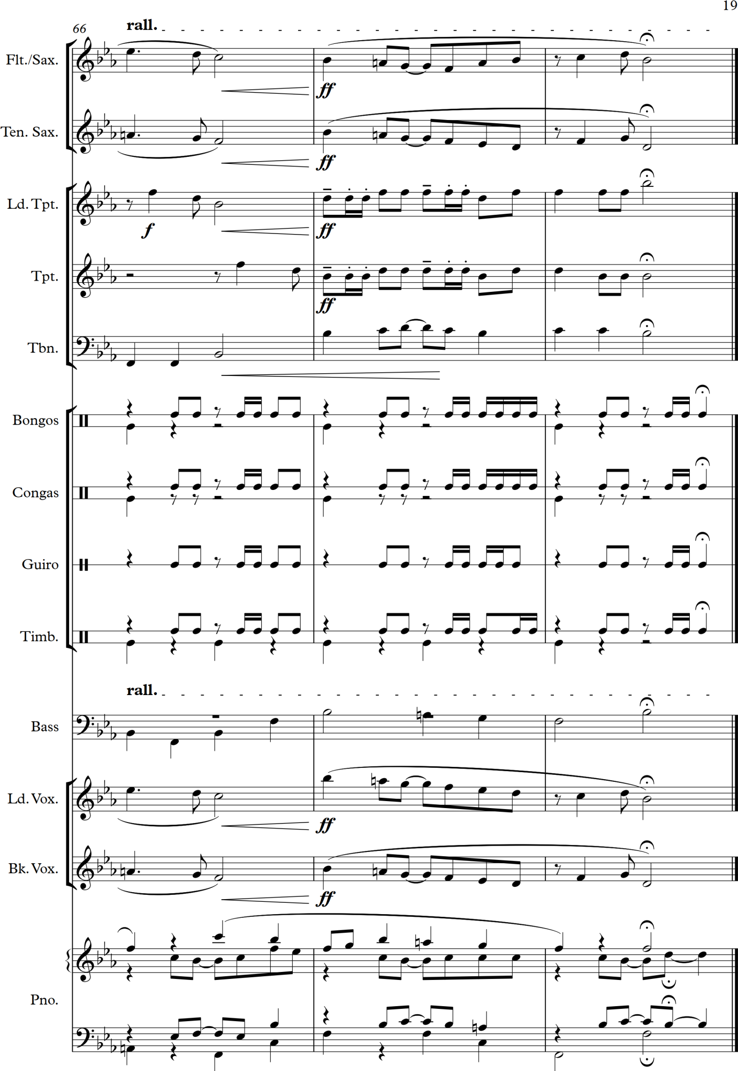

Tuesday 18 October 2016

Have started on the next ‘Reviving Skeletons’ piece in which I have to choose another piece to use as the basis for harmonic progression/rhythm – instead of using one of the suggested pieces I have decided to use a Violin Concerto by Benedetto Marcello – although this piece is also published as a Concerto Grosso! See more detailed notes on the piece below. I started with wanting to use a work by Wagner and downloaded from the Petrucci Library the Preludes to his operas ‘Parsifal’ and ‘Tristan und Isolde’. I decided this was a challenge too far at this stage of my development as the harmonies are highly complex and the range of clefs and instruments in various pitches entailed so much translation in to terms that I can easily understand that I decided to go for a simpler piece at this point. I like the suspensions and harmonic progressions in the piece I have chosen.

Also a brief note, in passing, about discovering the Six Studies in English Folksong for cello and Piano (or Viola or Clarinet) by Ralph Vaughan Williams composed in 1926 for the cellist May Mukle and first performed by her and her sister Anne. I was searching for twentieth century pieces for viola as part of my ongoing reflections and preparation for Assignment 1 and discovered I have a recording of them and also managed to download the music from the Petrucci Library. Lovely evocative pieces that are simply written to great effect – a lesson for me in ‘less is more’!

Sunday 23 October 2016

Further notes on the chosen piece for the next exercise: I have based the harmonic progression on the Bach Concerto for solo keyboard BWV 981 – movement III. This is an arrangement by Bach of the Concerto Grosso Opus 1 no 2 for four string parts and continuo (harpsichord) by Benedetto Marcello. I downloaded the parts from the Petrucci (IMSLP) Music Library (Naumann, 2007) and checked the copy of the piece by Marcello there which is in the key of E minor. The Bach reworking is in C minor. Here are the bars that I used as my starting point, i.e. my skeleton:

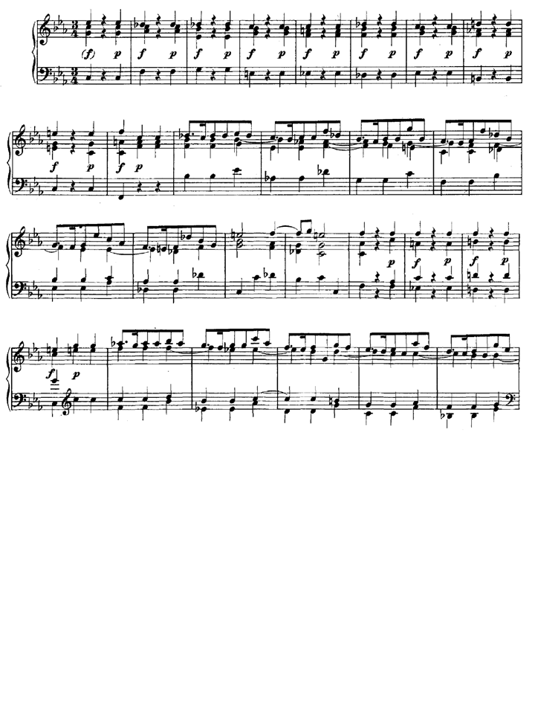
And here is my transcribing of the harmonic structure for my initial study and ideas:

I have been trying to analyse the chords used here and the progression and have found that some of them are difficult to identify – this what I have managed to work out so far:

C minor – F minor - E♭ major – C major (seventh) – F major (seventh) - B♭ minor – C minor – Diminished 7th starting on B natural – C major – F major – F major – B♭ minor - E♭ major – A major - D♭ major – G minor – C major – F major - B♭ minor - E♭ major - A♭ major – crunchy chord I cannot work out (D♭ + E♭ + F + A♭ - maybe D♭ major with interest) - B♭ major – C major plus 7th – D major – C major – F major

I like the sound of it all but have one thought – the piece contains some bars where the top line is moving in quavers and therefore the harmony might be constantly moving although these could also be passing notes. Or maybe I still have lots more to learn about deconstructing harmony and musical analysis?

Saturday 26th November 2016

I am still working on the above described piece – it is taking me ages partly because I am being very (over?) thorough about its composition and partly because I have been away on a short, and much needed, holiday preceded by yet another fluey cold.

I have been reflecting on the piece as I m writing it and have the following thoughts and ideas to jot down:
- Try holding harmony notes for longer and think about what actually needs to move – I note this as most of my compositions are very busy and I am finding it a real challenge to write pieces that are not contrapuntal and that create a sense of suspending time – listening to Fratres by Arvo Part yesterday reinforced that I struggle with this
- I need to check the harmony across the various clefs I am writing in – having two viola parts in alto clef is a challenge for me!
- Study the Brahms String Sextets for ideas about how to structure and write harmonically and accompaniments to a melodic line
- I note that in this piece I am writing a very dominant melodic line for Violin 1 which leads the music and that I could play with interplay and share the leading voice around more – for instance, I could have a new melody in a lower instrument which is then repeated or varied in a higher instrument
- I could utilise block chords as phrase marks and cadence points
- Follow a rising phrase in higher instruments with a quicker version or resounding phrase lower down
- I could repeat musical phrases between different instruments or repeat with a strong rhythmic accompaniment
- I could change the time signature
- I could put a big tune in the lower instruments with a plucked accompaniment on the higher instruments

I have also met with a medical colleague who is a very fine viola player (he plays in a number of local orchestras and chamber groups and is respected by many professional musicians I know) to discuss writing for the viola as I am composing for two of them in the current piece underway and also need guidance for my Assignment 1 piece. Points noted from the discussion:

- The viola is like the cello but an octave higher and has similar registers to a clarinet
- The strings are pitched at C G D A (violin is G D A E) so a fifth lower than the violin
- Don’t write above an E on the A string
- Lower strings sound better in terms of quality and richness of sound
- The strings are heavier than those on a violin so the instrument cannot respond as quickly
- Suggested I listen to the beginning of the Brahms German Requiem for a good example of viola writing – or the Brahms Viola Sonatas

Monday 13 February 2017

Just to note that I have now brought my reflective and listening logs up to date and am about to recommence on the exercise (composition) that I have been working on and is described above. I have now composed 28 bars of music and am about half way through and having just listened to the piece I am glad to write that I still like it and look forward to taking it forward – however this will have to be another day as I now need to go to my paid work. This has been quite a break, which was

Sunday 19 February 2017

Another note to register that I have been further working over the piece so far and that I have had to go back through it and deconstruct the harmonic progressions I am using as I have forgotten much of the concepts and thinking behind the piece and picking it up some months later is quite hard to do. I notice that although I started off with the intention of following the harmonic rhythm as Bach utilised it but at a half or quarter of the speed I have in fact not stuck to this and varied it more although I have elongated the rhythm considerable in order to make a much longer piece. I will put on the next page a scanned copy of my rough working notes* as these help explain where I am at just now – I also have the whole manuscript printed off and covered in notes and squiggles to try to recapture my intentions and thoughts.

A passing thought I have had many times and must note down is this: Marcello and Bach in composing (in Bach’s case rewriting would be a more accurate description of what he did) these pieces stuck to the harmonic progression with a few passing notes and additions but as the harmonic rhythm was straightforward and fairly quick the progressions are very clear. However in elongating the music and making it more complex and also varying more the times spent on each chordal structure underlying the music I may have introduced other passing harmonies within the overall key being utilised at the time. My question is - am I actually introducing a more complicated and different harmonic rhythmic in doing this or am I still sticking to the skeleton they used but doing something different with it? And is this in keeping with the spirit of the exercise set?

See next page for image described in text above at *.

Monday 27 February 2017

I have reflected at length this morning on my challenges in getting organised and progressing with this course and have set myself the following aims, in order of undertaking, for today – both detailed in my Reflective Log and copied here:

For today I have set myself the following plan:
- Update notes in my Reflective Log (doing at the moment!)
- Decide 3 music books to read and put them in priority order and allot time to starting the first one
- Continue with current exercise – composition
- Check OCA e-mails
- Add in details of the recent music I have been listening to and CDs I have ordered into the Listening Log
- Review today’s success and limitations and plan Friday’s studies
I have now (at 11.30 – big interruption from a friend who wanted me to track down a melody written by Boccherini which he hummed out of tune – the famous Minuet from his String Quintet no. 5 in E major, Opus 11 G275) updated my Reflective Log and have now also decided which books to study after having to go the OCA website to find the reading list which I have lost – I will read these three all of which I own copies of:

- Fundamentals of Music Composition by Arnold Schoenberg
- Structural Functions of Harmony by Arnold Scoenberg
- A Geometry of Music by Dmitri Tymoczko

I will start studying these on Friday as I wish to work more on my composition for Project 2 today.

Note at 4.40 pm after working on music studies all day:

I have achieved most of the aims I have set myself for the day except updating my Listening Log – I will do that on Friday along with further work on Project 2 and starting to work through the first book listed above.

I found continuing with the composition hard – I wanted to move it into the next key in the progression (from A♭ major to D♭ major) but have lost my sense of structure with the music and don’t know what melodic themes to use. Truth is that I have not devised a structure to shape the music nor am I consciously planning the use of themes and therefore it is more of a free flowing creative piece following the harmonic sequence I chose based on the piece by Marcello as described above. I am encouraged to be creative and push boundaries more but I feel I need to learn what the boundaries and rules are first. This all seems confusing and tough at the moment. I am trying to be more unitary and homophonic in my harmony and part writing and to move away from contrapuntal and polyphonic styles and baroque influences.

Monday 6 March 2017

I have started studying the book ‘Fundamentals of Composition’ by Arnold Schoenberg (Schoenberg, 1967). I have already found some sentences that really speak to me and mean much – I have put them in my reflective diary but have typed out below others that will be useful to me in my composing. I am still working on Project 2 and making very slow progress – partly because I am unsure of what I am doing. I have remembered that in my last course I listed the elements of composition and am going to find them and type them out again here as I think that they may help me in composing the rest of the piece – I do have the harmonic progression fixed for me but have already varied the harmonic rhythm although still sticking to it to some extent – that could have been a mistake as it has loosened up the pace and changed the pattern at which the harmonic changes progress as compared with the original ‘skeleton’ that I have been using as the basis of the piece.

The list of elements of the style of a piece of music as I described them in my reflective notes for Assignment 5 of Composing Music 1:

- use of rhythm and rhythmic devices
- a particular (and deliberate) use of structure
- (favourite) uses of harmonic progressions
- inspiration by particular and individual themes,
- the way a piece is orchestrated to create a specific timbre
- good melodies
- dynamic variance
- the giving of breath to the music (how pacing, phrasing, silence and rests are used)
- how the music sounds and feels
- sonic texture – i.e. the deliberate construction of sounds and patterns to create effects

One point I have noted in reading the Schoenberg book noted above is that he puts less overall emphasis on rhythm as fundamental in music in comparison to the Composing Music 1 course I have completed. In the course rhythm was the starting point for composition whereas Schoenberg starts with form and then phrasing with rhythm third in the order of explanation. Rhythm is used as a variation in the use of melody and harmonic progression in the examples he gives earlier on in the book. He states:

Rhythm is particularly important in moulding the phrase. It contributes to interest and variety; it establishes character; and it is often the determining factor in establishing the unity of the phrase. The end of the phrase is usually differentiated rhythmically to provide punctuation

(Schoenberg, 1967)

Thursday 16 March 2017

I am continuing with the string sextet based on a progression of chords from the piece by Benedetto Marcello detailed above. This has become more than an exercise as a friend has offered to have it played by a semi professional string sextet in Bristol that he plays with. This means that I am now taking it even more seriously – not sure whether this is good or bad but does mean that my progress with it continues to be slow.
I have found that I am struggling with new ideas and how to work my material. I am also realising that I am finding the fixed chord progression limiting and is stopping me for taking the piece in the directions my imagination wants it to go. In order to get some ideas I have listened to recordings of the following pieces and listed the ideas that I heard which seemed usable by me at this stage of my musical development. Further details of the recordings I used are detailed in my Listening Log in References 13, 14 and 15 within the Sound Recordings Section and in the references below.

Erno Dohnanyi (1877–1960) – String Sextet in B♭ major (Budapest Quartet, 2006)
Mihaly Mosonyi (1815–1870) – String Sextet in C minor (Budapest Quartet, 2006)
Arnold Schoenberg (1874-1951) – Verklärte Nacht, string sextet version (Artemis Quartet, 2006)
Johannes Brahms (1841-1904) – String Sextet in B♭, Opus 18 (Prazac Quartet, 2013)

I note that nearly all these pieces are early works – like mine! I am overawed by the Schoenberg and Brahms sextets as they are so masterly and flow organically, particularly Verklärte Nacht which is so brilliantly composed with a boundary pushing use of chromaticism and unusual harmonic shifts and construction. I must also note that the String Sextet by Philip Glass which is an arrangement of his 3rd Symphony has also influenced me hugely. I think at the moment I am fascinated by this musical ensemble to the point of almost obsession!

Ideas from the sextets I listened to:

Dohnanyi – String Sextet in B♭ major

- start a musical theme in the lower instruments and then repeat it in higher instruments with a plucked bass accompaniment (Brahms did this too)
- have the middle instruments (violas) give a driving forward effect by repeated rhythms
- give the violins a melody and the violas a counter melody
- one musical line makes a statement and the others in turn repeat it
- a sequence of the same melodic phrase constantly modulated into different keys
- a falling bass line under a slow melody in the violins
- violas repeat a melody after it has been stated by the violins
- the bass line(in the cellos) rises up and then the violins and/or violas descend in response
- repeat an earlier melody faster in tempo and staccato over a lyrical bass line
- repeated phrases in the bass that slow down significantly
- a repeated short phrase on two instruments with a following statement in the bass that is then repeated in various ways
- a longer melody on the higher instruments with a plucked or staccato bass line
- a melody is played on the lower instruments and then is repeated with a driving rhythmic chord sequence in the higher instruments above it
- all the parts are through composed in long lines like a slow hymn with a smooth harmonic progression with a constantly shifting sonic texture and feel to the music
- a long rallentando in pairs of instruments to end a movement
- descending phrases in a major key repeated in the relative minor key, then the dominant, then the tonic

Mosonyi – String Sextet in C minor

- driving regular bass (on cellos) rhythm that starts and drives the piece forward with a slower tune emerging in the higher instruments
- the bass and higher musical lines off beat with each other and oscillating back and forth between the two lines
- repeating a melody in the higher instruments with increasing variations to the tune over the same repeated accompaniment in the lower instruments
- state a melodic motif in the lower instruments and then repeat in the higher instruments and after establishing this as a pattern create a longer melody in the middle instruments against this sonic background which serves as an accompaniment
- repeat a harmonic sequence a number of times increasing the volume and speed on each repetition thus escalating the intensity of the music

Schoenberg – Verklärte Nacht

- repeat initial musical motif adding in other instruments and also to the lower tones of the musical texture each time it is restated
- use cadences as breathing and change points in the musical texture (beautifully integrated so that the piece flows organically – so brilliantly done!)
- sudden contrasts – particularly through moving quickly into slower and quieter sections that then increase in intensity (volume, pace and harmonic interest and complexity)
- theme through the whole piece with a use of devices similar to Wagner’s leitmotifs – that is, short melodic fragments that depict various aspects of the story underlying the piece, and this is so skilfully done that I cannot analyse it any further. In the internet searches I have made I found lots of articles admiring Schoenberg’s skill in composing the piece but no actual musical analysis of it.
- suddenly use loud plucked chords for a dramatic effect
- interplay between violas and violins by having a theme played low down on the violas with a corresponding ‘answer’ in the violins
- unexpected chords and harmonic shifts – some very daring and unconventional, and therefore unexpected
- build up the musical texture to achieve dramatic and intense climaxes and then melt the music away into softer and gentler passages (so difficult to describe this in musical terms – my own limitation here)
- use lots of suspensions and dissonances and then resolve to create a sense of peace (again gorgeously done by Schoenberg)
- use pairs of instruments to bring a focus to the music when ending sections within the piece and use one instrument to ink the material to the next phase
- violins and violas over a plucked accompaniment in the cellos

Brahms – Sextet in B♭, Opus 18

- musical phrases grow smoothly out of the previous ones creating an organic and flowing feel to the piece
- some phrases are a more elaborate version of a previous phrase repeated on a different instrument
- longer musical phrases on higher instruments over a plucked accompaniment on lower instruments
- builds up in intensity to climaxes and then ebbs away
- much interplay between two voices with harmonic enrichment on other instruments around them (again this is so complex musically that I am not advanced enough yet to analyse how this effect is actually created)
- some sections have all instruments plucking which creates a new texture in the sound of the piece
- use a tune and follow with variations – the second movement based on La Follia
- main theme stated in the cellos with occasional chords on the other instruments with increasing weight of sound and complex texturing

I have now typed up a long list of compositional possibilities including the above and some other suggestions previously made and will have this alongside me to give ideas as I continue composing.

Saturday 1 April 2017

After months and months I have now finished the reviving skeletons exercise that has so taxed me. I am not entirely pleased with it and it raises lots of questions. I like the following:

- that I have written a piece nearly 9 minutes long that sounds reasonably cohesive
- I have managed to use the harmonic structure that Bach stole from Benedetto Marcello
- the piece has various moods and some of the progressions work beautifully (some not so good!)
- I have now written a piece for a string sextet which I wanted to do
- my dear friend Susan Harvey who is a fine pianist and performs regularly for the National Trust in Cornwall really likes it, as does my husband
- that a viola playing friend wants his regular sextet to play it in a concert
- that I have experimented with sonic textures and to some extent have written the sounds in my head
- I kept composing and used little repetition but tried to create constantly new material – with a few bars exceptions where I did reuse some material, although in different keys
- although having a harmonic structure I have adapted the rhythm of the harmonic progression to suit my ideas as they have developed while respecting it as far as I could

There are lots of reflection points and concerns as well:

- Are the pizzicato sections actually playable? I am still waiting for feedback on this
- The harmonic skeleton I used is probably not very recognisable as I have used it mainly as a basis for ideas. One big issue for me was how closely to stick to the actually key and position of the chords from the original piece – I have tried as far as possible to keep the positions identical when changing from one key or chord to another so that the progressions are there, however this piece is more complex than the Bach version I started with and there are further sub harmonies and other passing progressions as a result.
- Another issue I also had to grapple with – was I really following the intention of the exercise in doing what I have done?
- I have stuck to a narrow use of the instruments and suspect my previous tutor would have suggested more ground breaking uses of the instruments to show more ‘creativity’ and experimentation. At this stage I feel I am trying to understand harmony and writing music and these can come later – although again my confidence is low about future potential as a composer as I think I am not very harmonically advanced – I will comment further on this in my reflective log.
- I seem to have vastly over articulated the piece – I was encouraged by my last tutor to put in detailed expressions and dynamics but may have gone too far. Sibelius is not the best guide for hearing the result I suspect.

Overall though I feel this is an achievement – the piece is on the next 16 pages.

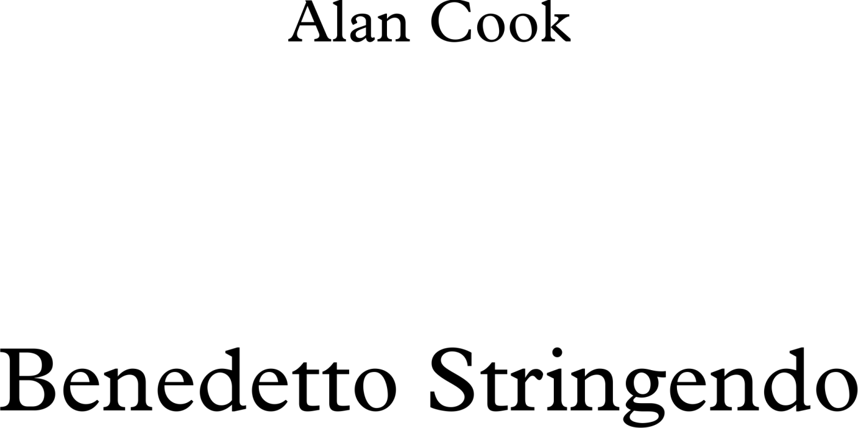

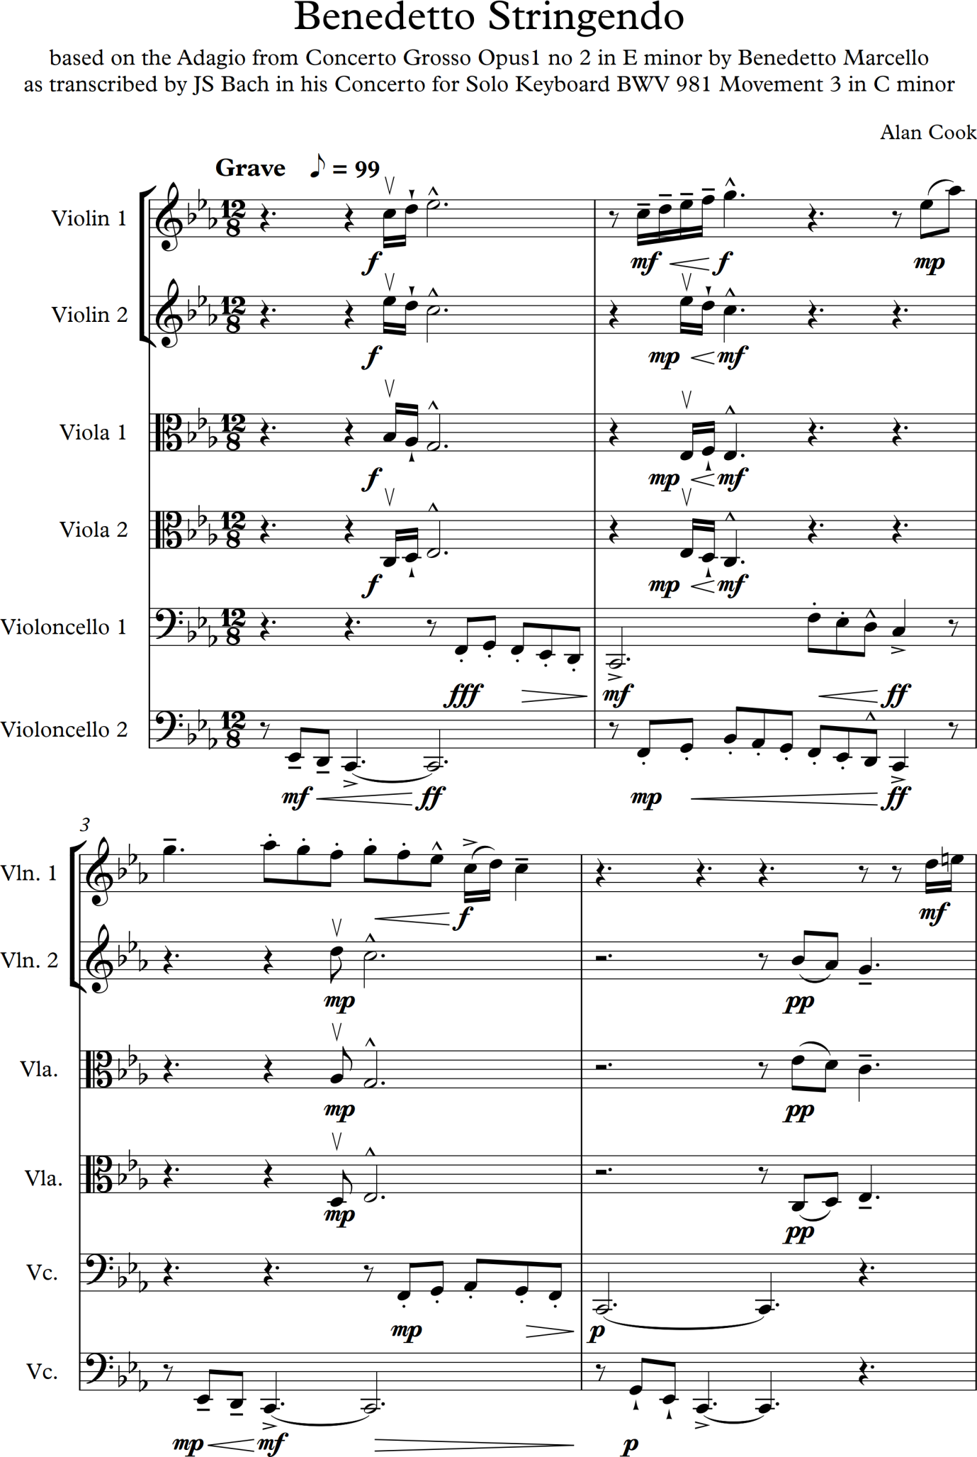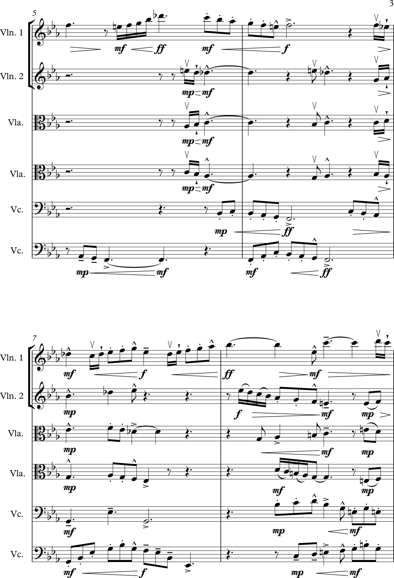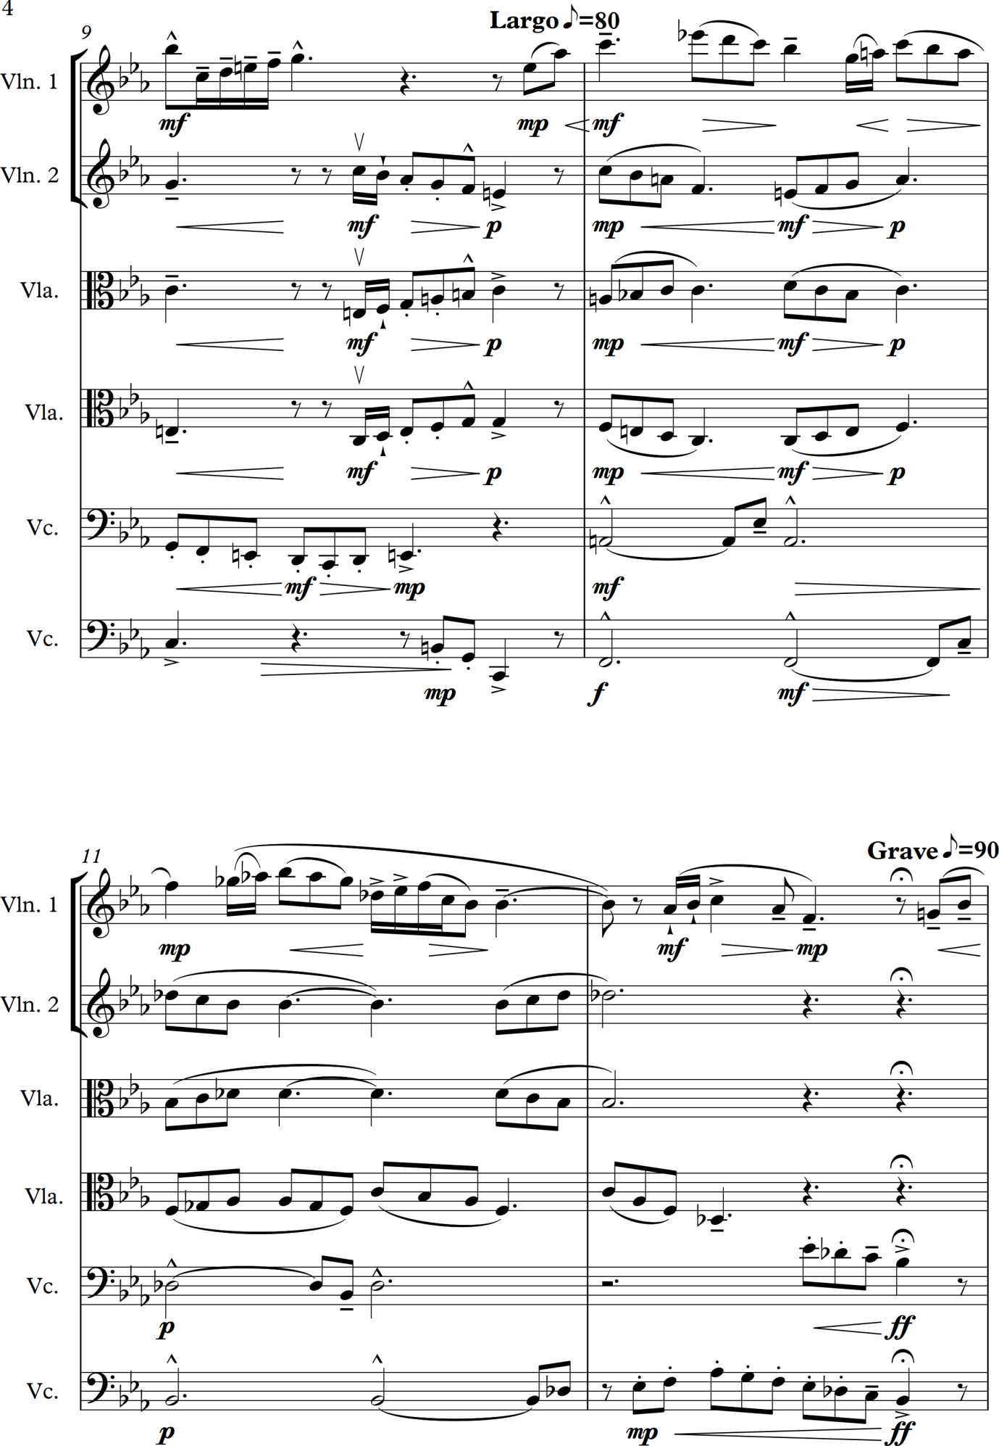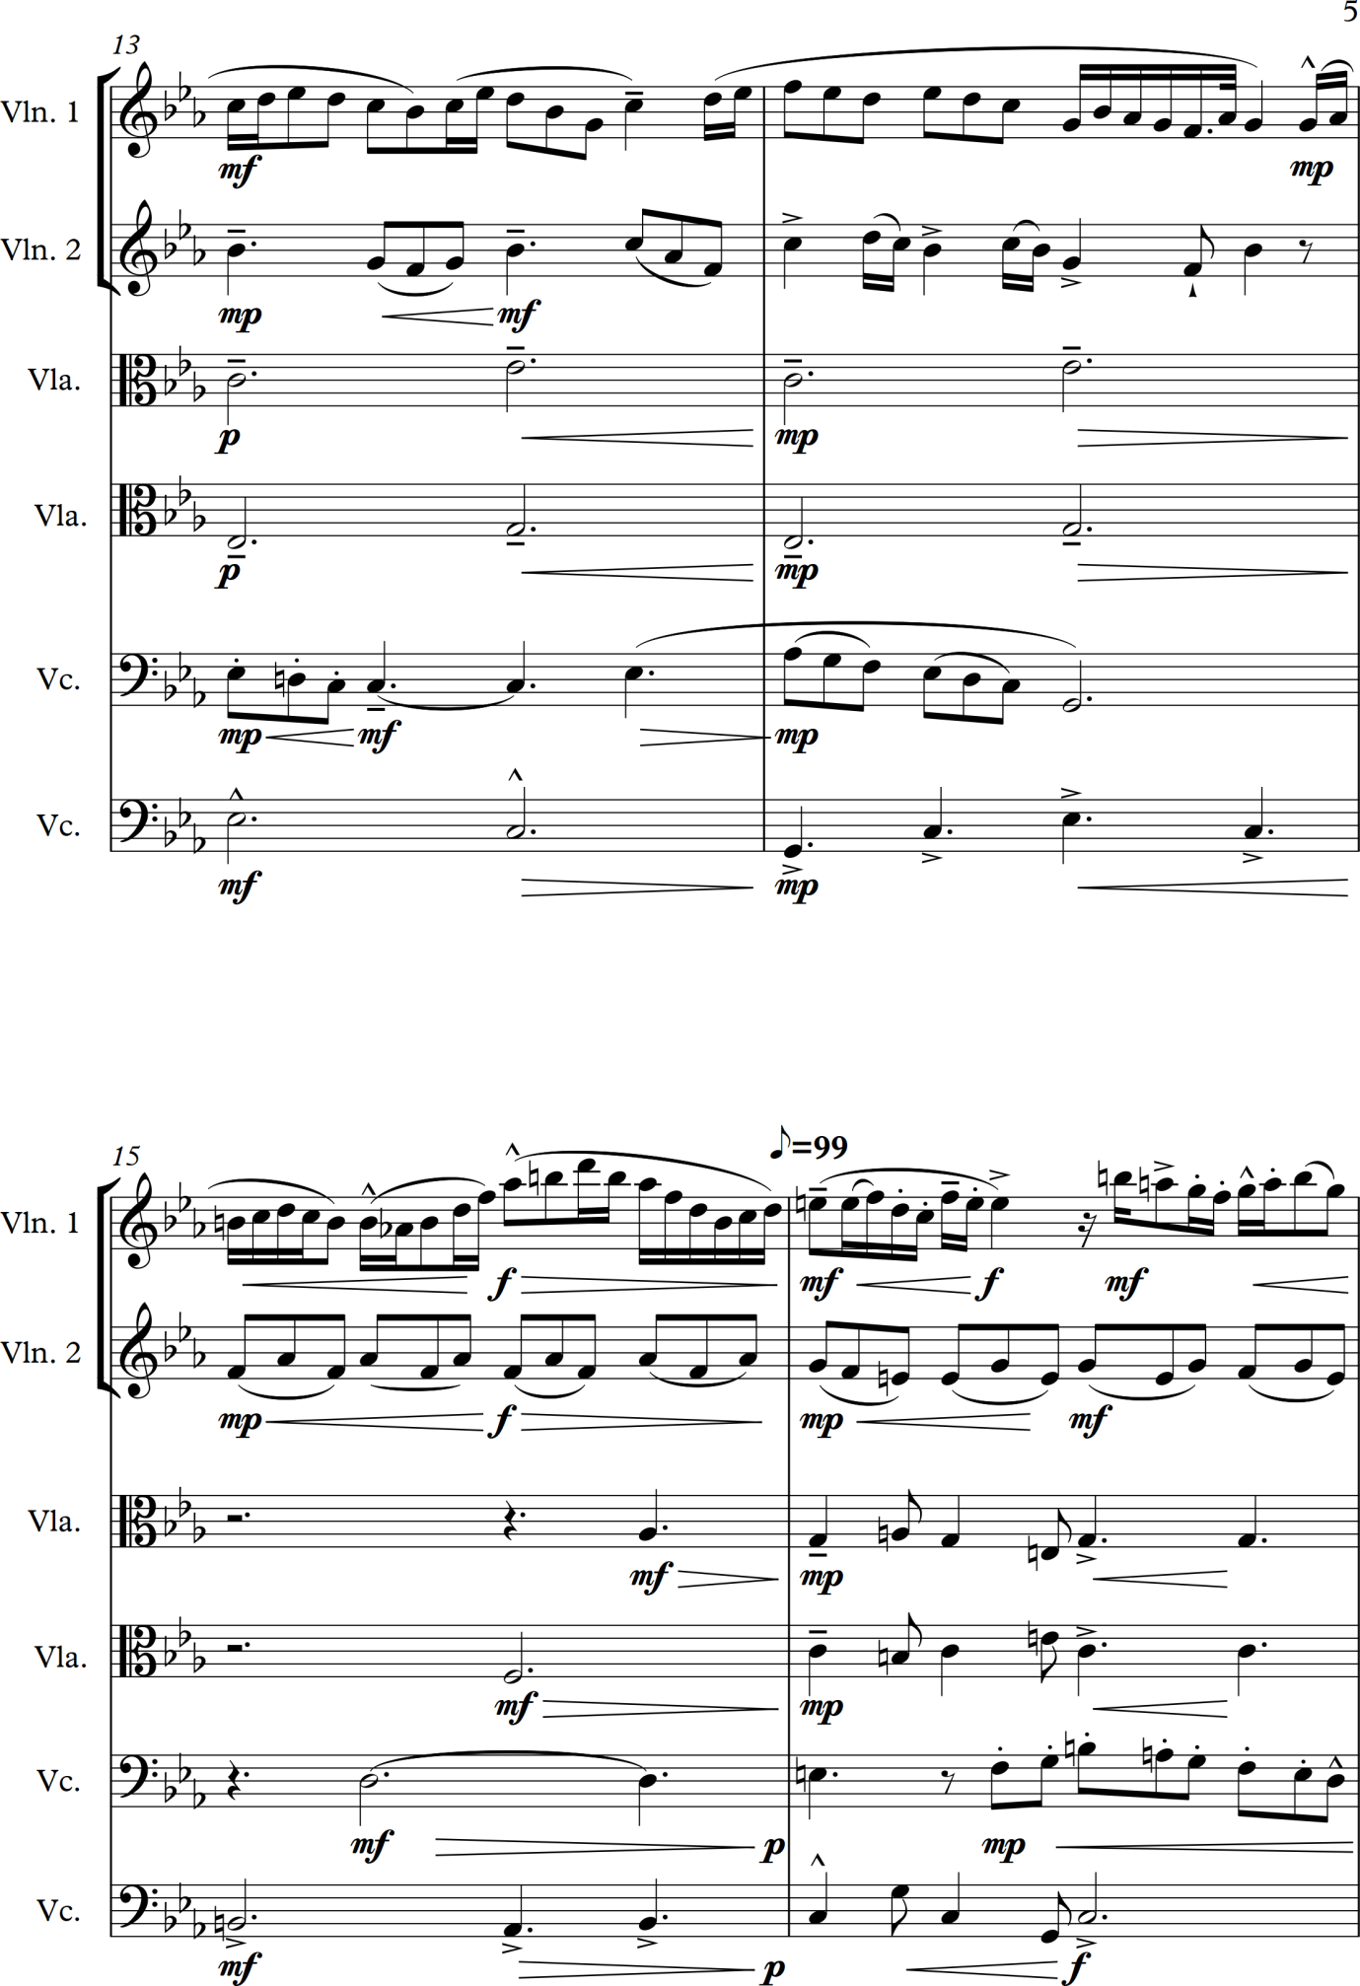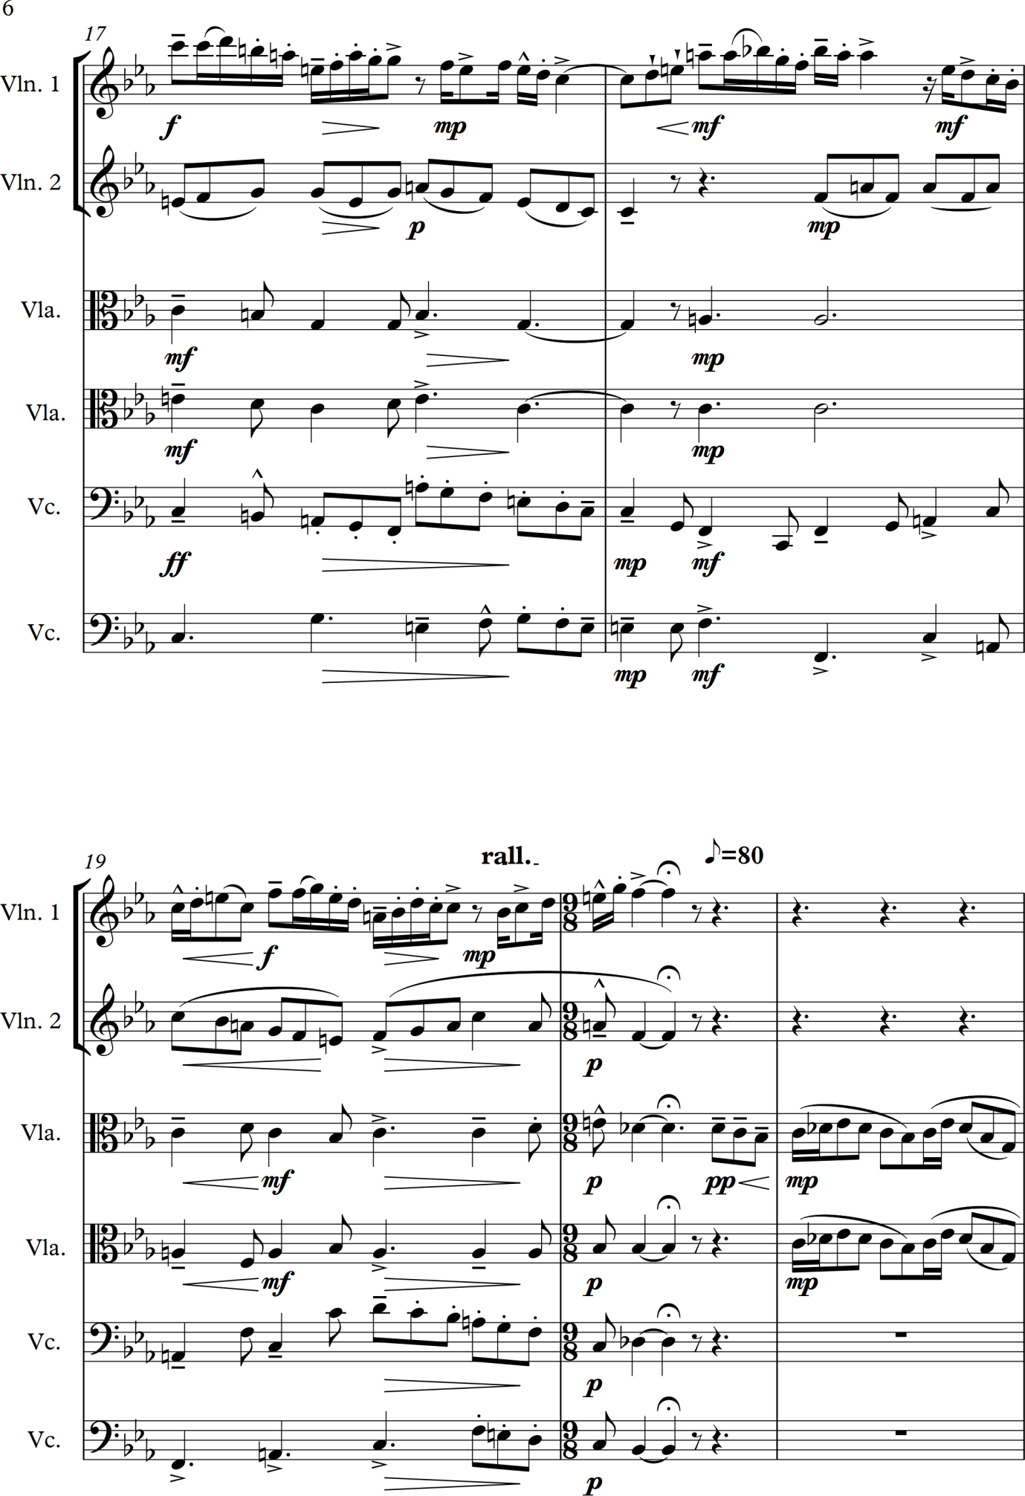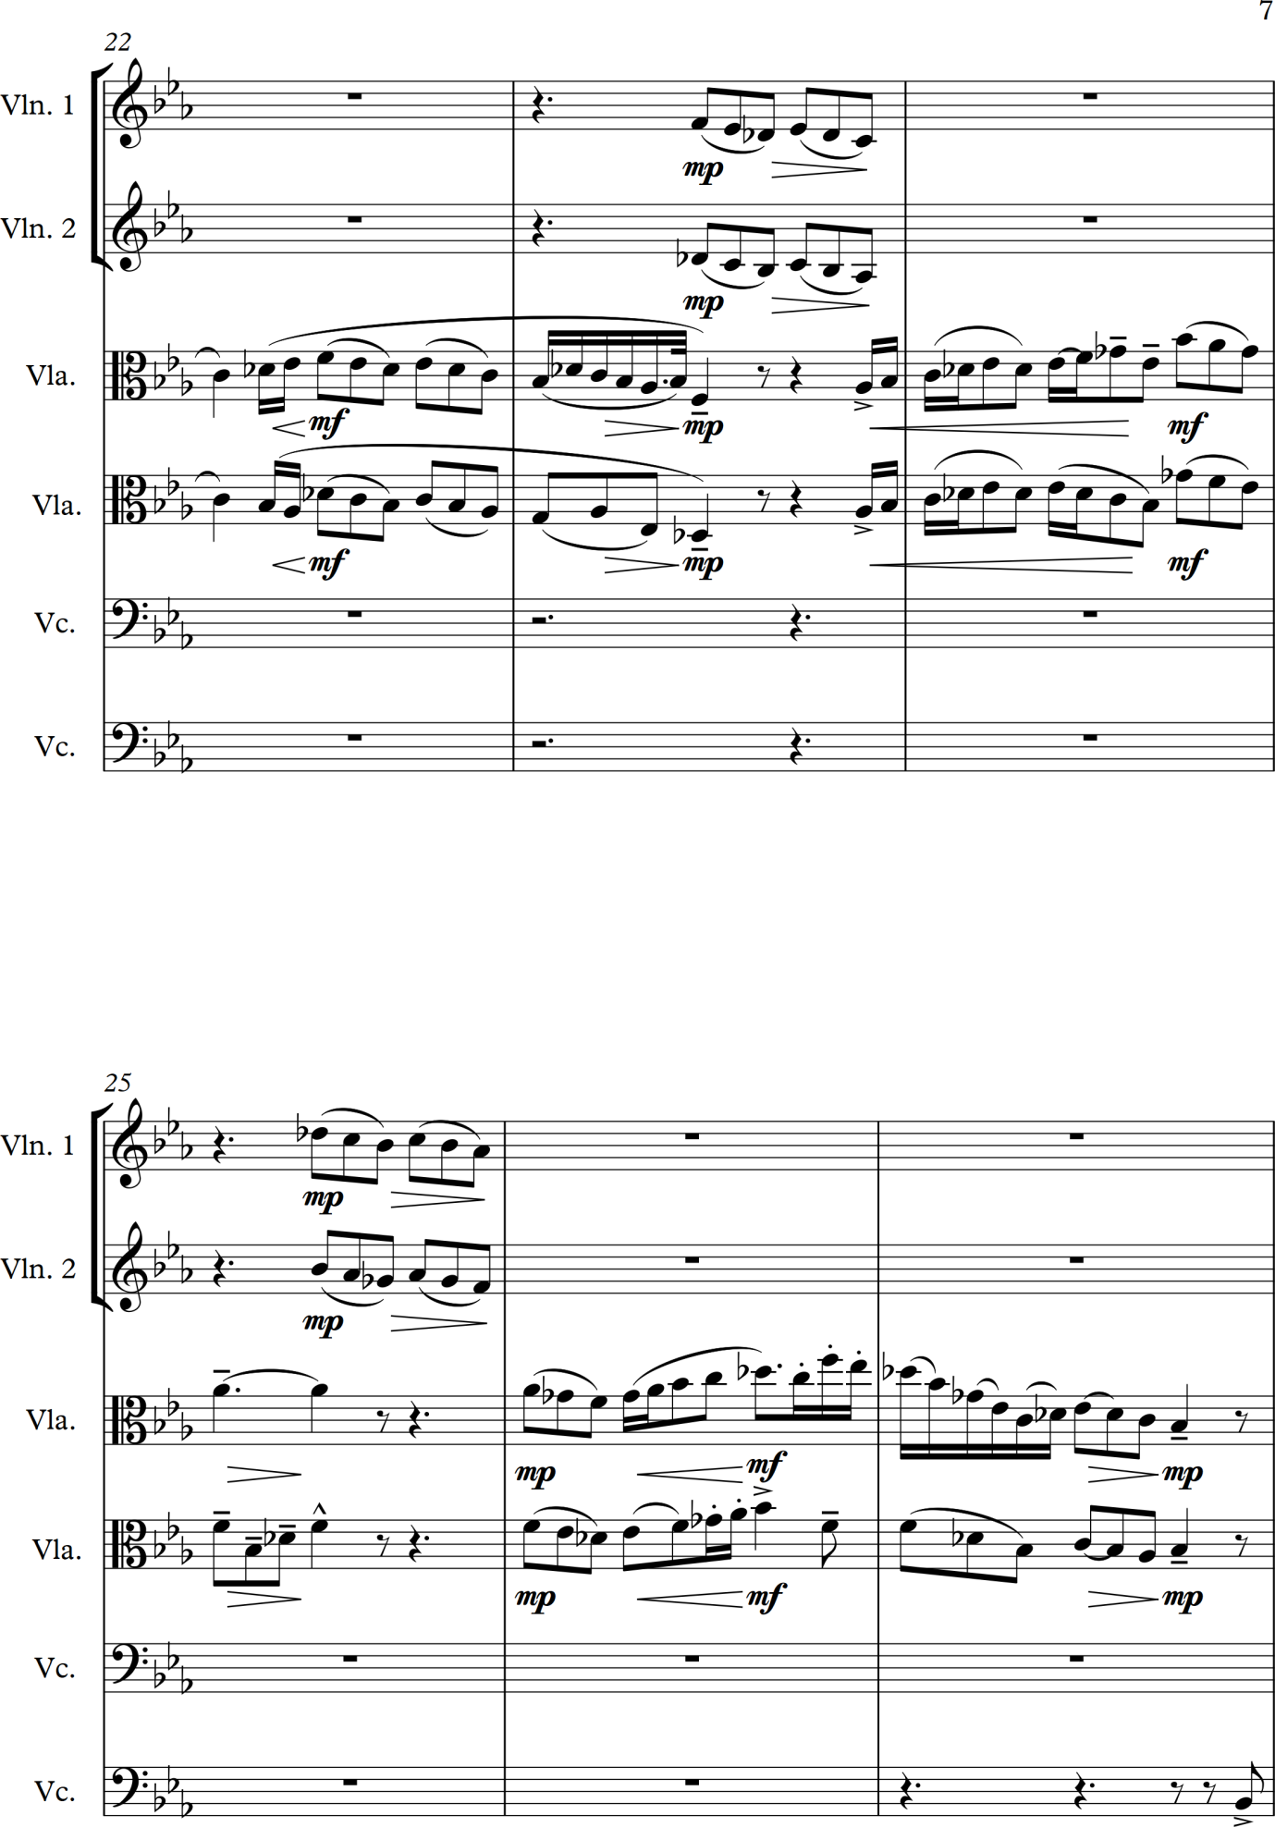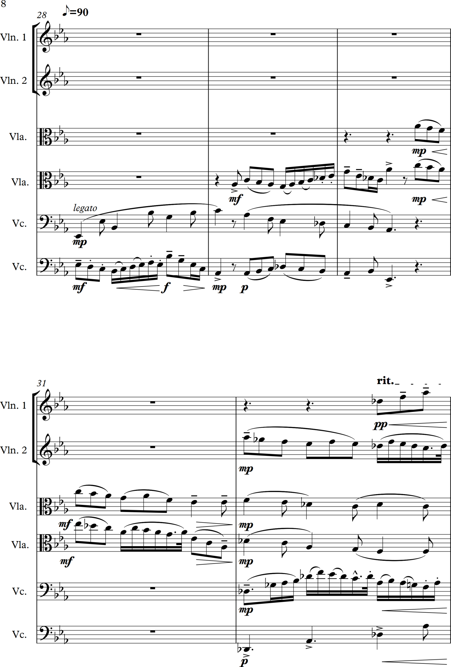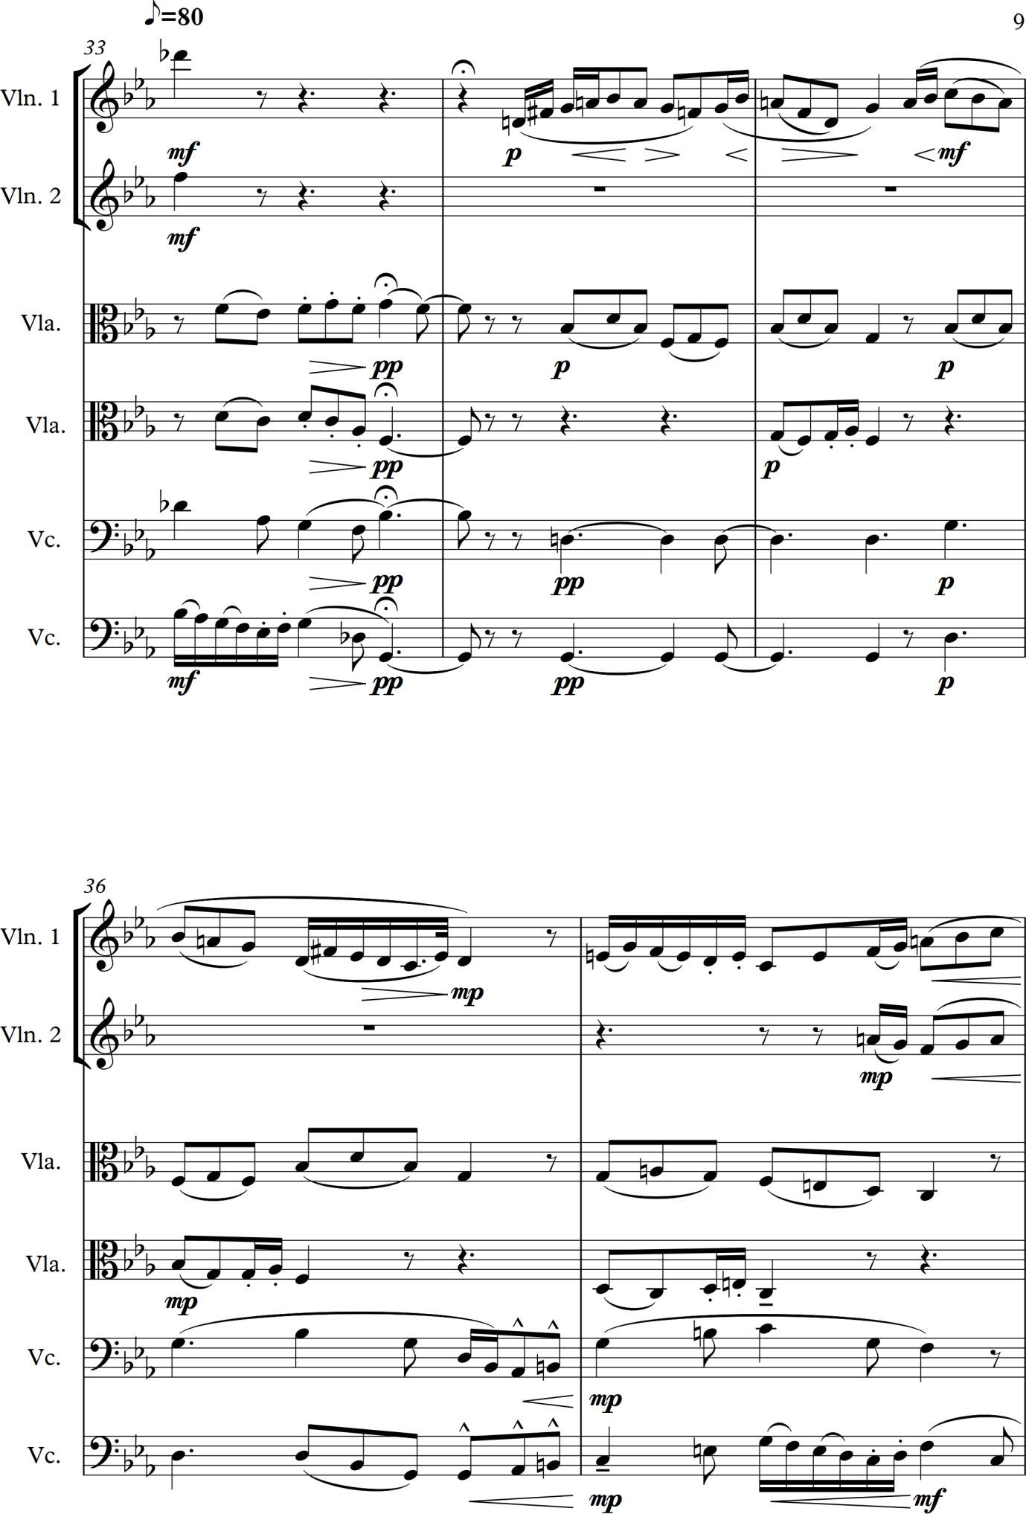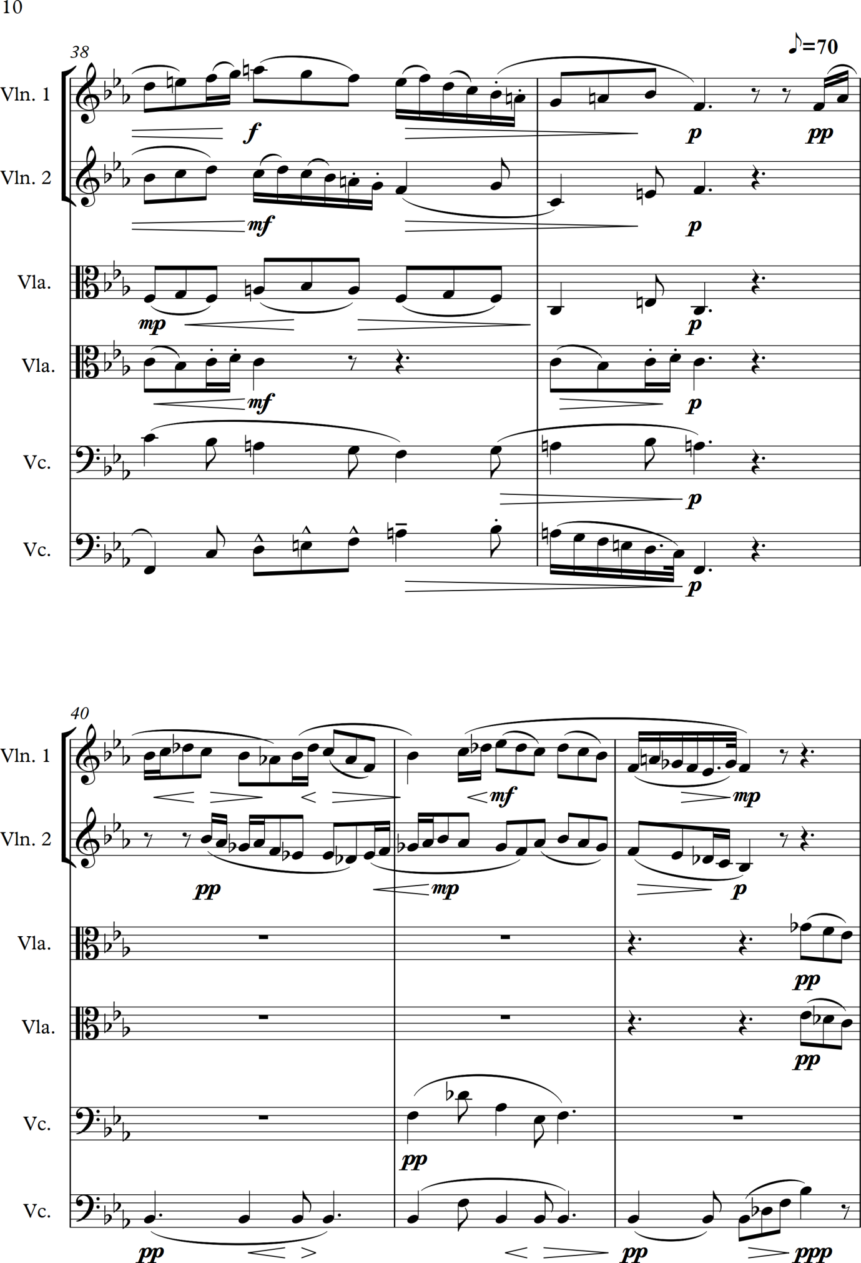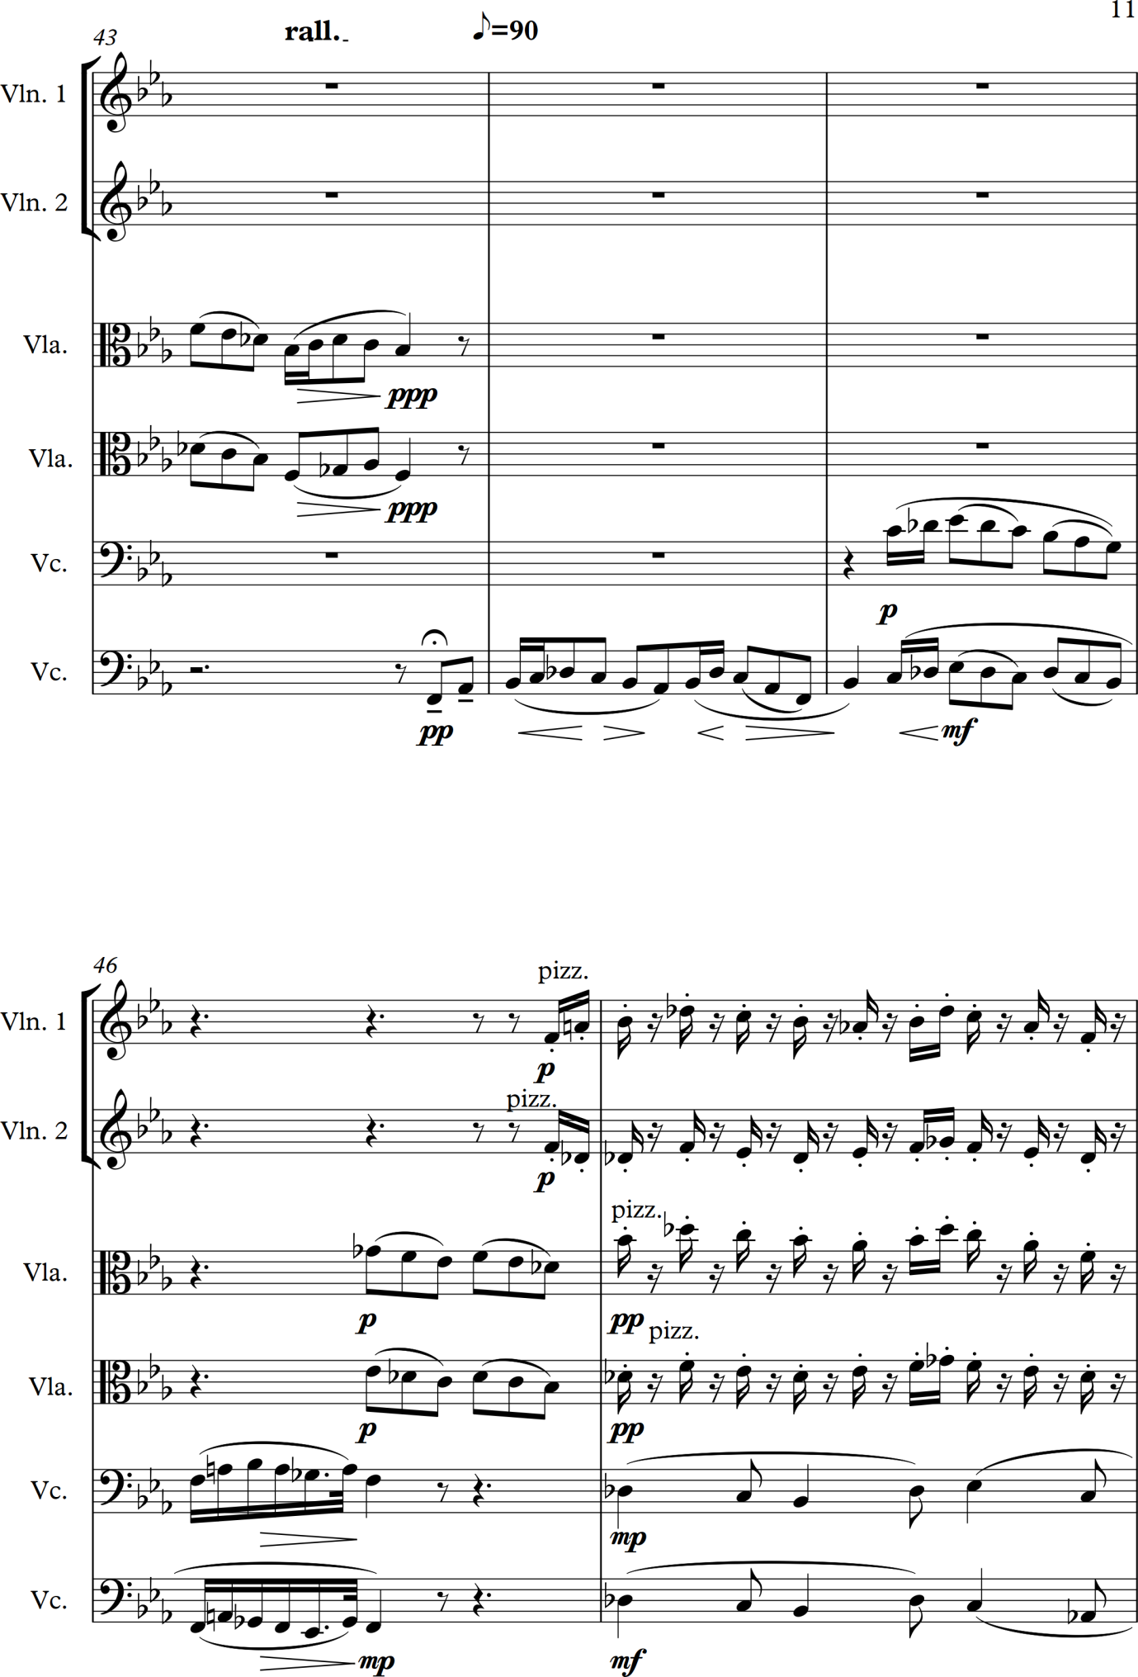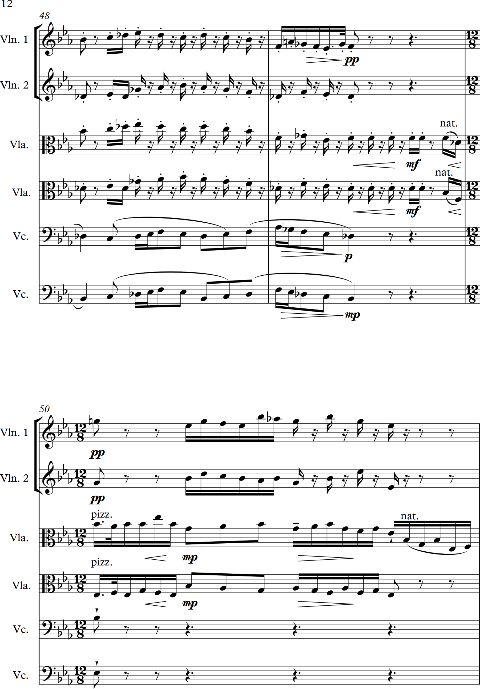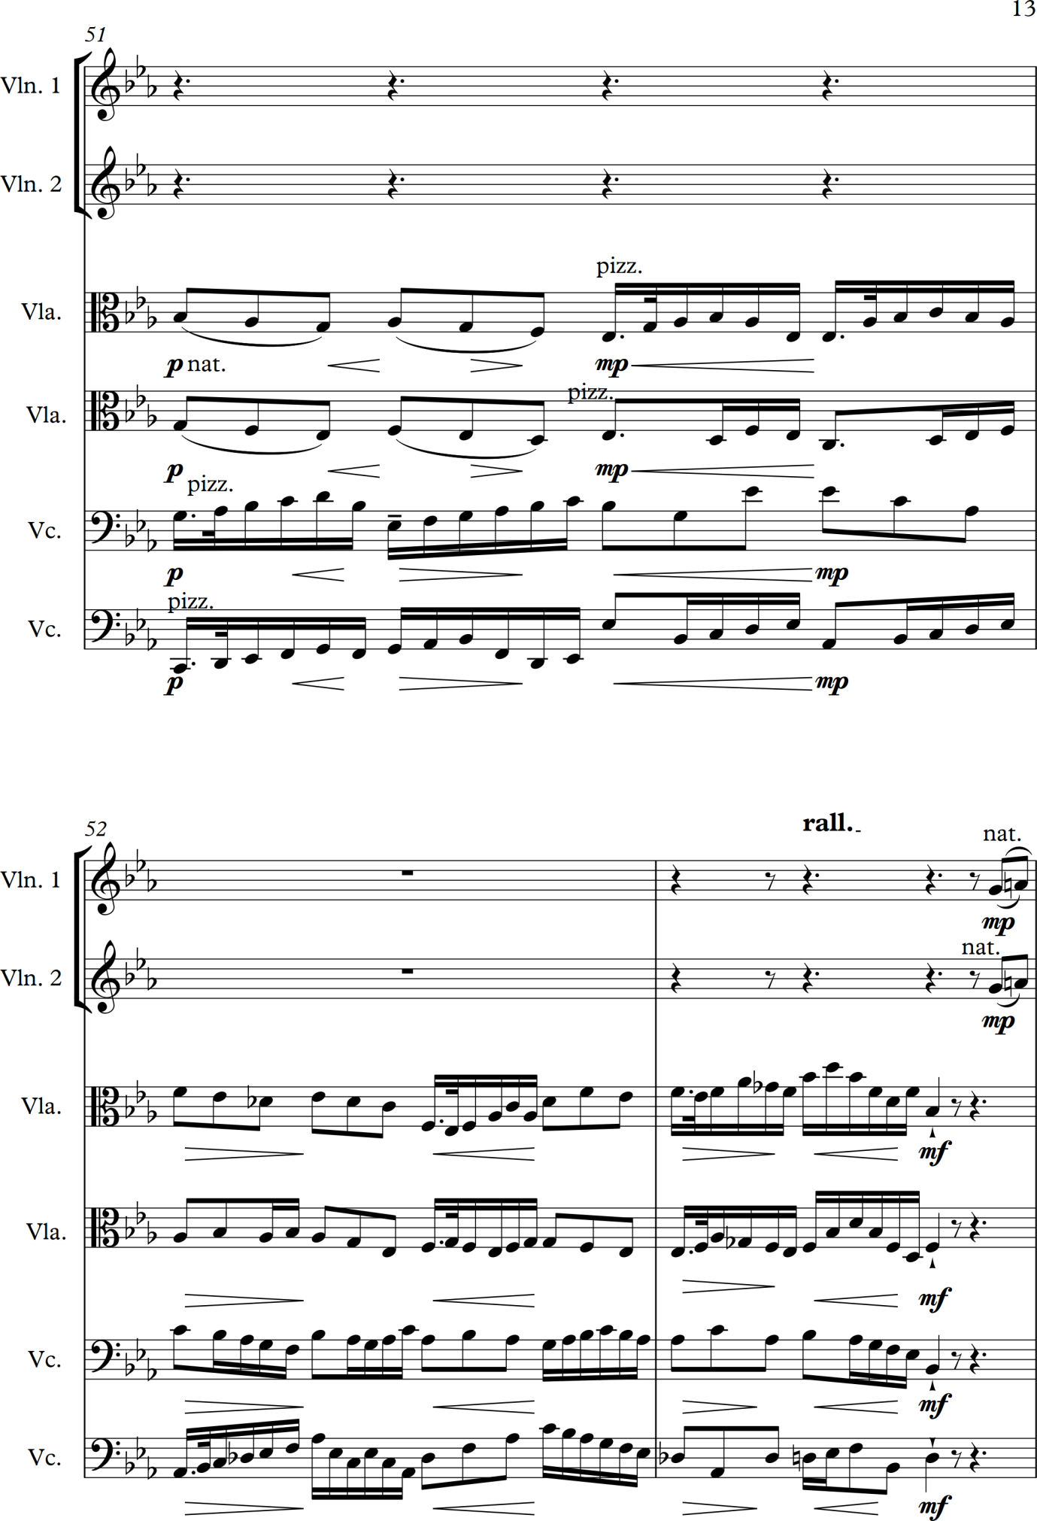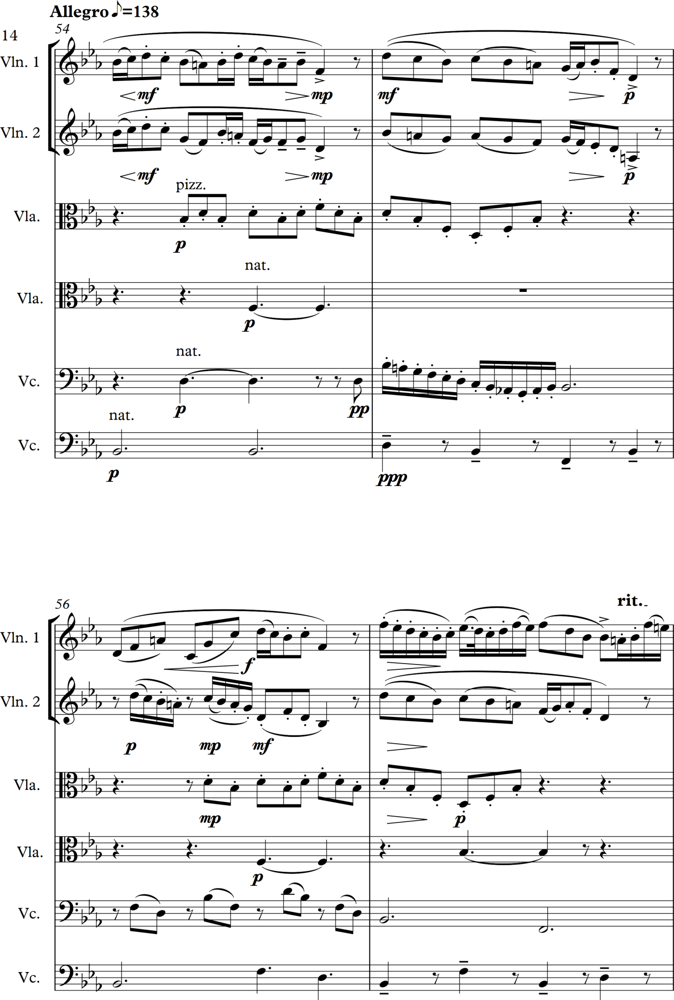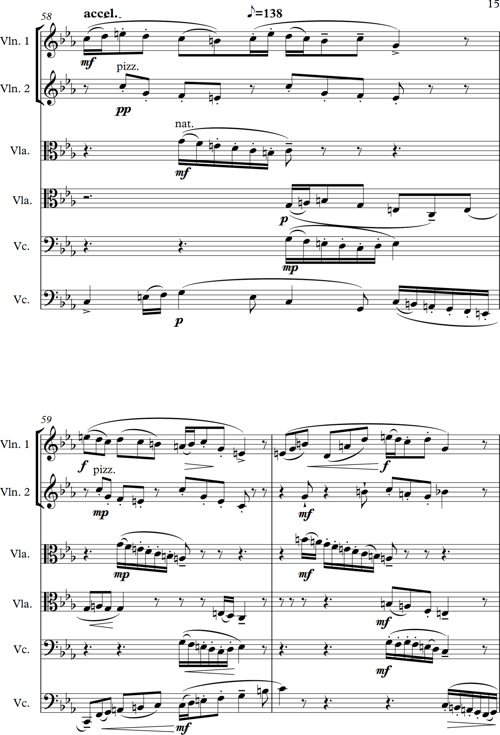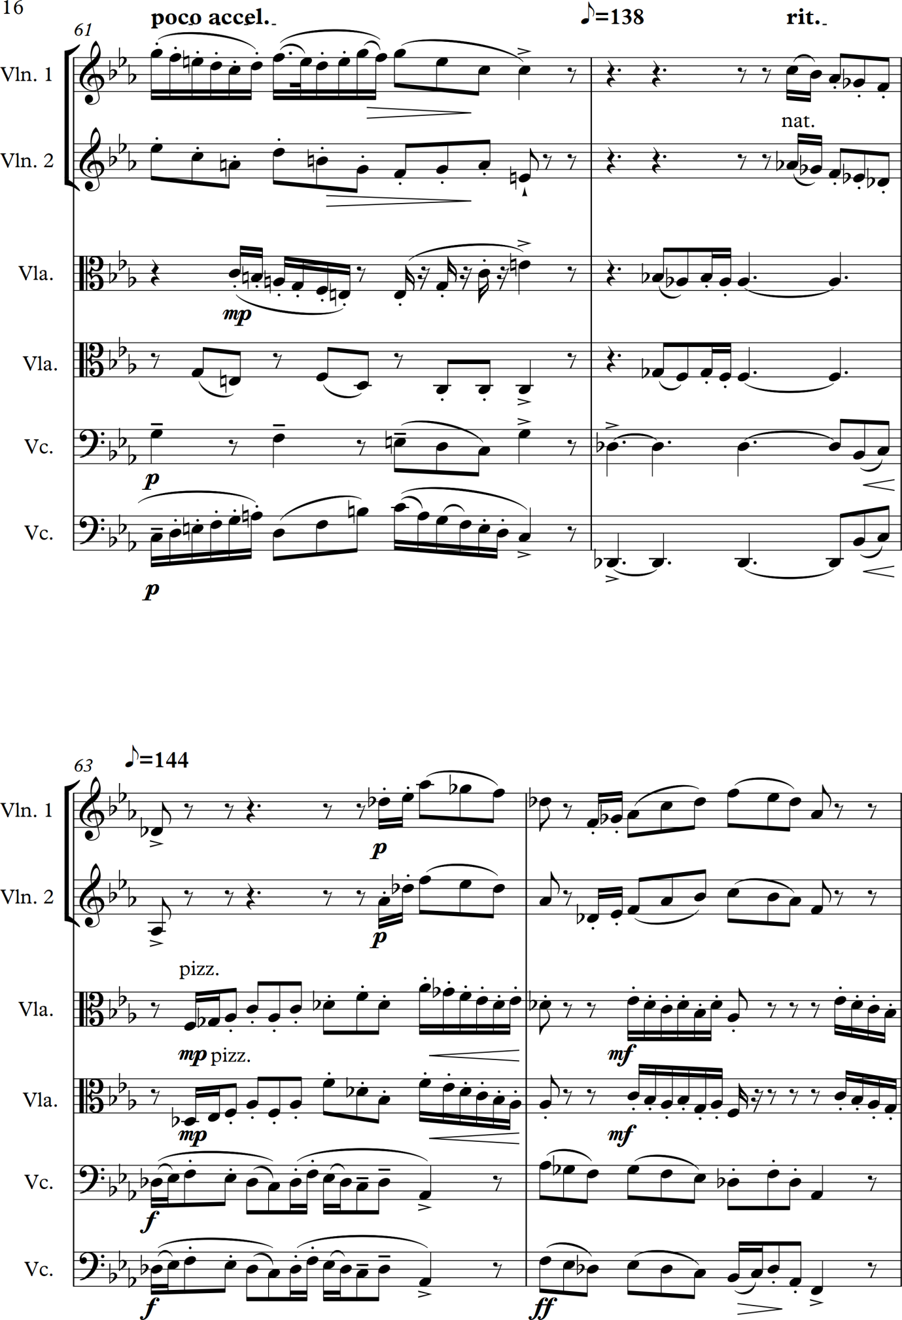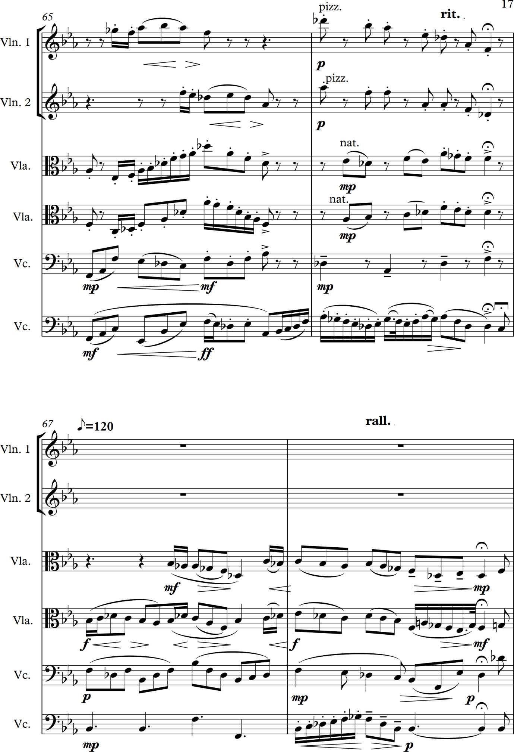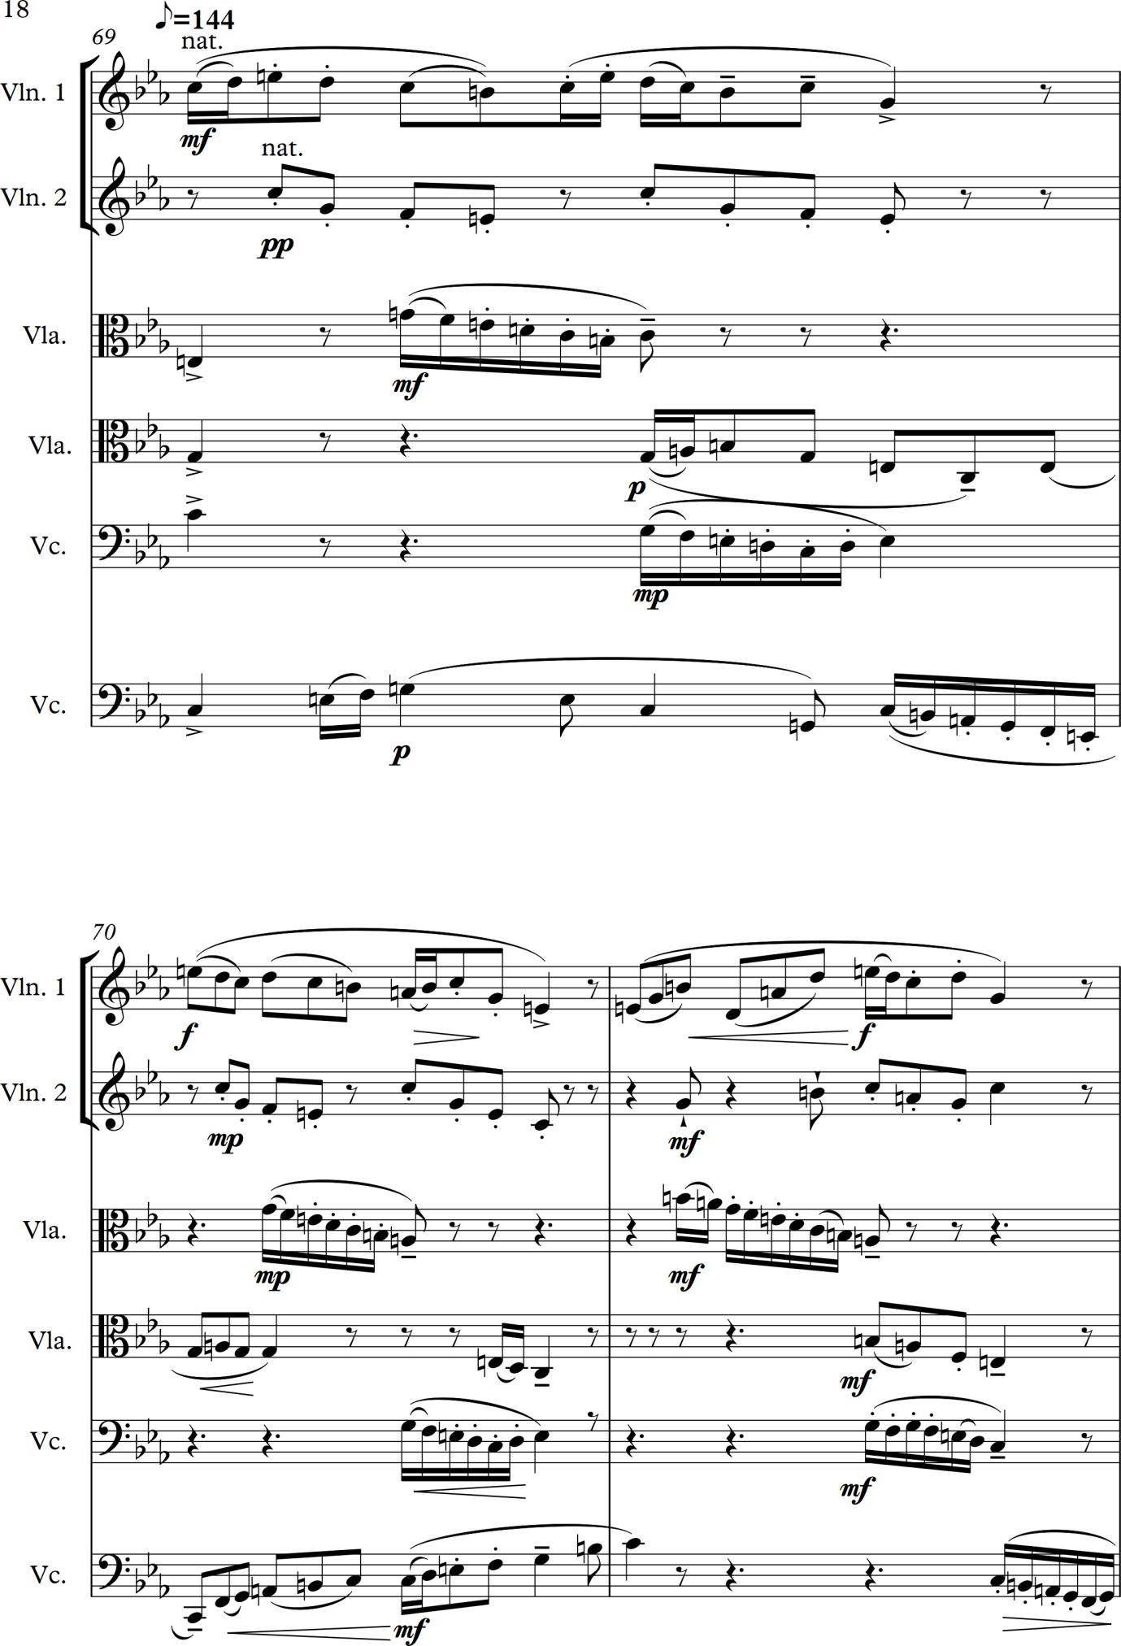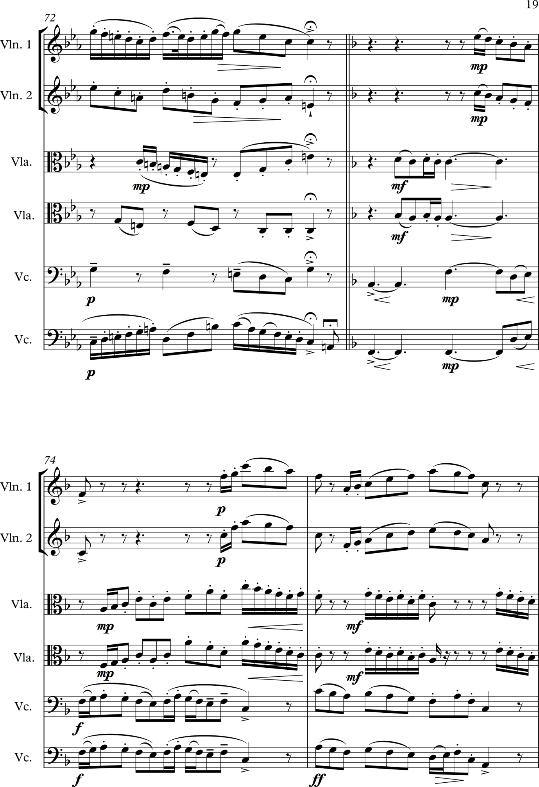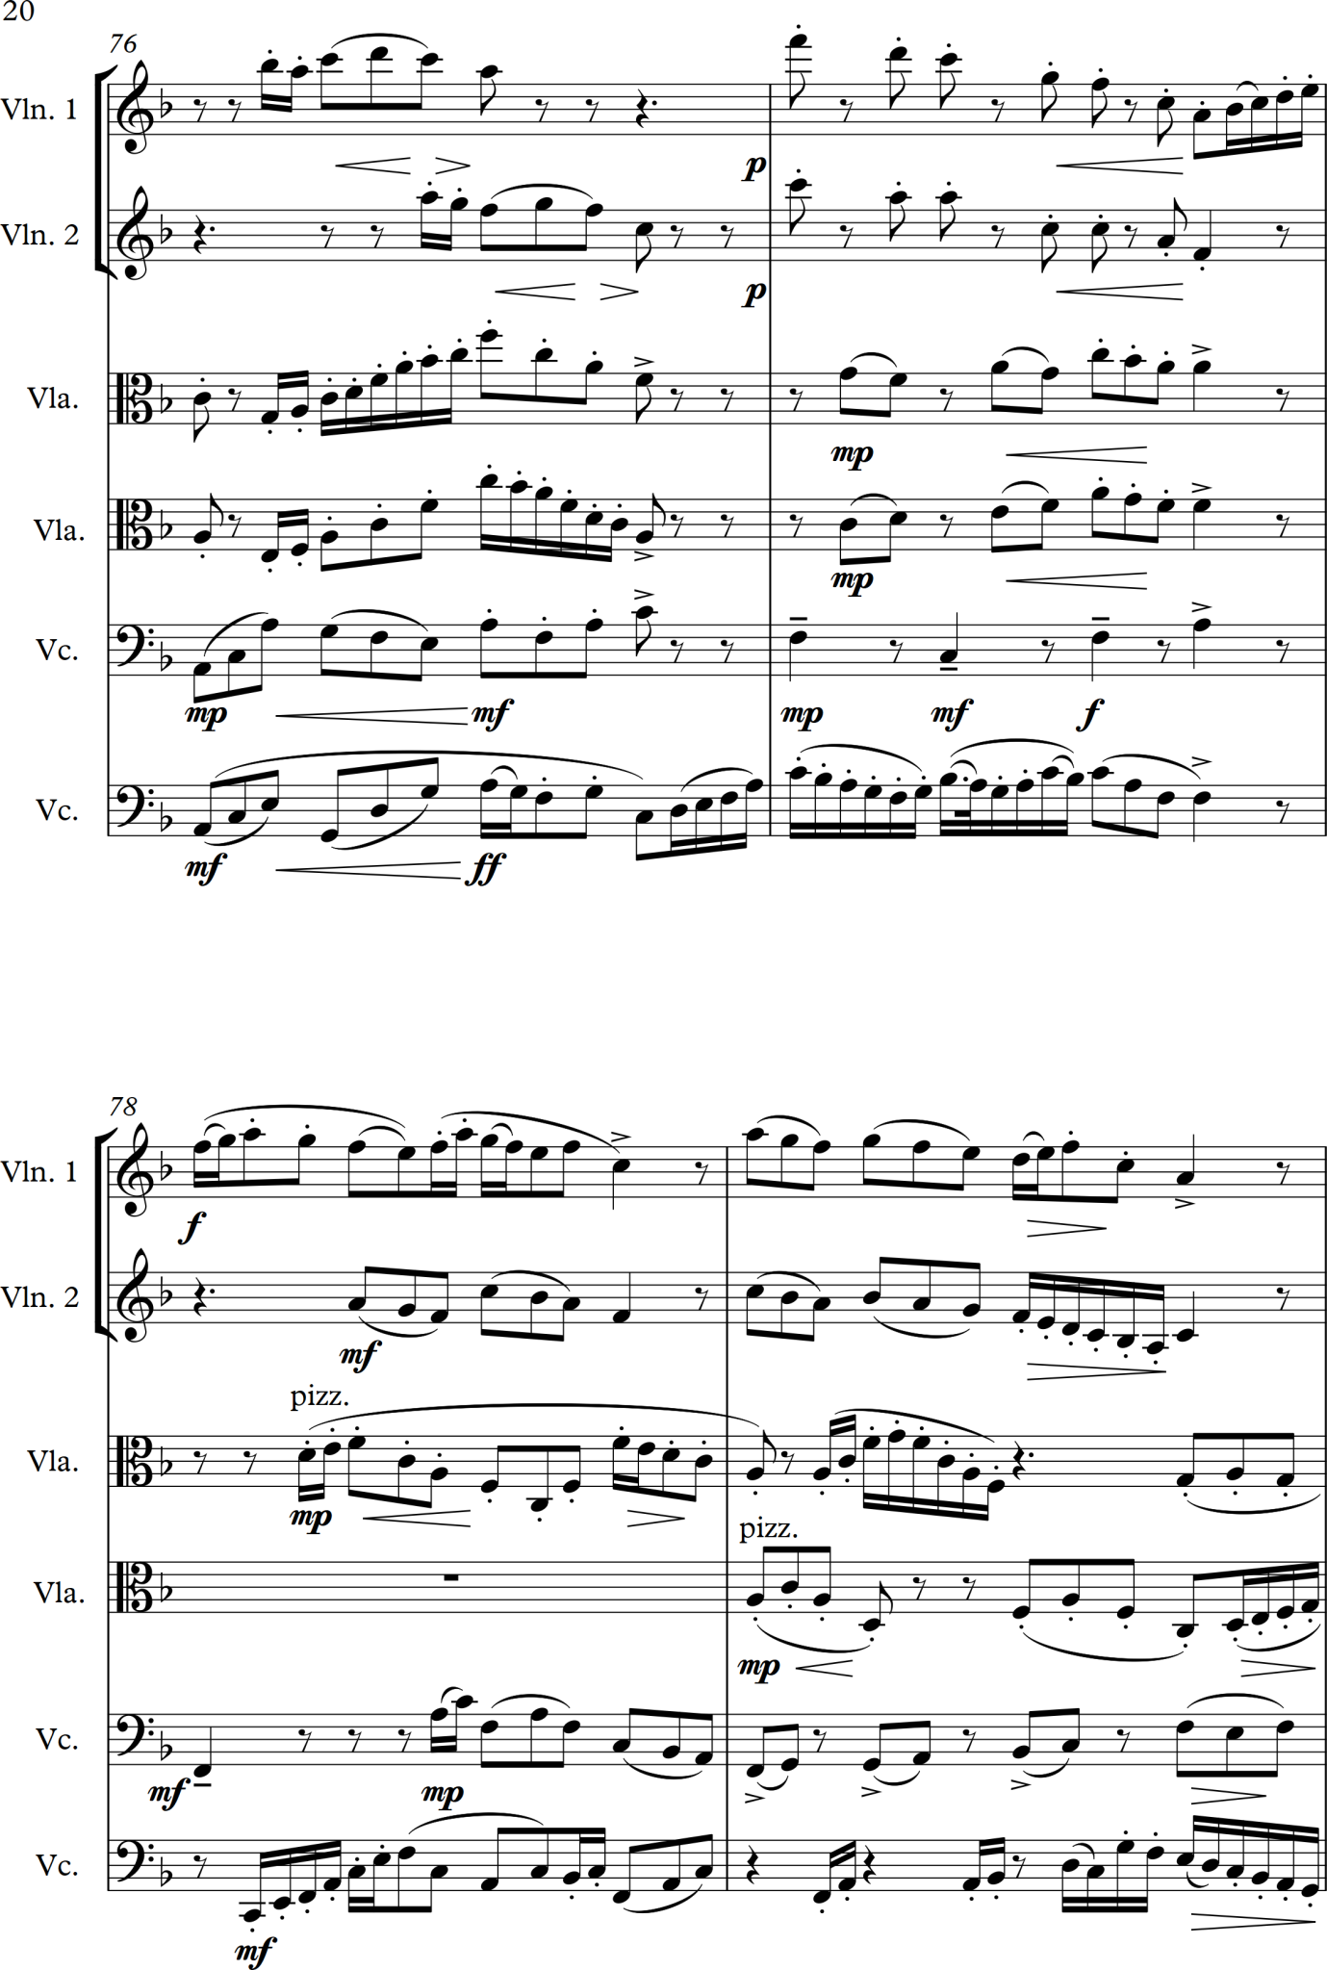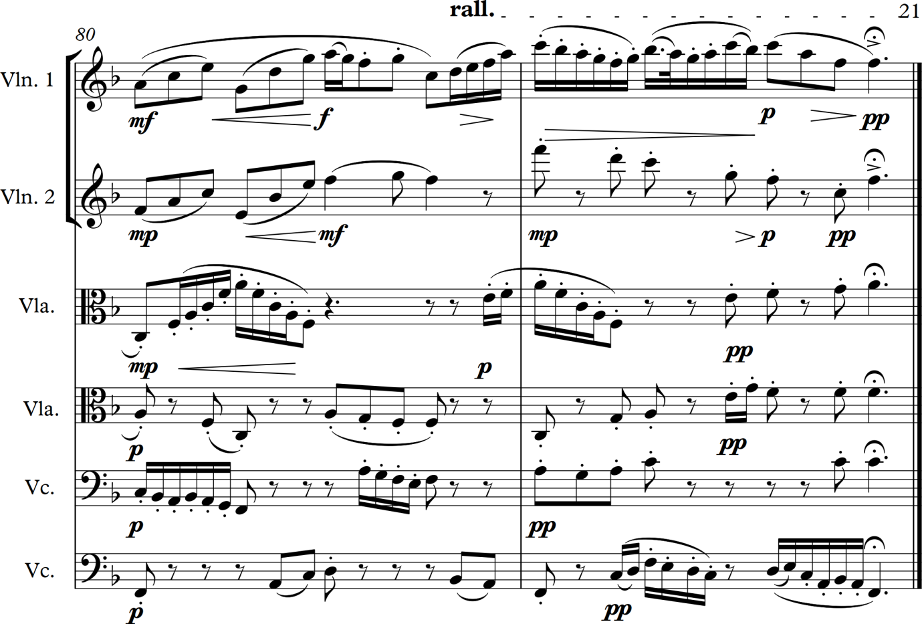

Here are my working notes that I made and guided me to the end of the piece:

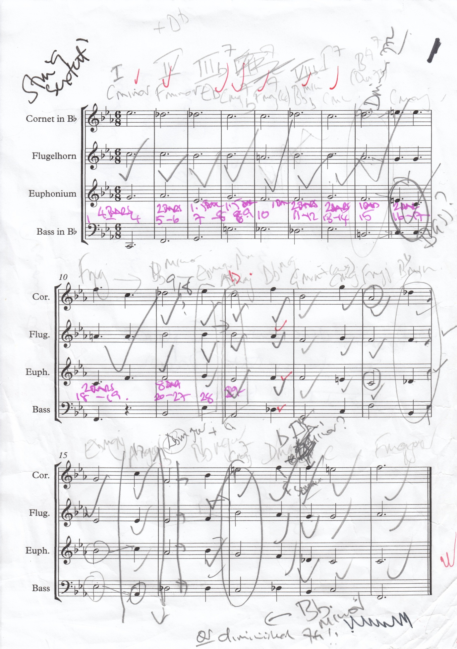

Monday 10 April 2017

I have now sent off a copy of the sextet music I wrote for the reviving skeletons exercise to a group of musicians in Bristol for consideration for rehearsal and performance. I have also started on Project 3: Accompaniments and have written already in my Listening Log about my reactions to some of the folksongs gathered by Cecil Sharp over 100 years ago and recently performed at a folk festival in the UK. I have started listening to arrangements of folksongs by Vaughan Williams, Moeran and Britten – I do like the Moeran and Britten arrangements and realise that although Vaughan Williams is also a brilliant arranger that I do not actually like the songs he clearly loves! I have been very dismissive of folk music generally in my Listening Log and have realised that I am in error in doing this as I adore folksongs from other parts of the world (particularly southern Europe and South America) – for example those arranged by Christina Pluhar and performed and recorded by her music ensemble L’Arpeggiata whose CDs I have already written about in my Listening log.

Tuesday 25 April 2017

I have just realised that my notes on folksongs (for Research point in Project 3: Accompaniments) should be in here rather than my listening log where I have listed many folksongs I have listened to over the last few weeks with lots of comments and thoughts. I have listened extensively to arrangements of folksongs by Vaughan Williams, Benjamin Britten, E.J. Moeran and Percy Grainger – with mixed reactions to them. I have also noted that I do in fact listen to many folksong arrangements from around the world but had not registered them as such. However the composer whose arrangements I wish to make notes on is the contemporary American composer Steven Mark Kohn who was born in 1957 who from the late 1990s has been focussing on the writing of songs. His website states:

Also in the late 1990s, Steve decided to focus on the writing of Art Songs, with the intent to fuse folk, classical and theatrical elements, and has to date, created a small catalogue, published by Glendower Jones of Classical Vocal reprints. David Daniels and Martin Katz premiered the first of his three-volume collection of American folk-song arrangements in Carnegie Hall. Since then they have been performed all over the world by hundreds of artists…
(stevenmarkohn, 2017)

Sunday 30 April 2017
Below are copies of two pages from The American Songbag (Sandburg, 1927) – a collection of American Folksongs put together and published by Carl Sandburg in 1927 and which Kohn used as the source for some of his American folk song arrangements – he has published three volumes. I sourced the images from the manuscript of The American Sandbag which I downloaded from Internet Archive (Sandburg, 2017). These illustrate the version of Ten Thousand Miles that Kohn arranged in the version that so touched me when I first heard – see entry on Friday 21 April 2017 in my Listening Log. As well as being a serious contemporary composer Kohn has also worked as a recording engineer, composed music for TV commercials and films, as well as for children’s animations and health imagery recordings on topics such as healing, guided imagery, relaxation, coping with bereavement etc. For some time he was the director of the electronic music studio at the Cleveland Institute of Music and has also made some short films.
Copy of the folk song from The American Songbag that touches me deeply in Steven Mark Kohn’s arrangement (Sandburg, 1927):
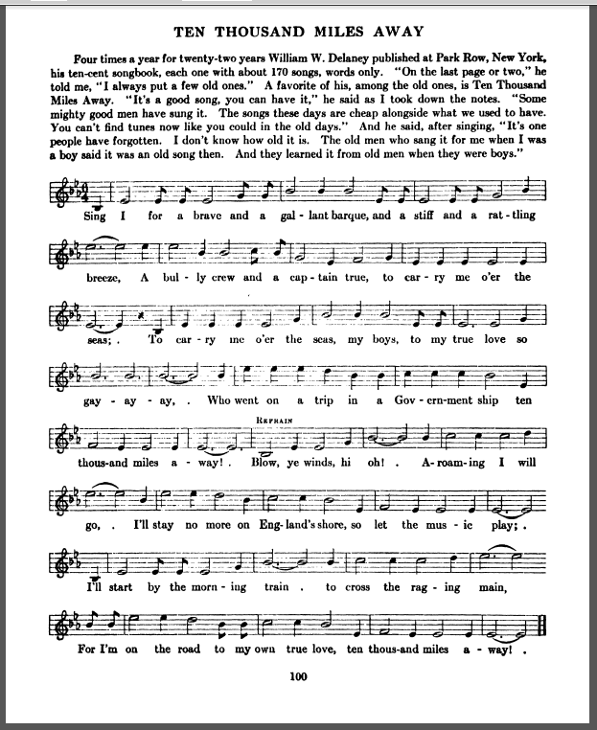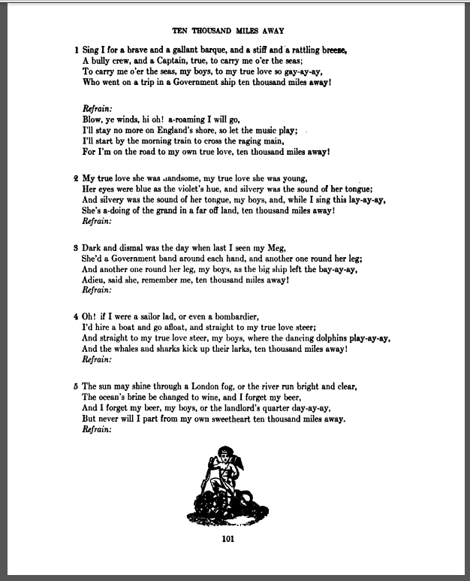
Monday 1 May 2017
Timothy Fallon about to sing ten Thousand Miles Away at the Wigmore Hall (Fallon, 2013)
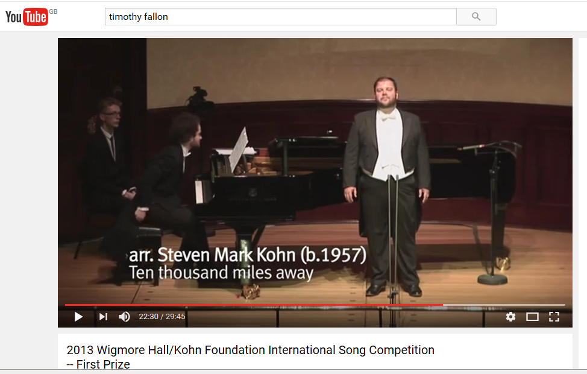
Image referenced below – (Fallon, 2013)

Notes on Kohn’s arrangement of Ten Thousand Miles away
I first noticed that for the tenor performance the key had been put up to G♭ major/F♯ major from the key on the ‘original’ (I am sure the original song is lost in time and probably originated from England or Ireland as I have found much earlier references to it related to these countries). The version for baritone voice is in E♭ major. I note that the music line is altered at places to make it flow better and also to facilitate some interesting harmonic progressions and cadence points in the piece. Only the first two verses are performed in the versions I have listened to – this seems to be a deliberate decision by Kohn as after the end of the second repeat of the refrain and following a few bars of solo piano the singer then repeats the last phrase followed by wordlessly singing the counter melody as a closing feature to the piece. It starts with a prelude on the piano of ripping arpeggios and after a moments of this the voice enters and for the first 2 bars the accompaniment is mainly arpeggios and a bass line – beautiful underpinning the melody. At the third bar a few notes are picked out in the right hand (treble clef) part of the accompaniment that seems to emphasize the flow of the musical line – it adds a lovely texture and poignancy to the sound of the piece. The rippling arpeggios continue with some interesting harmonic progressions that take it through some minor keys. When the third line of the text of the song is reached a counter melody is added into the treble part of the piano part which complements the main tune very well by emphasising the melancholy underlying the song – this countermelody is enhanced further during the refrain where it adds more to the musical texture. The last phrase and line of the refrain is taken at a much slower pace to telling effect. After the first verse and round of the refrain there is a piano interlude in which the counter melody heard earlier above the voice is played an octave down against the rippling arpeggios – I think it sounds gorgeous. The harmonic progression follows that established earlier. The piece is then modulated up a tone for the second verse and repeat of the refrain before the ending described above.
I think this accompaniment is simple, elegant and sensitively constructed allowing the music to speak for itself while enhancing its mood. To my ears this is a very classy arrangement of the song.
In addition to the performance by Timothy Fallon on You Tube(Fallon, 2013) I have also listened to a performance recorded on CD heard on Spotify by the American Baritone Andrew Garland who has recorded the first volume of Kohn’s folk song arrangements (Kohn, 2009).
Notes on the arrangement of On the Other Shore by Steven Mark Kohn
This is the second song on the CD that Andrew Garland has recorded and that I have listened to on Spotify (Kohn, 2009). I have been unable to find a copy of the music for the song and I note that it does not appear in The American Songbag. This is a sad song mourning the death of the singer’s mother and the lyrics express the belief that the singer will one day be joining her and other neighbours ‘on the other shore’ – a metaphor for death. It is a reflective and melancholy song (again) and Kohn’s arrangement is simple in many ways with block chords sparingly used for much of the time allowing the voice to carry the melody and to be the feature. It is subtly and sympathetically done and creates a powerful feeling of mood and introspection. As with Ten Thousand Miles Away there is a short introduction with a brief excerpt from the main tune of the song accompanied by chords and ending with a short arpeggio. The voice enters unaccompanied then simple and sparingly scored chords steal in alongside it. The arrangement is slightly syncopated at points which emphasizes the American Spiritual feel of the melody and arrangement. After the first verse there is a piano interlude where a section the tune is restated again simply a accompanied. Verse 2 has a fuller accompaniment which befits the lyrics – for example ‘Won’t that be a happy meeting?’ – and has a more agile bass line in the piano. Then the accompaniment is simplified back to chords and the whole piece slows down. Verse 3 is modulated up a tone and is again stronger and louder with chords utilised again but spread out more to include more bass and treble notes so that it has a more stirring feel to it. The piece resolves with a simple ending to the song and concludes with a quite block chord coda.
This is a quiet, dignified and affecting arrangement and perfectly illustrates the old dictum that ‘less is more’.
Sunday 7 May 2017
NOTE: a close friend, Regan Callow, has recently visited and we have discussed folk music at length. He plays the traditional squeeze box (Anglo Concertina) and has extensive knowledge about English folk songs and music. See entry in Reflective Log for today for further information about our discussions and comments he made as well as how I have come to learn about the cajón which is a traditional Latin American percussive box used in Peruvian and other folk music and which is now appearing in music gigs across Somerset! He has introduced me to a whole range of people who have been very influential on British folk music including the following:
William Kimber (1872-1961) – an English concertina player who played a significant role in reviving Morris Dancing in the early twentieth century.
Maud Karpeles (1885-1976) – she created a folk dance group based in the Canning Town Settlement which performed many of the folk dances that Cecil Sharp uncovered. She also assisted him significantly with his active research in collecting folk tunes and songs including travelling with him to the Appalachian Mountains in North America.
Seamus Ennis (1919-1982) – an Irish singer, musician and music collector who popularised the traditional Irish (uilleann) bagpipes during the mid twentieth century.
Kathryn Tickell (1967 - ) – a contemporary and highly respected performer of the Northumbrian pipes who has played with many traditional folk musicians, popular artists and classical musicians. She has received many public and academic awards for her initiatives and contributions to culture and music.
Alistair Anderson (1948- ) - another contemporary musician who is a master of the English Concertina and a fine performer on the Northumbrian Pipes and who is trying to revive and continue interest in traditional folk music, songs and dances. He was on of the two founders of Folkworks which is an organisation based at The Sage in Gateshead which runs many workshops, summer schools and festivals to promote and encourage the furtherance of folk music.
Notes on the arrangement of California by Steven Mark Kohn
This is the first song I have found, so far, in the American Songbag that had an accompaniment with it – see image below. However although Kohn has used some of the harmonic progressions he has added greater rhythmic complexity and variety and again varied the melody somewhat. He has also changed the order of the verses for dramatic effect. The arrangement starts with a piano introduction which has syncopated and strongly rhythmic features that remind me greatly of the faster dance sections of Copland’s Appalachian Spring and this has made me wonder if Kohn is strongly influenced by Copland. The basic features of the tune are kept but with the lengthening of some notes on imperfect cadences which creates pauses and a sense of anticipation at points in the song. The accompaniment is driven with a strong rhythm and more semi quavers than in the song and a frequent use of an offbeat emphasis which creates a passing syncopated effect while the voice is declaiming on one note using quavers. All verses are sung making this a longer piece than some of the others he has written. About two thirds of the way through he sets one of the verses to a slower less driven and more romantic accompaniment that fits the reminiscing nature of the lyrics – he has moved the verse from earlier in the piece to place this effect before an energised end which is similar to the bouncy and dance like features of the earlier verses but with an ever more elaborate piano part with some sweeping arpeggio like chords rippling up the piano keyboard. The refrain is repeated four times with increasing intensity and the last line also repeated to end the vocal part which is followed by a short and lively coda.
Copy of the folk song California from The American Songbag (Sandbach, 1927)
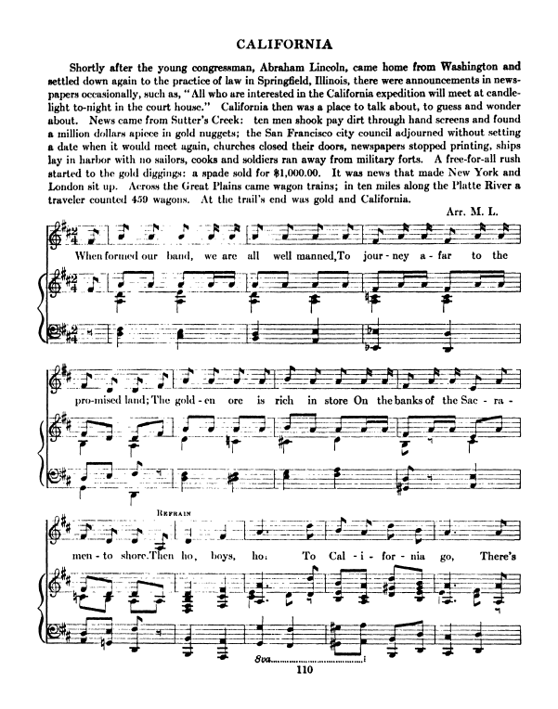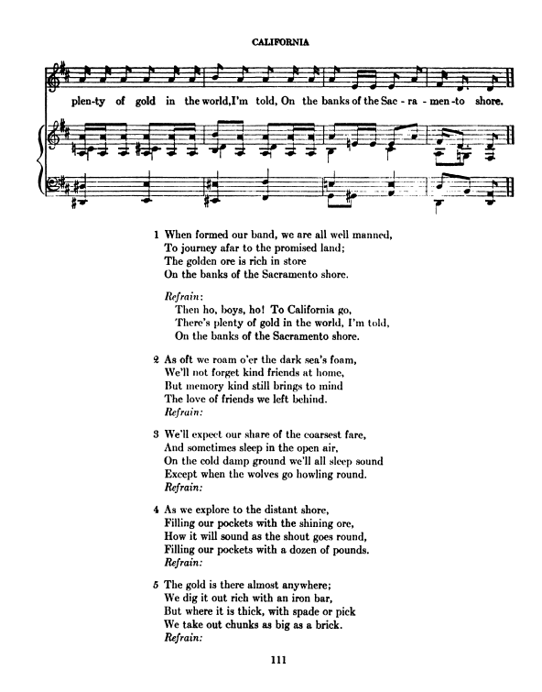

Friday 26 May 2017
I have been trying to work for the last 10 days on composing an accompaniment for the Swedish folksong in the course notes which I really like (Vyssa lulla). I will place below my workings to date to show far I have got – I have been sitting at the piano working out a progression I like and now have become very bogged down in what to do next – i.e. how to actually write the accompaniment. This is partly because I have got muddled and confused about harmonic progressions and whether I ought to be knowingly following classic rules. I have been re-reading my notes from the Music Composition 1 course and they have been making little sense to me. Must acknowledge my deep levels of tiredness from work and the intense temperature on this hot afternoon (28°) are not helping my concentration.

Sunday 28 May 2017
Didn’t get far on Friday – tiredness and heat did me in. So back again this afternoon and below are scanned copies I have made of my initial working notes and trying out the chords. I will also note that I will next look at the progressions in terms of Circle of Fifths, traditional cadences and chord positions – I am confused as to how best to progress all of this but will keep going.
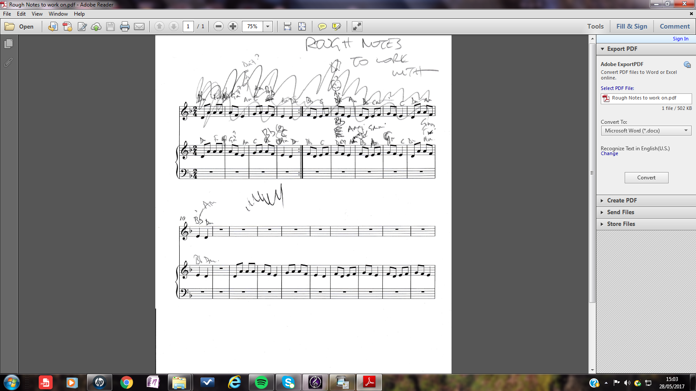

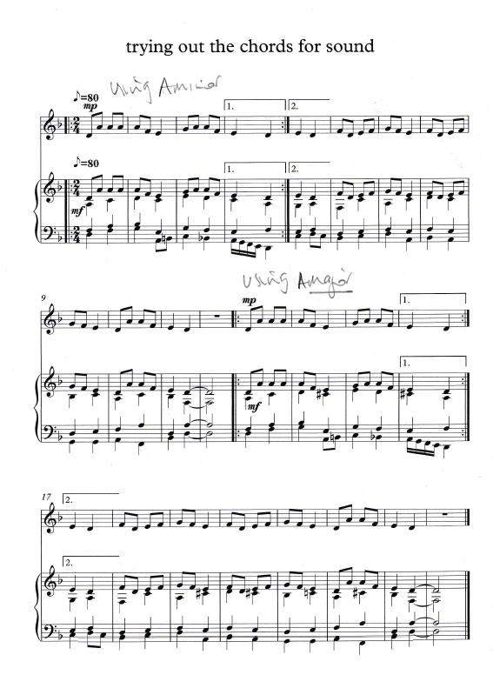
Monday 29 May 2017
A note to register that I have now started work on the arrangement of ‘Vyssa lulla’ and have composed an introduction and got to the first verse which I have had great fun putting the lyrics into the music manuscript – and have given up for the moment on finding the letter o with an umlaut on it Swedish style as the Sibelius instruction manual has defeated me today with that. I wanted a simple yet atmospheric introduction as the tune is straightforward and modal and it would be easy to overcomplicate it. I have decided to also have a singer hum the tune at half speed first before it is actually sung to tempo with the words. I aim to build up the intensity and would like to create some piano effects that I know how to play but struggle with knowing how to put them into manuscript form. More work and study required! I will continue on Friday when I next have a day at home.

Monday 12 June 2017
To note that I have finally finished the arrangement of ‘Vyssa Lulla’ and am reasonably pleased with it – I will write further notes below the music itself which I will copy into this document after this paragraph. I have found this an interesting undertaking and in the course of creating the piece studied how the contemporary American composer Morten Lauridsen writes accompaniments to pieces he has composed. I studied his Nocturnes and the wonderful choral piece O Magnum Mysterium which he has written a piano part for rehearsal purposes and which is straightforward enough for even me to play! I have published copies of all these pieces in my possession as I have long been a great admirer of Lauridsen – more than that, he very much inspires me and his music and life have profoundly affected and influenced me. Lauridsen’s writing for the piano is very spare and elegant, i.e. not many notes and a compact and clear structure. I remember that in an interview with him (cannot recall where I saw this) he stated that he writes for good amateurs so that his music can be performed everywhere and enjoyed. He keeps momentum going by dividing the on beats and off beats between the two hands and creates amazing harmonic effects by holding notes over as the harmony changes or introducing a new note which initially sounds discordant but with the movement of the music lines everything is resolved – eventually. His is the art that conceals art and he is clearly masterly at composition for piano and voices. I admire him hugely.
Sunday 18 June 2017
I have sent MP3 files of Vyssa Lulla to my three closest friends and they have sent me some great feedback in e-mails:
Alan I have sat quietly and listened to the piece. I love it I found it rather moving. Your composition blended perfectly and harmoniously with the voices. Enormous well done.
(E-mail from Lizzi Walton received on 12 June 2017)

Two words. BEAUTIFUL AND ELEGANT. Well done. Am very proud of you.
(E-mail from Susan Harvey received on 13 June 2017)

Your piece is rather beautiful and haunting as you intended it to be.
(E-mail from Susan Harvey received on 14 June 2017

Thank you for the most beautiful start to my day. Your piano composition is just as you wanted it beautiful haunting and I found very calming and reflective. A piece which fits our country's mood at the moment with so much turmoil going on and of course that which we can all face at times when it feels like life's a daily struggle … So a big thank you. I shall be a regular listener.
(E-mail from Caroline Taplin received on 22 June 2017)
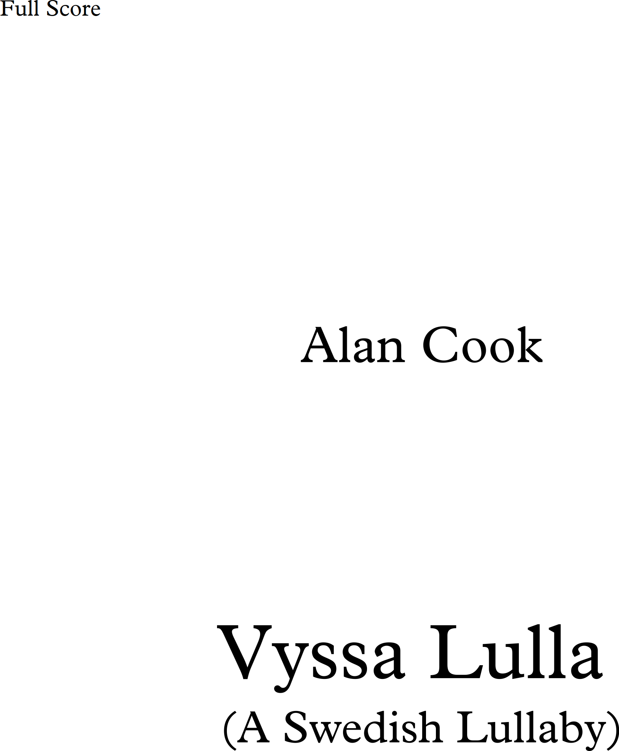

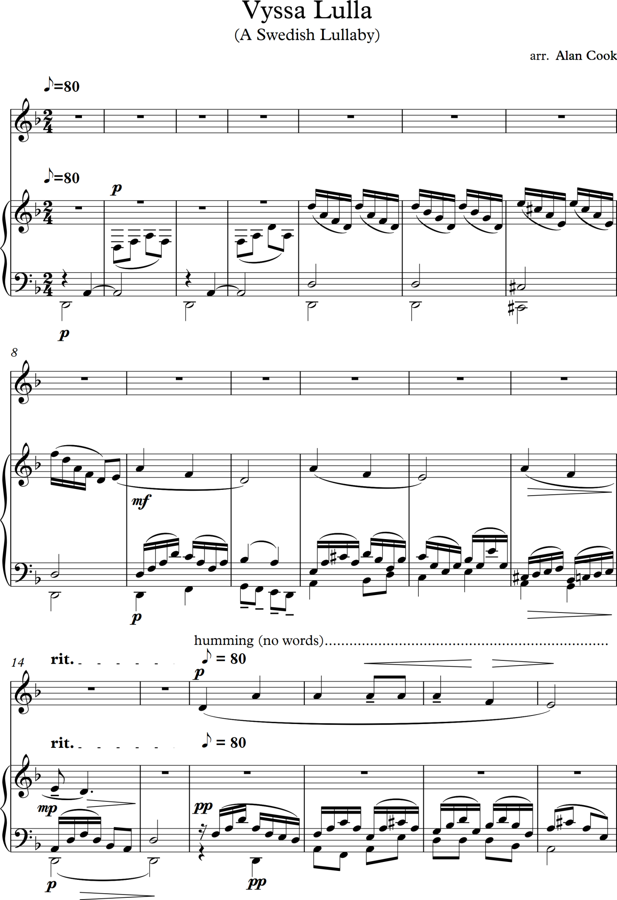
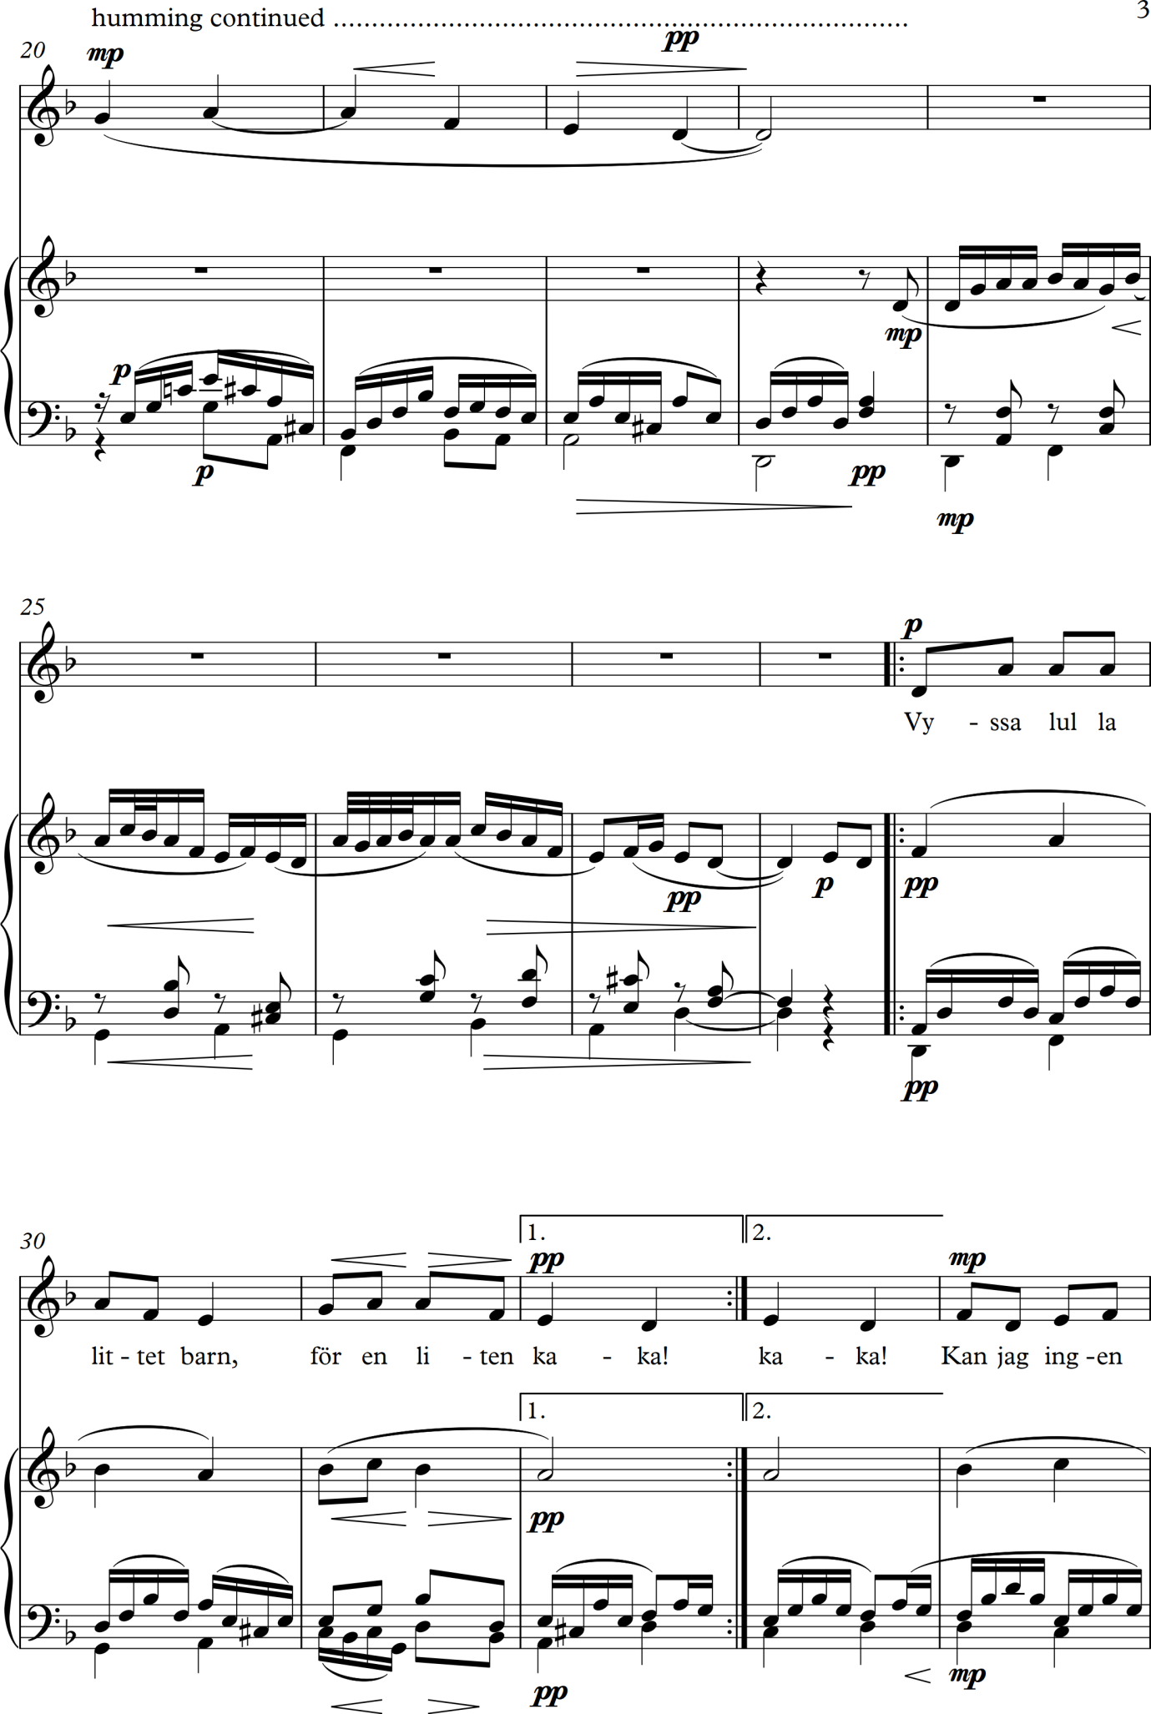
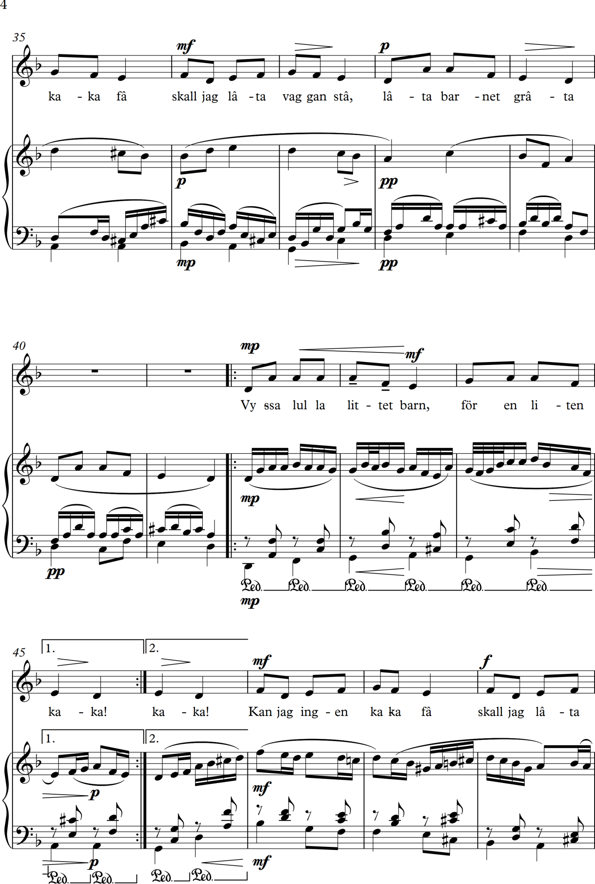
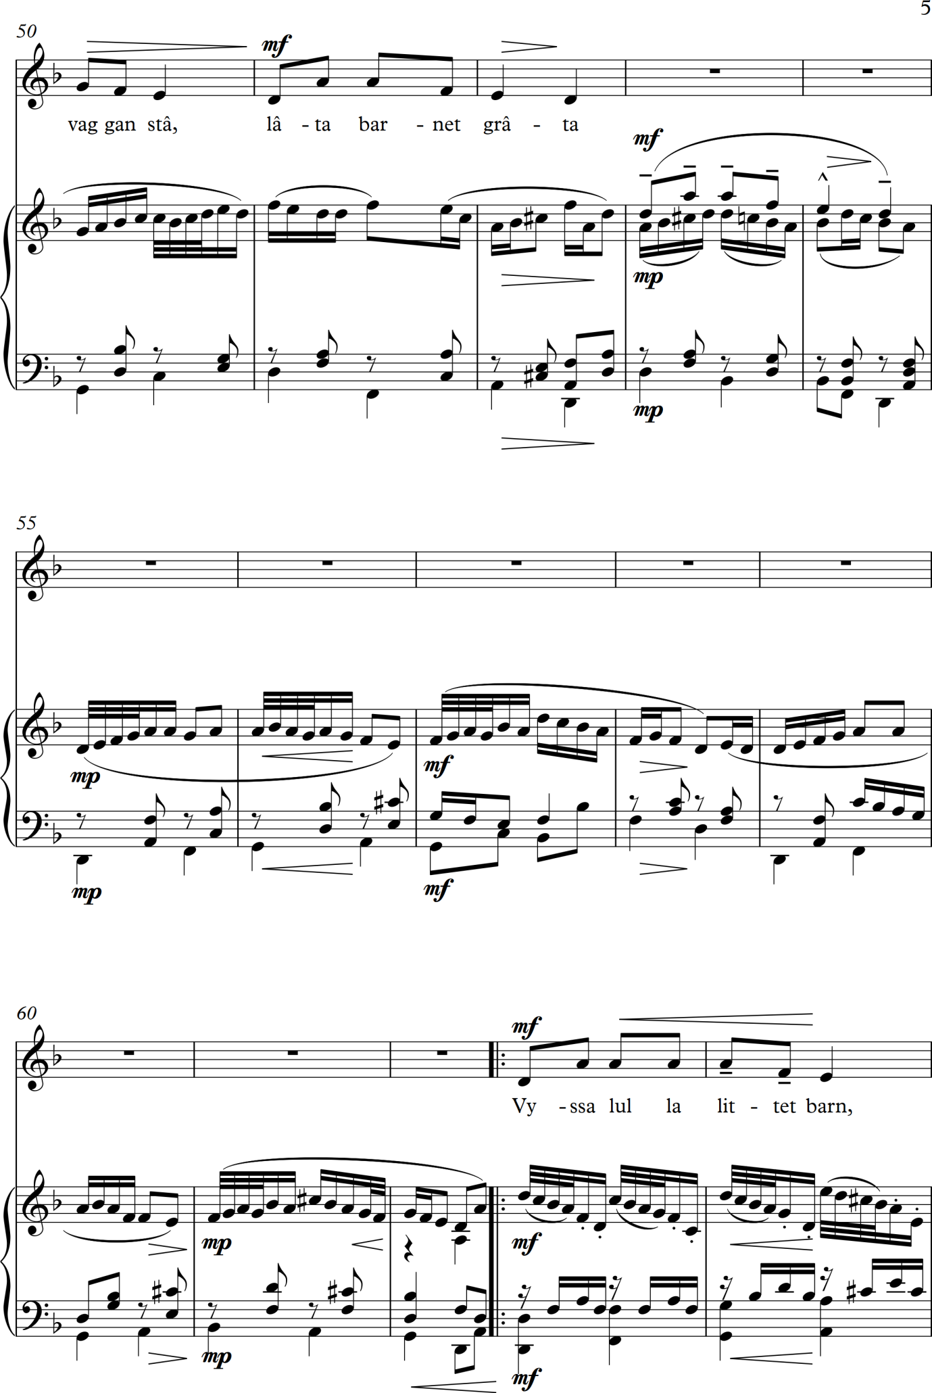
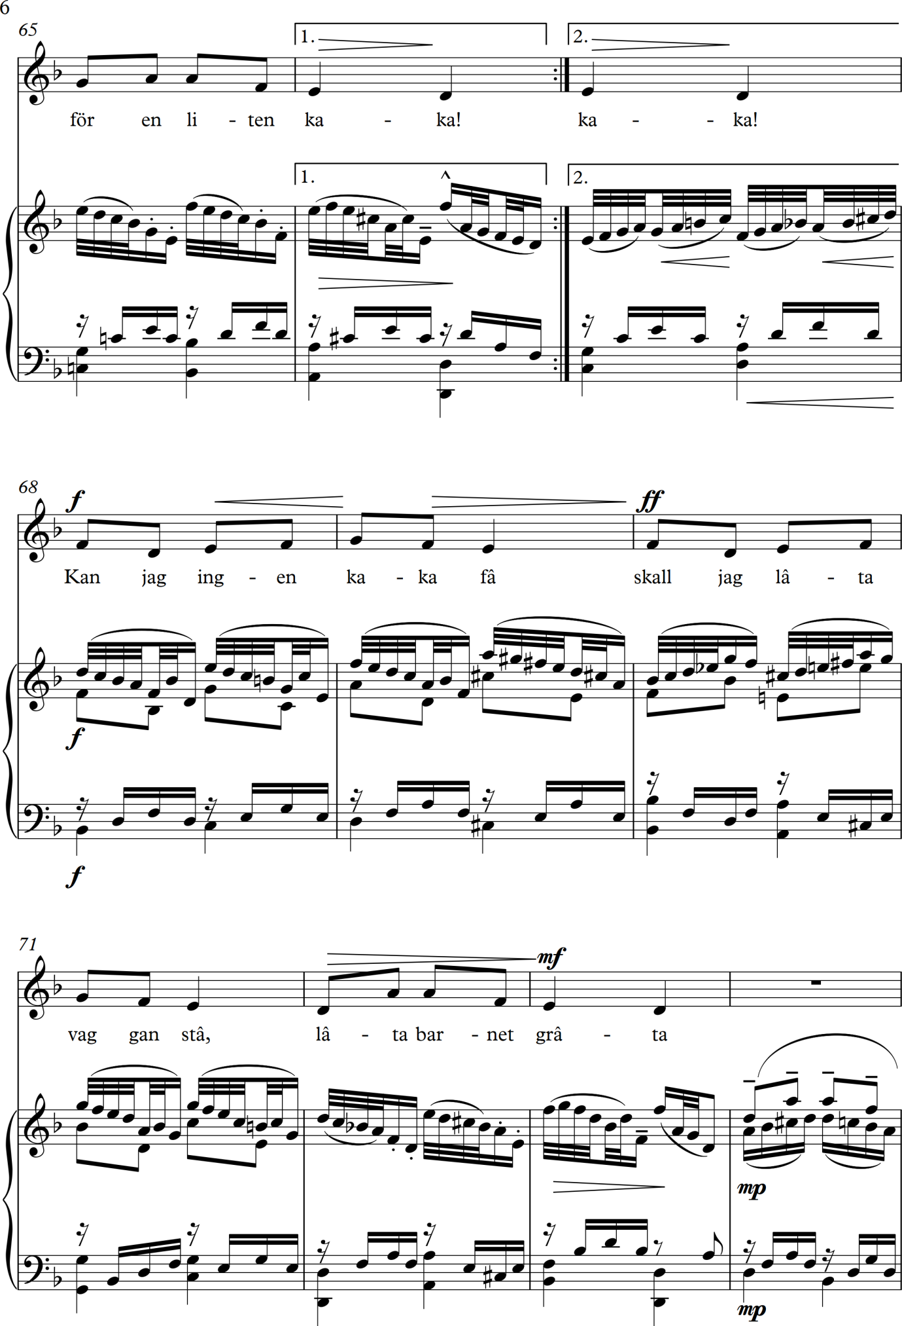

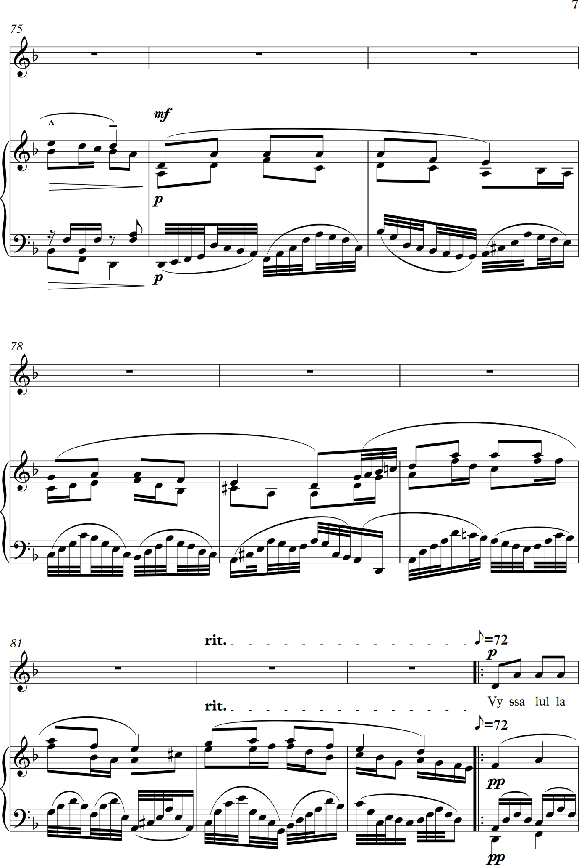
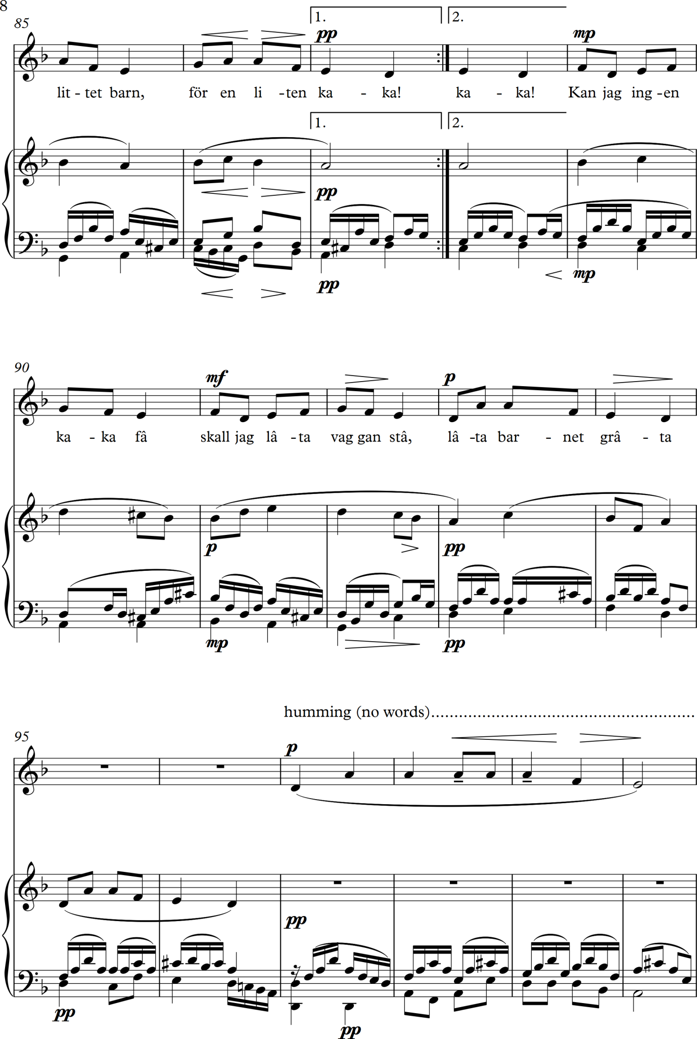
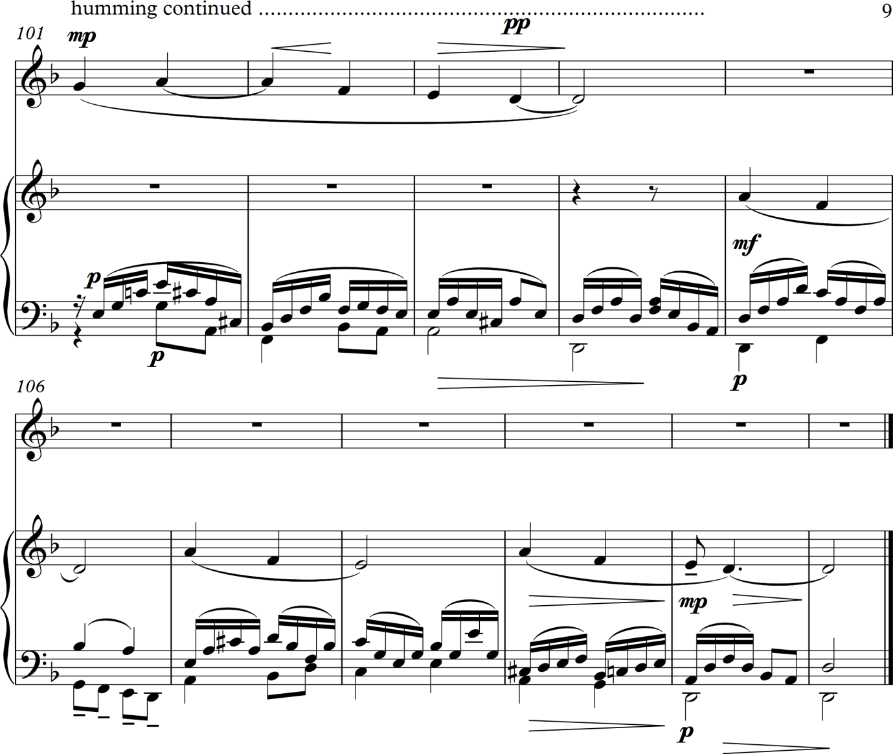

Notes on the criteria and aaproach I used in composing the arrangement of Vyssa Lulla
I imagined this piece being sung by a lonely mother to a baby at night while she is waiting for her husband to return – he has been away for some weeks either fishing or hunting and she is fearful that he may never come back. I did not want to over elaborate the arrangement but still wanted it to build up in intensity and fade away with a sense of sadness and resignation that yet another night had gone by without any sign of him and that she only has the child as a reminder of his presence. I created the harmonic progression at the start working out on my piano and then cross referencing it with the circle of fifths. The use of B♭ major to D minor is not a usual final cadence but works for me – not sure why and also makes me think of Wagner’s use of harmony in his opera Tristan und Isolde. I also had alternative chords at various points as can be seen from an earlier rough sketch copied above and used this at times to create variety in the sound world I was weaving. The piano introduction utilises parts of the melody at half speed as an introductory device and to set the mood of quiet contemplation I wanted. I was not sure how much to develop the melodic line as I notice that the arranger’s of folk tunes I studied sometimes alter the vocal line for dramatic purposed which did not feel right to me here – the repeated refrain of the same line of music for me symbolises hopelessness and a growing resignation to whatever fate holds for the singer. I thought that I cheated a bit as I reused material from the start of the piece to end it although slowing it down somewhat and altering a few notes and harmonies here and there as felt appropriate. I did this as I felt I had spent long enough on this exercise and want to get on with the rest of the course and get Assignment 1 completed and sent off.
22 June 2017
A note to state that I have started again trying to set up a blog online to upload my logs on to but am stymied already by the sheer complexity of it all and my inability to work it all out. I have paid an annual subscription so that I get more storage on-line and no advertising. Here is the web address: https://compositionworks.blog/?utm_campaign=pp-onboarding-2016-1 (not worth looking at yet as all I have managed to do is upload one photo of me and a terse comment about how difficult I am finding it!) Have also discovered the guides to blogs on the OCA website – and that there are also OCA guides on Wordpress – back to these another day!
Now on to the next part of the course: Project 4: Word setting

Research Point – word settings
Gilbert and Sullivan
I have found manuscripts of most of their works in the Petrucci International Music Library on line but find the PDFs move slowly and unhelpfully on my computer. I have also found other downloads of the key songs but decided to study them on line and also listen to recordings of many pieces via Spotify. The following are songs I listened to/studied:
- ‘A Wandr’ing Minstrel’ from The Mikado – a light aria for tenor voice with a flowing and easy to listen to and catchy tune with fairly straightforward harmonies and accompaniment. The meanings of the words are not really reflected in the music in any profound way although the phrase ‘are you in sentimental mood’ is slower and more pensive in style and the word ‘sorrow’ in the text shortly afterwards is given a long melisma and minor harmonies to reflect its meaning. All in all it is a pleasant song to hear that is easy on the ear.
- ‘I’ve got a little list’ – first line ‘As someday it may happen that a victim must be found, I’ve got a little list …’ from The Mikado – what is known as a ‘patter song’ – a humorous lengthy poem with lots of words and fun lyrics to entertain an audience and usually sung by a comic character. The words are declaimed in a fairly straightforward style relying on the interpretative powers of the performer for their effect rather than the music which really just carries the words along with a straightforward rhythm and fairly conventional harmonic progression. Gilbert and Sullivan used a lot of these – in a somewhat similar way that Rossini also did in his comic operas – usually sung by men, baritones or basses.
- The Flowers that Bloom in the Spring, tra la’ from The Mikado – another straightforward catchy tune in ¾ time that is initially sung by one character with a repeated refrain for the chorus. At romantic implications the music slows down to reflect that, however the text is again set in a way that reflect speech patterns – this does make for easy projection of the words and clear diction. Musically this has no interest for me at all.
- ‘Take a pair of sparkling eyes’ from The Gondoliers – a tenor aria sing by the young romantic male lead. Another catchy tune with a straightforward setting of the words and conventional use of harmonies in 6/8 time.
- ‘Poor wand’ring one’ from The Pirates of Penzance – sung by the romantic soprano lead and is a ballade like slow song with a gently affecting tune and straightforward waltz rhythm and again conventional harmonic progressions and setting. The words are again mainly syllabic in the way they are used which appears to be the default setting for this composer and lyricist.
Overall I do not respond very well to the musical comedies/operettas of Gilbert and Sullivan – I have sung in both The Mikado and Iolanthe and can testify to the effectiveness of their word setting which is clear and articulate and makes it easy for the performer to deliver in an easily understood way. I find the melodies trite for the most part and can see why many productions resort to a high camp style to maintain interest and engage the audiences as the music for the most part is nothing special – at least to my ears. I write these critical remarks with some trepidation as I know many people adore all of the works by Gilbert and Sullivan and find them endlessly fascinating. They are just not to my personal taste. I do also understand that some of the music is ironic and a pastiche of grand operatic works of their time by Verdi and his compatriots and that some of the writing is very effective, but for me these are rare moments.
Ira Gerswin and DuBose & Dorothy Heyward
- ‘Summertime’ from Porgy and Bess – I think this is an amazing piece of word setting. It is so advanced compared with the pieces by Gilbert and Sullivan. The whole piece is like a tone poem of a hot, lazy summer’s day. The piece comes after a faster and highly energised section of the opera and starts with three and a half bars of slow atmospheric harmony – simple but effective. The tempo has reduced considerably and the piece starts with the first two syllables of the first part of the word summertime in syllabic use and then the music stretches underneath and extended third syllable – time – which is over the minor tonic having started in E major as the dominant, but subsequently adds in the 6th to the tonic key to make it more jazzy. The phrase ‘and the livin is’ is faster and syncopated in rhythm with the following word ‘easy’ again stretched much longer over two chords. I could carry on and on illustrating how the rhythms are used to demonstrate the meaning of the word – for example a quaver on the first syllable of jumpin’ which is perfect word setting to my ears and so skilful. The subtly shifting harmonies which slide around beautifully also help a great deal in creating the laid back soulful and jazz like feel to the piece. One point to note is that the syllable ‘in’ features often in words such as mornin’ and wings’ often over long held notes. Like the word ‘summertime’ itself this allows for a myriad of performance options on where to sound the change from the vowel to the consonant. Often classical singers will hold the vowel open longer whereas jazz and popular singers often head for the n or m – each option creating a subtly different effect. These are small points which with everything else in the score add up to a brilliantly set lyric and a fabulous piece of music that continues to be performed in a myriad of arrangements and styles.
- ‘Bess, you is my woman now’ – from Porgy and Bess – another wonderful example of word setting and a great use of harmony – based on conventional circle of fifths but given a jazz twist with added 6ths and other notes and also some interesting side moves in the harmony that add colour and tension – I don’t yet fully comprehend all of the structures here but admire it hugely. The musical line (tune) does follow a more syllabic approach but at time stretches on certain words for dramatic emphasis as well as musical effects – and yet done in such a way that increases the meaning of the text and depicts the feelings lying behind it – for example having 3 beats on the word ‘Bess’ followed by straight crotchets for ‘you is my woman now’ creates a sense of the name being caressed in the music which is a lovely effect. The phrase ‘de sorrow of the past is all done’ set to quavers both creates more tension about the past and implies wanting to hurry on from it to the future – all the more poignant as we know that this relationship is doomed. The repeating of the word ‘done’ on 3 beats then underlines this feeling even more. There are numerous more examples like this which show me how brilliantly Gershwin and the Heyward’s created this work. Comparing these pieces with other works by Gershwin that he compared with his brother Ira writing the lyrics, such as ‘Nice Work If You Can Get It’ and ‘Embraceable You’ show that with the Heyward’s Gershwin achieved much greater rhythmic and harmonic flexibility and sophistication – these latter two songs have great tunes and are lovely to listen to and perform but somehow the numbers from Porgy and Bess have achieved more with their settings. This may be because Gershwin was trying to write a serious opera for black people to perform and he poured so much imagination, feeling and skill into it to create a more complex work.

Studying these pieces by Gershwin has increased my respect for him enormously and I am hugely impressed by what he achieved. I have also learned some ideas about how to create tension, feelings and effects in the way words are set from someone who was clearly highly expert at this.

26 June 2017

Stephen Sondheim

I have now reached Stephen Sondheim and have been studying and listening to the song Losing My Mind from his musical Follies. I first learned this song in 1990 when I was having singing lessons with Joseph Lloyd-Collatin who trained and coached many West End stage performers in singing roles and also performed the role of Javert in Les Miserables for a significant period of time. I struggled with this song and looking at it now I can see why. It is brilliantly written and the way the words are set is wonderful and leads to many different interpretations as the performer can pause on the words in numerous ways, play with the rhythms and still achieve a great musical effect.

It starts off beat and is syncopated. It is conceptually interesting as the lyrics are asking the performer to reflect on an experience – ‘The sun comes up, I think about you. The coffee cup, I think about you …’ It is very Buddhist in practice! That is that the singer is seeing items and this is making her think about someone who visited and has left and the song is contemplation about this. The rhythm is therefore not syllabic in a straightforward spoken way but does reflect someone talking to themselves in a pensive way pausing on words as if they are recapturing memories. A little later on there is a phrase with straight quavers which starts off beat again - ‘It’s like I’m losing my mind’. Here I think the singer is allowed to play with the length of the notes and the rhythms (as most do in all the recordings I have listened to and as I also was encouraged to do by Joseph) as they are placed above extended held chords. There is a repeated section for the last two thirds of the song which also repeats the opening for its latter parts but starts with a new theme which again plays around with where the beat is, again reflecting the irregularities of spoken human speech, although I feel there is a more definite musical shape here with again some great effects – for example the run down of four semi quavers for ‘ev-‘ry little chore’ illustrates the speed with which these tasks are done as the singer is more occupied with thinking about the person they are remembering. The harmony is gorgeous throughout with some lovely sleazy big band moments in passing which I imagine are a reminder in the singers memory (i.e. that is what the music symbolises) of a high old time together and subtle arrangements elsewhere – again like the best composers Sondheim is sparing in his use of notes with every one counting.

I find this song to be incredibly well written and illustrates a different approach to word setting than those used by Gilbert & Sullivan and Gershwin. From my knowledge of other works by Sondheim I would say that this song amply illustrates his care and skill in word setting.

Irving Berlin

For me Berlin has something that Sondheim does not and that is the BIG tune – he creates some wonderfully singable melodies that are very catchy. A great example is ‘There’s No Business Like Show Business’ from the musical Annie get Your Gun. His word setting is nowhere as particular as Sondheim or Gershwin but he does take the sense of a set of lyrics and creates music that overall reflects these – his evergreen classic ‘White Christmas’ perfectly illustrates this with its relatively straight forward rhythms but glorious tune and affecting harmonies which captures an essential Christmas time mood – here of course is where an example of music and feeling reinforce each other as most of us now alive have grown up with this played every year in December and therefore associate it with Christmas – but it works musically brilliantly. He does attend to the musical shape of his melodies and the words so that cry is often set to a low note in a minor key in many of his songs, the word love usually gets a longer note and is often at the apex of a curve in the musical line and so on. These are features that many composers use and I would therefore describe as typical and in general use by many people.

NOTE: I have found it difficult to find and copies of scores by Berlin and so have listened to many recordings and found a few brief music illustrations on line.

Cole Porter

Another favourite of mine! And again I have learned quite a few songs by him over the years. And the proof for me of the effectiveness of his tune and song writing is that rather than analyse the word setting he achieves I went straight to the piano and started working through a number of his songs I love and have enjoyed over the decades! Now for a closer look at what he does with words and music.

Generally I think Cole Poster is similar to Irving Berlin in that he takes the general feel of a set of lyrics nearly all of which he wrote himself and then set to wonderful tunes. As he was writing for musicals and films some of the numbers are there as plot devices and some deal with emotions and feelings. Some are catchy up beat numbers with a feel good factor such as ‘Blow Gabriel Blow’ from the musical Anything Goes where fun lyrics are married with an infectious and energising tune. Other numbers from that musical have a deeper feeling, such as ‘Easy to Love’, with a gently rising tune and the classic lingering over the word love.

Looking at the song ‘Love for Sale’ from the musical The New Yorkers based on a book by Henry Field although again Porter wrote both lyrics and composed the music. I find this interesting as the introduction to the main musical theme and body of the song is like a classic recitative in an opera by Handel or a contemporary where there was a more syllabic and declamatory introductory section followed by the aria with big tunes. The introduction to this song has a syllabic setting of the words where the rhythms follow very closely the way the words would be spoken in everyday speech as if telling a story. Then the big tune arrives on the phrase, love for sale. The word love is paused on and stretched to 7 crotchet values (7 beats), as is the word sale. The phrase moves downwards and goes from the dominant (E♭) to the minor key version of the tonic (B♭m) which is a little unsettling aurally. The word appetising which follows is syllabic and then love stretched again though not for as long – the word sale again lasts for 7 beats, emphasizing what this is all about. The musical phrase is repeated with the word who stretched for 7 beats thus emphasizing the lyrics again. As the song progresses Porter combines interesting harmonic shifts with emphases in the melodic line to create effects – I particularly like the way he slows done the tune and gives minims to the words true love to add emphasis and poignancy. And of course using the word love over nearly four bars at the end of the verse creates a great climax musically and also creates a sense of irony as of course it is not actually love that is for sale. I think this song is brilliantly written with a combined approach to musical structure, melody, harmony, and word painting that are masterly and work together brilliantly. He was clearly very talented – and I imagine that he must have written the lyrics first and wonder if the tunes were developing in his mind as he did so? See quote below which shows I am wrong!

In the book of his songs that I own there is an interesting comment in the editorial about his compositional method (Collier, 1977):

His methods of working naturally varied. Usually he worked away from the piano, first working out the rhythmic impact of a song and then creating words and music almost simultaneously. He liked to obtain a good opening and a good ending and work towards the middle. This method often produced songs with an artistic unity ...

(Collier, 1977)

Friday 30 June 2016 – Research on word settings continued
Lionel Bart
I have not been able to find copies of the score for Oliver – it is suggested in the course notes that Bart’s word setting in this musical is studied. I have listened to recordings on Spotify and have the following observations:
- Overall this is a very tuneful musical with a good story that includes pathos, excitement and humour based on the novel Oliver Twist by Charles Dickens. It is a classic work that has seen a number of stage productions in the West End and across the world including several in Broadway and a famous film. Bart won the Tony Award for the musical score in 1963. It is full of catchy lyrics and memorable tunes many of which have become very well known.
- ‘Food Glorious Food’ – a chorus for children with a strong rhythmic introductory section and a great main tune that is memorable. The lyrics are humorous but the music is not hugely reflective of the actual meanings of the words - after all they are starving and desperate for food, a situation which could lend itself to music full of yearning and pathos rather than sentimental and humour laden recalling of food that is reminiscent of traditional school dinners. The tune at times builds to brief climaxes on key words such as steak and food.
- ‘I shall scream’ – the style of the melody for this piece reflects the humour of the lyrics. The word scream is given a much longer note value to emphasize it. In 4/4 time with a driving beat in the accompaniment and a conventional harmonic progression. It reminds me of Gilbert and Sullivan and Rossini patter songs.
- ‘Boy for Sale’ – this does remind me at moments of ‘Love for Sale’ by Cole Porter but this may because they both hold the music note for word sale for a long time. The word sale is emphasized. Some of the descriptive lyrics, for example, small boy rather pale are scored at a slow tempo and in a minor key which does reflect the overall sense of the words. I note that singing actors tend to motor fairly quickly through the vowel sounds when singing and spend much time on consonants such as the ‘l’ in sale – very different from the classical bel canto style I like and was trained in when I was not leaning musicals!
- ‘It’s a fine life’ – A humorous song sung by a female in the cast about life with a catchy tune and rather trite lyrics. Children come in at some points as a chorus. Rather conventional musical setting of fun words without much musical word painting.
- ‘As long as he needs me’ – a rather lovely ballad for a female singer in a minor key with a memorable and affecting tune and occasional interesting harmonic shifts in the accompaniment. Again it is clear that they lyrics were written first and then set to music – I note that it has a more emotional effect when the main melody moves downwards and then climbs up to a higher pitch for its next descending passage – this somehow sounds sadder and more moving than constant upwardly moving melodies.
- ‘Oom-pah-pah’ – a very catchy tune reflecting jaunty and fun laden lyrics in waltz time with a fairground and hurdy-gurdy feel to it. Conventional harmony. For solo voice and chorus. The detailed word setting is less important than the overall feel and uplifting and entertaining effect.
Sunday 2 July 2017
Continuing with studies of word setting which is useful as it is opening up possibilities and ideas. Next I am going to look at the settings of lyrics by Oscar Hammerstein – composers who set his words to music include Jerome Kern, Rudolf Friml, Sigmund Romberg, and Richard Rodgers.
Jerome Kern
‘All The Things You Are’ from Very Warm For May is a lovely piece with a great melody and lovely supporting harmonies. Again another song that I have been singing for years and get much joy from. Quite straightforward in many ways but little touches add menacing, for example the first phrase states:
Time and again I’ve longed for adventure
You will see below from the illustration below which I have transcribed from my copy of the song (Williamson Music, 1995) that the dotted rhythm of the first two notes, which are the first two notes of the whole song, gives a kick to the start of the piece and starts us of on an adventure – the last word I this excerpt. The quaver on the first syllable of the word adventure reflects the way it would usually be spoken but also gives energy and emphasis when sung. The word longed is on a longer value note in this phrase which allows the singer to emphasize it.
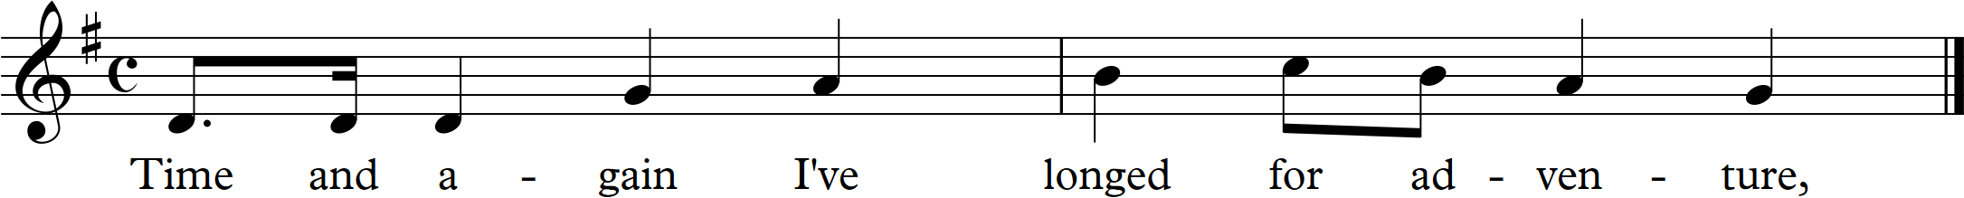
Another feature of Kern’s music is the way the notes and words are great to sing – for example when the main refrain starts the first two words are You are and they have an interval of a fourth between them moving upwards which is a gift for the performer as the throat opens up from a more closed oo sound to an open ah sound. The harmonic progression is delicious as it basically follows the circle of fifths moving from minor to major which also creates a positive feel.
NOTE: this shows me that with word setting much can be involved from detailed reflection of the rhythms and meanings of specific words in the notes selected with attention to the overall melodic shape and feel, the underpinning harmony and the overall shape and progression of the piece and its place in the overall scheme of things depending on whether it is a standalone solo work or a number in a collection or part of a dramatic whole. There is much to work on when setting words to music. I have started working through a pile of scores from twentieth century musicals and would like to consider word setting by Kurt Weill, Ebb and many more that I love but am going to give one more example form a musical by a serious musician – Leonard Bernstein and then consider a song by Robert Schumann as a contrast.
Leonard Bernstein
I have always had a high regard for the music of ‘West Side Story’ by Bernstein. I have just discovered that the lyrics were actually written by Stephen Sondheim based on a book by Arthur Laurents which was inspired by Shakespeare’s play Romeo and Juliet. I have decided to look closely at the word setting of the song Maria from the show partly because again I learned it with Joseph Lloyd-Collatin and partly because I think it is a glorious piece of music that remains a very popular song. The song starts low in the singers register declaiming the first sung words in triplets (the name Maria is spoken first) followed by quavers and a minim - see excerpt reproduced below from a copy of the music that I have (Bernstein, 1988). This is syllabic but allows much rubato and room for interpretation by the singer and in music and words perfectly illustrates someone thinking dreamily about the name of someone they have fallen head over heels in love with. The next bars have the name declaimed in music and then repeated over again three times, twice using triplets. This really does capture the feel of obsessive young love.
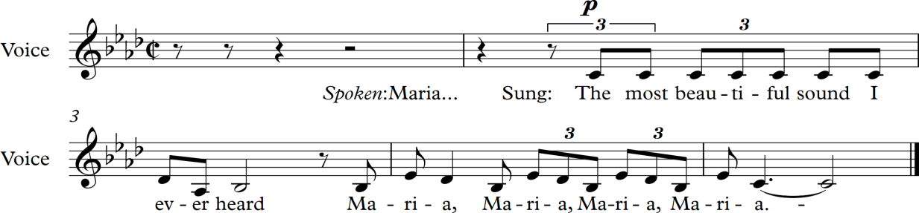
(Bernstein, 1988)

The main tune, labelled Chorus on my copy, also features triplets extensively which are syllabic but work wonderfully well musically too which makes the song have both a natural and lyrical feel to it. The name repeated with an ascending melodic line adds a sense of ecstasy at one point and then later on a descending motif gives a sense of contemplating the name and the person behind it. The words in the middle section of this main section at one pint state ‘I’ll never stop saying Maria’ and indeed the piece has repeated iterations of the name often with the third syllable of the name held on a high or low note for many beats while the harmony shifts subtly underneath it again illustrating the feeling state behind the words.
I am left with the thought that these well known numbers do demonstrate a wonderful melding together of words, harmony, rhythm, musical structure and a glorious tune that allows individualistic interpretation by the singer.
Robert Schumann
I have decided to consider a classic art song for my final word setting research – In Der Fremde, the first song from the song cycle Liederkreis Opus 39 by the 19th century classical composer Robert Schumann. Again this is a piece I have learned and sung although this time my lessons were from the opera singer Charlotte Newstead who is based in Bristol. She always emphasized in lessons the great importance of the meanings of the words and how their sense should be put into the music by the singer. For me this music so powerfully works because the words and the music combine together brilliantly to huge effect. The rhythm of the song depicts the weary tred of a person on a long journey – in this case back to their homeland. This is achieved through using common time and a regular beat throughout the piece. This melody is put over a rippling arpeggio like accompaniment that also creates a sense of movement and flow. Again there is a great tune but with little touches throughout that show and alertness and response to the words. An example of this is in the 7th and 8th bars - see excerpt below (Schumann) – where the words mean that the singer’s (that is, the persona they are assuming for the performance of the song) father and mother have been dead for a long time and Schumann gives a longer note for the German word for long – ‘lange’. The harmony also changes under the held note creating a suspension which creates tension too which then resolves on the word ‘todt’ which is the German for dead. This is lovely to sing and adds much poignancy.
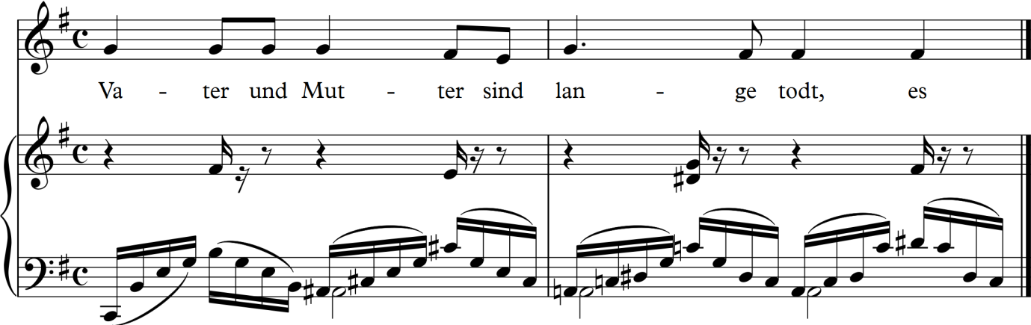
Excerpt from In der Fremde by Robert Schumann
Further on into the song the words ask the question for how long the singer will have to wait for peace for him or her self. The words for peace and too (or as well) are given longer notes again and add an emphasis which can be felt to reflect the singer’s restlessness and maybe longing for death too.
I also notice that the harmony here is subtle and complex, again based on the circle of fifths but with a constantly changing feel to it as the accompaniment ripples on. It is in the key of E minor and this has also reminded me of comments made in the book The Dynamics of Harmony by George Pratt (Pratt, 1996) in Chapter 3 titled ‘Interlude I: The Major-Minor Misapprehension’ that pieces of music often change mode between major and minor frequently and that to think a piece is in one key all the time is misleading and that a substantial period of time is needed before a piece actually modulates into another key.
Saturday 8 July 2017
Some writers (See Wikipedia, 2017) think that the piece modulates through a series of different keys before returning to the home key and that the harmony at times is unsettled using devices such as the Neapolitan 6th which reflects the unease expressed in the words – my current knowledge levels make this difficult for me to easily analyse without much detailed study (should I?). In practice this is my felt experience in performing the song – as always it is easier for me to construct harmonic progressions myself that reflect some meaning to me rather than deconstruct someone else’s in a complex piece.

Notes on the Traditional modes in
The AB Guide to Music Theory by Taylor Chapter 23 ‘Before the tonal period’

The classical Western tonal system as described in the AB Guide (chapters 8, 9, 15, 16, 17) emerged gradually and was fully formed by the early 17th century. The 20th century saw rapid developments on from it in a number of different directions. Nowadays there are often comparisons made between modern forms of music and that which existed before the tonal period. Other music forms that have a different structure behind them include folksongs and music from outside the Western hemisphere.
For the 300 years from the 17th century in the West music was based on scales that derived their foundation from the first note and the variations between major and minor. The traditional 8 note scale had been defined and harmonic progressions based on chords founded on the various notes in the scale and the pitch it is at. Earlier music did not have this tight scale structure and the types of forms used are usually describes as modes and existed for thousands of years. These were based on melodies, usually unaccompanied tunes without harmonies. The ‘Dorian’ mode, which many traditional tunes and laments utilised, is similar to a scale of 8 notes on our Western stave system starting on the note D but without any sharps or flats.
NOTE: I find it interesting that such a mode can have an equivalence in the equal temperament based system which is a device to make tuning easier and of course was not established until several hundred years ago which implies either interesting features physiologically in how we experience sound or denotes a gloss over a much more complex reality here.
In a similar way the ‘Phrygian’ mode starts on the key of E and so on. Not all of the notes may have been used and often the tunes based on these modes were pentatonic in nature and structure. Each mode had two forms – the authentic which started on the first note (e.g. D in the Dorian mode) and the plagal which started a fourth below or a fifth above this (= A in modern terminology). These plagal modes may also have had the first note of the Dorian mode as their final note when utilised in a melody (NOTE – the chapter is confusing at this point and seems to be trying to establish simple principles for very complex principles). In use not every note of the scale was used in these modes but instead a certain number and in established patterns – examples are given in the chapter to illustrate this. (And maybe we are projecting a modern system of recording music pitches on to a more ancient practice as it is the only way we can start understanding it?). Some traditional folk songs, for example The Royal Oak are constructed ion this pattern. This statement on page 241 (Taylor, 1991) helps me:
Plainsong and folksong modes, then, are not quite the same as scales. A mode is a complex of melodic patterns. The notes used in these patterns can be arranged in order to form a one-octave scale… this is merely a device of theorists: modal melodies themselves never include such scales…do not even use all the notes contained in the theoretical modal scale.
Often Folksongs are pentatonic and like plainsong melodies, which were often in the modes written about above, and existed long below methods of recording them in graphic form were invented. They would have been sung at whatever pitch suited too. Early notation showed the intervals between notes in a tune but not the pitch they were sung at.

Project Four – Exercise – give a poem a melodic setting
NOTES for me - stages of doing this are:
- Select the poem
- Carry out literal rhythmic ‘setting’ – as spoken syllabically
- Flex the setting of the rhythms to suit my purposes and interpretation
- Create the melody
- Add accents and review and/or change note values (where do the strong and weaker beats occur, and are off beats used?)
- Consider the mode of the melody and setting

Monday 17 July 2017
Poem chosen for Exercise – melodic setting:
The One Before the Last by Rupert Brooke (Brooke, 1932) written on 11 January 1910
I dreamt I was in love again
With the One Before the Last,
And smiled to greet the pleasant pain
Of that innocent young past.

But I jumped to feel how sharp had been
The pain when it did live
How the faded dreams of Nineteen-ten
Were hell in Nineteen-five.

The boy’s woe was as keen and clear,
The boy’s love just as true,
And the One Before the Last, my dear.
Hurt quite as much as you.

Sickly I pondered how the lover
Wrongs the unanswering tomb,
And sentimentalizes over
What earned a better doom.

Gently he tombs the poor dim last time,
Strews pinkish dust above,
And sighs, ‘The dear dead boyish pastime!
But this – ah, God! – is Love!’

- Better oblivion hide dead true loves,
Better the night enfold,
Than men, to eke the praise of new loves,
Should lie about the old!

Oh! Bitter thoughts I had in plenty
But here’s the worst of it –
I shall forget, in Nineteen-twenty.
You ever hurt a bit!

11 January 1910
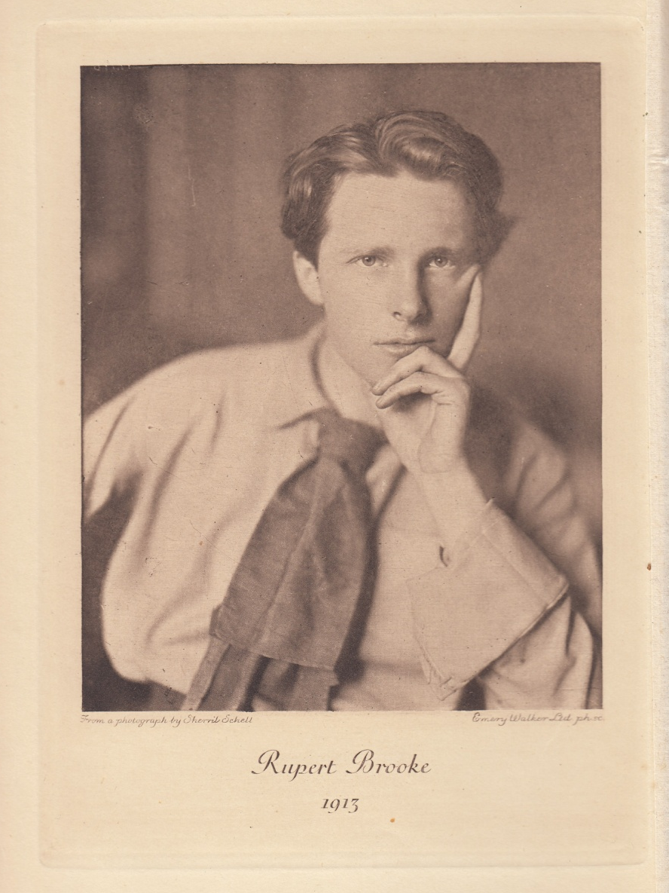
Fig. 20. Photograph of Rupert Brooke (1913)

Tuesday 18 July 2017

Projects 4 – Exercise – melodic setting syllabic – first go
A note to say how challenging this actually was – particularly as every time I read the poem I find a different rhythm and interpretation for it. I am not entirely sure that I have all the rhythms accurately down but it works after a fashion. I can see that when I compose the melody next that I may alter the timings, put in extra rests and change the feel again. I think the rhythm is actually more complex in reality with more hesitations than I have captured. However poems were written to be declaimed with a certain regular pulse and I think I have caught that – although the last phrase is maybe twice the length it should be.
I have also decided to leave it at the first three verses as this is an exercise and I intend using a different poem for the actual assignment. This has been useful for me though and I am excited about setting more words to music and feel glad to be discovering how to do this.
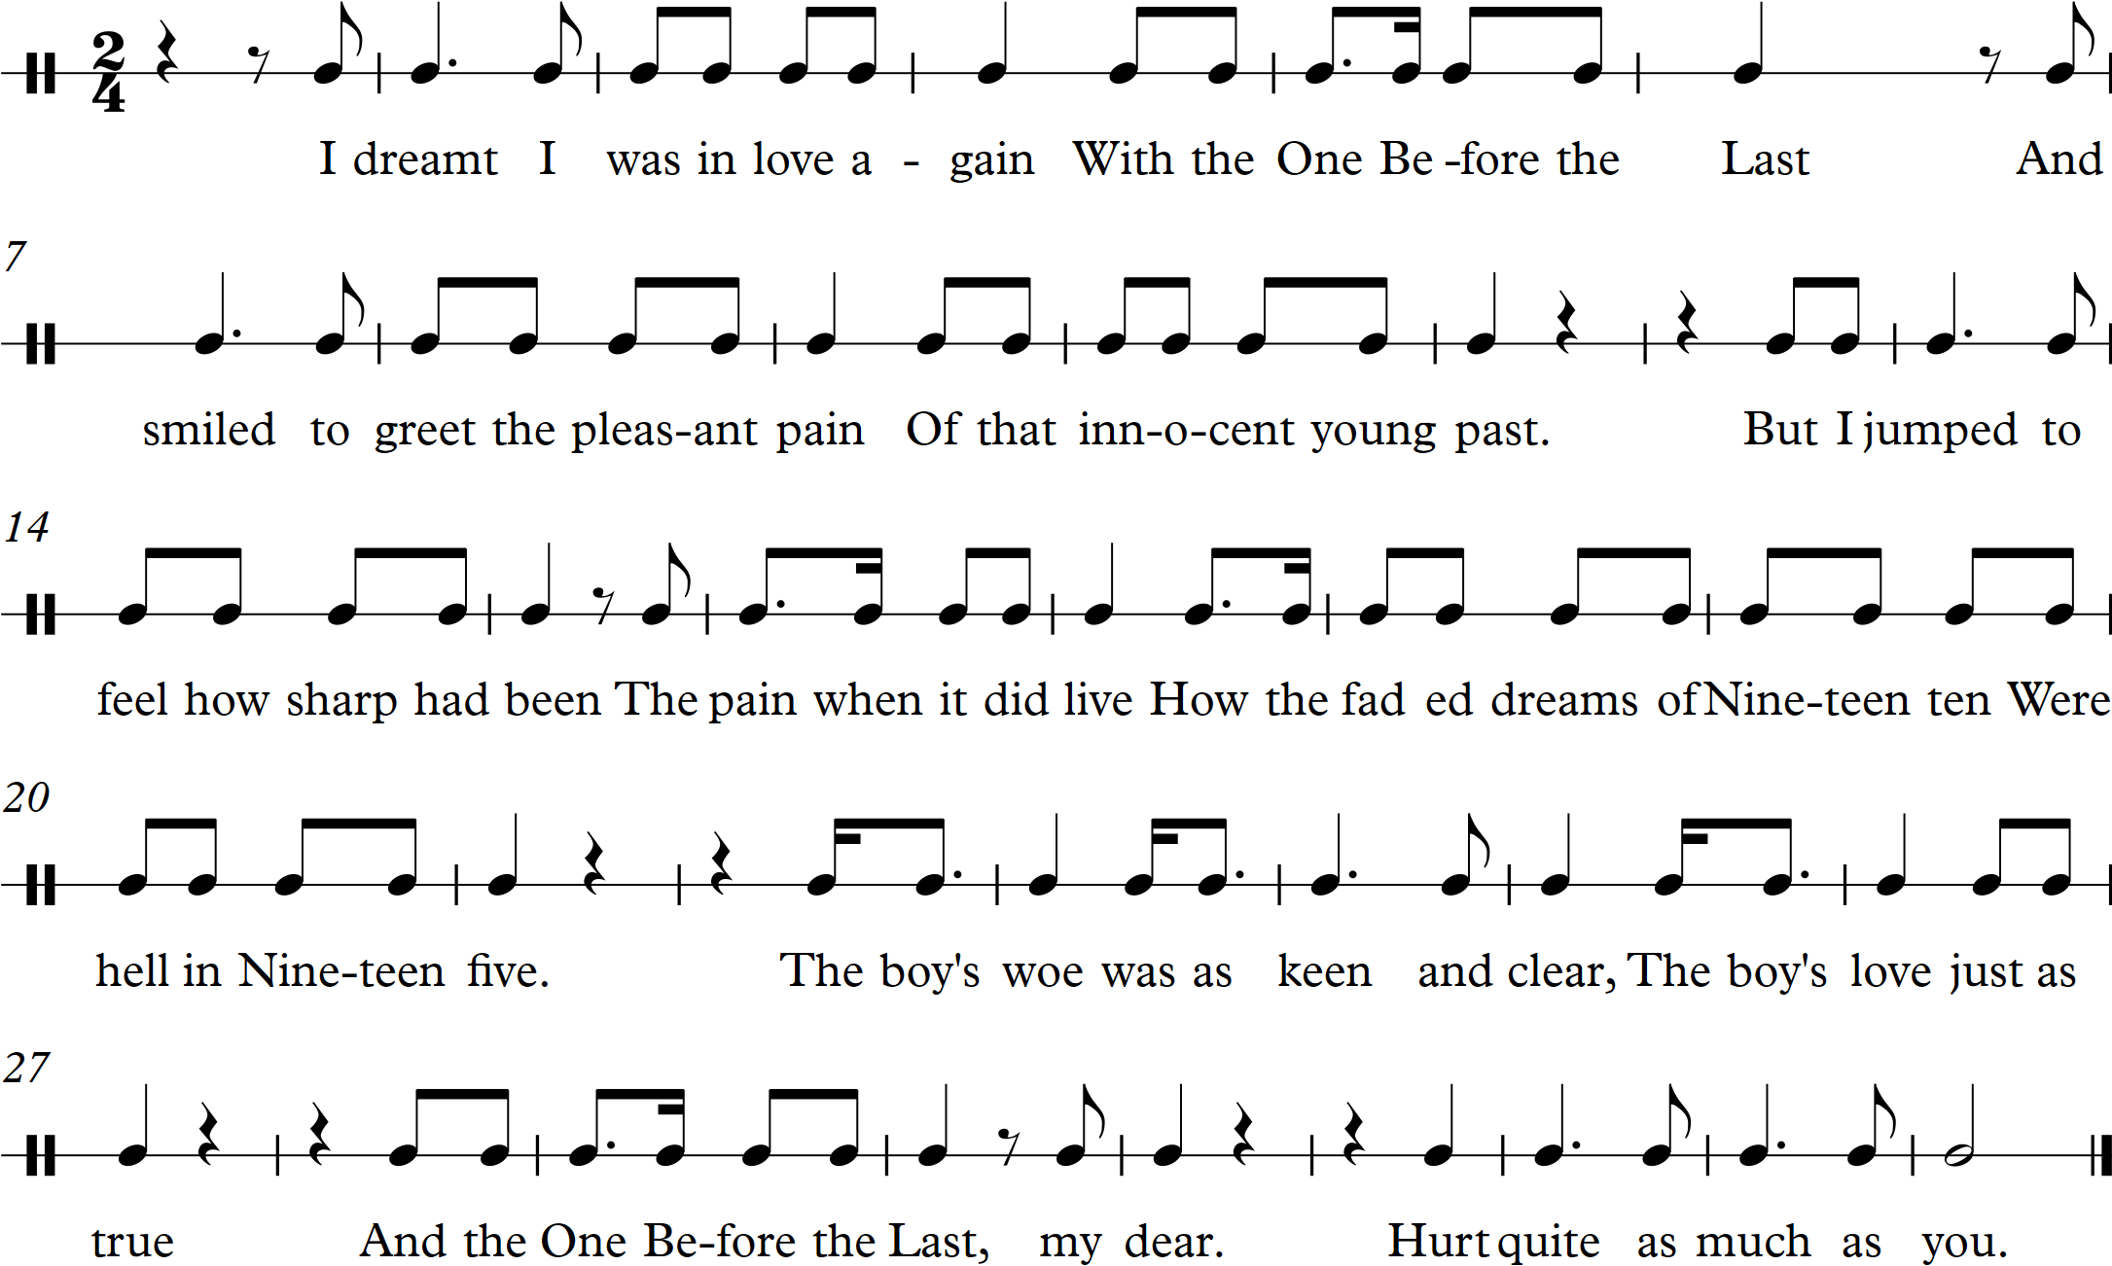

I have spent all day working on this piece creating a melody for it which I have inserted on the next page below. I am not entirely happy with it however. I like the first 8 bars. Then it goes awry and although I can hear what I want to do with it I find writing the actual tune and notes a lot more difficult to accomplish. I have worked on it all day and have decided to leave it until I have another free day when I am less tired and hopefully have a clearer mind.
I also have to decide whether to leave this as an exercise, or work further on it, or to choose another poem for the actual assignment. As I started working on this one I did think that I would set the whole poem to music as I was inspired by its writing and content – well I was seven hours ago! I thought I could make the first 3 verses lighter and bouncier and then the next 3, which are more serious in mood, more reflective and weightier and then for the last verse which returns to a more humorous mood revert to lighter and more playful music. This all feels quite technically challenging and I would really like to have a go at it. However I am also aware that I want to get on with Assignment 1 and send it off to my tutor.
The other poem that I am considering is Sonnet, again by Rupert Brooke (Brooke, 1932). Here is the first verse:
Oh! Death will find me, long before I tire
Of watching you: and swing me suddenly
Into the shade and loneliness and mire
Of the last land! There, waiting patiently,

This has a much more serious and melancholic feel with a lighter touch towards the end of the poem. A different creation altogether and I think it would produce from me a more lyrical melody that I would find easier to compose and work with – and in minor tones which I like so much.
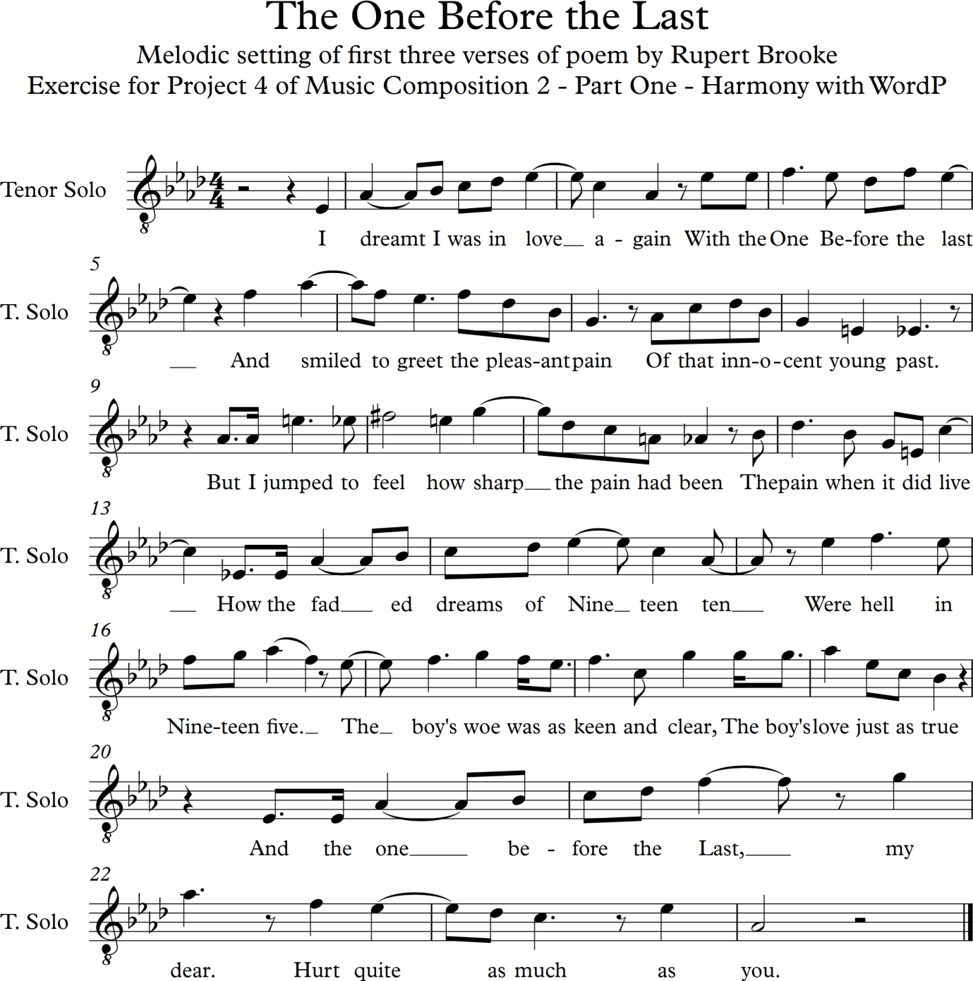

Sunday 23 July 2017
I have now revisited this melody and added a few accents in the melodic line changing it very slightly at points – this version is below. I started to set it to a piano accompaniment which I was becoming engaged in and thought might do for my assignment but cannot quite get to the fun and quirky sound effect I wanted. Also I am drawn to setting the other poem mentioned above so have made a decision to work on that as my assignment piece. I must add that I have reviewed the first poem I wanted to set to music for this assignment – The Moor by RS Thomas but that piece is less steadily rhythmic and would present a greater challenge in terms of a regular pattern for the accompaniment as asked for in the assignment details. I shall copy it below the reworked melody on the next page as a reminder as it is a poem I really do want to set to music and also with a viola in the mix too to carry and express the spiritual longings deeply embedded in the words.
The One Before the Last – reworked version:

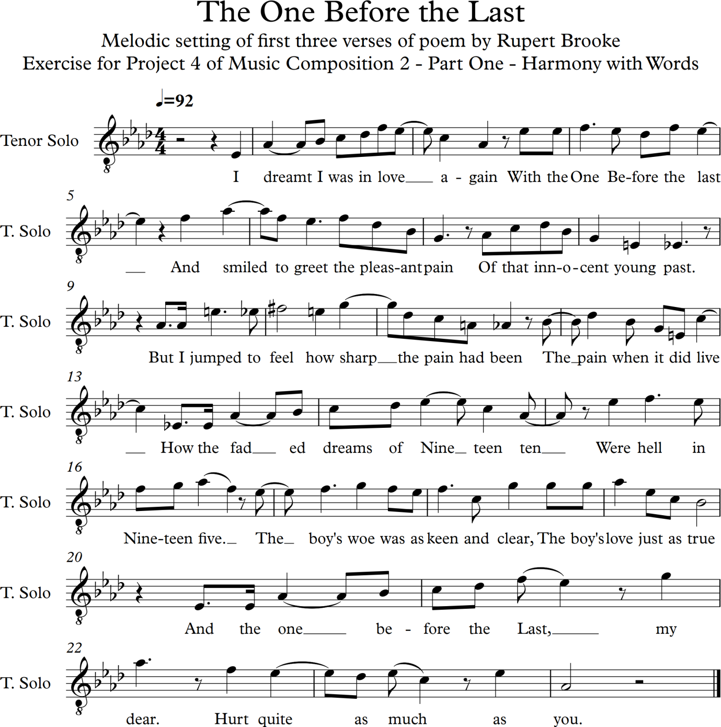

The poem by RS Thomas that I also wish to set to music (Unknown, 2012) followed by a scanned copy of the Rupert Brooke poem (Brooke, 1932 & Ref. no. 23) that I will be using for Assignment 1:
The Moor
By RS Thomas
(Original Language English)
It was like a church to me.
I entered it on soft foot,
Breath held like a cap in the hand.
It was quiet.
What God was there made himself felt,
Not listened to, in clean colours
That brought a moistening of the eye,
In movement of the wind over grass.
There were no prayers said. But stillness
Of the heart's passions -- that was praise
Enough; and the mind's cession
Of its kingdom. I walked on,
Simple and poor, while the air crumbled
And broke on me generously as bread.

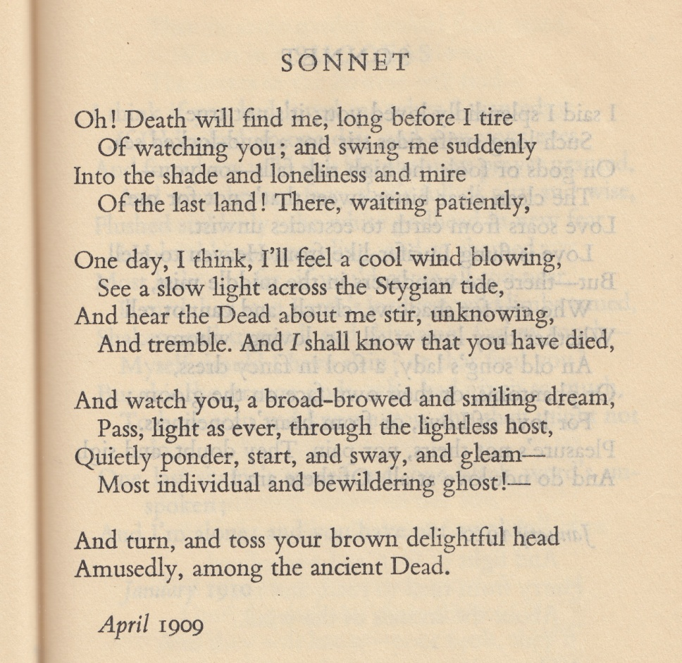

Syllabic rhythm setting of poem chosen for Assignment 1:

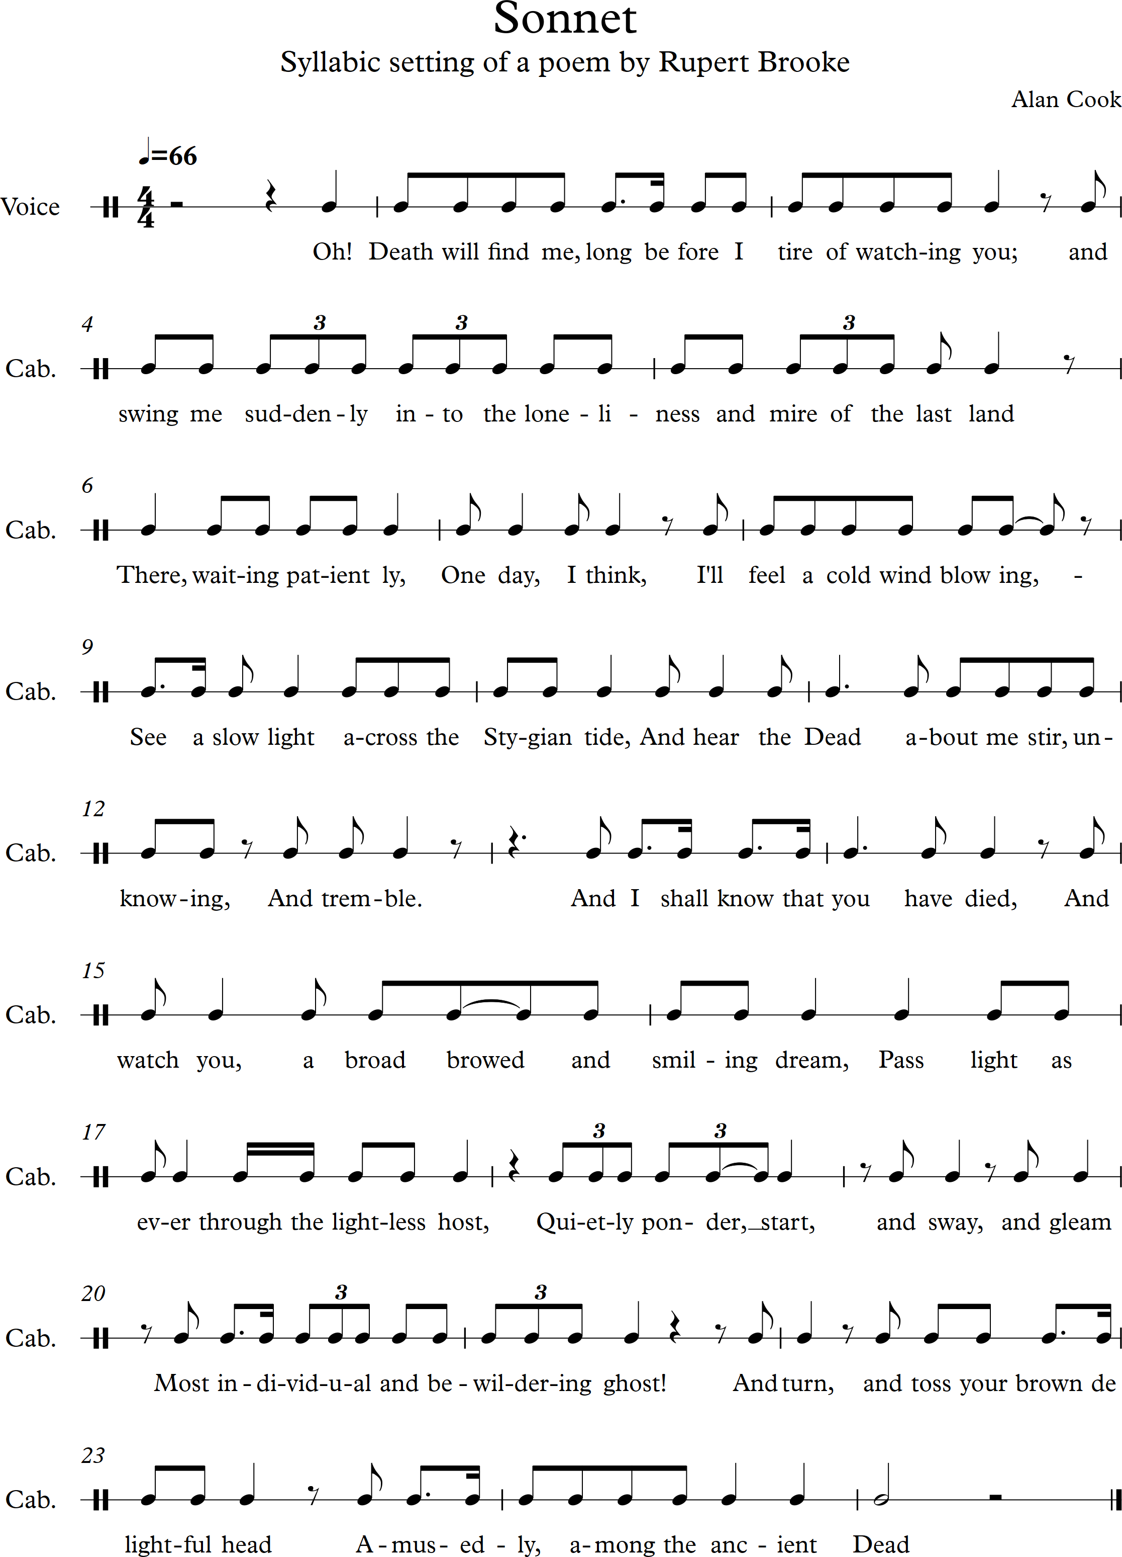
I note that in the course notes it tells me that I should use harmonic resources explored in the earlier projects, or possibly a ‘skeleton’ harmonic framework drawn from an existing composition…’. I have decided to use that which I created for my arrangement of Vissa Lulla, the Swedish folksong that I arranged and which I fell in love with. Even two days ago I received more feedback about it by e-mail from my stepmother in France:

Wanted to thank you for sending the composition and say that I thoroughly enjoyed Vissa Lulla. Haunting is right, the theme is attractive and the finished result captivating.

e-mail received on 21 July 2017 from Susan Watson

Here are the rough notes that I copied earlier into this log to remind me of the chords and tonality I used:

Here is my first working version again to help me with the construct of this new piece:

Monday 7 August 2017
An update note on progress on the piece for Assignment 1: I have been steadily working on the piece for a couple of weeks now and making progress slowly. Copied below is a scan of my working notes followed by a copy of where I have got to date. I am blocking out the chords with a few extra passing notes occasionally – still finalising the main harmony I am using. I am struggling with it and not sure about all the chords I have chosen as a basis but will keep on and see what happens.
I like the main melody I have written although if composing it now might create something more dramatic – listening to Liszt songs has upped the game for me! I have been reading about creativity and improvisation with spontaneity and am going to try following the advice given by Robert Poynton which I have written about in my reflective log dated yesterday – 6 August 2017. That advice is to use everything which entails the following actions: notice more (everything around you and with you), let go (of inhibition, criticism and negativity), and everything’s an offer (whatever is around and is happening now can inspire you). On this basis I am responding to today’s wet and rain and thinking that the rain makes me think I could use a regular rhythm and pattern in the accompaniment and vary it as the rain does over time – sometimes gently and almost unnoticeably and at others dramatically. This immediately brings to my mind music by Philip Glass.
Taking breaks is important to me (just had a sip of tea) and maybe the music needs ‘breaks’ in it – changes of tempo and pace to allow the listener some respite from ongoing intensity so that the emotional impact of the piece comes in waves – just like the sea I heard this morning as I walked near the seafront here in Weston-Super-Mare where I live.
I am full of feelings and thoughts at the moment – about the recent anniversary of my former life partner’s death and also musing much about friendship and family, love and grief. And so maybe I continue to try to express such feelings through the music I am composing – again notes from yesterday’s Reflective Log entry explain what is going on for me with all of this and the impact the poem and piece I am composing is having on me.
I am also struggling with Sibelius software again – why do upward arpeggios selected for chords not sound on replay – I need to delve into the manual to work this out. The layout drives me nuts – but then I read many blogs and accounts of others struggling with this too. It is brilliant but clunky and not intuitive to use, in my view.

Scanned and graphic images below:
- Rough working notes with chords I have selected – this is by my side as I work out the accompaniment

- Graphic image of progress to date – this has taken me weeks to accomplish and is very rudimentary – when I play at the piano I create a simpler accompaniment which I sing to and am wondering about trying to write that down instead if being ‘clever’ about this and imagining an accompaniment and then attempting to realise it.

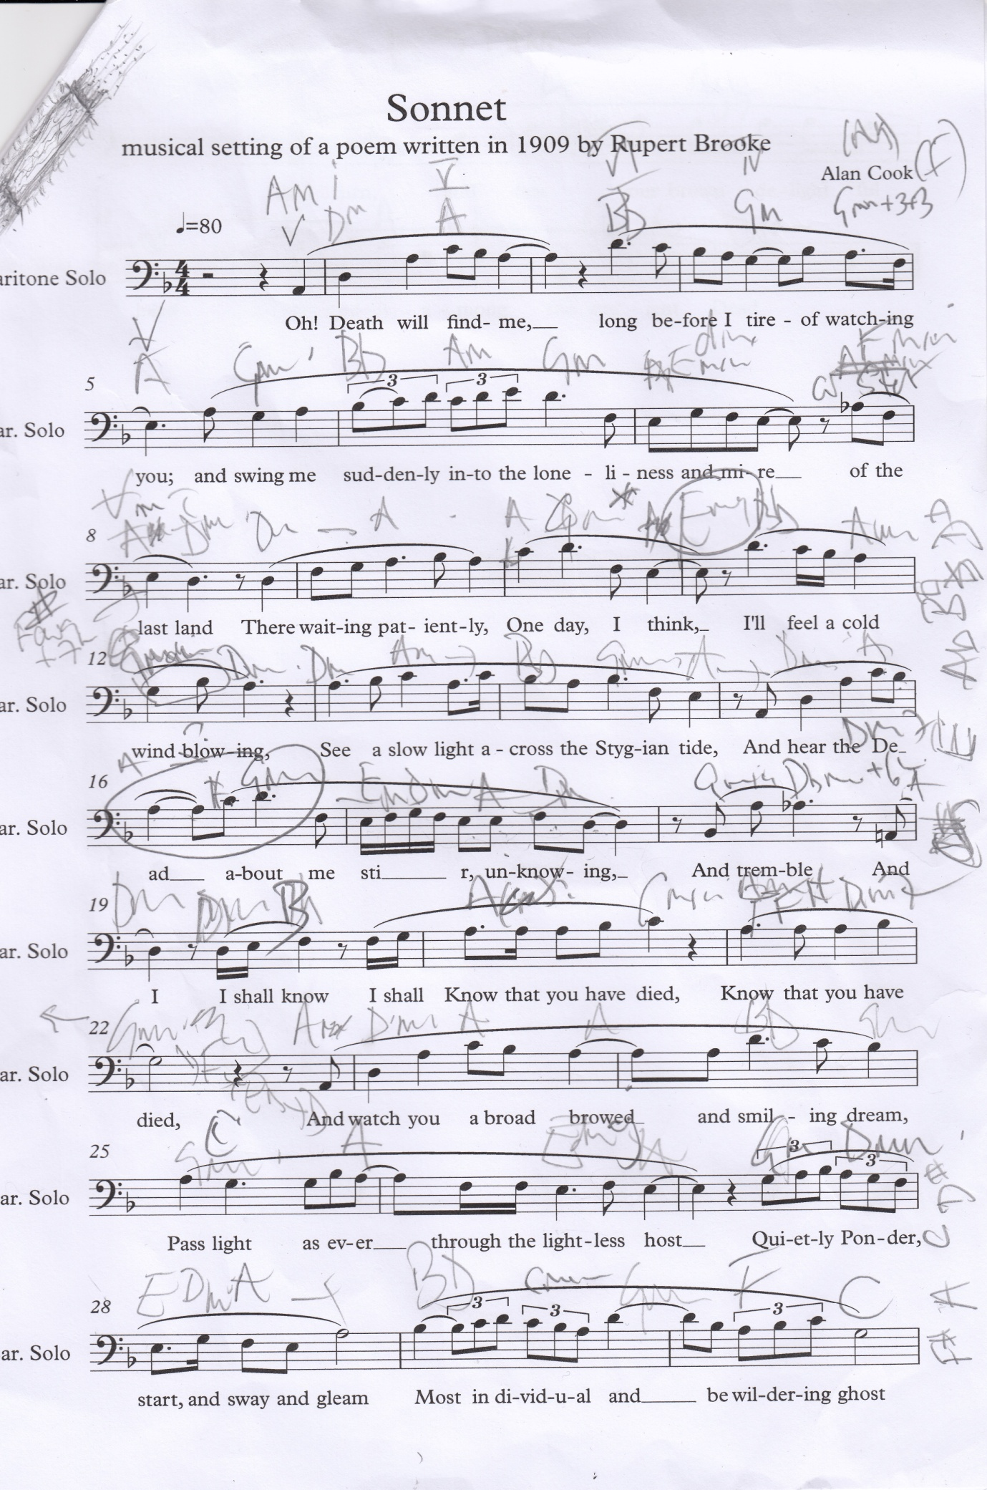
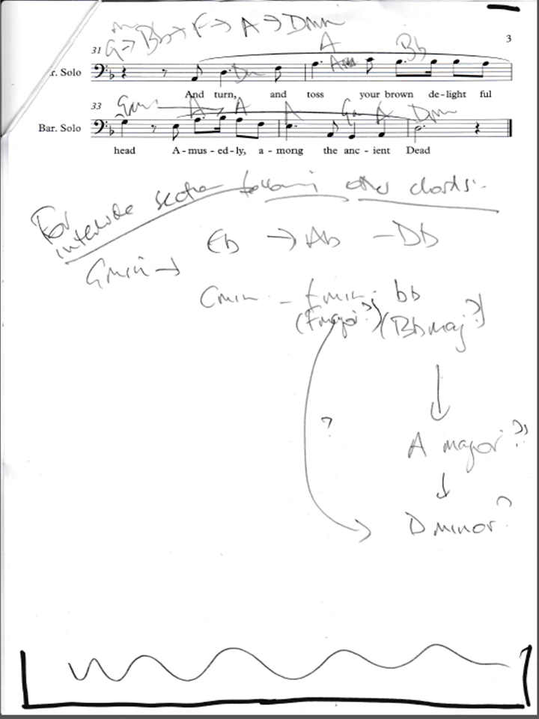

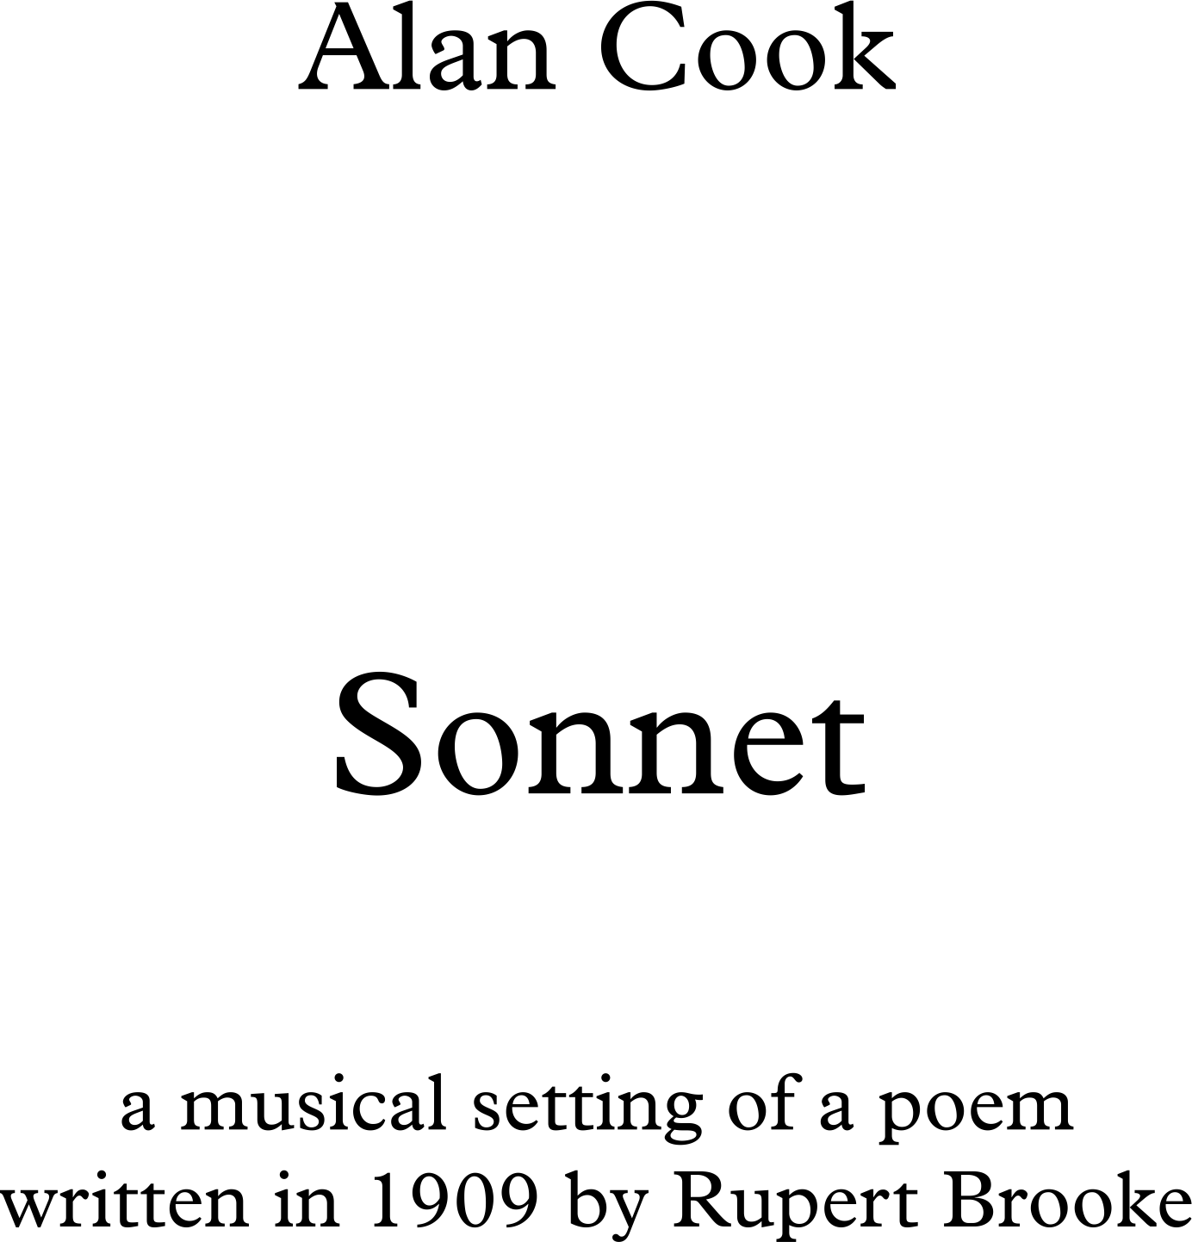
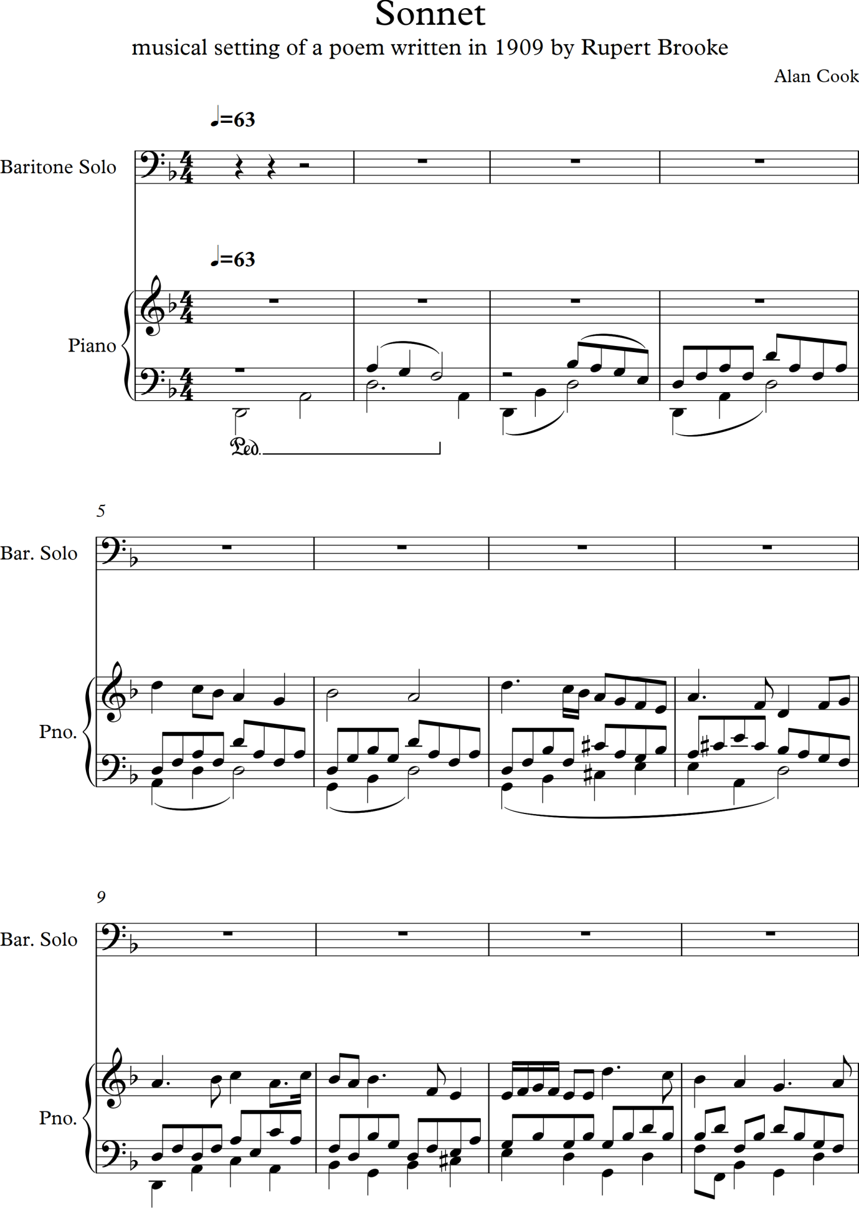

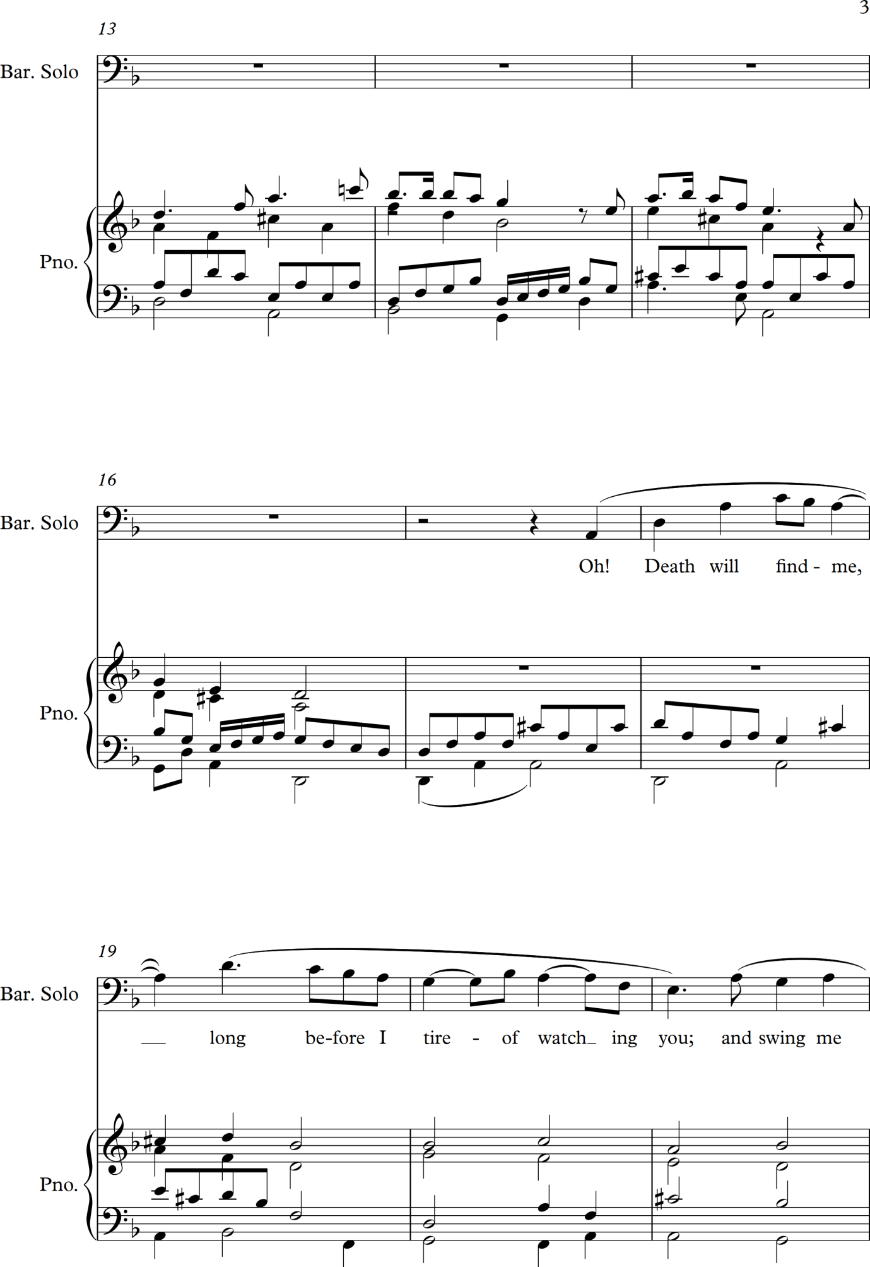

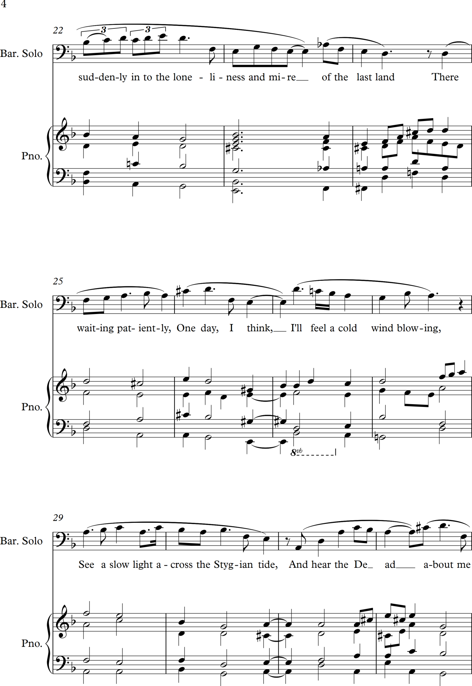

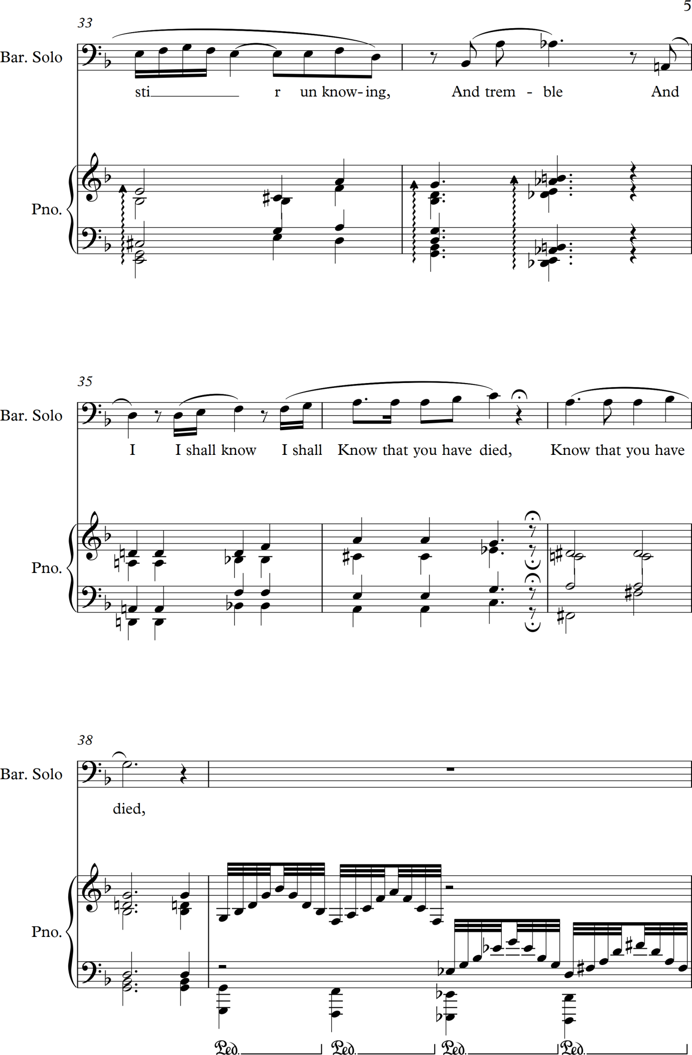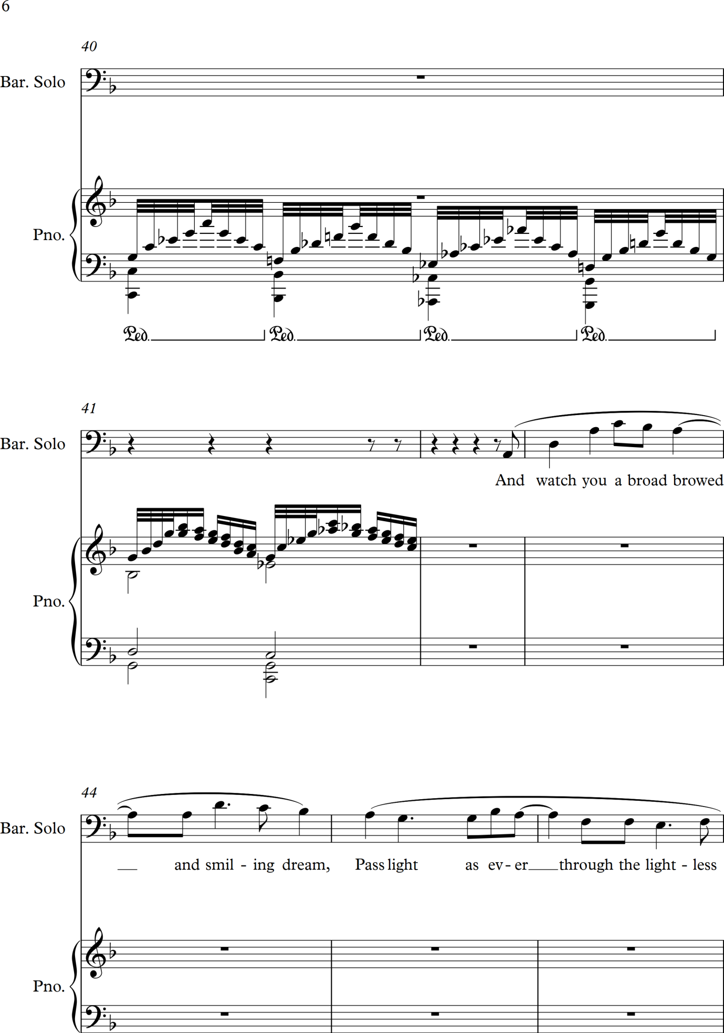

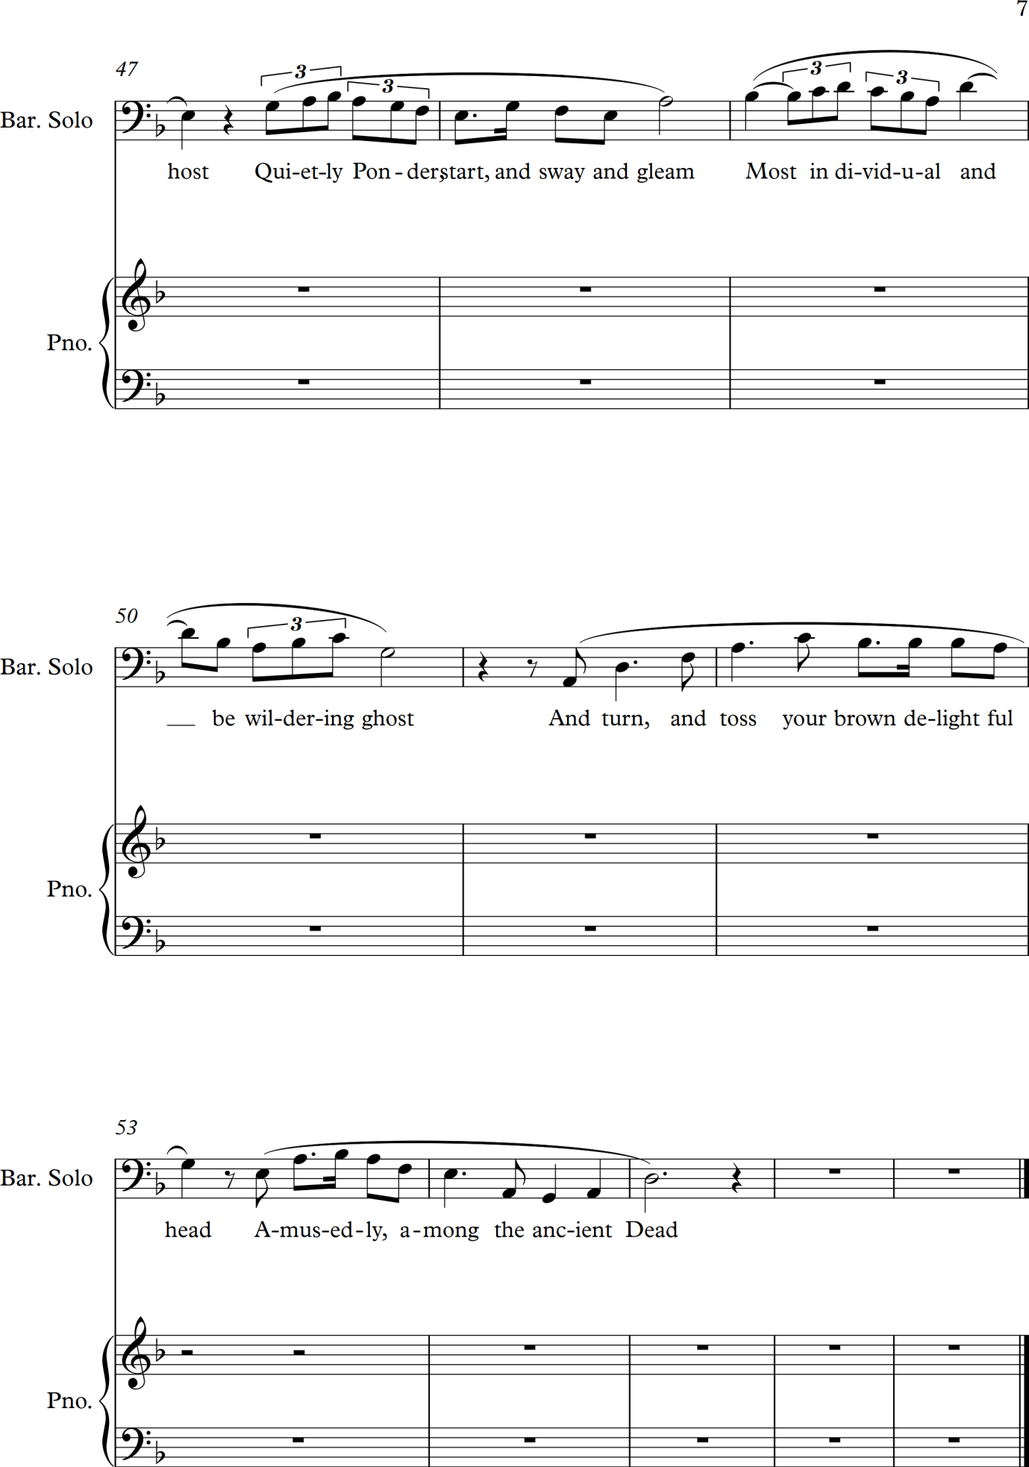

(Scanned image of progress on Assignment 1 as at 8.40 am on 7 August 2017)
14 August 2017
The piece is finished – or as much as it can be with my current skill set! See on next 9 pages.
I am critical of it in as much as I feel the piano part could be further refined – and I have perhaps put in too many notes. I think it works as a piece though and is my first attempt at writing a song. The harmony is crude, I think, and more study of principles and going through the books by Schoenberg and others will help me become more sophisticated in my writing. It has taken me a great deal of time to create this piece and I think contact with my tutor and feedback is needed to help guide me as to how to develop further.
I will be creating a blog site for holding this piece v and these logs too so that my tutor can access them. I have recorded myself singing the piece – a record that I am not proud of ads my voice is gruff from lack of use, my upper register congested and I cannot get the timing correct at one point. But it does give an idea of how it will sound in performance and is better than the la la la vocals of Sibelius software sounds to my mind. The piano accompaniment should be playable – I have tried it all myself and can get through it – very slowly but all the notes fit under my fingers with some intelligent and careful fingering choices.
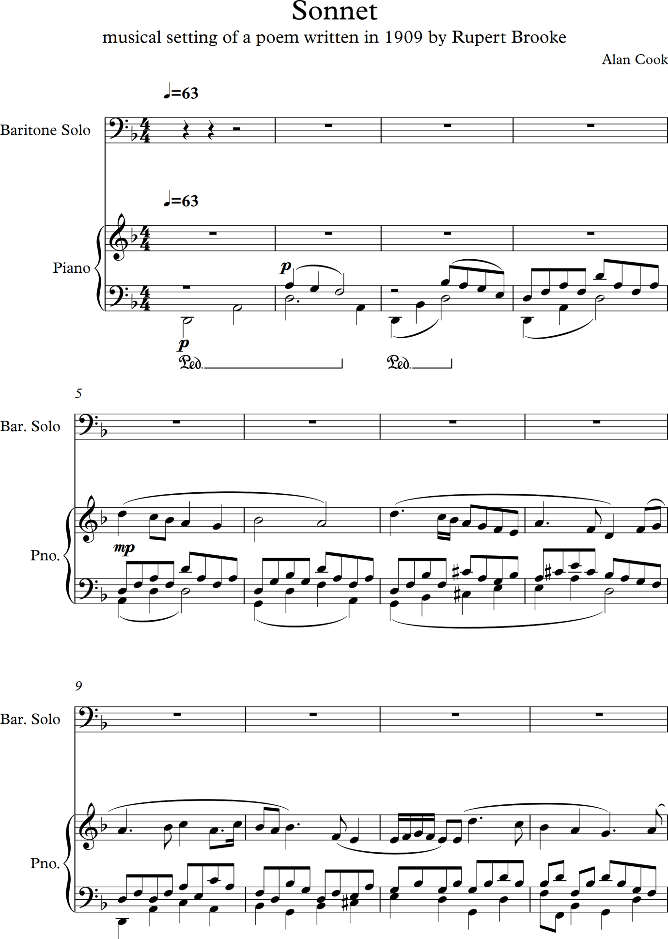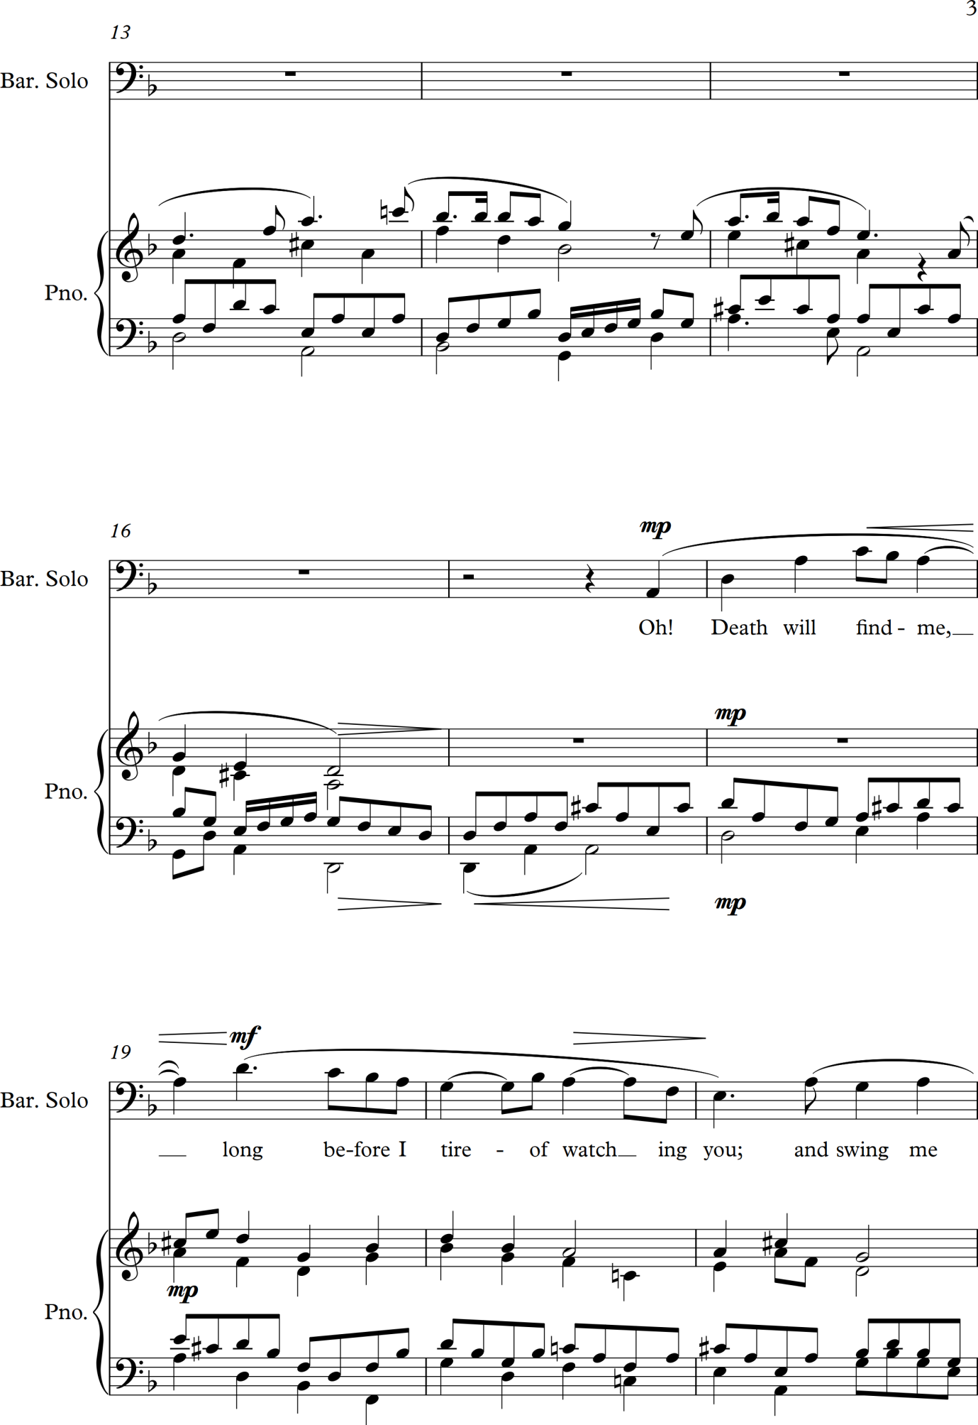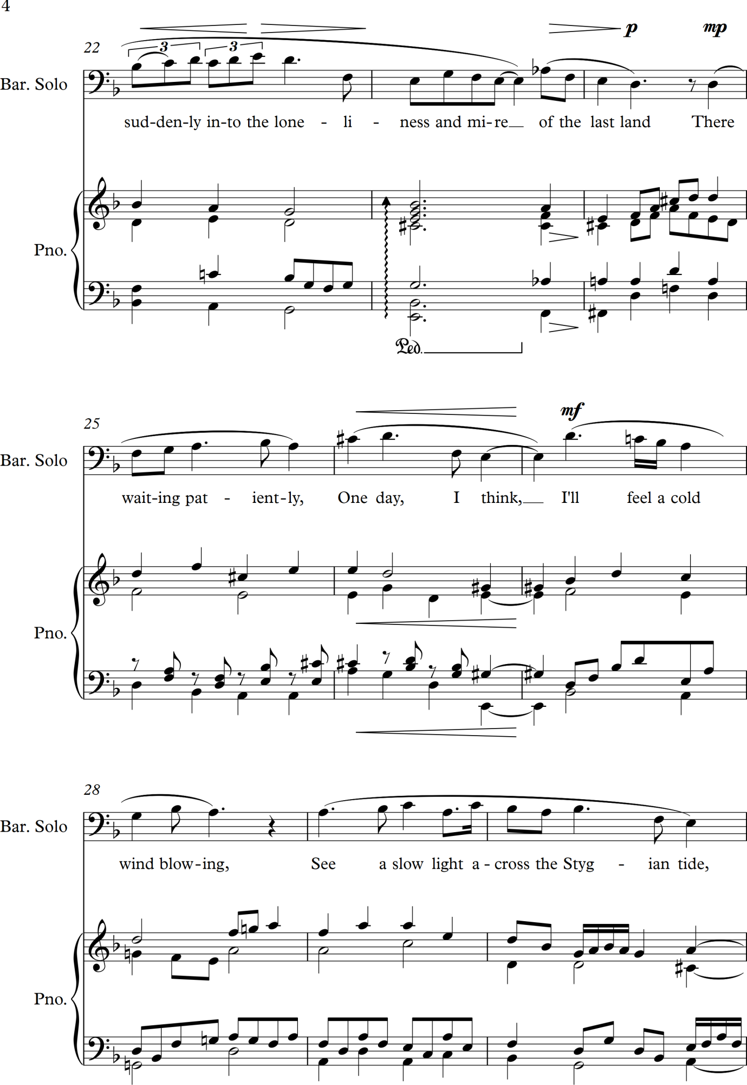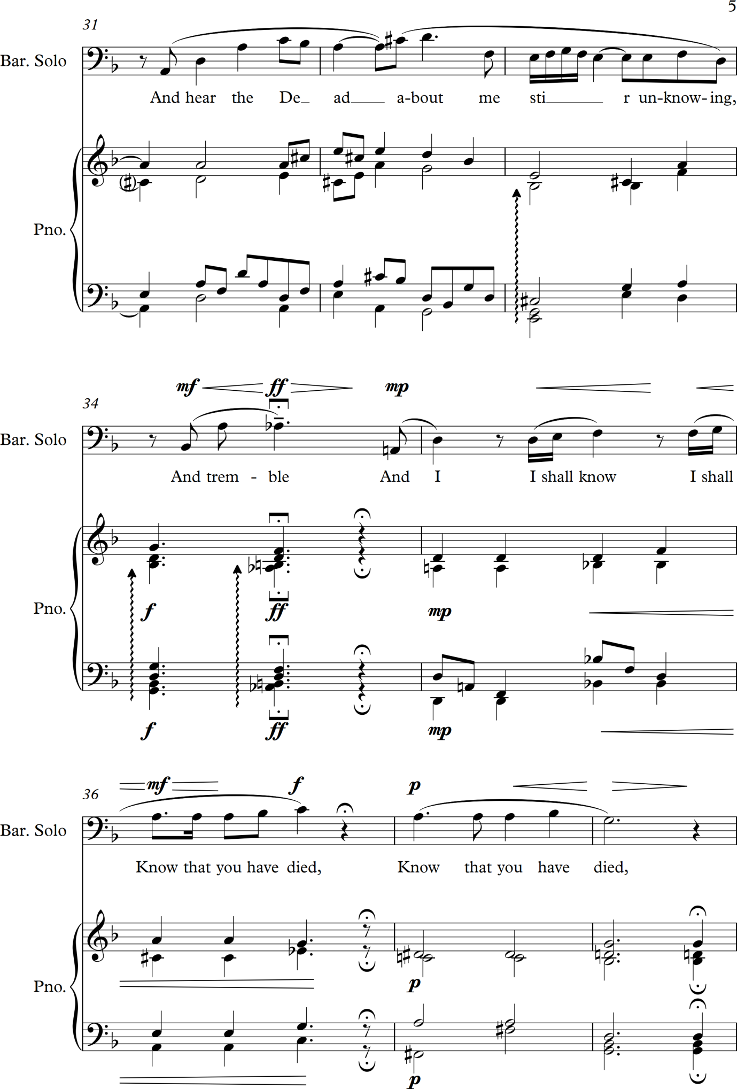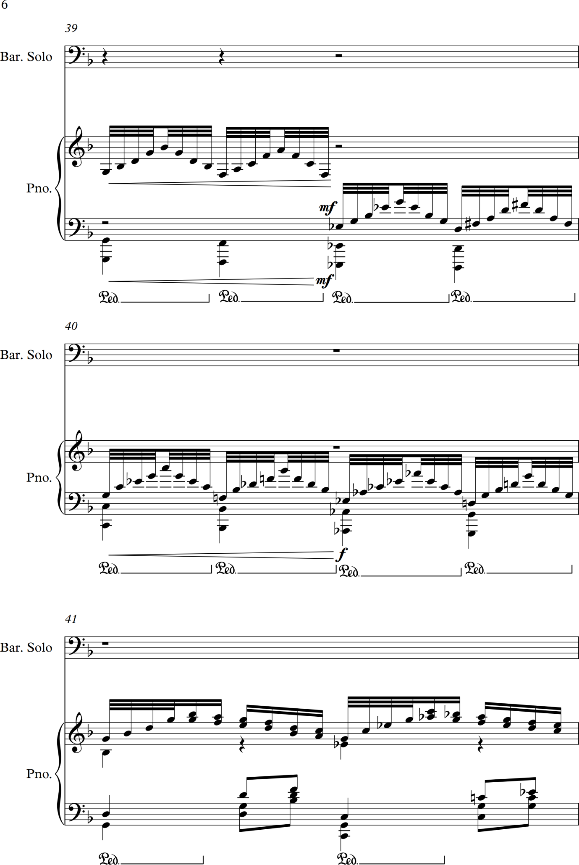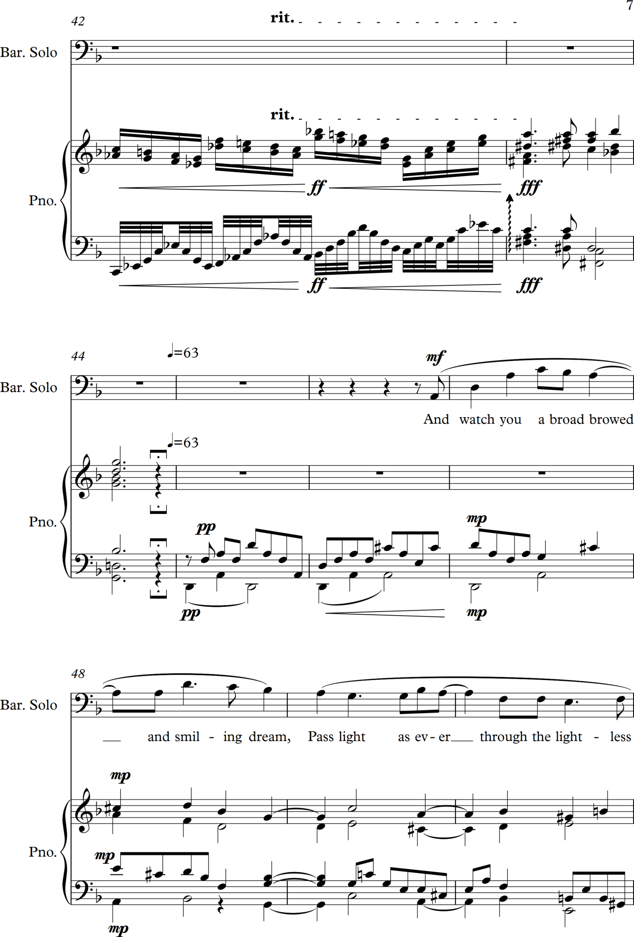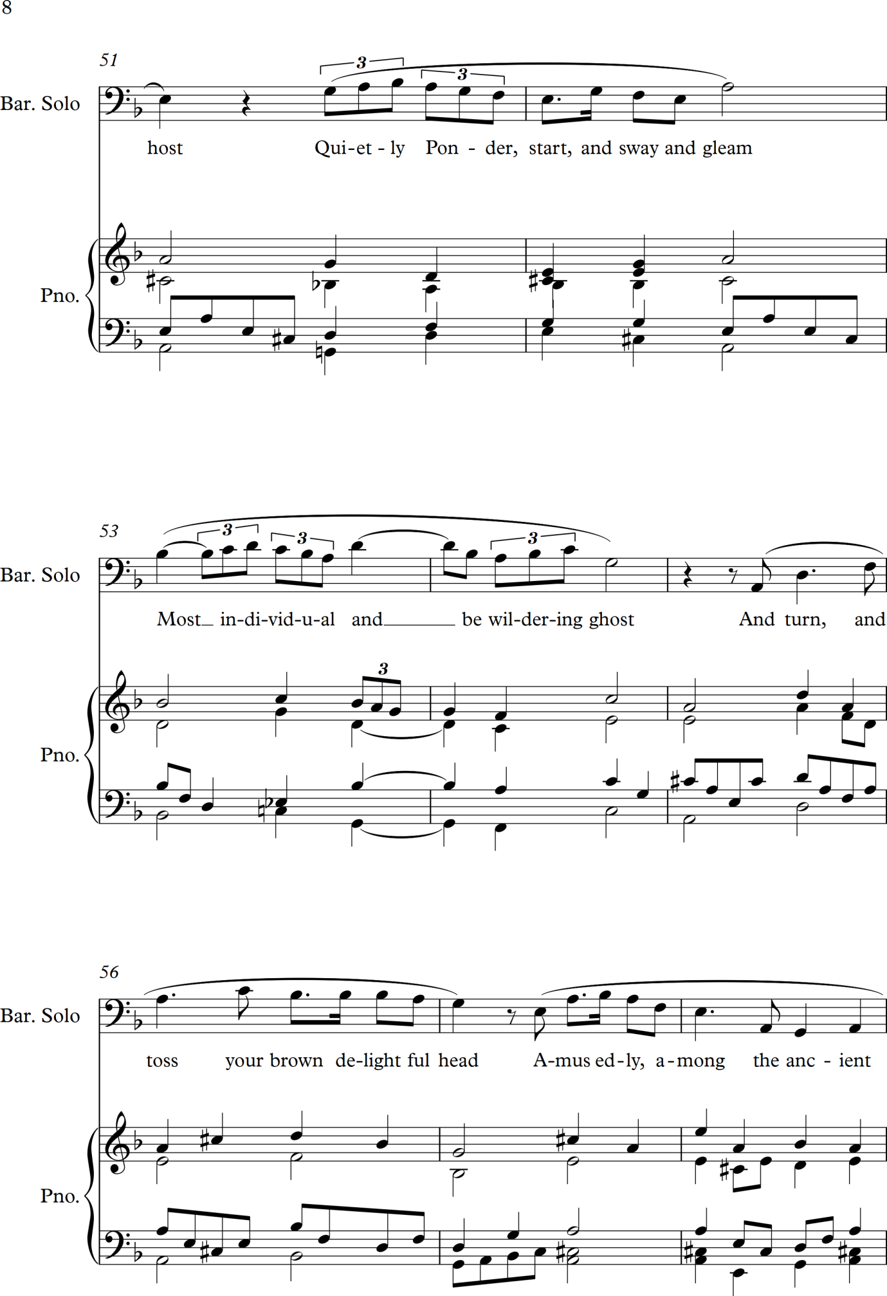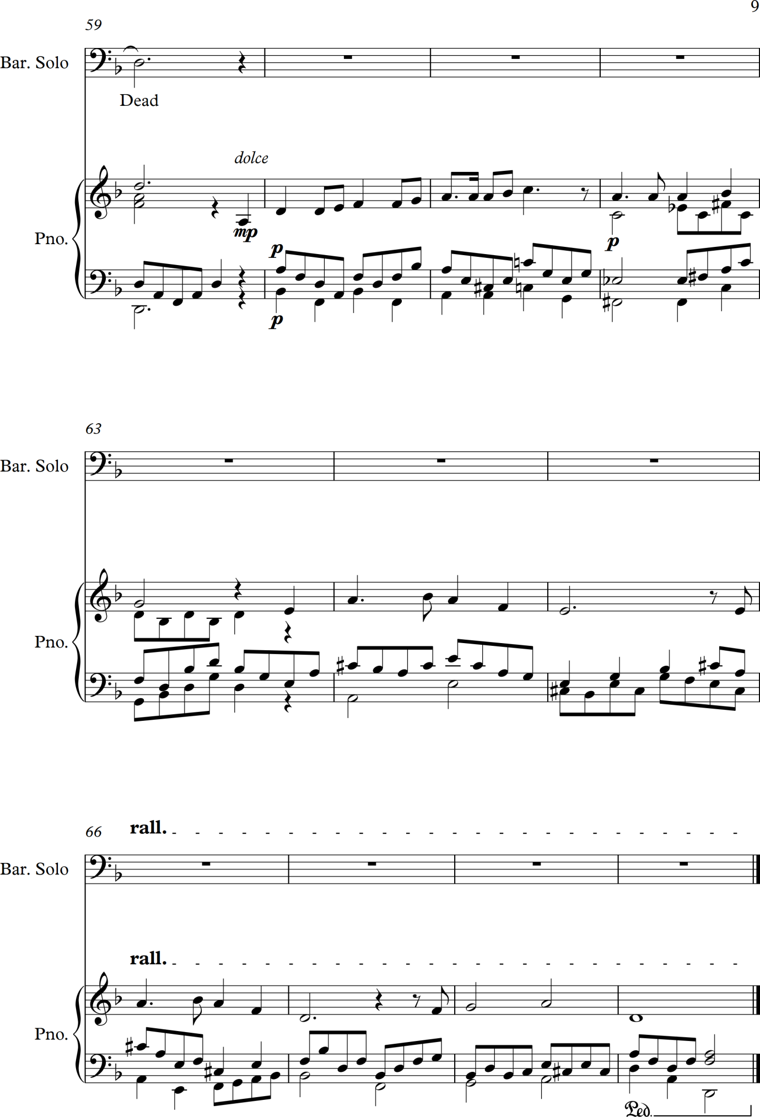
Monday 21 August 2017
I have finished the piece for Assignment 1 as copied above, written my reflective notes against the course assessment criteria, which are detailed below and also recorded myself singing the piece with a Sibelius sourced piano accompaniment. I will contact the college to ascertain how to get everything to my course tutor and also I will load as much as possible onto my purchased Wordpress blog site. I have received some feedback from friends by e-mail and copied this below too:
Alan I have listened to the final version with piano
First one sent.
You are very clever and it is a delightful composition.
My one thought – I am scared to say as all is good and positive I feel and I know how much work you put into your music – but one thought is to ‘speed’ up, give the compositions life and more vigour.
Move it forward

But listen who am I to give a comment.
I like it
Brought me pleasure just needs to ‘romp’ along a bit more!!!

Hope Onyx likes it!

L xx

Listen, dear friend. I enjoyed it. It is good and fine so be proud.
Relax try to chill and be positive. Cup half full
L xxxxxc

(both above received from my friend Lizzi Walton, an experienced arts curator, on 14/08/2017)

Hi Alan

Have managed to open the files you sent me. Complex music that would sound even better played on a proper piano with you singing live rather than through electronic medium. However, it is rather melancholic and beautiful. I hear some influences there from Mozart for the drama and Bach for the beautiful arrangements of notes. Well done. This needs to be performed in front of a live audience, not hidden away from the public.

Suexx

(received 18/08/2017 from my piano playing friend Susan Harvey)

Good morning Alan! I have just listened to this again. I am so impressed! It is a really powerful piece. Thanks you for sending it over. Reading your other emails again now and will respond separately! Much love. June X
June Burrough - Social Enterprise, Leadership, Facilitator and Life Coach
(received on 16/08/2017 – June single handedly restored music education in Zimbabwe some years ago, under Mugabe’s regime)

Thank you for the sonnet. I thoroughly enjoyed it and was so pleased to hear you in song too. I realise how essential it is to have some decent speakers. The rendition is clearly seriously impaired by the speakers on this little laptop. I now have neighbours (next door but one) with a son of +/-16 who plays the piano. I plan to pass him the score and see if he can play it for me - unless there is a copyright hindrance?

(received on 18/08/2017 from Susan Watson, my stepmother who lives in France and paid for me to do Music 1)

Mi Caro

What a beautiful piece. Both the electronic and your voice. Preference for your voice as it had more depth of meaning if that makes sense.
Haunting yet reassuring, loved it. Thank you for sharing.

(received 21/08/2017 from my friend Carol Barnes who lives in Italy and is a pianist)

And now my own assignment reflective notes follow on the next page

Alan Cook Student no: 509958 18 August 2017

Reflections on Part One ‘Harmony with Words’ and Assignment 1 (using Assessment Criteria from the course handbook on page 15)
Course: Music 2 – Moving on with Composition

Reflective Commentary - overview
I have found, as the notes in my reflective log illustrate very fully, this to have been a hard module to work my way through. Partly this has been due to major life changes for me over the last 18 months along with increasing dependency commitments on my time and energy, but also because the learning curve has been so steep – more like a high cliff I have been clawing my way up as I have stated numerous times in my Reflective Log. I have, however, found, many moments studying for this course exciting as I have been learning how to write songs which are a favourite musical form for me. I think my understanding of composing is developing although my harmonic writing seems to me to have become more basic and less complex – I need to study this further in my view. I am highly concerned at the length of time I have spent on this part of the course as I am not sure I can meet the university deadlines for the rest of Part 2 and I so want to get the degree at the end of all of these years and particularly when I have made such significant life changes to enable this, including a substantially reduced income. I need tutor feedback and find this is a lonely way to learn the skills and knowledge for what is in essence an interactive art form that needs involvement with other people in order to realise its potency. I was unable to get to the composition day in Birmingham this summer due to ill health which is the once a year opportunity to make real links with other learners. The college guidance is to use social media interconnections which I loathe and again have written about in my reflective log.
The compositions I have created have given me great satisfaction – once completed. I have had some lovely feedback from friends and colleagues about them and this encourages me to continue. Music needs performing live and this is a challenge for me to make happen with my works. I have enjoyed singing the assignment song even though my voice, as can be heard from the recording I made, is very rough indeed. Overall I have learned much and am keen to carry on however I am unsure as to my real potential and the level at which I am working with music at the moment.

Assessment criteria point 1: Technical Presentation
Clarity of scores and orderly presentation
These seem clear to me, although I struggle with knowing how much white space to have around notes, dynamics and expressions. They can get cluttered sometimes.

Good command of appropriate software
I have a basic command of Sibelius and am very glad I printed off the full manual which I constantly refer to. It is not the easiest software for me to use and I think I have learned something well only to find a few weeks later that it has disappeared from my memory! I suspect this will be a life long struggle. I still cannot get arpeggios or arpeggiation effects to play back although I have clearly put them into the score and creating a decent space before them has been a challenge too. And today I have been frustrated by trying to position a semibreve rest in the middle of the bar rather than at one end – and still have not cracked this either.
Accuracy of notation
What I hear on playback is what I am writing – except for the arpeggios as detailed above. II take great efforts to ensure that the notes I write reflect what I hear in my head. I am not sure what else this specific criterion might refer to.
Understanding and application of graphic publishing conventions
I have followed basic rules here – the positioning of dynamics and expressions is consistent with the published music I purchase. I find some challenges as to where I should put dynamics when there are lots of notes on the score but it all seems logical to me.

Assessment criteria point 2: Compositional skills
Evidence of craftsmanship in manipulating material
Some craftsmanship in evidence I think – although I cannot always manipulate material to achieve the effect I hear in my mind and imagination. In writing the music for the Sonnet I have had to manipulate the vocal line, the piano part and the rhythm to create the effects and sound I wanted. By and large I have achieved this although there are a few moments where the flow is bumpier than I would like but to change it would need rewriting substantially or introducing odd bar changes which would also look peculiar and unsettle the music in a different way, particularly around the beats and pulse of the piece.
Structural cohesion
The structure here is not a formal one in the sense of classical forms but it does have a clear shape that I wanted from the beginning which is an introduction on the piano used to set up a particular atmosphere and feel to the music based on thematic material from the song, the first part of the song rising musically and emotionally to a climax point followed by an intermission on the piano. Then the second half to the song and the whole piece concluded with a piano postlude based on a distillation and more reflective account of the central climax and most intense feelings. I have not been able to separate the structure and the feeling or journey that I wanted to create as they were both intertwined for me and emerged naturally from the ideas the poem sparked off in me. I have tried to create patterning in the accompaniment as required by the assignment although at points I have varied this to suit the effect I was striving for in the music. The poem itself, although called Sonnet, does not entirely follow the more rigid structures rhythmically that some do – although the way words are pronounced affects this to some extent.
Exploration of ideas
I wanted to create a melancholic, reflective and wryly humorous atmosphere – that last aspect was needed at passing moments to reflect a self knowing wistfulness in the poem. My musical ideas were linked directly to my arrangement of the Swedish folk tune Vissa Lulla and I am not sure how much this constrained me – I suspect it did. The central piano section in which I use a classic progression of four chords followed by a variation on this with further bars of more frantic music was an attempt to put an idea into practice and to my ears is not as successful as I wanted it to be. I felt a need to express musically the enormous range of feelings behind the word died sung on one note. This was an attempt to communicate what many bereaved people feel of the hopelessness and frustration of through words trying to put across vast feelings and tensions within one’s self.
Appropriate and correct use of performance resources
I think all of the piano part is playable – I can reach all the notes slowly. The vocal part is possible – I can sing it – badly with my out of practice voice. The part sounds beautiful on the euphonium. I would like to have made more of the piano part in many ways.

Assessment criteria point 3: Creativity
Exploration and inventiveness toward developing an individual voice
I am developing a personal feel within my music, I think. I am still hugely influenced by Bach and my writing is still a bit generic in my opinion. I think I have created a very specific feel to the Vissa Lulla piece which captures exactly the mood I wanted to create. I am still becoming an individual voice – I realise that I am not being hugely inventive but I am trying to express feeling rather than cognitively play around with sound effects. In previous feedback (in Music Composition 1) my tutor thought I should push boundaries more for the sake of creativity and invention – but I have to work with what arises from within me. I also want to be more whimsical and playful with music I create but that feels much more difficult harmonically than I am yet capable of.
Original ideas and experimental adventurousness
I think my ideas are original although I know that I am hugely influenced by the music I study and listen to – particularly baroque composers and Rachmaninov and Richard Strauss. I want to experiment more and am hugely looking forward to studying minimalism. I am not very adventurous with my music, but am trying.

Assessment criteria point 4: Stylistic awareness
Evidence of listening and reading, research, critical thinking and reflection
There is much evidence of my broad and intense listening habits and I am working though the classic text on harmony and form by Schoenberg (Schoenberg, 1967). I reflect critically a great deal and this should be apparent in my logs.
Development of responses to exploratory enquiry and analysis
I do respond to the ideas I come across but feel I need to analyse more and apply the results more daringly.

References for this Assignment 1 reflection piece:
- Schoenberg, A. edit. Stein, L & Strang, G (1967) Fundamentals of Music Composition London: Faber and Faber Ltd

References for Work notes and log of progress

- Hazan, M (1983). The Second Classic Italian Cookbook. London: Papermac. p3-4.

- Taylor, A. (1991) The AB Guide to Music Theory Part II London: ABRSM (Publishing) Ltd p166

- Schoenberg, A (1967). Fundamentals of Music Composition. London: Faber and Faber. pXIV.

- Hazan, M (1980). The Classic Italian Cookbook. London: Papermac. p179.

- Brass Quartet Volcano. (2013). A Classical Quartet [CD] UK: Obrasso Records

- Jacques Loussier trio. (1997). Vivaldi: The Four Seasons [CD] France: Telarc International Corporation

- Jacques Loussier. (1959) Play Bach [CD] France: Universal Music SA (Decca)

- Jacques Loussier. (1985) The Best of Play Bach [CD] London: Start Records Ltd

- Naumann, E. (2007). 16 Konzerte nach verschiedenen Meistern, BWV 972–987 (Bach, Johann Sebastian). Available: http://imslp.org/wiki/16_Konzerte_nach_verschiedenen_Meistern,_BWV_972%E2%80%93987_%28Bach,_Johann_Sebastian%29 . Last accessed 22nd Oct 2016.

- Unknown. (2012). RS Thomas "The Moor". Available: http://www.poemsbypost.com. Last accessed 1st October 2016

- Shall We Dance? (2005). Happy Feet [CD; track 3] Commercial Marketing

- Schoenberg, A. edit. Stein, L & Strang, G (1967) Fundamentals of Music Composition London: Faber and Faber Ltd

- Schoenberg, A. edit. Stein, L & Strang, G (1967) Fundamentals of Music Composition London: Faber and Faber Ltd p3.

- Budapest Sextet. (2006) Dohnanyi, E & Mosonyi, M: String Sextets [CD] Australia: Hungaroton Records Ltd

- Artemis Quartet. (2006) Music for String Sextet – Strauss, Berg & Schönberg [CD] EMI Records Ltd/Virgin Classics

- Prazac Quartet. (2013) Johannes Brahms String Sextets [CD] Paris: AMC/Praga Digitals

- stevenmarkkohn. (2017) Biography. At: http://www.stevenmarkkohn.com/about.html (Accessed on 25 April 2017)

- Sandburg, C. (1927) The American Songbag New York: Harcourt, Brace & Company, Inc

- Sandburg, C. (2017) The American Songbag. At: https://archive.org/details/americansongbag029895mbp (Accessed on 30 April 2017)

- Fallon, T (2013) At: https://www.youtube.com/watch?v=Zl52PGMhZko (Accessed 1 May 2017)

- Kohn, S.M. (2009) American Folksong Settings [audio recording, CD] Rec. Azica Records. At: Spotify (Accessed on 21 April 2017)

- Collier, T (1977) The Best of Cole Porter London: Chappell & Company Limited

- Collier, T (1977) The Best of Cole Porter London: Chappell & Company Limited p10

- Williamson Music (1995) The Oscar Hammerstein II Collection Milwaukee: Hal Leonard Corporation p76

- Bernstein, L (1988) West Side Story – Vocal selections England: G Schirmer Limited, & Campbell Connelly & Co. Limited p2

- Schumann, R (no date) Liederkreis Opus 39 for voice (low) and piano New York: International Music Company

- Pratt, G (1996) The Dynamics of harmony – principle and practice New York: Oxford University Press p24

- Not known. (2017). Liederkreis, Op. 39 (Schumann). Available: https://en.wikipedia.org/wiki/Liederkreis,_Op._39_(Schumann). Last accessed 8th July 2017.)

- Taylor, A. (1991) The AB Guide to Music Theory Part II London: ABRSM (Publishing) Ltd p271

- Brooke, R (1932). Rupert Brooke: The Complete Poems. 3rd ed. London: Sidgwick & Jackson Limited. p56-57.

- Figure 20. Brook, R. (1913) Image of Rupert Brooke [Photograph] In: Brooke, R (1932). Rupert Brooke: The Complete Poems. 3rd ed. London: Sidgwick & Jackson Limited.

- Brooke, R (1932). Rupert Brooke: The Complete Poems. 3rd ed. London: Sidgwick & Jackson Limited. p39.

- Unknown. (2012). RS Thomas "The Moor". Available: http://www.poemsbypost.com. Last accessed 1st October 2016.

- Brooke, R (1932). Rupert Brooke: The Complete Poems. [scanned image from book] 3rd ed. London: Sidgwick & Jackson Limited. p39.

