Listening Log

Composing Music 2 – Moving on with Composition
Alan Cook - Student no: 509958

First entry – Wednesday 11 May 2016
Despite my blocks with getting started with this course (see Reflection Log) I want to note down that I am still exploring and listening to music. Recent endeavours have included:
- Going to a live concert on Saturday 16 April to hear the UWE Singers and the Lydbrook Band perform a range of works including ‘Silver Rose’ by Liz Lane. Liz is a contemporary composer is the Senior Lecturer in Music Technology at the University of the West of England and who is mentored by my own line manager at work – Professor Selena Gray, although Selena’s expertise is in Public Health. She does, however, play the flute in Pizzazz! the work place music ensemble I formed with her some years back. ‘Silver Rose’ is a beautiful piece based on the poems of Isaac Rosenberg a First World War poet with Bristol connections – hence the interest in him here in the South West. Liz has agreed to meet me for coffee at UWE to discuss composing – which is brilliant!

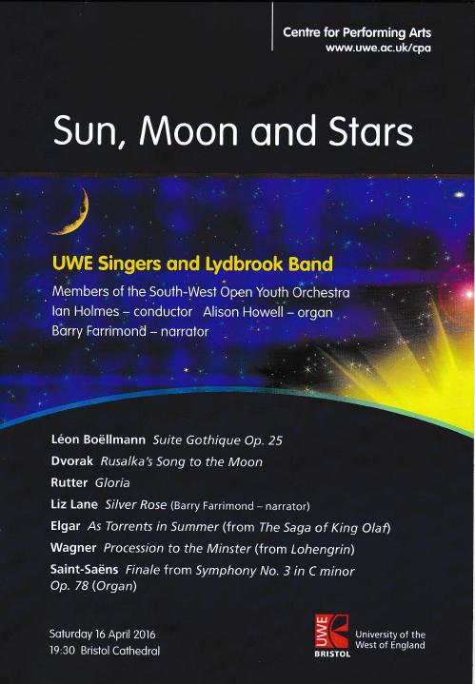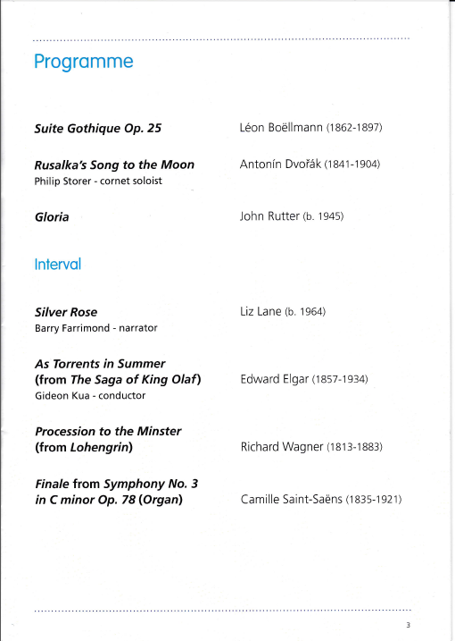

(Reference: Figure 1 – Images)
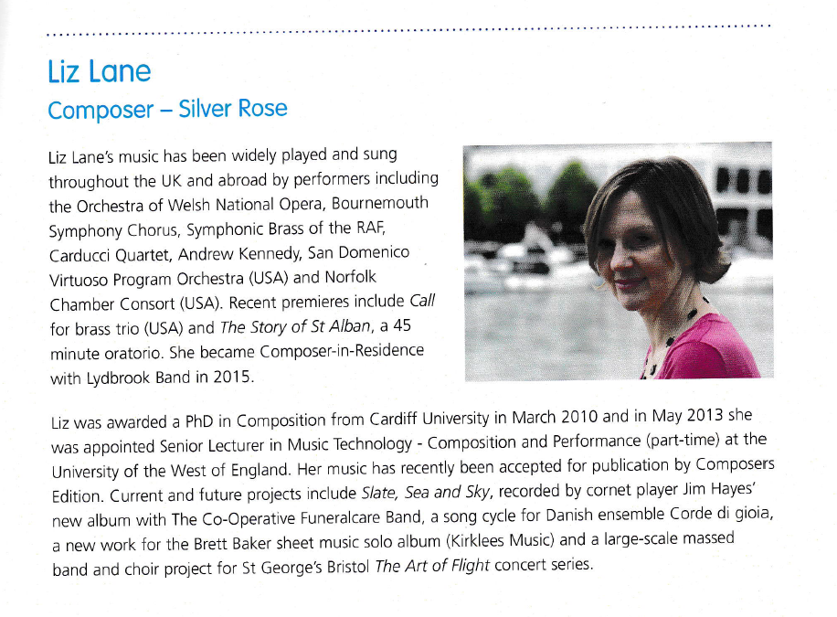
Information from above programme about composer Liz Lane (Reference Figure 1- Images)
- Discovering music by Elena Kats-Chernin, a contemporary composer who trained in Russia and who now lives and works in Australia. More anon.
- Also discovering the American contemporary composer Lowell Liebermann who I have quoted in my Reflective Log as I found his interview in a recent Gramophone magazine inspiring. Have bought a recording of his Piano Concertos – lively and well constructed music with a soul.
- Have also been buying CDs, as always, including Victor Herbert’s cello concertos and various pieces by Norwegian composers – I particularly like works by the violin virtuoso Ole Bull – very affecting although fairly simply constructed. Deeply felt and moving. And always more Bach – another CD of his violin concerti with the Dunedin Consort (Butt, 2016) and his arrangement of the Pergolesi Stabat Mater, retitled ‘Trauerode’. Lovely performance with the Bach Collegium Japan directed by Masaaki Suzuki and with Carolyn Sampson and Robin Blaze as soloists (Suzuki, 2016). Also a new CD of music by Gerald Finzi, some in arrangements, but which although I initially thought was gentle and peaceful music I now think is dull. His melodic invention is highly rated, according to reviewers, but it all sounds very similar to me. Maybe I have jaded ears and need to get out to some more live music? The arrangements are bland and I am sure the original scoring must be better and more interesting – to be pursued at some point!

Saturday 21 May 2016
Played in Pizzazz! this morning – our work based music group. It was today an eclectic mix of one violin, many flutes a couple of clarinets, a handful of saxophones, a cello and me on the euphonium. We played through a range of light and Latin American pieces in simple arrangements for a school mixed ability group. A pleasant and social experience but I feel we should be attempting music of greater worth – we do have some Mozart, Elgar and Moskowski in the library.
In terms of listening, as always I have a large collection of CDs to accompany for the several hours I spend in my car each working day. This week has included Davidsbundlertanze by Schumann, his Fantasie in C and Etudes Symphoniques, and the usual large collection of Bach pieces. I noticed that of the two recordings I listened to of the Symphonic Studies, one by Stefan Vladar (Vladar, 1993) and the other by Marc-Andre Hamelin (Hamelin, 2001), that they were slightly different pieces and that they were in a somewhat different order too. This threw me and research into this has uncovered (for me, that is) that Schumann published these in two different versions – he did the same with his Impromptus Opus 5 and the Davidsbundlertanze Opus 6. The first version was composed in 1834/5 and published in 1837 and titled ’12 Etudes Symphonique’ – a bit misleading as the whole piece consists of a number of themes or studies which were then followed by variations – forming overall 18 distinct short pieces with varying titles and numbers attached to them (the Vladar recording). He then revised them and republished them with a different publisher in 1852 with the title ‘ Etudes en forme de Variations’. This version omitted the 3rd and 9th pieces of the originals and contained other revisions as well (the Hamelin recording). The interpretations and performances by these two pianists are also quite different in many respects which fascinated me. One thought I had about all of this is that a good and well constructed piece of music can take many interpretations and points of view. It also reminds me of how many composers have often reworked pieces and some are never satisfied or feel they have properly done with some pieces - something I am discovering for myself too!

Monday 30 May 2016
Am obsessed with comparing recordings of Schumann’s Fantasie in C Major Opus 17 after a CD review feature on it last Saturday – as so often with me I ordered another recording from Amazon that I thought would be the best of any (Jonathan Biss) only to realise that I have it anyway! Again another piece that can stand many varying interpretations but finding the definitive one that I can most strongly respond to is as elusive as ever.
On another note – I notice that I have a very limited response to music these days, probably because I am so distracted by work and other life issues that are draining me considerably. I went to hear Burtle Silver Band play in Grove Park here in Weston-super-Mare yesterday afternoon. It was good to hear a brass band again although they played simple pieces. I miss playing with a band on my euphonium – again, there just is not time to do everything!
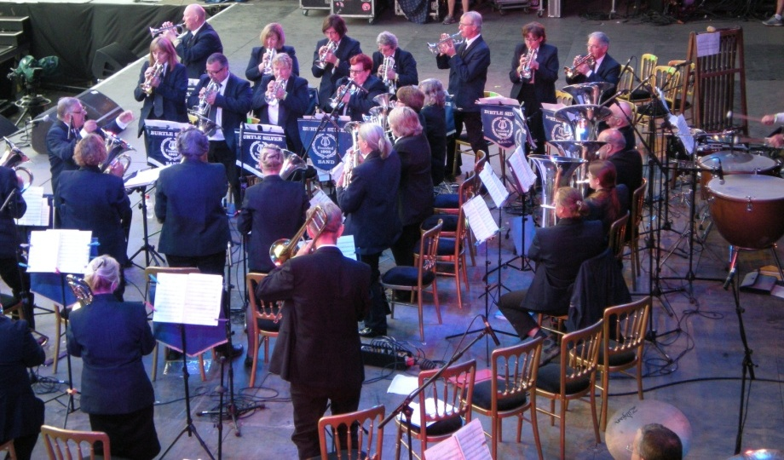
Burtle Silver Band
(Image reference: Figure 2)

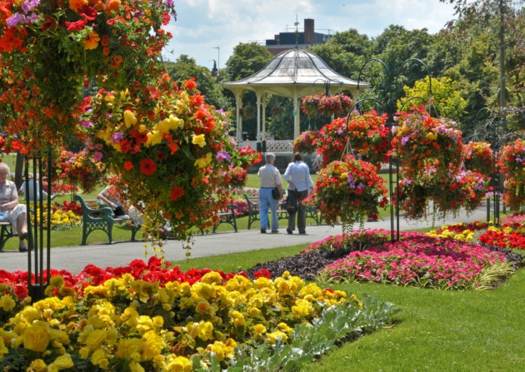
Grove Park, Weston-super-Mare, with bandstand where Burtle Band played yesterday and I have often played in the past with North Somerset Community Brass
(Image reference: Figure 3)

Sunday 19 June 2016
Lots going on in my work and personal life which means that music listening has mainly been CDs in the car. So lots of Bach and Mozart recently. I have ordered a CD of Argentinean classical songs performed by the mezzo-soprano Bernarda Fink (Fink, 2006) so there is still some active interest there!
Yesterday played in Pizzazz!, our work ‘orchestra – 3 flutes, 1 violin, 2 clarinets, 1 oboe, 3 saxophones and me on the euphonium. We played lots of Latin American pieces and an arrangement of ‘Besame Mucho’ with the 3 saxophones swinging the tune and me on the bass part – it was splendid and a joy to be part of. We also played a wonderful polyphonic arrangement of ‘Blue Bossa’ which was very satisfying with the parts weaving in and out of each other.

Monday 4 July 2016
Pizzazz! again on Saturday – so satisfying to play music with others - did some Latin American pieces again, wonderful! Have been listening to lots of recorded music for pleasure recently to try and chill out a bit during a very stressful work and home life. Pices have included:
- Debussy and Takemitsu pieces for strings – a new CD recommended by BBC Radio 3 CD Review programme (Morton, 2016). Includes the String Quartet in G Minor Op 10 by Debussy and film scores by Takemitsu. All arranged for the Scottish Ensemble by Jonathan Morton, Colin Matthews and James Manson. Loathed it and remembered that I often prefer the original conceptions and that beefed up strings may be initially seductive but remove something too.
- Brahms Piano Concertos 1 & 2 – in the recordings with Stephen Hough (Hough, 2013) - not so good to my ears - and Nelson Friere [fabulous!] (Friere, 2006). Bit heavy and overdone but wonderful for my mood 10 days ago.
- Schubert Impromptus – have been comparing the various performances on CD that I own and ordered two new ones: by Alfred Brendel (Brendel, 1997) – his early 1970s recordings, and Krystian Zimerman (Zimmerman, 1991) – less subtle as a performance but in glorious sound and big scale. Reminds me that a good piece of music can take, and needs to appreciate it, a myriad of performances.
- Sibelius complete piano works – I listened to manay of these short pieces yesterday on Spotify from a recent recording by Janne Mertanen (Mertanen, 2015) – a very rhythmically alive and responsive set of performances. Have ordered it from Amazon. Then discovered that I have all of them on a set of Naxos CDs played by Havard Gimse (Gimse, 2001) – not as ‘good’ to my ears although still very acceptable performances and recordings – gentler in a way but less big scale romantic and much faster. Mertanen finds impressionistic colours that Gimse does not and I find myself pulled into the intensity of his playing and performances.
- Bruckner Symphony no 8 – the Karajan last recording (Karajan, 1999). One of the great recorded performances and a real core part of my CD library and a piece I turn to when needing a boost and to ground myself. Wonderful as always. Exposed weaknesses in my new very expensive Sennheiser headphones – subsequently replace by another new pair (so much money!) – Audioquest Nighthawks – fabulously comfortable on the head and easy to listen to for hours and hours without doing my head in due to over emphasized treble frequencies (i.e. Sennheiser).
- Moskowski Piano Concerto in B minor, Op 3. Another newly released CD of a only very recently discovered work written when he was a student. Big boned, highly romantic and dramatic and long winded. Worth getting and listening to. As was the CD filler – the Russian Rhapsody by Schulz-Evler. I am glad that I have been responding to this music as I had begun to think that the joy of music had left me. Not so, just life events wearing me down.
- Heard the Requiem by Delius on Radio 3 last Friday night and liked, but subsequent listening on Spotify has not enthralled me. A bit of an acquired taste which I have not yet got, despite trying.
- And as always Bach Cello Suites and Violin Concertos in many different recordings as my constant companions on the frequent journeys up and down the M5 and M4 to various work events and meetings. These two pieces focus and lift me – always.

Friday 15 July
Not sure how much detail to put into this log as I am constantly listening to music and if I put down and commented on everything I listen to on Radio 3, in the car and CDs when I am grabbing 10 minutes of music in the evening then I would always be typing! So I will list and comment on pieces that particularly move me or grab my attention. This morning heard the first two movements of the Petite Messe Solennelle in the recording conducted by Antonio Pappano (Pappano, 2013) from Italy in the later version which is accompanied by an orchestra rather than two pianos and a harmonium. I have spent half an hour dotting between various versions on Spotify comparing and contrasting and do like the orchestrated version more I think. A weird work – serious subject matter (the Roman Catholic Mass) set to quite jaunty music – uplifting in a way and with very hummable melodies! Have also been listening more and more to Sibelius piano music and think it wonderful. I know some musicians criticise it as being little more than salon music (which I like anyway) but I think this is unfair as there is some quite serious music here with fascinating harmonic shifts and much that is a kind of northern Rachmaninov in its passion, intensity and overt romanticism. I love it!

I have also been exploring Beethoven string quartets again – endlessly interesting and absorbing for me. Here is an excerpt from my reflective log last weekend:
‘Stylistic evolution is a major theme in any discussion of Beethoven’s oeuvre, as it is with artists such as T.S. Eliot and Picasso. For a man whose uncanny perception of the profundities of the human condition shone through his music from the very start, from a larger-than-life soul and intellect, it is deeply meaningful to see how life experience and philosophical questioning over time comes to be reflected in the art work. Beethoven is in fact the quintessential example of the idea of a late style in music, of a broadening of insight and the willful manipulation of form and rhetoric to accommodate that insight.
Coming out of his “middle” period, the so-called heroic style epitomized by works such as the Eroica Symphony or the Op. 59 quartets, Beethoven’s vision of the world and of his, and by extension mankind’s, place in it underwent a radical metamorphosis. Ego, the primacy of effort and the battle of ideas begin to dissolve and make way for a vision of wholeness, of a sacred order. All that he had explored with the sense of a human protagonist in his music shifts so that the composer no longer seems so much in the world as of it. Beethoven was deeply interested in Hindu and Brahman philosophy at this point in his life (as was fashionable at the time) and copied into his notebooks numerous statements from their sacred texts. The relationship with time, will and vision all move in new directions in the late quartets.’
(Steinberg 2016)
Found this quote when researching Beethoven String Quartet slow movements – trying to find one that I used to find deeply moving and that I have ‘lost’. I remember it as an expression if his pain at either his own medical problems or his brother’s death – cannot remember which nor find the actual piece so am working though them all as breaks in reading music theory. So far I have listened to Opus 18 no 1, Opus 59 no 1 and Opus 127. Not yet found what I am seeking! The quote above intrigues me particularly the comments about his philosophical development and how this affected his music and his interest in Indian religious ideas. This I did not know.
I have since found the movement I was searching for – the last movement of Opus 18 no 6 – which is titled ‘La Malinconia’. Apparently this movement, which starts off very slowly and intensely, is intended to depict Beethoven’s distress and reactions to his hearing loss and rapidly oncoming deafness. It has also been described as a good musical description of manic depressive feelings. It is a tremendously affecting piece of music and touches me – I can project similar interpretations on to it but that does not matter. It is searching, moving and profound. I have years of study ahead of me with these string quartets, and the Shostakovich string quartets to follow!
Listening further to Rossini’s ‘Petite Messe Solenelle’ I can hear that it is not just bouncy tunes and that there is a serious side to it too and I now know that both he and the person he wrote it for had recently suffered bereavements.
Reading the latest Presto Classical news that I receive every week I was moved to find an article on a new oratorio that was inspired by the life and death of a young gay man in 1998 who was tied to a fence after a brutal attack and left to die. He calls his work a fusion piece and it has parallels to the ‘Requiem to Life’ that I want to compose and have written extensively about in previous listening and compositional logs. Here is an excerpt from the website:
For his latest project, Craig has turned for inspiration to the death of Matthew Shepard at the age of 21 in 1998. His musical response, Craig says, has been gestating in his mind ever since the events of that day; it has emerged in the form of a modified Passion drama - drawing on a huge range of poets from Rumi to Tagore, as well as Dante and the Old and New Testaments and even extracts from reactions to the murder.
(Smith, 2016)

Saturday 16 July 2016
I received my August copy of Gramophone this morning and want to note down how excited I was and also to record that I have been purchasing and studying this magazine since I was 20 and first discovered it (over 41 years ago). The OCA recommend getting the BBC Music Magazine each month which I also do and although it is a good read and some of the articles on composers and musical works are interesting I find Gramophone more stimulating and stretching – it seems to have many more modern composers featured and recordings of more contemporary works reviewed. Here are today’s finds:

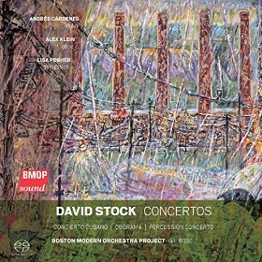
This CD (Stock, 2016) is a recording two major works by the Pittsburgh composer David Stock who died last year at the age of 76. He founded the Pittsburgh New Music Ensemble in 1976 and wrote many pieces for it often borrowing ideas from jazz and traditional music genres. His music is not radical and easy to listen to but full of life and energy with strong rhythms and an upbeat, if conventional, feel. I liked the review and have listened to the music on Spotify. I am grateful to the OCA course for introducing me to the wonders of Spotify! (Image reference: Figure 4)
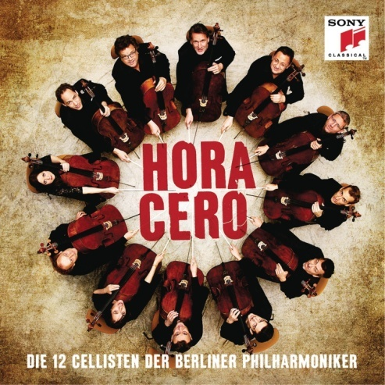
This is the latest in a long running series of CDs (Berliner Philharmoniker, 2016) of the 12 cellists of the Berlin Philharmonic playing arrangements of tuneful music – very populist! The reason for my attraction to this CD is that all of the pieces are tangos and the majority by Piazzolla who I adore and admire. So I just had to listen to it – sampling briefly after my late lunch. It is just alive with energy and rhythmic vitality and brilliantly recorded. I have also purchased this CD. (Image reference: Figure 5)

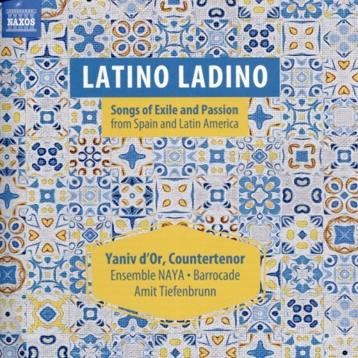
This is an album of songs from oral traditions passed down through exiled Latin communities – all arranged by the counter-tenor Yaniv d’Or in what he terms a ‘fok-Baroque’style. I enjoyed sampling this disc and have ordered it from an on line seller – it has similarities to the works that Christine Pluhar has recreated with the original instrument group L’Arpeggiata who I enjoy a lot on CD. (Image reference: Figure 6)
There are many other recordings of works by contemporary or recent composers reviewed including Grażyna Bacewicz (new recording of her string quartets), Samuel Adler, Friedrich Cerha, Toru Takemitsu, Péter Eötvös, Morton Feldman, Christopher Rouse, Van der Aa, Hans Abrahamsen, Michael Finnissy, Mark Simpson, and Bent Sorensen (a full feature) – so much to explore and listen to!

Tuesday 2 August 2016
Am obsessed, again, with recordings of Sibelius Symphonies – not sure why apart from their wonderful construction and interesting sound world. I bought a new set earlier this year recorded in Finland by the Lahti Symphony Orchestra conducted by Okko Kamu (Kamu, 2015) and they are wonderful, but maybe not the last word – as I have written before, a great piece of music can take many interpretations. As an avid collector I guess I look for new stimulation and experience from alternative recordings – and this can limit me from exploring new musical works which is less good.
On another note (hah!) I heard the Sarabande from Bach’s Cello Suite no 5 this morning on BBC Radio 3 on the way to work. I have listened to it again this afternoon and tried to play it on my Euphonium. It fascinates me as it is an abstract piece of music that has interesting harmonic progressions implicit in the single music line – I must work out what they are as they are not obvious to me and also could be open to interpretation I think. The original manuscript (or at least the version that Casals found in the mid 20th Century when the pieces were rediscovered) may have additional notes that are not in my brass instrument adaptation so I will find that on the Petrucci Music Library and this may indicate the underlying chord structure more directly. Or maybe not!
See next page for copy of my Euphonium edition of this piece-actually sourced from a transcription for the trumpet (Image and book reference {Cooper, 1995}: Figure 7) – I will still try to find the original and put that below it. I will also work on the chords implicit if I can analyse them and the progressions – or find an article on line that does!

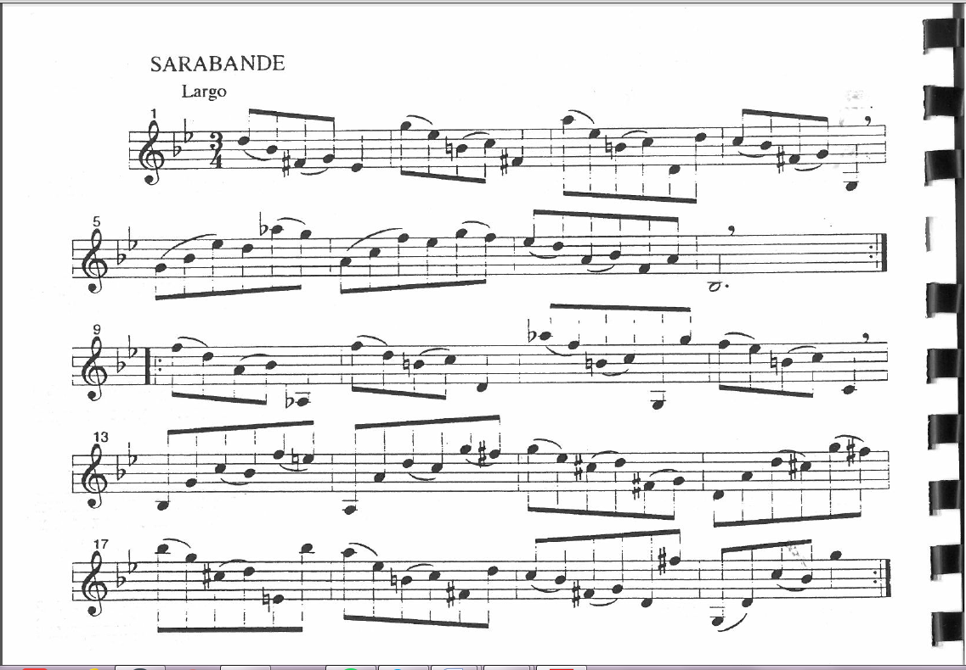

Below is a copy of the Anna Magdalena manuscript that I downloaded from the Petrucci Music Library (Image reference: Figure 7):
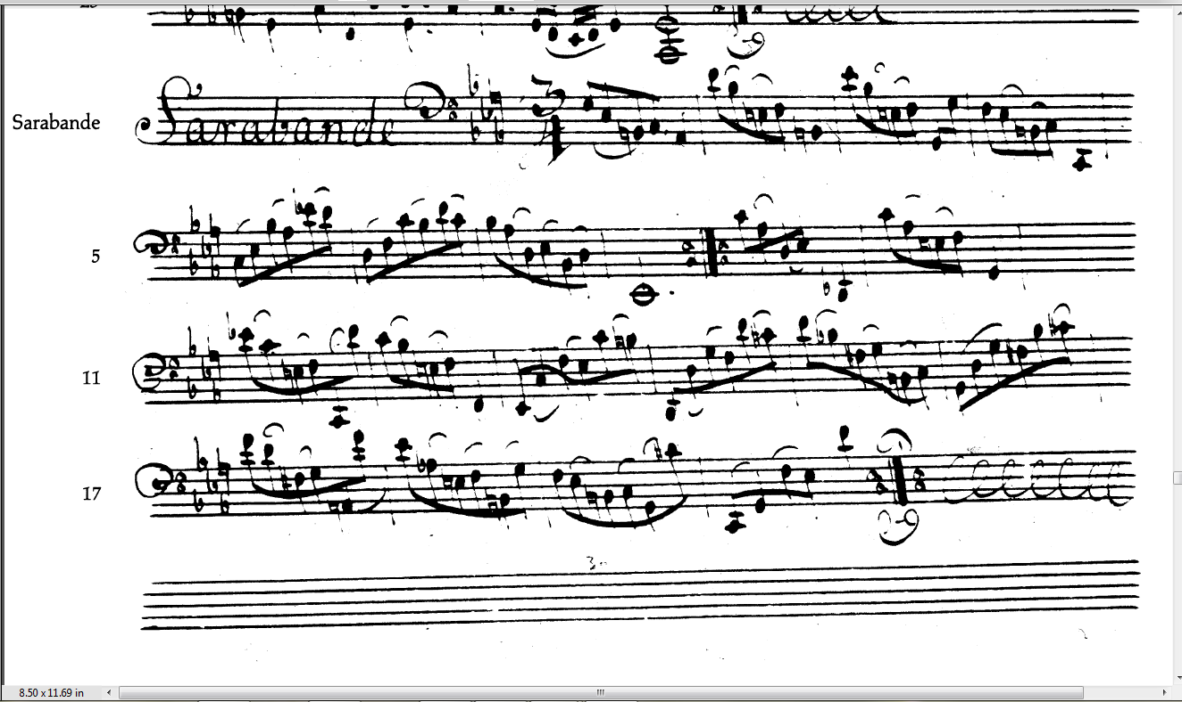
(Image reference: Figure 8)

Tuesday 9 August 2016
Have not had time to analyse the Bach above yet – will get to it. Meanwhile have ordered and received a recording of the complete Mozart String Quartets (Hagen Quartett, 2006) and started listening to them – I am enjoying them and admire the construction. I bought them in memory of my partner who died 22 years ago and in whose remembrance I always purchase each August music that he would have enjoyed and liked me exploring – usually Mozart or Schubert and occasionally Verdi. He was a professional musician – taught music and played violin, and ended his career as Chorus Manager at the Royal Opera House, Covent Garden.
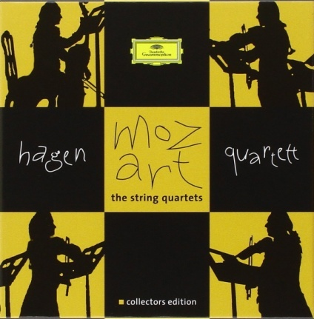
This is the purchased recording – great sound and good performances – an investment!
(Image reference: Figure 9)
I discovered that I also own a recording of the complete String Quartets by Mozart and am also listening to these too – marvellous music and invention. And still obsessing over the symphonies by Sibelius which have really grabbed me – the sound world completely transports me. It is interesting for me to note that when studying the 5th Symphony in the first music course with OCA (Music from the Present to the Past) I was dismissive of it but now cannot hear it often enough! I think the more Scandinavian ‘noir’ recordings have opened my ears along with a deepening appreciation of the inventiveness and skill that Sibelius had and used. I have also discovered the four Orchestral Suites by Tchaikovsky which I did not know of – again lots of inventive music and more homophonic lessons for me – although he also writes some great fugues in them too.

Friday 12 August 2016
Have now found and purchased a recording of the First Symphony by John Corigliano – see Reflection Log for some thoughts/feelings about this work and its significance for me.
‘During the 1980s and ‘90s I lost many friends and colleagues to the AIDS epidemic, and the cumulative effect of these losses, naturally, deeply affected me. My First Symphony was generated by feelings of loss, anger and frustration.
A few years ago, I was extremely moved when I first saw “The Quilt”, an ambitious interweaving of several thousand fabric panels, each memorializing a person who had died of AIDS, and, most importantly, each constructed by his or her loved ones. This made me want to memorialize in music those I have lost, and reflect on those I am losing.’
From the sleeve notes by John Corigliano that accompany the recording on CD issued by Naxos, no. 8.559782, in 2016 (Corigliano, 2016)

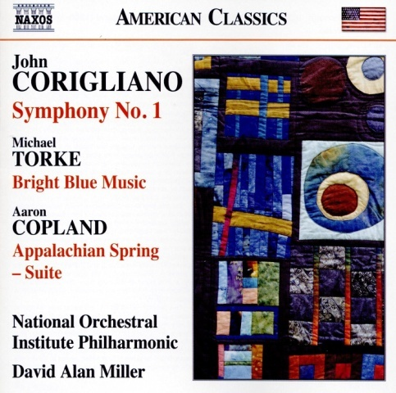
(Image reference Figure 10)

Saturday 13 August 2016
Have now found an article on line about the Sarabande from the Bach cello Suite no. 5:
Many consider this sarabande, a very unusual, sparse, and pure movement, the very heart and soul of the six suites. It is truly mysterious on a number of levels; it’s the only sarabande – in fact, one of only 4 movements in the entire cycle of six suites – with absolutely no appearance of chords. We can imagine a multi-voice structure, but all harmony is created through implication, never with an obvious spelling of a chord progression. The only typically sarabande features of the movement are the meter – triple – and tempo – slow to moderately slow. But despite the triple meter, we don’t hear the expected emphasis on the 2nd beat of three; most measures of this sarabande have a sense of arrival on the 3rd beat (the general rhythmic flow in the movement is 4 eighth notes followed by a quarter note). Overall, we have a very stark, minimal, severe, intensely beautiful, and in some ways quite simple movement that in the end is devastating, sometimes even painful to experience. And yet it’s perfect in its emotional effect and balance within the suite.
(Costanza,2014 – reference Internet 2)
He also points out that the Suite No. 5 in C minor is Bach’s cello version of the lute suite in G minor. However I have found other commentaries that propose the opposite and that Bach transcribed the piece for the lute from the cello Suites! (see quote below) And I have copied the most original manuscript I can find on the Petrucci Music Library site to check if any additional notes are there in the score which might add information about harmony – see below. And the answer is NO!
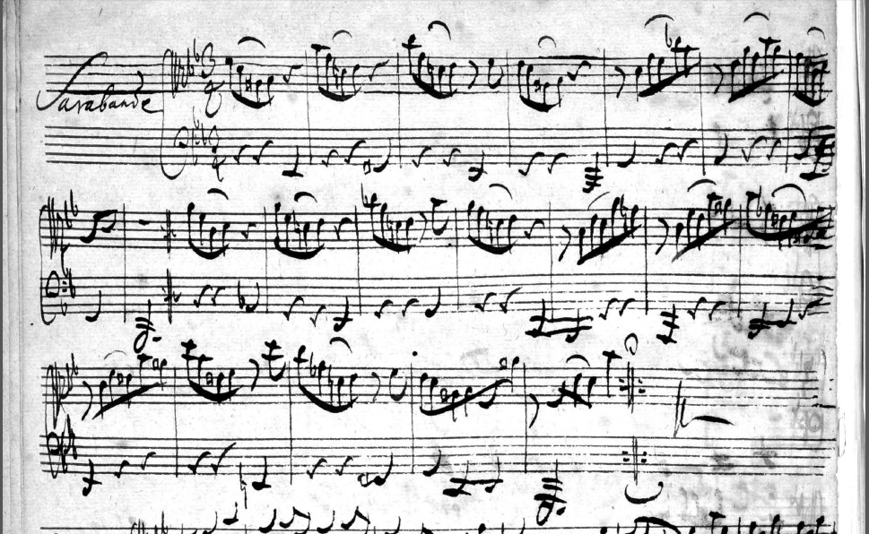
(Image reference: Figure 11)
Interesting to note that it is written across two clefs – I wonder why that was a convention?
Quotations from the sleeve notes to the recording of the Bach Cello Suites arranged for theorbo (13 course baroque lute) performed by Hopkinson Smith state:
When Bach was requested one day to compose for the lute, it was certainly no mere coincidence that he happened to choose to adapt one of his cello suites for this instrument (BWV 995). We still have the autograph manuscript of this arrangement, which is not the case for the suites themselves; it enables us to get a better understanding of the author’s intentions and the technique he used to bring them into play. An autograph MS and an anonymous version in French tablature confer upon this work a privileged place among those that concerns us here. It is in face an arrangement of the Suitte 5 discordable in C minor for the unaccompanied cello, BWV 1011. Considering that a musical work is evolved by a process of successive additions rather than deletions – a principle observed by Bach himself in many violin compositions which he transcribed for the keyboard – we must assume that the cello version composed at Cothen towards 1720 was the original. In the absence of any autograph version of the six Cello Suites – despite the value of the copies of them by Anna Magdalena Bach, Johann Peter Kellner, and Westphal - this lute version is a source whose authority is too often neglected by present-day cellists
(Reference: Books 1 - Smith & Chauvel, 2013)
None of this is getting me any further forward with actually analysing the harmonic progressions implicit in the piece – I will try to do that later on today AFTER some more composing for the course.

Sunday 14 August 2016
Listened to much of this recording (Brass Quintet Volcano, 2013) in trying to figure out how to write interestingly for a Brass Quartet – this was the most interesting one I found on Spotify. Observed some interesting techniques including:
- Plain chordal accompaniments with a great tune above
- Chords being built up one note after another and in volume
- Tunes being repeated at different pitches across the instruments
- Harmony static in 2 instruments, melody in thirds in the other two
- Some polyphony for fast lively sections then calming down – much interplay of voices of instruments

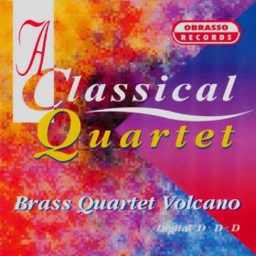
(Figure 12)
Now back to composing (see work log) my own piece for Brass Quartet – I am learning lots and probably forgetting even more!

Saturday 10 September 2016
I have been away working in Barcelona and not had much opportunity to do much systemic listening, reading and analysis for the last 3 weeks. However I did observe and hear the following in Spain which impressed me:
- a performance by 3 guitarists and 2 dancers of Catalonian Rhumba performed at the opening ceremony of our conference – see picture below (NOTE: all photographs in Barcelona taken by myself):
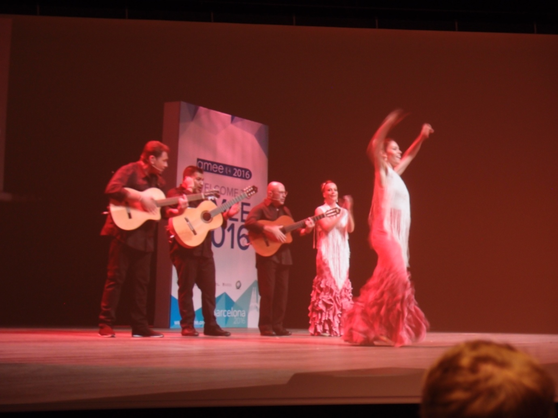

- seeing a young man practising and performing flamenco dancing in a park in central Barcelona:
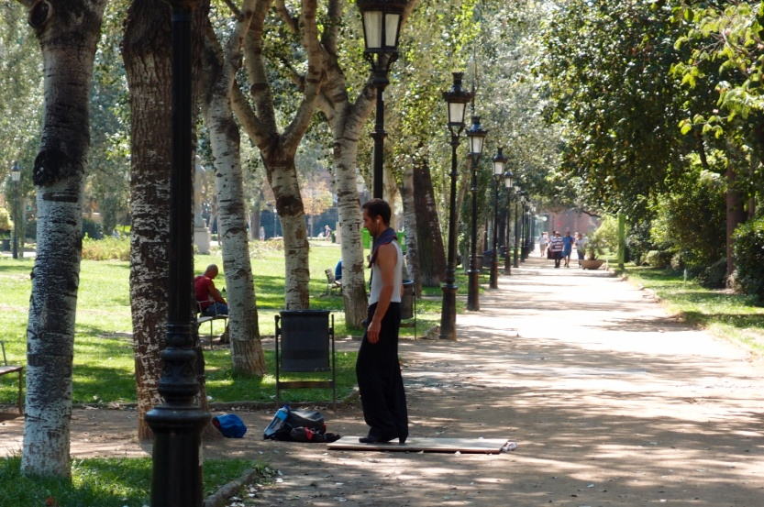
- going to the Palau de la Musica Catalana – a wonderful modernist design (early 20th century) concert hall where I heard a short organ recital of Bach, Wagner, Mozart and John Williams (Star Wars no less) played on a gorgeous organ in a wonderful acoustic. See photo below.
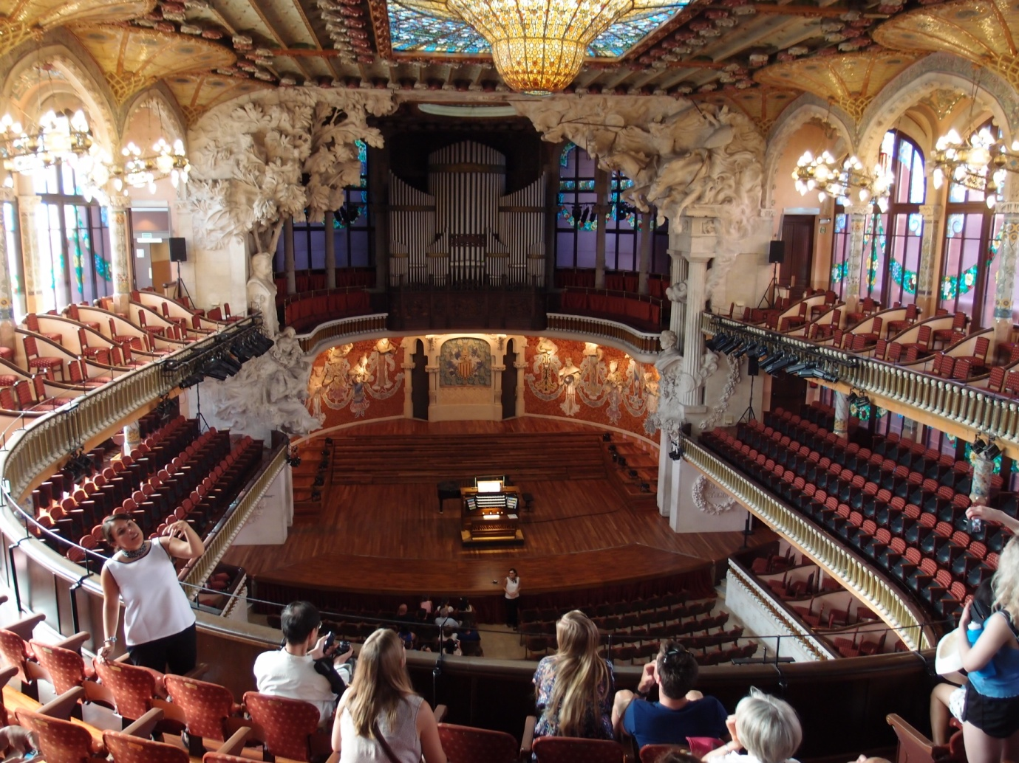

- hearing a local older man singing traditional Catalan songs outside the old cathedral in Barcelona:
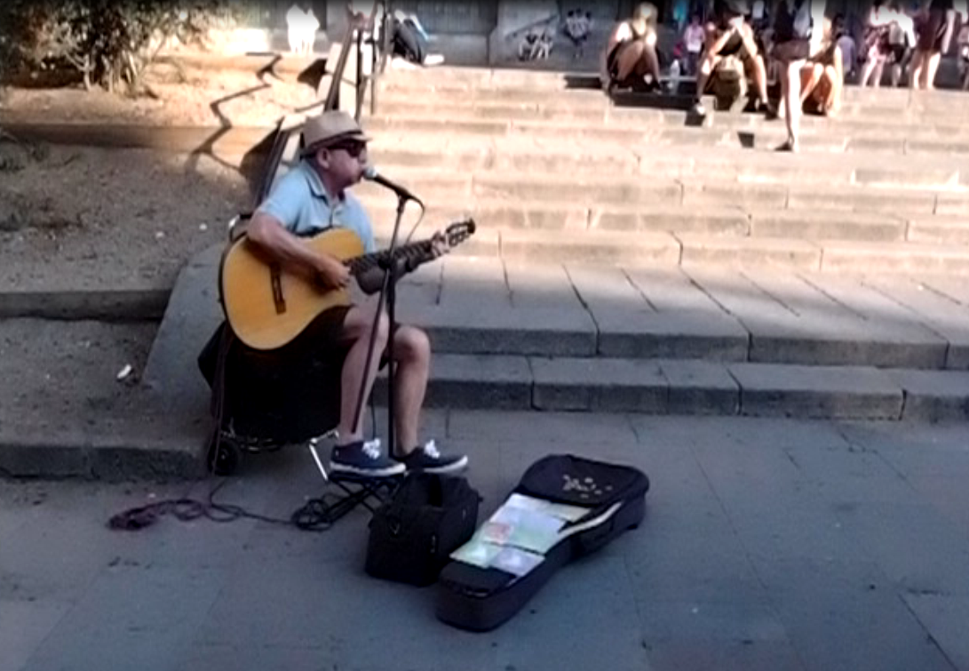

- seeing and watching a large group of people dancing an Argentinean tango in a park late one night – in the dark! A wonderful experience:
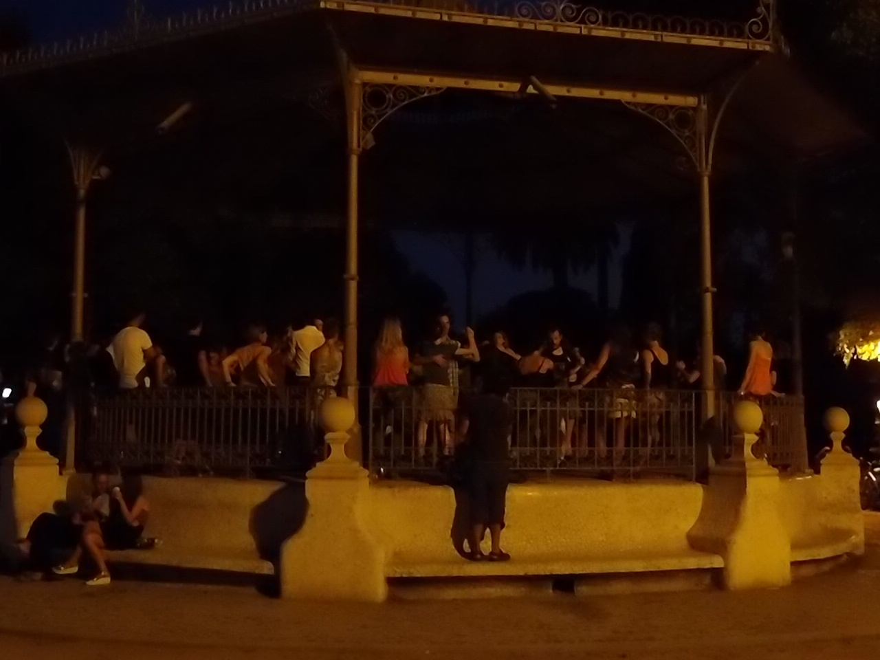
As can be seen by the number of photos and my eulogies I loved the way music and dance in Barcelona permeates everything. Inspirational and I bought a CD of traditional flamenco music and have since then been exploring the music of Granados – and have ordered yet another recording of his piano work Goyescas and pieces by Mompou as well as chamber pieces by Granados that intrigue me for their simple harmonic accompaniments to the melody in the higher instruments – something for me to learn from in my quest to become more homophonic!

Sunday 25 September 2016
The Granados/Mompou (Negrin, 2016) recording has arrived and it is wonderful. Javier Negrin is a wonderfully sensitive pianist and the Momou piece is new to me. It is a set of variations on a theme by Chopin – the A major Prelude Opus 28, no. 7. It contains some wonderfully jazzy and impressionistic pieces that all retain elements of the Chopin in them. Brilliant! Much to learn from these pieces too. I have also received a CD of chamber works by Granados too which are highly enjoyable although more mainstream European classical in feel and style with a few Spanish additions. This recording includes the Piano Trio Opus 50 and the Piano Quintet in G minor, Opus 49 (Image: Figure 13)

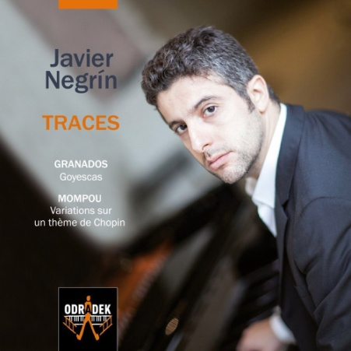
In addition to these I have also purchased a CD of verismo opera arias sung by the dramatic soprano Anna Netrebko (Netrebko, 2016) as I love big dark operatic voices and yet another recording of the Bach solo violin Sonatas and Partitas – this one of performances by Isabelle Faust (Faust, 2016) which have been highly rated by many reviewers. I do not need another recording but found it for sale at a very cheap price in Montpellier in France.

Tuesday 27 September 2016
This CD arrived today (Devieilhe, 2015) – it won a Gramophone award this year. It is of arias and music inspired by the three sisters who he became close to – he married one of them, Constanza and also wrote music for the other two as well as her. The review refers to the sweetness of tone of the singer on this recording and as I love soprano voices I ordered it at a good price on line. I do not like it – the voice is light and forward placed with a strident quality. The music is great – classic Mozart which I find uplifting and inspiring as always. The learning for me here is about the type of voice I like and might potentially write for – softer grained and deeper in timbre – more expressive of itself rather than bright and agile with a hard edge to the vocal sound.
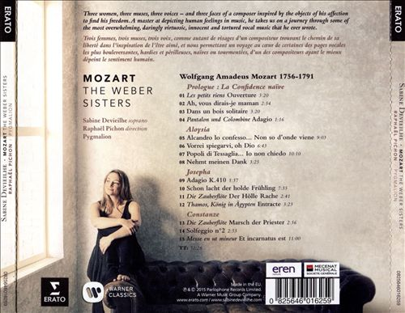
(Figure 14)

I also listened on line to a new recording of Faure songs accompanied by Malcolm Martineau (Martineau, 2016) and performed by a range of contemporary classical singers including Ann Murray and Janis Kelly – a bit past their best form. The singer I really liked is Iestyn Davies, a young Welsh countertenor with a gorgeous (to my ears) voice. I was also struck by the simplicity yet sophistication of Faure’s music writing – to be emulated by myself as I tend to overwork my pieces – less is more!

Saturday 1 October 2016
I have ordered some CDs as part of my studies for the Assignment 1 piece which is slowly unfolding in my mind – an arrangement of the poem ‘The Moor’ by RS Thomas (reference: Internet 3 -Unknown, 2012) for voice, viola and piano. I have remembered that Brahms composed some gorgeous songs for lower female voice and viola with piano accompaniment so will listen to and analyse those. Also his Alto Rhapsody. I have additionally ordered a recording of a contemporary singer, Patrick Watson, whose music I have discovered through watching videos of kites on You Tube (reference: Film 1). This music is very slow and atmospheric with much minimalism in it. I think he must have been influenced by his countryman (both Canadian) Marjan Mozetich as his orchestration is highly reminiscent of works by Mozetich. See next page for a picture of the CD and some stills from the wonderful video on You Tube. This piece of media has given myself and close friends much joy and comfort – it is so stilling to watch and feels spiritual and otherworldly in its feel and the thoughts it evokes.

I also have pulled out the Elgar Cello Concerto to listen to as I am feeling nostalgic and regretful about leaving my job (see Reflective Log) and am hoping this piece will provide some catharsis.

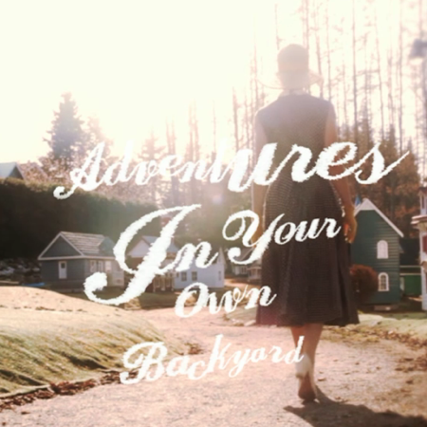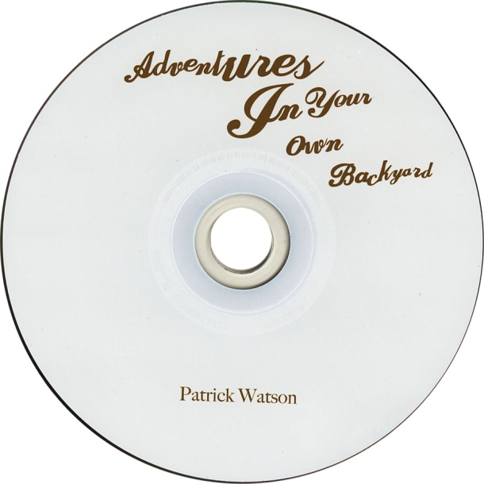

(Figures 15 &16)

Here are images from the video mentioned above:

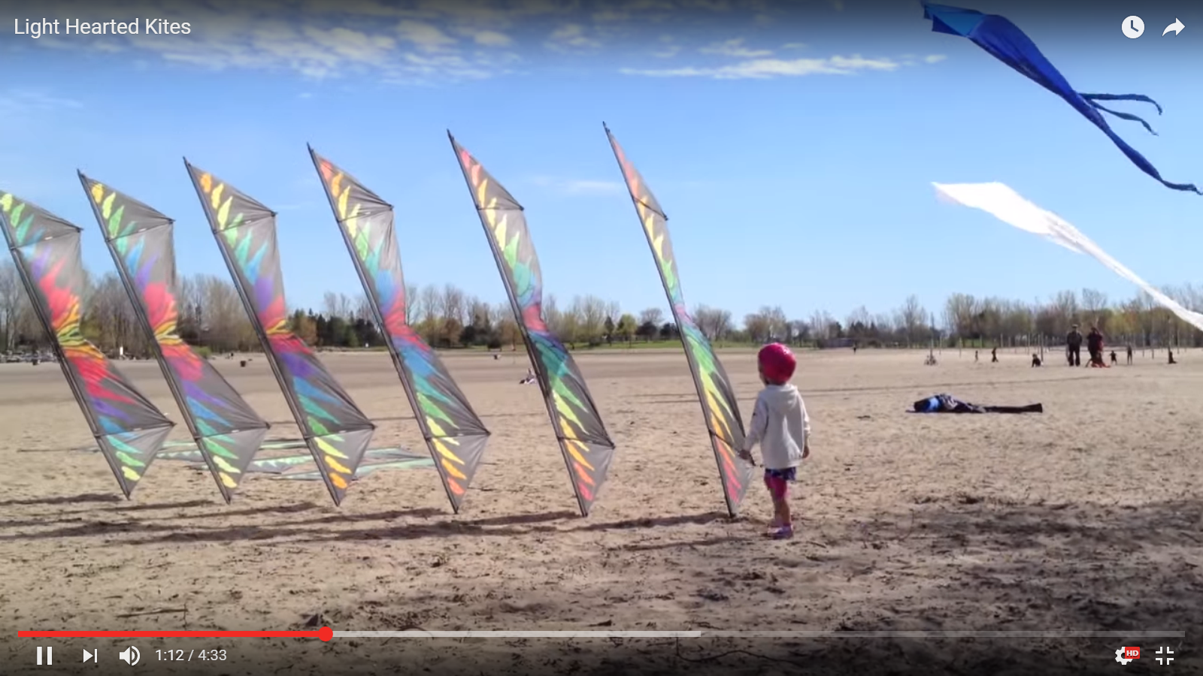

(Figure 17)
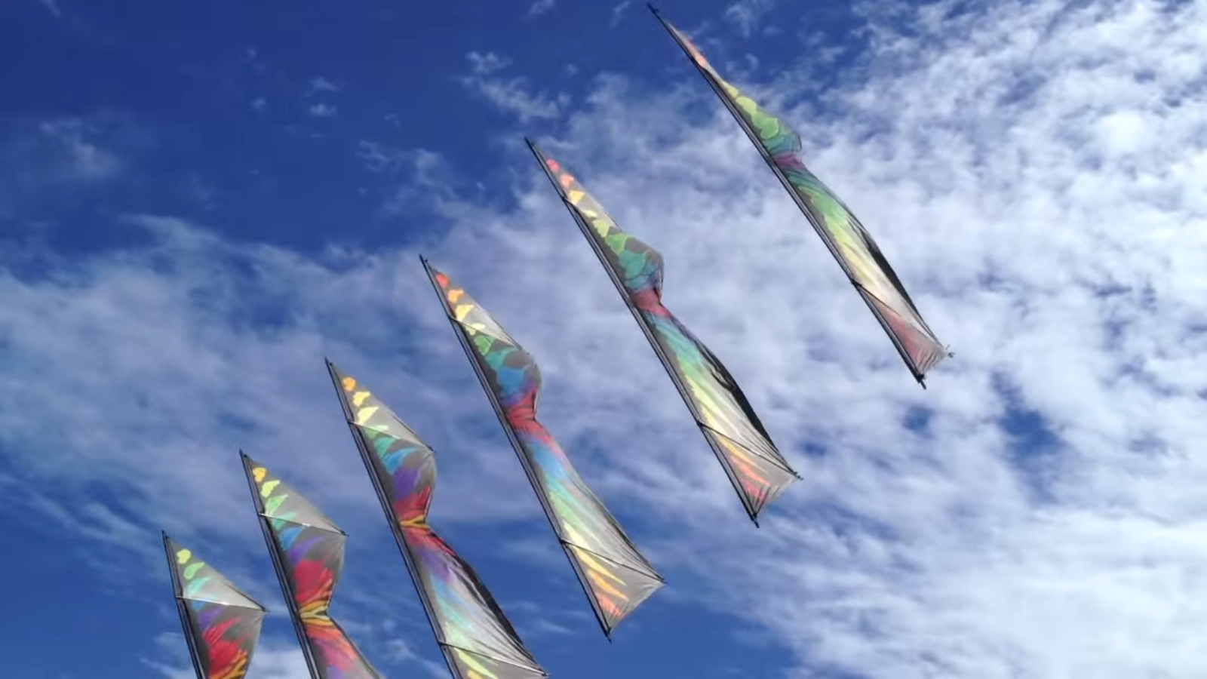

(Figure 18)

Friday 7 October 2016

Pieces that I will listen to in preparation for my Assignment 1 vocal piece:

- Brahms – two songs with viola (for scoring and expression of deep feelings)
- Brahms – Alto Rhapsody (for vocal arrangement)
- Richard Strauss – Morgen (for hushed quietness and anticipation)
- Richard Strauss – Zueignung (for excitement and joy)
- Debussy songs – for composition and interplay between piano and voice
- Sibelius songs – because I love them and his way of composing
- Morten Lauridsen – video on composing a song (Dirait-On)

Have also discovered a new composer from Radio 3 this morning – a Welsh composer – John Thomas who I think was a harp player – I have ordered a CD of his simple (Lipman Harp Duo, 2007) but effective works which should arrive tomorrow – he exemplifies ‘less is more’ – an aim of mine in music. Plus orchestral pieces by Frank Bridge, including The Sea, (Judd, 2004) which was also broadcast on Radio 3 early this morning and which I responded to.

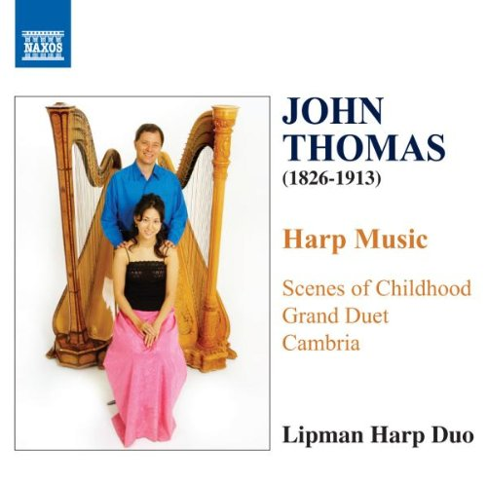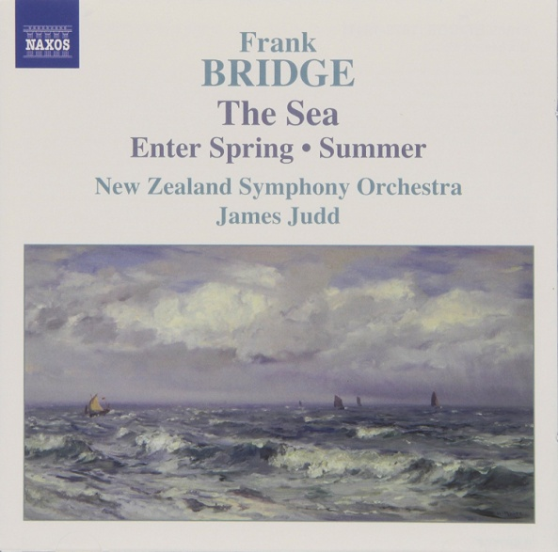

(Figures 19 & 20)

Saturday 22 October 2016

Last night I went to hear the American music group ‘Pink Martini’ at a concert in the Colston Hall in Bristol – they are on tour in England this week. I have been a fan for a long time and thoroughly enjoyed the concert. They are a contemporary ‘Latin lounge’ ensemble – the touring band has about 12 musicians with some singers, although this is augmented when they perform at their home town of Portland Oregon. They were formed in 1994 by Thomas Lauderdale who trained as a concert pianist at the Juilliard School of Music and formed a music ensemble to entertain people at political rallies in the USA and the group grew from there and are now internationally famous with a huge following worldwide. Their music comprises original songs mainly composed by either Thomas Lauderdale, China Forbes the ensemble’s principal singer or them both together along with arrangements of classic songs from films and traditional folk songs from all over the world which they arrange in an upbeat stylised fashion. One of the songs, ‘Je ne veux pas travailler’ (translation: ‘I don’t want to work’), composed by Lauderdale and Forbes for ‘Sympathique’ Pink Martini’s first recorded album (Pink Martini, 2007) has become famous throughout France and is now frequently sung by striking workers in that country when taking industrial action. That song brought instant fame in Europe. One of my reasons for mentioning this in so much detail here is that at the moment I am in the section of the course called ‘Reviving Skeletons in which I am asked by the course notes to take the harmonic progressions used or created by a composer such as Vivaldi or Schubert and use them as the basis for my own composition – pushing boundaries as far as I like! Thomas Lauderdale often borrows music from other composers and uses it as the basis for a song for the ensemble – an example of this are two complementary songs from the album ‘Splendor in the Grass’ released in 2009 (Pink Martini, 2009) which use the Fantasy in F-minor, Opus 13, for piano four hands by Franz Schubert as a starting point. The songs are titled ‘And Then You’re Gone’ and ‘But Now I’m back’. He also uses an excerpt from Peter Ilyich Tchaikovsky’s Piano Concert no 1 in B-flat minor, Opus 23 in the title track of the album. These are not cross over type arrangements as they take some musical ideas and then develop original compositions from them. Unfortunately on the latest album released yesterday (Pink Martin, 2016) there is a ghastly crossover type arrangement of the song ‘Serenade’ by Franz Schubert which for my ears shows a great lack of good musical taste! However another song on the album, ‘Fini la musique’ uses the great pop song by Gloria Gaynor, ‘I Will Survive’ as its inspiration but again achieves something new.

When introducing one of the performances last night Thomas Lauderdale spoke of how he is personally inspired by the composer Poulenc who he has recently been further studying and the influences of this composer can be heard in the three songs on this album that he and China Forbes have written for a new French film ‘Souvenir’ which is to be released in December of this year. This is a coincidence as I have recently purchased a CD of arrangements of Edith Piaf songs in the style of Poulenc along with piano versions of some of Poulenc’s own songs by a contemporary composer Roberto Piana (Pompa-Baldi, 2013). These are performed by the pianist Antonio Pompa-Baldi. The CD is titled ‘The Rascal and the Sparrow – pictured further below. I have also purchased a CD of music for the viola and piano by late 19th century and early Twentieth century composers performed by Lawrence Powers (viola) and Simon Crawford-Phillips (Powers, 2016) – I am clearly focussing on an era and style here! The CD is titled ‘Fin de Siecle- - again pictured further below. This latter CD is also to help me with my assignment as listening to pieces for viola will, hopefully, help me understand the possibilities of the instrument and give me a greater ‘feel’ for it. I also have a colleague who is a semi-professional viola player and will also talk in detail with him too.

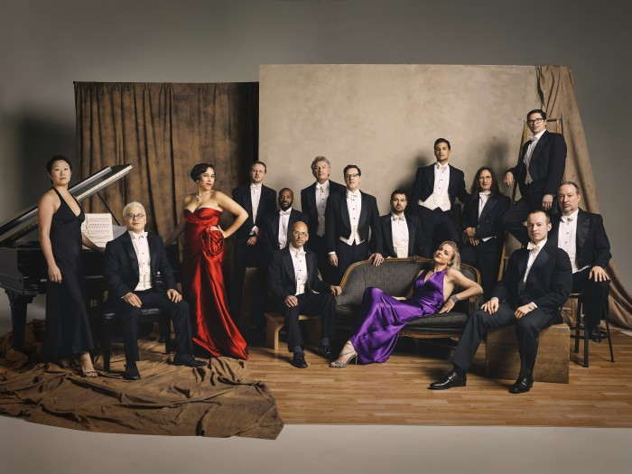
Above picture from Pink Martini’s website (Figure 21)

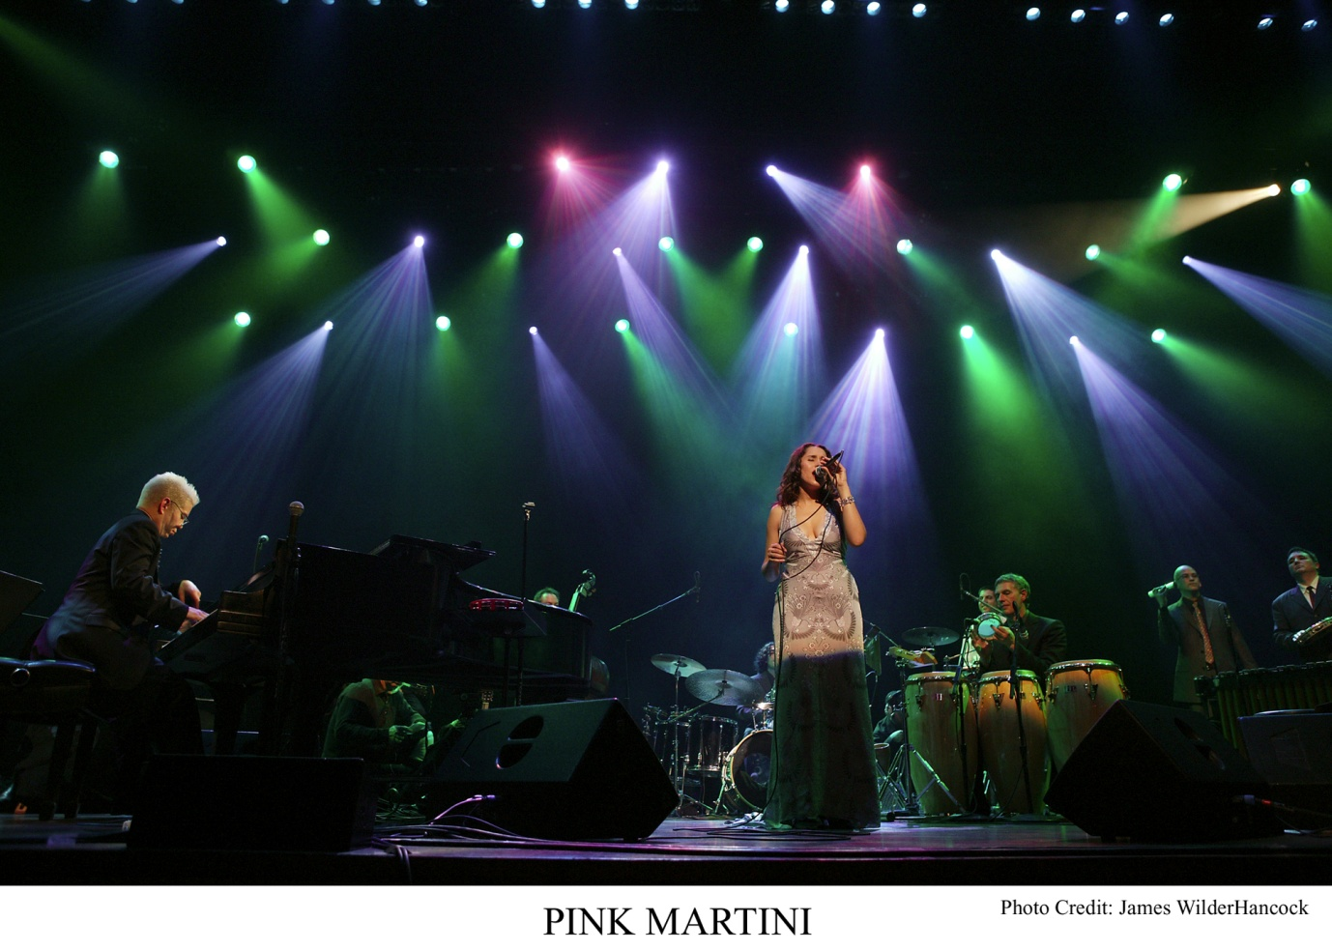

Figure 22 – Pink Martini in concert

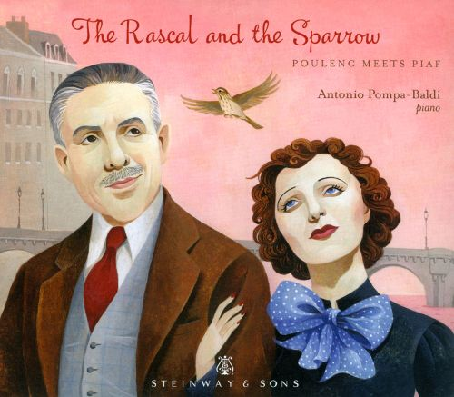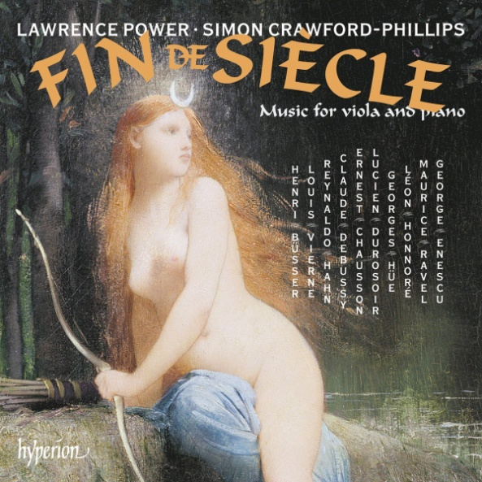

Two recent CD purchases referred to in the text above. (Figures 23 & 24)

Saturday 29 October 2016

I have recently become obsessed with listening to and comparing recordings of Bach’s Goldberg Variations. I have a number of recordings – with only one of these being on the harpsichord, the instrument they were originally written for. Here is the list of performers I have CD recordings of performances by:

- Angela Hewitt (piano)
- Murray Perahia (piano)
- Glenn Gould - 1955 recording (piano)
- Glenn Gould - 1955 recording remade on an electronically controlled Yamaha (piano)
- Glenn Gould - 1981 recording (piano)
- Lars Vogt (piano)
- Andreas Steier (harpsichord)

I also have the Jacques Loussier recording (Loussier, 2000) of his jazzy version of the Goldberg Variations with percussion and string bass in addition to the piano. See Figure 1 for a reproduction of the front cover of the CD. This has interested me particularly as one of the suggestions for listening in the course manual is to Loussier’s way with Bach. I own all of his Bach recordings and in most of them he is quite free with his jazz inspired renditions but in the Goldberg variations he sticks more closely to Bach’s original writing often assigning the lowest musical line to the string bass to play. He is more improvisatory in a few of them (variations number four and eleven) but most of them do not stray far from the original versions which leaves a question in my mind – are some ‘skeletons’ inappropriate for reworking as they are so beautifully constructed that changing them does not produce anything better? Or are the Goldberg Variations so iconic that they are untouchable? There are a number of arrangements of the piece for string trio and string orchestra available and that have been recorded.

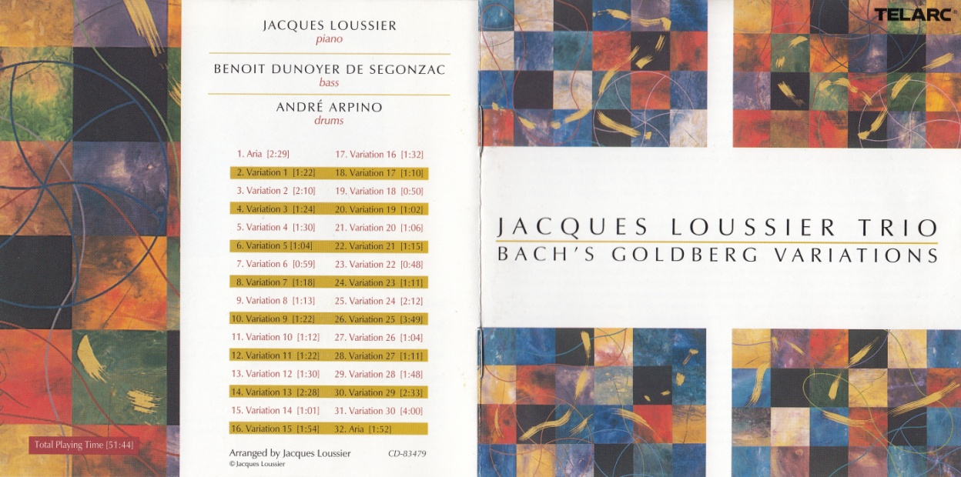
Front and rear cover of booklet accompanying CD of Jacques Loussier’s arrangements of the Goldberg Variations by JS Bach (Loussier, 2000)
Figure 25

Saturday 26th November 2016

There has been a month’s gap since I last wrote in here – lots of listening has gone on although I have not kept a note of it all. Currently I am fascinated by Godowsky arrangements of pieces by other composers and have recently purchased a lovely new CD of his arrangements of works by Bach, Chopin, Schubert and Saint-Saens (Wagschal, 2015). He has created very interesting additions to the harmonic structures and language taking many of the pieces in an impressionistic direction, some ending up rather gorgeous to my ears. I am also left a bit uncomfortable as he also distorts the purity of the composers’ original works which are all fine in their own terms – food for more thought which I shall return to. See photo of CD cover below. I also find the pianist, Laurent Wagschal – new to me – a very sensitive and skilled performer. 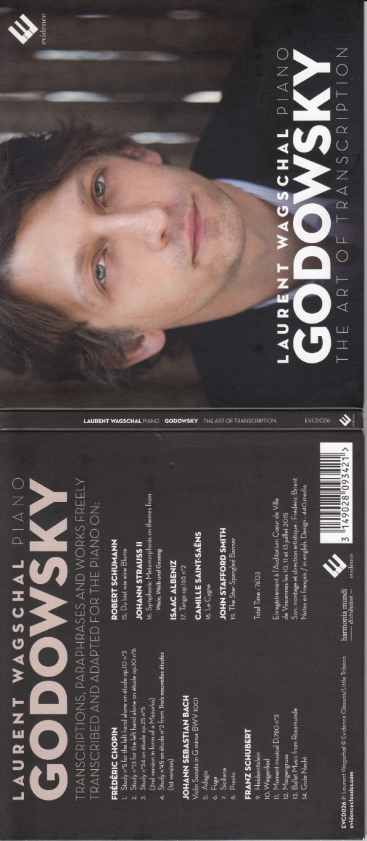
Figure 26 (NOTE: I am not sure why there are such large gaps around this image – must find out how to rectify)

Saturday 3 February 2017
Resuming the studies after a break due to significant work changes and Christmas hiatus – see reflective Log for more details about all of this.
I have been buying many CDs as always and listening as I travel although less time has been available for serious listening and study. The pieces that I have responded to most strongly over the last 9 weeks have been:
- Symphonic and vocal works by Alphons Diepenbrock – after hearing a piece by him on Radio 3 – he was a Dutch composer who lived from 1862 – 1921 and has similarities to Richard Strauss in his compositional style although with his own twist of polyphonic writing with polychromaticism like Wagner and later some impressionism. The details of the piece I heard are: Lydische Nacht (1913) version for orchestra only, music Arranger: Eduard Reeser played by the Royal Concertgebouw Orchestra conducted by Hans Vonk and broadcast on the 5 December 2016. As a result I have purchased two CDs of his music (Residentie Orchestra The Hague, 1990) including an overture and several orchestral suites and a collection of his symphonic songs.
- A recording of Baroque piano pieces performed by the young French pianist Alexandre Tharaud (Tharaud, 2010). There are there discs in the collection – by three separate composers: Rameau, Bach and Couperin. The Bach disc consists of pieces by other composers, such as Vivaldi, that he arranged for the harpsichord and includes his version of the piece by Benedetto Marcello that has inspired the current composition I am working on. This is the Concerto for solo keyboard BWV 981 – movement III which is an arrangement of Marcello’s Concerto Grosso Opus 1 no 2 for four string parts and continuo (harpsichord).

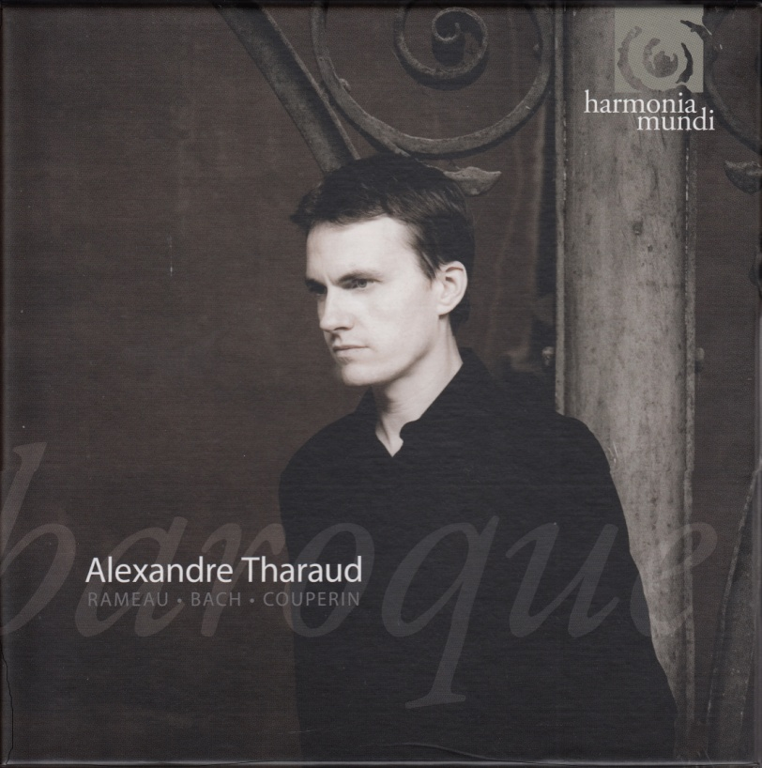
Figure 27 – cover of box containing the CDs and booklet
A wonderful musical and visual experience for me was listening to the collection of Rameau pieces from the above recording while watching the slow TV film ‘Sleigh Ride’ ( All Aboard The Sleigh Ride, 2015 – see Film 2 and Figure 28 in the references section). This film from Karasjok in Norway, two hundred miles north of the Arctic Circle, is of a journey by a young Swami woman with a reindeer across the tundra by the Taiga Forest. The scenery is stunning and the sounds recorded are of the natural sounds of the journey including the reindeer’s bell clanging and tinkling away. I turned down the sound and watched it accompanied by Rameau – a totally involving and mesmerising experience and a surprise for me that the baroque music on the piano would be such a perfect accompaniment – this makes me think about the research by the author Steven Johnson in to where innovative and creative ideas come from which he explains in his book on this topic as often deriving from what he terms ‘serendipitous encounters’ – the colliding or coming together of two unrelated features that create a third new possibility (Johnson, 2010: 121 – see Books 1 in references section). There are numerous techniques for setting this up including many that I have learned firsthand from the wonderful creative genius and expert on creative writing Jurgen Wolff – I often use his techniques when creating ideas for musical themes and compositions particularly utilising random visual images and words.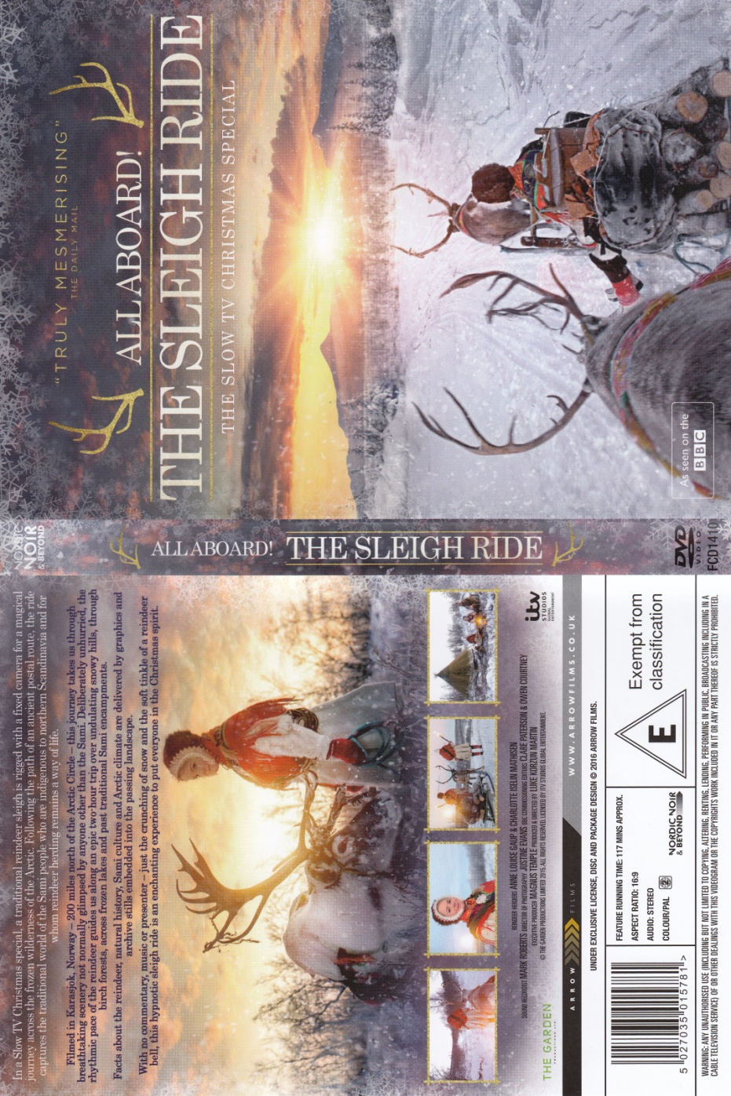Figure 28 – cover of the DVD of the film All Aboard The Sleigh Ride
- A new recording of The French Suites by JS Bach by Murray Perahia (Perahia, 2016) – although I have great recording of these already performed by the Russian pianist Andre Gavrilov when I heard this one on the radio I knew I had to have it. It is a wonderful interpretation and rendition of these works – poised, elegant, appropriate ornamentation and full of amazing musicianship. The quality of the recorded sound is excellent – this matters to me – and I am continuing to listen and enjoy these works.

- The latest recording by the European early music group set up and led by the theorbo player Christina Pluhar that performs and records early music and themed collections of folk and indigineous music from European and latin American countries. I have loved their work for many years and the latest issue, ‘Orfeo Chaman’ (L’Arpeggiata, 2016) is a reteeling of the story of Orfeo using arrangements of baroque and folk music from South America and the Mediterranean focussing on shamanic elements of the story. I find it to be very atmospheric and moving – as always I love the sounds that Pluhar creates and her use of voices in the mjusical textures she conjures up.

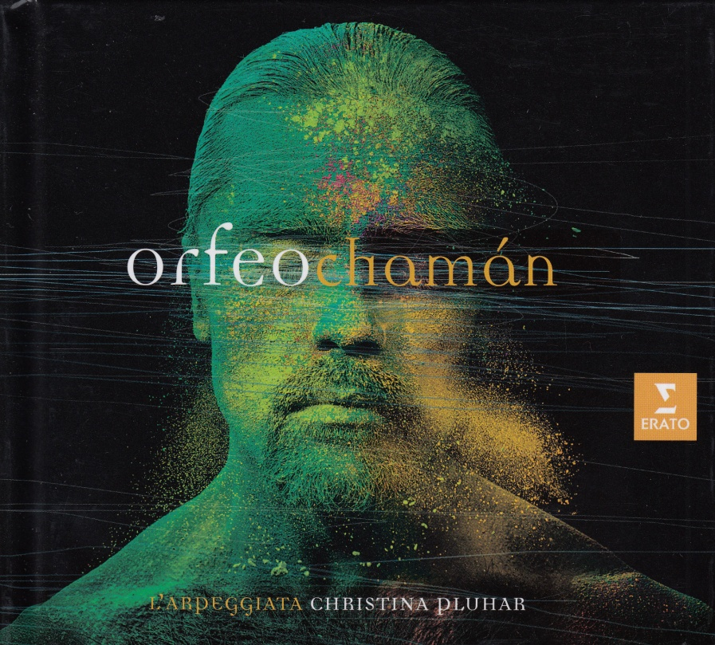

(Figure 29. Scan of cover of CD of Orfeo Chaman)

- I endlessly listen to instrumental Bach (JS of course although sometimes his son CPE) and have bought yet another recording of the Cello Suites – these are pieces that fascinate me and like many colectors of recordings I have numerous performances now. A reviewer in a music magazine - I cannot remember who or in which publication – wrote that the performances by Mstislav Rostropovich are time less and will be listened to two hundred years from now.

NOTE – in looking for the review in which I found this comment - which I tried, unsuccessfully, to do just after writing the above sentence, I have been on one of what I term my ‘musical rambles’. By this I mean that I came across a review of an older recording of the Bach Cello Suites in the form of a printed discussion between two regular reviwers for the magazine Gramophone (Reference: Books 3 - Cowan & Gill, 2017) and this led to listening on line to the recording and them my attention was caught by another artice reviewing available recordings of the Bach Flute Sonatas in the same edition of the magazine (Reference: Books 4 - Gill, 2017) and so I next listened to various recordings of those works too, again on line, and read reviews available on the Amazon website. From this I started exploring other works and recordings by the artists involved and before long much time had passed! And very enjoyably too. However I have strayed a fair distance away from my original intention of listing and commenting on all the CDs I have purchased and listened to recently and now have the challenge of referencing these articles too.

I did purchase the classic EMI recording - now on Warner Classics - of Rostropvich playing the Suites (Rostropovich, 2014) and like it – the first movement of Suite 1 is very fast indeed and in fact he does play many of the pieces at a fair lick but with a romantic feel rather than a more modern dance like stylre as is favoured by contemporarty baroque practice. However I do respond to them – although they will not replace in my affections the various recordings by the Dutch cellist Peter Wispelwey.

NOTE – pause for a few moments reflection on why I find Bach so endlessly fascinating – my previous tutor commented that I am perhaps too influenced by Bach and indeed I find it difficult to get away from his structures and techniques in my mind when composing. His music has been a revelation for me and I am still exploring it. I think he was a genius and I am astonished by the elegance and technique employed in his works.

- Another CD that has really impressed me is a new recording of the Etudes-tableaux and Moments musicaux by the young Israeli-Russian pianist Boris Giltburg (Giltburg, 2015). I came across this by chance when browsing new releases on the internet and ordered it straightaway as I thought the performances and the recording to be fabulous. I also did not know the Moments musicaux and love their focused expressions of ideas and moods. I find this music touches and exhilarates me equally.

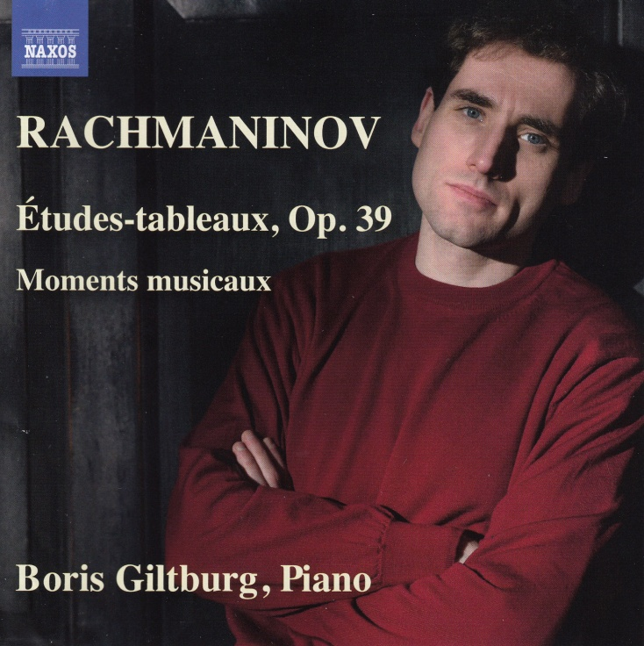

Figure 30 – front of CD booklet

- More JS Bach – also recently discovered his Oboe Concertos and bought yet another CD (Hommel, 1997). I must think more about why I am so responsive to bach instrumental music – it fascinates me in the same way that the music of Philip Glass does – somehow the patterns and rhtyms mesmerise me and pull me into a reflective and engaged experience in a way that other composers do not.

- I used to adore opera – going to it live in London at the Coliseum (English National Opera) and the Royal Opera House, Covent Garden. My former life partner, Stephen Laidler, was the Chorus Manager at the Royasl Opera House for 5 years until his death in 1994 and through him I was able to go to a huge number of performances in good seats. Since he died my musical tastes have taken off in a different direction with exploring chamber and Baroque music and more contemporary comnposers throught the widening of perspectives that this OCA study has encouraged me in. However recently I have been returning to some operas and recently was prompted to listen again to Puccini’s work ‘La Fanciulla del West’ which has, I think, an extraordinary score with elements of Debussy like impressionism, Wagnerian harmonic shifts and melodies sourced from native American sources. I have already in my collection the performance recorded with the cast from the production of the opera at the Royal Opera House in the 1980s starring Carol Neblett as Minnie, the heroine, and Placido Domingo as Dick Johnson her love interest (Mehta, 1978). I have been enjoying this recording a great deal over the last few months and decided to treat myself to a filmed version of the opera and purchased a DVD of a filmed version of a more recent production at the Vienna State Opera House starring Nina Stemme and Jonas Kaufmann in the main roles and conducted by David Aronson (reference: Film 3 - Breisach, 2015). This version has been updated in that the stage setting is stylised on the 1960s in rural America which works reasonably well. The performance is great – perhaps not as consistent as the Mehta performance (there is a DVD available of that production too).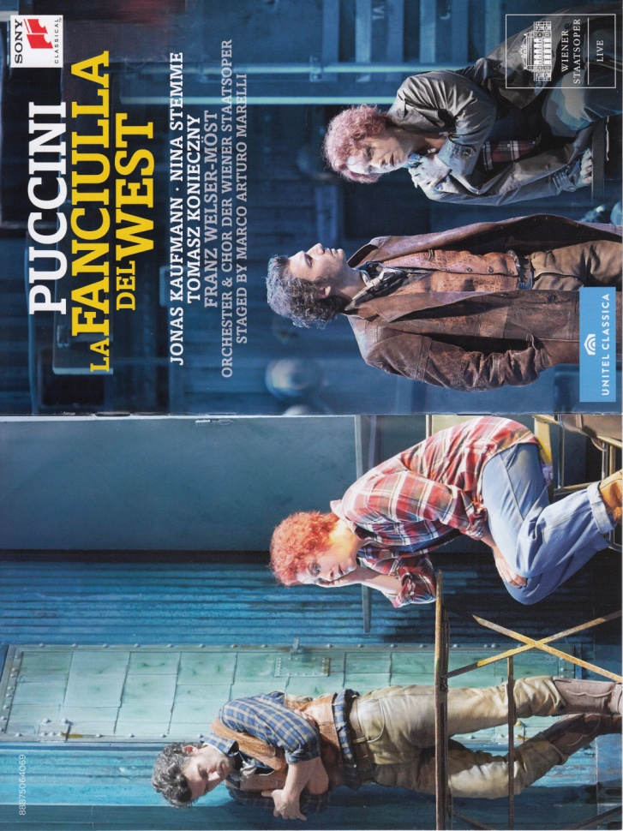Figure 31

Sunday 12 February 2017

Lat night I went to a very stimulating concert of minimalist music at St George’s Brandon Hill in Bristol - here is information about it I have copied from a screenshot from the St George’s website:

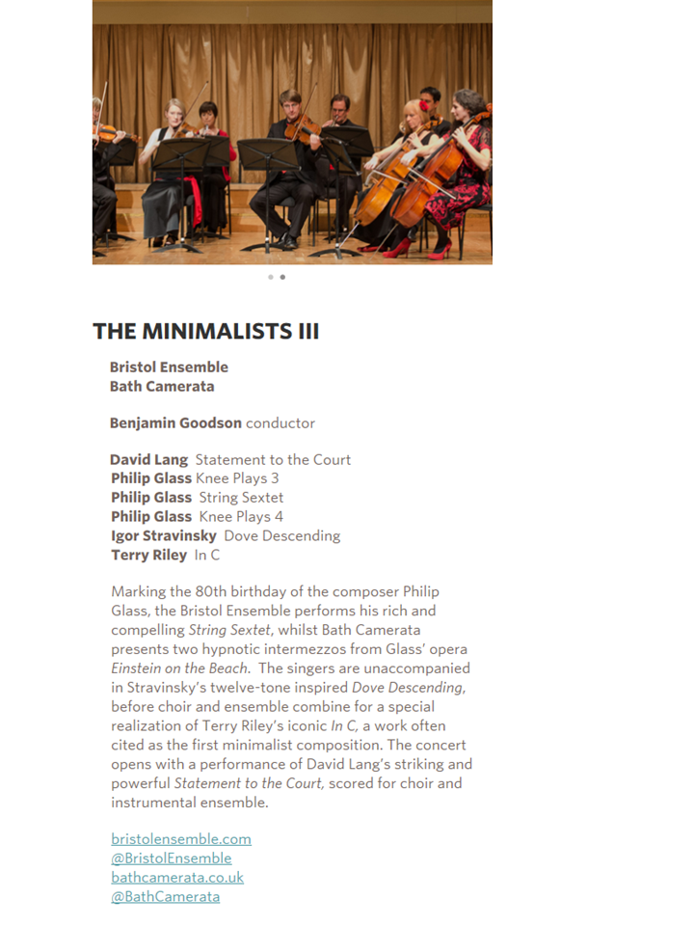

Figure 32
This was a highly stimulating event for me. I will comment on each piece in turn:

- David Lang Statement to the Court

This a setting to music of a left wing piece of writing by the American early twentieth century political activist Eugene Debs when making a court appearance for refusing to support the American entry into the First World War. It is a long text – see copy below (Reference: Internet 4) – set for choir and orchestra with a prominent bass drum part. The chorus declaim the whole text with various solo lines also added in by members of the chorus.

Statement to the Court Upon Being Convicted of Violating the Sedition Act
Delivered by Eugene Debs, September 18, 1918
Your Honor, years ago I recognized my kinship with all living beings, and I made up my mind that I was not one bit better than the meanest on earth. I said then, and I say now, that while there is a lower class, I am in it, and while there is a criminal element I am of it, and while there is a soul in prison, I am not free.
Your Honor, I have stated in this court that I am opposed to the social system in which we live; that I believe in a fundamental change-but if possible by peaceable and orderly means. Standing here this morning, I recall my boyhood. At fourteen I went to work in a railroad shop; at sixteen I was firing a freight engine on a railroad. I remember all the hardships and privations of that earlier day, and from that time until now my heart has been with the working class. I could have been in Congress long ago. I have preferred to go to prison.
I am thinking this morning of the men in the mills and the factories; of the men in the mines and on the railroads. I am thinking of the women who for a paltry wage are compelled to work out their barren lives; of the little children who in this system are robbed of their childhood and in their tender years are seized in the remorseless grasp of Mammon and forced into the industrial dungeons, there to feed the monster machines while they themselves are being starved and stunted, body and soul. I see them dwarfed and diseased and their little lives broken and blasted because in this high noon of Christian civilization money is still so much more important than the flesh and blood of childhood. In very truth gold is god today and rules with pitiless sway in the affairs of men.
In this country - the most favored beneath the bending skies - we have vast areas of the richest and most fertile soil, material resources in inexhaustible abundance, the most marvelous productive machinery on earth, and millions of eager workers ready to apply their labor to that machinery to produce in abundance for every man, woman, and child-and if there are still vast numbers of our people who are the victims of poverty and whose lives are an unceasing struggle all the way from youth to old age, until at last death comes to their rescue and lulls these hapless victims to dreamless sleep, it is not the fault of the Almighty: it cannot be charged to nature, but it is due entirely to the outgrown social system in which we live that ought to be abolished not only in the interest of the toiling masses but in the higher interest of all humanity.
I am opposing a social order in which it is possible for one man who does absolutely nothing that is useful to amass a fortune of hundreds of millions of dollars, while millions of men and women who work all the days of their lives secure barely enough for a wretched existence. This order of things cannot always endure.
Your Honor, I ask no mercy and I plead for no immunity. I realize that finally the right must prevail. I never so clearly comprehended as now the great struggle between the powers of greed and exploitation on the one hand and upon the other the rising hosts of industrial freedom and social justice.
I can see the dawn of the better day for humanity. When the mariner, sailing over tropic seas, looks for relief from his weary watch, he turns his eyes toward the Southern Cross, burning luridly above the tempest-vexed ocean. As the midnight approaches, the Southern Cross begins to bend, the whirling worlds change their places, and with starry finger-points the Almighty marks the passage of time upon the dial of the universe, and though no bell may beat the glad tidings, the lookout knows that the midnight is passing and that relief and rest are close at hand. Let the people everywhere take heart of hope, for the cross is bending, the midnight is passing, and joy cometh with the morning.
I am now prepared to receive your sentence.

(Debs E, 2016)

The music is made up from short segments that are highly declamatory with the choir speaking the words and the orchestra accompanying with repeated minor thirds in triplets and phrases started with mighty drum strikes interspersed by occasional short, highly intense lyrical passages. I found

listening to this piece deeply stirring and totally absorbing. I think it is a very powerful piece – it starts with an impact and continues in a strong vein and builds up slowly but steadily in tension. I am very pleased to have discovered both this work and its composer.

- Philip Glass Knee Plays 3

This is one of a series of interludes that serve as pieces that connect different parts of Glass’s opera Einstein on the Beach’ – his first operatic work based on the life of Albert Einstein. These interludes were termed knee plays as a reference to knees in the human body being the connection between parts of major limbs. Although Glass had commissioned a text for these interludes from the writer Robert Wilson they never arrived and while waiting for them he decided to continue with the composition and used repeated numbers and solfege to substitute for the test and then decided to stick with them. They do make for a fascinating effect, particularly when the pitches sung do not correlate with those indicated by the solfege used. I first heard minimalist music described as an auditory representation of the patterns one sees when two pieces of netting are moved slowly across each other and I certainly visualised this listening to Knee Plays 3. I was almost amazed by the ability of the singers to clearly pronounce all the numbers at such high speed and intensity. Musically I was impressed by the vital rhythmic drive that Glass imbues his music with – this was also a feature of the String Sextet too.

- Philip Glass String Sextet [which I am listening to on Spotify as I write this] (Carducci Quartet, 2015)

This mature work is an arrangement of Glass’s Symphony no 3 by Michael Riesman. That symphony was a more intimate work than his previous symphonies having been written for 19 players. I loved this piece – and in particular the intense third movement which is in the form of a canon that builds up and up in focus and feeling and is based on repeated short melodic fragments and rhythms in a minor key. It ends up sounding incredibly complex and has a marvellously detailed texture to the sound. The last movement has a driving and pulsating rhythm to it which I found very energising and exciting. The repeated phrases really do hook me and uplift me at the same time. This is mesmerising music elegantly constructed. I was also reminded of Glass’s classical roots arising from his composition classes with Nadia Boulanger – she influenced so many mid and late twentieth century composers and therefore contemporary music.

- Philip Glass Knee Plays 4

A second Knee Play form Einstein on the Beach. Again I noticed the use of solfege independently of the expected pitching. I also noticed that the rhythms and pitches seemed to be grouped in threes – something that occurred in other pieces this evening, particularly the David Land composition.

- Igor Stravinsky Dove Descending

A hymn like piece that Stravinsky wrote for the New Cambridge Hymnal based on the poem The Dove Descending Breaks the Air by TS Eliot in 1962. The work fully utilises serialism and is therefore based on themes constructed from twelve note rows and using the full range of serialism techniques. I quite enjoyed this piece although it is so skilfully written that identifying specific patterns and their use was not possible for me.

- Terry Riley In C

I struggle with appreciating this piece – I studied it in the Composing 1 course and did not like it then and now having heard it live still do not. It was, I know, a seminal and ground breaking work in 1964 and heralded the start of minimalism music after earlier works composed by La Monte Young. It is constructed from 53 bars of short fragments of rhythm and notes that any number of players can use – the performance I heard utilised a small orchestral group and a chamber choir together with a piano and bass drum. The piano repeated the grounding notes in the key of C which are intended to hold the piece together. Players start at different times but then rigorously follow the sequence of the 53 fragments. Reviewers of the work elsewhere have often commented on the rhythmic pulse as being a great feature of the work but for me this never varied throughout the thirty minutes of the performance. I thought that overall there was a great deal of uniformity to the sounds I heard with occasional increases in volume and intensity but little shape or direction to the sonic experience. The person who introduced the piece (a music professor from Oxford University whose name I did not catch and who was not listed in the programme) stated that the piece created a ritualistic feel akin to that often featured in Indian music and an effect of time being suspended. I did not experience either of these – instead I felt great irritation at the sonic onslaught of distorting harmonics crashing through the air and enormous relief when it ended. There was one singer who sang far too loudly with a piercing tone and who was totally out of tune with everyone else. I must point out that the audience was very enthusiastic in its applause so I am clearly in a minority in my response to this piece. I much prefer the beautifully constructed pieces by Philip Glass that take me on a journey in sound and are thoughtfully composed.

Saturday 4 March 2017

As a result of going to the concert described above I have been on a Philip Glass listening binge – and purchasing too! I found that I had in my huge CD collection a recording of his 3rd Symphony (Alsop, 2004) that the String Sextet was based on – lovely to hear the work with an additional weight of sound and more texture – a different experience perhaps less intense than the intimacy and immediacy of the sextet but with a deeper resonance to the sound that brings more sonic impact. Both are wonderful and again remind me of how Glass uses repeated rhythms to drive the music forward with such a sense of energy that infects me and always draws me in. That along with the harmonic sound worlds he creates through his orchestration which I think is done with such accomplished expertise. I also note the gorgeous little melodic fragments – often in a minor key – that he weaves through much of his music and that hook me in.

I have also purchased a recording by the Australian saxophone player Amy Dickson of an arrangement of Glass’s Violin Sonata and Concerto for saxophone – both by herself – see (Dickson, 2017) for details and Figure 33 for the scan of CD cover below. I find them thrilling and again am totally drawn into the sound world that the composer creates for all the reasons I have expressed in the last paragraph. I also like the saxophone better in this music – but this may be because in the CDs recording I have of the original pieces the violin player occasionally plays out of tune which grates harshly on my ears – particularly when the constant subtle harmonic shifts Glass engineers in his pieces can be distorted by poor playing – they do seem to need a careful and attentive precision in execution.

At the other extreme I have been continuing to explore and enjoy music by Jean-Philippe Rameau – this has surprised me but is , I guess, a logical continuation of my ongoing current love affair with Baroque music. I have just purchased a recording of a compilation of various pieces into a cohesive arrangement by the conductor Marc Minkowski that he has called ‘Une Symphonie Imaginaire’ (and that was performed live at the Theatre de Poissy in north central France during 2003 – see reference (Minkowski, 2005) for details and figure 34 for the scan of CD cover below. Gorgeous and so different from his contemporary Bach – and a real lesson for me in how to create such a wide range of feelings, moods and effects with more straightforward harmony (compared with contemporary music I mean) but great attention to construction, orchestration, structure and how the harmonic language and rhythm is utilised. Also the CD is brilliantly recorded with real impact on a good reproductive system.

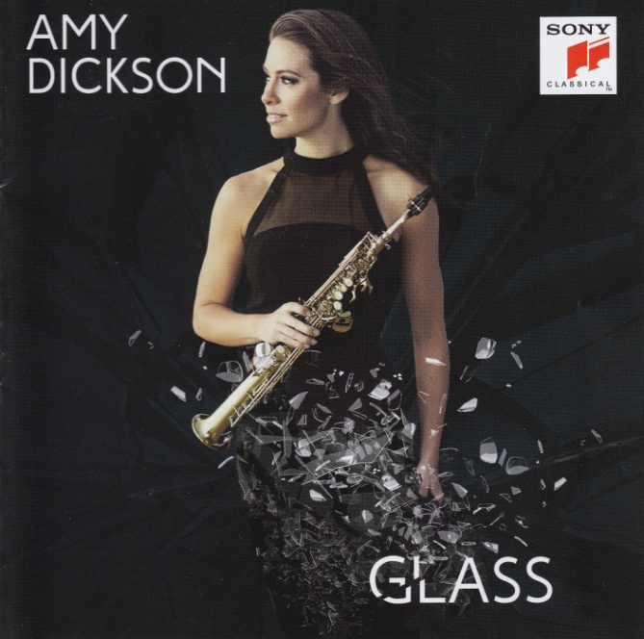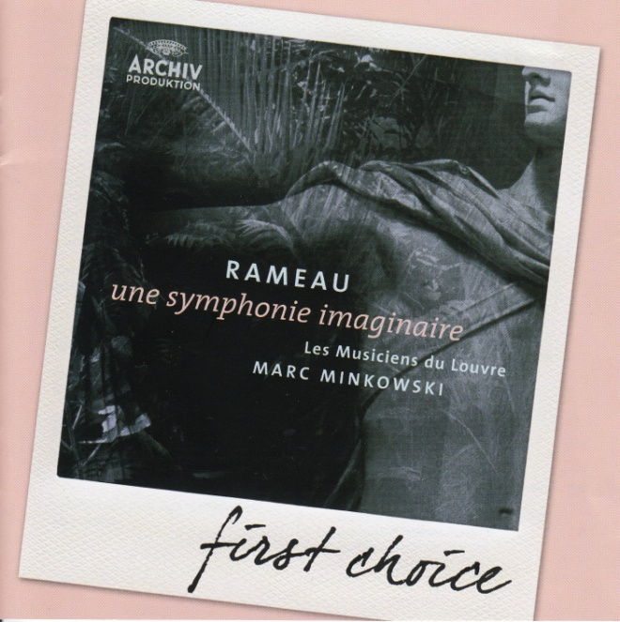

Figure 33 Figure 34

And in the post yesterday arrived the latest recording in the Hyperion Romantic Piano Concerto series – no 7 - and of three works for piano and orchestra by composers who were women – in time to listen to it on March 8th, International Women’s Day. They are Amy Beach (American), Dorothy Howell (English) and Cecile Chaminade (French) – I will reflect on these pieces after listening to them a few times – see reference (Driver,D & Miller, R, 2017) for details of the CD and Figure 35 for the scanned CD cover below

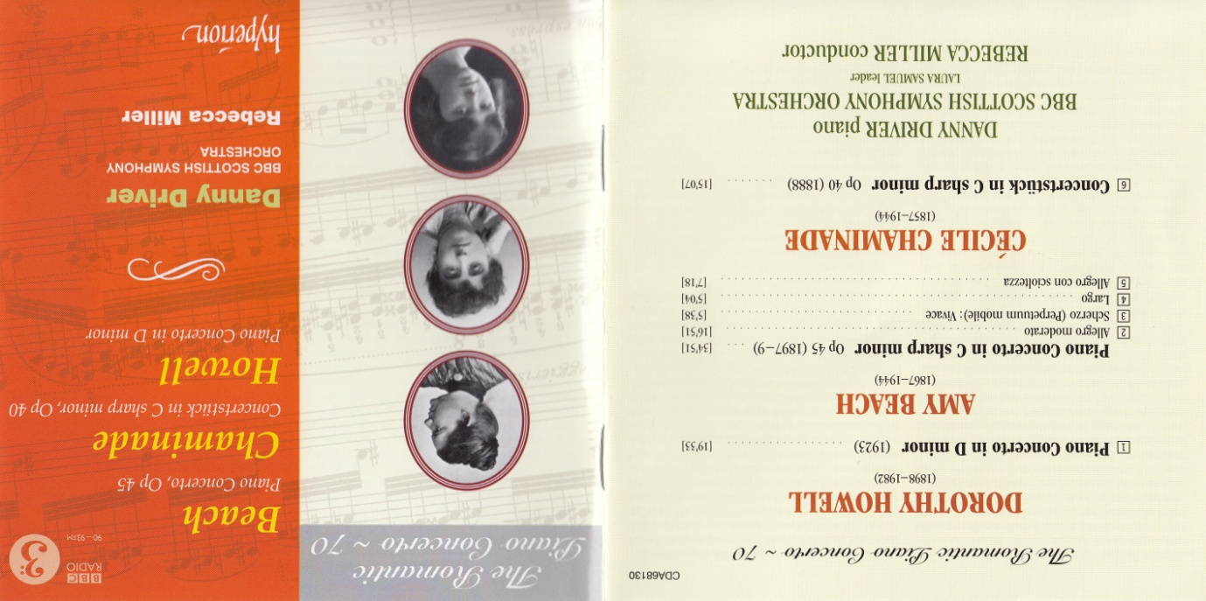

Figure 35

Saturday 11 March 2017

As always with me listening to BBC Radio 3 brings pieces of music that are new to me and I inevitably end up finding them on Spotify, listening further and then buying. The latest arrived yesterday and is a recording of Spanish fandangos played by Andreas Staier on the harpsichord. What grabbed my attention was the arrangement for two harpsichords and castanets of the Quintetto no 4 D major, G448 by Boccherini broadcast on Radio 3 on Thursday 9 March at 7.12 am [Petroc Trelawny Classical Breakfast Show, 2017 - see reference: Radio Broadcasts no.1)]. This is featured on a CD of a collection of fandangos by a number of baroque composers including Soler, Galles and Ferrer (Staier, 1999).

Thursday 16 March 2017

I have been listening to a series of string sextets by a range of composers in order to help with my composing project – my ‘Working notes and Log of progress’ has more details about this under the same date as this entry. The recordings I listened to are as follows:

Erno Dohnanyi (1877–1960) – String Sextet in B♭ major (Budapest Sextet, 2006)
Mihaly Mosonyi (1815–1870) – String Sextet in C minor (Budapest Sextet, 2006)
Arnold Schoenberg (1874-1951) – Verklärte Nacht, string sextet version (Artemis Quartet, 2006)
Johannes Brahms (1841-1904) – String Sextet in B♭, Opus 18 (Prazak Quartet, 2013)

Monday 3 April 2017

Listened on Spotify (Roberts, 2011) to the CD the Cecil Sharp Project – picture of CD cover below. This recording was made after concerts in Shrewsbury and London by a team of artists who took part in a residential commission by the Shrewsbury Folk Festival and the English Folk Dance and Song Society that aimed to create new material based on the life and collections of Cecil Sharp who had created a huge collection of folk songs at the beginning of the twentieth century. The residential took place in March 2011 and was immediately followed by the concerts and the works created were also performed at the Shrewsbury Folk Festival in August 2011 and recorded on CD very shortly afterwards. Below is a picture of the artists involved (Figure 37)
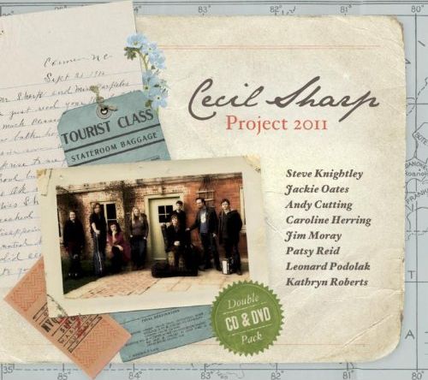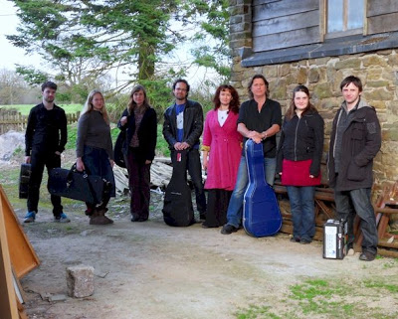
Figure 36 Figure 37
There are a range of songs on the CD that cover a wide range of concepts – some witty, some sad, and some stories. A variety of folk styles too from traditional airs to more contemporary approaches including country and western with almost blues touches to some of them. However they are not to my taste – the voices are too bland or have a wailing or breathy quality that I find grating and irritating - I like operas and art songs that deal with deep life themes and big emotions. The music seem to me to be simplistic and to my ears does not reflect the feelings or moods of the words – I’m not really very appreciative of folk songs or singers as must be apparent from these comments (I have been told frequently that I am a music snob). I tried with these to explore the genre and listen with fresh and unbiased ears but just do not like them at all – maybe the arrangements by classical composers such as Moeran, Grainger, Butterworth, Vaughan Williams and Britten will be more to my liking.
Wednesday 5 April 2017
Comment heard by announcer on Radio 3 this morning:
Folk music is the voice of a nation’s soul, part of our identity in a globalised world
(reference: Radio Broadcasts no.2)
This was part of an advert for the Uproot Festival starting in Hull from tomorrow for two days and which encompasses folk and roots music from Britain and around the world. The statement is quite a claim and I will use it as a frame of reference, a lens, for considering the folksongs that I listen to. If this is true then I am dismissing folk music too readily. As so many great composers were inspired by the folksongs of their countries I am going to try suspending the judgement I stated above and listen with a more open mind.

Monday 10 April 2017
Having written negatively about folk music above I have realised, to my embarrassment that I in fact listen to quite a lot of it! I love the arrangements by Christine Pluhar and L’Arpeggiata of folk tunes from many areas from around the world – I have all the recordings they have made of these on a number of CDs and listen frequently to them. I also realise that to write off an enormous range of music from a huge number and variety of backgrounds is foolish and very limiting – and reminds me of Harry Partch’s criticisms (more of Harry Partch in my Working notes and log of progress) of the dominance of nineteenth century Germanic music on classical music generally and of the aged and conservative audiences that listen to it. I have also found a beautiful performance of the old English folksong ‘Ten Thousand Miles Away’ on You Tube performed by the talented young American tenor Timothy Fallon [2013 Wigmore Hall/Kohn Foundation International Song Competition, 2013] – (reference below Film 4). I will write about this later as it is the arrangement I wish to focus on in more detail.
Friday 14 April 2017
I have just listened to two folk song arrangements by Vaughan Williams that I discovered I have in my CD collection. These are Searching for Lambs and The Lawyer both in the key of A modal minor and accompanied by a solo violin. The recording of these is performed by the tenor John Mark Ainsley with a violinist from the Nash Ensemble (Ainsley, 2000). They both have an introduction by the violin in a rhapsodic vein and an ending postlude – the first one (that for Searching for Lambs) being soulful and pensive in similar vein to the actual song and the second (for The Lawyer) very dancelike and sprightly. The accompaniments to them are carried out in a rich and varied manner devised as a counter melody that implies complex harmonic progressions although there are only two musical lines. The melody of the violin holds its own against the repeated verses of the folk songs. Despite the clear skill and enormously high level of accomplishment they embody they are not to my personal taste – but I can hear how beautifully written they are.
Friday 21 April 2017
This afternoon I have listened to more folksongs on Spotify – the first set being arrangements of folksongs from Norfolk and Suffolk by E.J. Moeran (Moeran, 2015). The piano accompaniments are beautifully constructed with sophisticated harmonic progressions that shift gently beneath the melodic line based on various techniques including spread arpeggios, and using interesting rhythms. Often short fragments of counter melodies feature and very short interludes between verses. Some of the accompaniments have a rocking feel to my ears. They all sound modal and wistful to me – even the faster ones.
I then listened to arrangements by Benjamin Britten and sung by Peter Pears (English Folksongs, 2013) – these also have introductions although Britten’s harmony is more acerbic in feel and less modal or romantic in tone. They interest me more as each arrangement is very different with the accompaniment seemingly taking some aspect of the song and translating it into musical terms – for example if the lyrics describe a character walking somewhere then Britten creates this feel in the piano writing. They are very varied and therefore difficult to give an overall description of – masterly!
Next to arrangements by Percy Grainger on a very recently released recording sung by Claire Bloom (not a voice I liked and it made me think about over produced voices singing simple songs as maybe being too much) and accompanied by the pianist Christopher Glynn (Grainger, 2017). These, like Britten, range in style although sounding simplistic – but definitely the art that conceals art as they are brilliant and create atmosphere wonderfully – some with lengthy introductory section and some with lovely harmonic features such as a string of suspensions or rippling arpeggios. Quite a few have the voice leading the music with the accompaniment tracking the voice with chordal progressions underneath it – all sensitively done. Many of these are quite slow and pensive songs. Some with good tunes Grainger has just arranged for piano alone such as the traditional Londonderry Air which he titles as Irish Tune from County Derry.
And finally to the folk song arrangement that I wish to focus on in more detail - the old English folksong ‘Ten Thousand Miles Away’ that I first heard on You Tube performed by the talented young American tenor Timothy Fallon (2013 Wigmore Hall/Kohn Foundation International Song Competition, 2013) – reference below Film 4. ‘Ten Thousand Miles Away’ is a traditional sea shanty that appears to date from the 18th Century and is most likely to be a lament about a lover who has been transported to Australia ten thousand miles away. It was very popular in the Victorian era and was frequently sung as a music hall number. The version I like was arranged by the contemporary composer Steven Mark Kohn – he has arranged many American folk songs for voice and piano. Interestingly I have found countless versions for the lyrics of this song and claims that it is Irish, English and American. My guess is that as a popular sea shanty that has been around for at least several hundred years it will have travelled and been altered and adapted for different countries. I have also found three main melodies for it too – each claimed to be authentic and several severely altered versions recorded by popular artists. Even different performances of the arrangement by Kohn that I have listened to on You Tube have varying lyrics too! I have written down the lyrics from the Fallon performance (2013 Wigmore Hall/Kohn Foundation International Song Competition, 2013) and typed them out below for future reference for myself. I was very moved when I first listened to the performance by Timothy Fallon as it touched a wistful and sad vein in me. For me it is an outstanding arrangement and performance.
Monday 24 April 2017
Ten Thousand Miles – lyrics of a sea shanty in the version arranged by Steven Mark Kohn
Sing I for a brave and a gallant barque
For a stiff and a rattling breeze
A baldy crew and a Captain true
To carry me o’er the seas

To carry me o’er the seas my boys
To my true love so gay
Who went on a trip on a government ship
Ten thousand miles away

O blow ye winds high ho
A roving I will go
I’ll stay no more on England’s shore
So let the music play

I’ll start by the morning train
To cross the raging main
For I’m on the road to my own true love
Ten thousand miles away

My true love she was handsome
My true love she was young
Her eyes were blue
As the violet’s hue

And silvery was the sound of her tongue
And silvery was the sound of her tongue my boys
And while I sing this lay
She’s a doing the grand
In a far off land
Ten thousand miles away

O blow ye winds high ho
A roving I will go
I’ll stay no more on England’s shore
So let the music play

I’ll start by the morning train
To cross the raging main
For I’m on the road to my own true love
Ten thousand miles away
Ten thousand miles away

I have now discovered through endless internet trawling that Kohn sourced this song from The American Songbag (Sandburg, 2017 – reference Books 4) – a collection of American Folksongs put together and published by Carl Sandburg in 1927.
Tuesday 25 April 2017
NOTE: I have just noticed that the course notes ask me to make notes on the particular composer whose folk song arrangements I choose to study in my ‘learning log’. I think this must mean what I have called my ‘Working notes and log of progress’ so I will make the next set of notes on Steven Mark Kohn’s arrangements of American folksongs in that log rather than this one.
Sunday 30 April 2017
A note to mark down that in addition to the above listening that over the past few months I have continued to listen extensively to music and reviews of recordings on BBC Radio 3 and on Spotify and as always have been adding to my extensive CD collection including recordings of:
- Liszt Songs – recorded by Timothy Fallon and Matthew Polenzani
- Brahms serenades
- Poulenc – complete piano music recorded by Paul Crossley
- Sibelius – pieces for orchestra including Tapiola (the piece I wanted)
- Russian cello Sonatas including Rachmaninov and Shostakovich
- Elgar – Cello Concerto
- Tchaikovsky – Rococo Variations – original version
- Tchaikovsky and Sibelius violin concertos – yet more recordings to add to all those I already have
Often my interest is stimulated by something I hear on the radio or one recording leads me to think of something else and on I go. At the moment I am in another Poulenc phase and have music by him on whenever I am doing tasks around the house – at the moment we have our house open for 10 days as part of North Somerset Arts week and his is the music I have on for visitors. I am exhibiting some of my photographs and my husband is displaying all his recent paintings.
Sunday 7 May 2017
NOTE - a note to follow up later to register here that I have been exploring at odd moments the compositions and ideas of Harry Partch – an early to mid twentieth century musician who rejected mainstream ideas and traditions and created his own instruments and tuning. I came across a reference to him in a review of a CD on Amazon – I cannot now find this to reference it – but the name stuck with me and I have investigated and found him fascinating.
Sunday 21 May 2017
I have discovered another English folksinger who is very popular and well established with a huge folk music career– June Tabor. This came about through trying to find a recording on line to listen to that has just been just released by Quercus which is a jazz folk trio comprising the pianist Huw Warren, the saxophone player Iain Bellamy and the singer I have already referred to – June Tabor. The recording is titled ‘Nightfall’ and the review that alerted me to it is in the latest edition of BBC Music Magazine (Thomas, R, 2017:102). The music is a combination of folk music and jazz and the reviewer states:
Here are stories of lost loves, wartime strife, forlorn hope and death by misadventure, all handled with a lugubrious grace of which Dowland would have been proud.
(see reference Books 5)
I managed to find short excerpts on the Amazon website (Quercus, 2017) and listened to as many as possible. Again I find the established tradition of folk singing in the UK to not be to my taste at all as exemplified by this recording despite its highly rated review and being Jazz choice of the month in the BBC Music Magazine. It is June Tabor’s voice that I dislike – it is too lacking in vibrato and richness and her choppy phrasing that lacks a line through it - no bel canto here. I think that the appreciation of a singer’s voice is a very individual thing and I note I am consistent in what I do and don’t respond favourably to. I do love well developed opera and lieder singer voices such as Bryn Terfel, Diana Damrau, Anne Sophie von Otter and Mark Padmore, to name a few I listen to regularly.
I have also deviated from folk music this afternoon and listened to the first of Beethoven’s String Quartets - Opus 18 no.1 in F major played on CD by the Takacs Quartet (Takacs Quartet, 2004) as I realised that I have not seriously listened to music I appreciate for quite some weeks now and needed to engage with a piece that resonates well with me.

Sunday 18 June 2017
A ‘catch up’ note to state that although I have spent much time working on the piece Vyssa Lulla, now complete, I have been listening to lots of pieces in my leisure time, little as it has been, and in particular Bach as always. I have purchased yet more CDs as is my wont – see list below. This last week has been a great feast of singing with the Cardiff Singer of the World competition broadcast on BBC 4 every evening with the Song Prize final last night ands the opera final tonight. I always find this exciting as I love opera and art songs and I find it thrilling to listen to so many singers one after another and hear major new talent.
Recent CD purchases:
- Beethoven Piano Concertos 1-5 played by Pierre-Laurent Aimard (Aimard, 2003) – a relatively recent and highly acclaimed recording that sounds fresh and invigorating to me – my mother loves it too (I bought her a copy as well).
- Nigel Hess – Concerto for Piano and Orchestra (Lang Lang, 2008) – bought as I have very recently discovered that the composer lived two roads away from me here in Weston-super-Mare, grew up with a friend and is the great nephew of Dame Myra Hess – his cousin recently heard another of my friend’s play Jesu Joy of Man’s Desiring by JS Bach at a recital at Trelissick House in Cornwall and told my friend that she had brought back great memories of Dame Myra Hess playing it. I think it is a light piece, composed on commission from Prince Charles to commemorate his grandmother’s life, the Queen Mother. It is lighter in style than Beethoven and at moments somewhat repetitive with some good tunes, perhaps overused.
- Handel – The Eight Great Suites performed by Danny Driver on the piano, rather than the harpsichord (Driver, 2013). It was 10 days ago that I discovered that there are a number of piano recordings of these pieces by Handel and I was thrilled to discover the recording by Danny Driver which I think is wonderful. I do seem to be responding to Baroque and early Classical pieces on the piano – a huge move from my obsession for decades with late romantic piano music by the likes of Rachmaninov, Scriabin and Liszt.
- The David Rees-Williams Trio performing mildly jazzed up arrangements of a range of pieces by JS Bach Rees-Williams (Rees-Williams, D. (2017). Gentle and very listenable – quite traditional compared with the Jacques Loussier Bach arrangements I grew up with as a child, and still love, but hugely enjoyable and not too demanding – which some folks would be horrified by. Good for a hot day for calming down to but still staying alert and engaged – and they are highly inventive and imaginative too. A new recording just released.

Sunday 23 July 2017
Another catch up note. I am trying to forge on with the last part of Part 1 and get the assignment done and off. Needless to say I still listen to music regularly although this has fallen off recently as my spare time has either been spent studying music for his course or running around my mother and other needful friends. I have, as always continued to buy CDs that intrigue or interest me including well reviewed new issues of the Nocturnes by Chopin and Impromptus by Schubert and a new discovery of piano sonatas by an Andalusian baroque composer Manuel Blasco de Nebra (Perianes, 2010). Also a beautiful CD of piano works by Philip Glass beautifully and sensitively played by a young pianist from Iceland – Vikingur Olafsson (Olafsson, 2017) – which I find both mesmeric and exciting. See cover below:
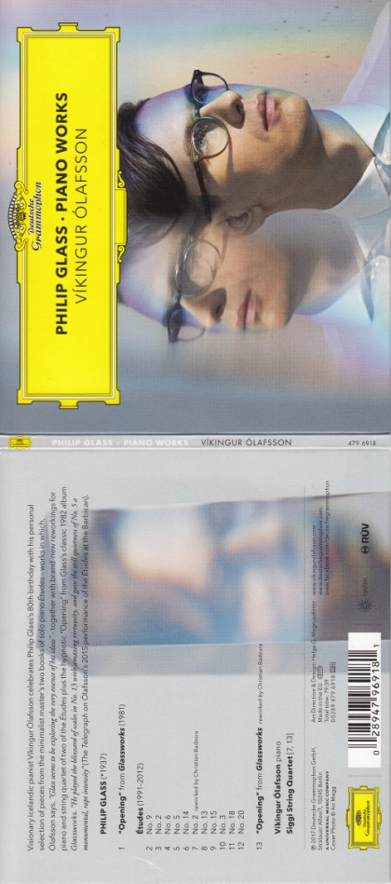
Figure 38

References section

Contents:

- Bibliography and journal articles
- Internet sourced documents
- Sound recordings
- Video and film
- Images
- Radio programme (listened to live)

- Bibliography and journal articles

Books 1. Smith H. & Chauvel, C. (2013) Bach Suites nos. 4,5,6 [CD booklet] Austria: Naive p. 10

Books 2. Johnson, S (2010). Where Good Ideas Come From. Great Britain: Allen Lane. 99-128, 246.

Books 3. Cowan, R & Gill, C (2017). ‘Classics Reconsidered’. In: Gramophone 94 (1145) pp. 100-101

Books 4. Gill, C (2017). ‘Bach’s Flute Sonatas BWV 1030-1035. In: Gramophone 94 (1145) pp. 104-107

Books 5. Sandburg, C. (1927) The American Songbag New York: Harcourt, Brace & Company,
Inc

Books 6. Thomas, R. (2017) ‘Aspects of Folk’ In: BBC Music Magazine 25 (9) p102

- Internet Sourced Documents

Internet 1. Steinberg, M. (2016). Beethoven Quartet opus 127. Available: http://brentanoquartet.com/notes/beethoven-quartet-opus-127/ . Last accessed 9th July 2016.
Internet 2. Costanza, C. (2014). Suite no.5 in C minor - Commentary by Christopher Costanza. Available: https://costanzabach.stanford.edu/commentary/suite-no-5-c-minor. Last accessed 13th Aug 2016.
Internet 3. Unknown. (2012). RS Thomas "The Moor". Available:
http://www.poemsbypost.com. Last accessed 1st October 2016.

Internet 4. Debs, E. (2016) Statement to the Court. At: https://www.youtube.com/watch?v=Bk-sB35FUpY Accessed on 12 February 2017

3. Sound Recordings

- Butt, J. (2016) JS Bach – Violin Concertos [CD] Glasgow: Linn Records

- Suzuki, M. (2016) Secular Cantatas: JS Bach Trauerode, Vol 6 [CD] BIS Records

- Vladar, S. (1993) Symphonic Etudes [CD] Naxos

- Hamelin, M-A. (2001) Schumann Piano Music [CD] England: Hyperion Records

- Fink, B. (2006) Canciones Argentines [CD] France: Harmonia Mundi

- Morton, J. (2016) Debussy & Takemitsu for Strings: Scottish Ensemble [CD] Glasgow: Linn Records

- Hough, S. (2013) Brahms Piano Concertos [CD] England: Hyperion records
- Friere, N. (2006) Brahms Piano Concertos [CD] Decca (UMO)

- Brendel, A. (1997) Schubert: The Complete Impromptus [CD] Philips (UMO)

- Zimmerman, K. (1991) Franz Schubert Impromptus [CD] Germany: Deutsche Grammophon

- Mertanen, J. (2015) Sibelius Piano Works [CDs] Finland: Sony Music

- Gimse, H. (2001) Sibelius Piano Music Volumes 1 – 5 [CDs] Naxos

- Karajan, H. (1999) Bruckner: Symphony No. 8 [CDs] Germany; Deutsche Grammophon

- Angelov, L. (2016) Moskowski Piano Concerto in B minor, Op 3 [CD] England: Hyperion Records

- Pappano, A. (2013) Rossini: Petite Messe Solenelle [CD] EMI (Warner Classics)

- Stock, D. (2016) Concertos [CD] Boston: Boston Modern Orchestra Project (BMOP) At: Spotify (Accesssed on 16 July 2016)

- Berlin Philharmoniker. (2016) Hora Cero: Die 12 Cellisten Der Berliner Philharmoniker [CD] Germany: Sony Music Classical

- d’Or, Y. (2016) Latino Ladino [CD] Naxos

- Kamu, O. (2015) Sibelius The Symphonies [CDs] Sweden: BIS Records

- Hagen Quartett. (2006) Mozart the string quartets [CDs] Germany: Deutsche Grammophon

- Corigliano, J. (2016) Symphony no. 1 [CD] Naxos

- Brass Quintet Volcano. (2013) A Classical Quartet [CD] Obrasso Records At: Spotify (accessed on 14 August 2016)

- Negrin, J. (2016) Traces: Granados; Mompou [CD,] Odradek Records

- Netrebko, A. (2016) Verismo [CD] Deutsche Grammophon

- Faust, I. (2016) Bach: Complete Sonatas and Partitas [CDs] France: Harmonia Mundi

- Devieilhe, S. (2015) Mozart “The Weber Sisters” [CD] France: Erato

- Martineau, M. (2016) Complete Songs by Faure Vol. 1 [CD] Signum Classics At: Spotify (accessed on 27 September 2016)

- Lipman Harp Duo. (2007) John Thomas: Harp Music [CD] Naxos

- Judd, J. (2004) Frank Bridge: The Sea; Enter Spring; Summer [CD] Naxos

- Pink Martini. (2007) Sympathique [CD] Wrasse Records

- Pink Martini. (2007) Splendor in the Grass [CD] Wrasse Records

- Pink Martini. (2016) Jes Dis Oui! [CD] Wrasse Records

- Pompa-Baldi, A. (2013) The Rascal and the Sparrow – Poulenc: Meets Edith Piaf [CD] Steinway & Sons

- Powers, L. (2016) Fin de Siecle [CD] England: Hyperion records

- Jacques Loussier Trio. (2000) Bach’s Goldberg Variations [CD] Telarc

- Laurent Wagschal. (2015) Godowsky The Art of Transcription] Evidence

- Residentie Orchestra The Hague. (1990) Alphons Diepenbrock Vol 1 - Orchestral Works. [CD] Colchetser, England: Chandos Records Ltd

- Residentie Orchestra The Hague. (1990) Alphons Diepenbrock Vol 2 – Symphonic Songs. [CD] Colchester, England: Chandos Records Ltd

- Tharaud, A. (2010) Baroque – Rameau, Bach, Couperin [CDs] Mas de Vert, France: Harmonia Mundi

- Perahia, M. (2016) JS Bach – The French Suites [CDs] Berlin: Deutsche Grammophon

- L’Arpeggiata. (2016) Christina Pluhar - Orfeo Chaman [CDs] France: Erato

- Boris Giltburg. (2015) Etudes-tableaux, Op 39 & Moments musicaux, Op 16 – Rachmaninov [CD] Monmouth: Naxos

- Christian Hommel & Cologne Chamber Orchestra. (1997) JS Bach – Oboe Concertos BWV 1053, 1055, 1056, 1059, 1060 [CD] Cologne, Germany: Naxos

- Mehta, Z. (1978) Puccini – La Fanciulla del West [CDs] Hamburg: Deutsche Grammophon

- Carducci Quartet. (2015) Philip Glass: String Quartet No. 5; Suite from Dracula; String Sextet [CD] Naxos. At: Spotify (accessed on 12 February 2017)

- Alsop, M. (2004) Philip Glass; Synphonies no. 2 & 3 [CD] Naxos

- Dickson, A. (2017) Glass. [CD] Germany: Sony Music

- Minkowski, M & Les Musiciens du Louvre. (2005): Rameau: Une Symphonie Imaginaire [CD] Berlin: Deutsche Grammophon

- Driver, D & Miller, R. (2017) The Romantic Piano Concerto – 70: Beach, Chaminade, Howell [CD] London: Hyperion Records Limited

- Staier, A. (1999) Variacones del fandango espanol [music track, CD] Teldec Classics

- Budapest Sextet. (2006) Dohnanyi, E & Mosonyi, M: String Sextets [CD] Australia: Hungaroton Records Ltd

- Artemis Quartet. (2006) Music for String Sextet – Strauss, Berg & Schönberg [CD] EMI Records Ltd/Virgin Classics

- Prazac Quartet. (2013) Johannes Brahms String Sextets [CD] Paris: AMC/Praga Digitals

- Roberts, K & others. (2011) Cecil Sharp Project 2011 [CD] Shrewsbury: Shrewsbury Folk Festival. At: Spotify (accessed on 3 April 2017)

- Ainsley, JM & The Nash Ensemble (2000) Vaughan Williams – Along the Field and other songs [CD] London: Hyperion Records Ltd

- Moeran, E.J. (2015) Folksong Arrangements [audio recording, CD] Rec. Naxos. At: Spotify (Accessed on 21 April 2017)

- Britten, B. (2013) English Folksongs [audio recording, CD] Rec. Decca: Eloquence. At: Spotify (Accessed on 21 April 2017)

- Grainger, P (2017) Folk Music [audio recording, CD] Rec: Avie. At Spotify (Accessed 21 April 2017)

- Quercus (2017) Nightfall. At: https://www.amazon.co.uk/Nightfall-Ballamy-Warren-Quercus-Tabor/dp/B06X9C786B/ref=sr_1_1?s=music&ie=UTF8&qid=1495382195&sr=1-1&keywords=June+Tabor Accessed on 21 May 2017

- Takacs Quartet. (2004) Beethoven – The Early String Quartets [CD] London: Decca Music Group Limited

- Aimard, Pierre-Laurent & Chamber Orchestra of Europe (2003) Beethoven Piano Concertos Nos. 1-5 [CD] UK: Warner Classics

- Lang Lang & London Chamber Orchestra. (2008) Nigel Hess Concerto for Piano and Orchestra [CD] UK: Universal Classics & Jazz

- Driver, D. (2013) Handel - The Eight Great Suites [CD] London: Hyperion records Ltd.

- Rees-Williams, D. (2017) Classically Reminded: Bach [CD] UK: Champs Hill Records

- Perianes, J. (2010) Blasco de Nebra: Piano Sonatas [CD] France: Harmonia Mundi

- Olafsson, V. (2017) Philip Glass. Piano Works [CD] Berlin: Deutsche Grammophon GmbH

4. Video and film

Film 1. Colpron, P. Lighthearted Kites (2012) [video online] At: URL: https://youtu.be/HCNfQ_HOlDc Accessed on 1 October 2016

Film 2. All Aboard The Sleigh Ride. (2015) Directed by Martin, LK [DVD] United Kingdom: The Garden Productions Limited

Film 3. La Fanciulla del West. (2015) Directed by Felix Breisach [DVD] Germany: Sony Music Entertainment

Film 4. 2013 Wigmore Hall/Kohn Foundation International Song Competition (2013) In: Wigmore Hall Kohn Foundation Song Competition 2013 [video online] At: URL: https://www.youtube.com/watch?v=Zl52PGMhZko Accessed on 10 April 2017

5. Images

Figure 1. UWE Singers and Lydbrook Band. 2016) Sun, Moon and Stars – Concert Programme [scanned image: programme cover] University of West of England

Figure 2. Burtle Silver Band. At: http://www.burtlesilverband.co.uk/resources/Michael%20Eavis%20enjoying%20Hootenanny.JPG (Accessed on 30 May 2016)

Figure 3. Grove Park Bandstand. At: http://images.archant.co.uk/polopoly_fs/1.3460962.1395394925!/image/4288843408.jpg_gen/derivatives/landscape_630/4288843408.jpg (Accessed on 26 August 2017)

Figure 4. Stock, D. (2016) Concertos [CD] Boston: Boston Modern Orchestra Project (BMOP) At: https://www.amazon.co.uk/Concertos-David-Stock/dp/B01BCQWENG/ref=sr_1_2?s=music&ie=UTF8&qid=1503732449&sr=1-2&keywords=David+Stock (Accessed on 16 July 2016)

Figure 5. Berlin Philharmoniker. (2016) Hora Cero: Die 12 Cellisten Der Berliner Philharmoniker
[scanned image, CD booklet cover] Germany: Sony Music Classical

Figure 6. d’Or, Y. (2016) Latino Ladino [CD] Naxos
At: https://www.amazon.co.uk/Latino-Ladino-Ensemble-Barrocade-Tiefenbrunn/dp/B01FXRZCQG/ref=sr_1_1?s=music&ie=UTF8&qid=1503733501&sr=1-1&keywords=Latino+Ladino (Accessed on 16 July 2016)

Figure 7. Cooper, D. (1995) Six Suites for Solo Cello J.S. Bach transcribed and edited for
Trumpet Blue Mounds Productions p.50 [scanned image from book]

Figure 8. Bach, JS. Cello Suite no. 5 – Sarabande IMSLP At:
http://imslp.org/wiki/Cello_Suite_No.5_in_C_minor%2C_BWV_1011_(Bach%2C_Johann_Sebastian) (Accessed on 2 August 2016)

Figure 9. Hagen Quartett. (2006) Mozart the string quartets [CDs] Germany: Deutsche
Grammophon (scanned image of box set cover)

Figure 10. Corigliano, J. (2016) Symphony no. 1 [CD] Naxos At:
https://www.amazon.co.uk/Corigliano-Symphony-Orchestral-Institute-Philharmonic/dp/B01FXRZCAM/ref=sr_1_1?s=music&ie=UTF8&qid=1503738299&sr=1-1&keywords=corigliano+symphony+1 (Accessed on 12 August 2016)

Figure 11. Bach, JS. Cello Suite no. 5 – Sarabande IMSLP At:
http://imslp.org/wiki/6_Cello_Suites%2C_BWV_1007-1012_(Bach%2C_Johann_Sebastian) (Accessed on 12 August 2016)

Figure 12. Brass Quintet Volcano. (2013) A Classical Quartet [CD cover] Obrasso Records At: https://www.amazon.co.uk/Classical-Quartet-Brass-Volcano/dp/B00B5GVBAQ/ref=sr_1_3?s=dmusic&ie=UTF8&qid=1503751296&sr=1-3-mp3-albums-bar-strip-0&keywords=Volcano+Brass (Accessed on 14 August 2016)

Figure 13. Negrin, J. (2016) Traces: Granados; Mompou [CD, scanned image of cover] Odradek Records
Figure 14. Devieilhe, S. (2015) Mozart “The Weber Sisters” [CD, scanned cover, rear inset] France: Erato

Figure 15. Watson, P. (2016) Adventures In Your Own Backyard [CD] Domino Records At: https://www.amazon.co.uk/Adventures-Your-Backyard-Patrick-Watson/dp/B01M5HOPPF/ref=sr_1_1?s=music&ie=UTF8&qid=1503753438&sr=1-1&keywords=Patrick+Watson (Accessed on 1 October 2016)

Figure 16. Watson, P. (2016) Adventures In Your Own Backyard [CD] Domino Records At:
http://images.coveralia.com/audio/p/Patrick_Watson-Adventures_In_Your_Own_Backyard-CD.jpg (Accessed on 1 October 2016)

Figure 17. Colpron, P. Lighthearted Kites (2012) [video online] At: URL: https://youtu.be/HCNfQ_HOlDc Accessed on 1 October 2016

Figure 18. Colpron, P. Lighthearted Kites (2012) [video online] At: URL: https://youtu.be/HCNfQ_HOlDc Accessed on 1 October 2016

Figure 19. Lipman Harp Duo. (2007) John Thomas: Harp Music [CD] Naxos At:
https://www.amazon.co.uk/John-Thomas-Harp-Music/dp/B000Y1BQV2/ref=sr_1_7?s=music&ie=UTF8&qid=1503754661&sr=1-7&keywords=John+Thomas (Accessed on 7 October 2016)

Figure 20. Judd, J. (2004) Frank Bridge: The Sea; Enter Spring; Summer [CD] Naxos At:
https://www.amazon.co.uk/Bridge-Sea-Enter-Spring-Summer/dp/B0002BXO3W/ref=sr_1_2?s=music&ie=UTF8&qid=1503754996&sr=1-2&keywords=bridge+the+sea (Accessed 7 October 2016)

Figure 21. PinkMartini (2016) At: http://pinkmartini.com/about/ (accessed 22 October 2016)

Figure 22. Pink Martini In Concert (2016) At: http://www.bing.com/images/search?q=pink+martini&view=detailv2&&id=F62CA78EC66A5061382D6F2E1ADF9B531D77B59C&selectedIndex=16&ccid=di96qbpY&simid=608055976042957979&thid=OIP.M762f7aa9ba58555f09c6c2e568b5e601o0&ajaxhist=0 (accessed 22 October 2016)

Figure 23. Pompa-Baldi, A. (2013) The Rascal and the Sparrow – Poulenc: Meets Edith Piaf [CD] Steinway & Sons. At: https://www.amazon.co.uk/Poulenc-Antonio-Pompa-Baldi-Steinway-STNS30015/dp/B00DXNIEB8/ref=sr_1_1?s=music&ie=UTF8&qid=1503756398&sr=1-1&keywords=Pompa-Baldi (Accessed 22 October 2016)

Figure 24. Powers, L. (2016) Fin de Siecle [CD] England: Hyperion records. At: https://www.amazon.co.uk/Siecle-Lawrence-Power-Crawford-Phillips-Hyperion/dp/B01HOU7GU0/ref=sr_1_1?s=music&ie=UTF8&qid=1503756483&sr=1-1&keywords=Powers+Fin+de (Accessed 22 October 2016)

Figure 25. Jacques Loussier Trio. (2000) Bach’s Goldberg Variations [scanned image, CD booklet cover] Telarc

Figure 26. Laurent Wagschal. (2015) Godowsky The Art of Transcription [scanned image, CD cover] Evidence

Figure 27. Alexandre Tharaud. (2010) Baroque – Rameau, Bach, Couperin [scanned image, CD box] Harmonia Mundi

Figure 28. All Aboard The Sleigh Ride. (2015) Directed by Martin, LK [scanned image, DVD cover] The Garden Productions Limited

Figure 29. L’Arpeggiata (2016) Christina Pluhar - Orfeo Chaman [scanned image, CD book front cover] Erato

Figure 30. Boris Giltburg. (2015) Etudes-tableaux, Op 39 & Moments musicaux, Op 16 – Rachmaninov [scanned image, CD booklet] Naxos

Figure 31. Felix Breisach (2015) La Fanciulla del West. [scanned image, DVD booklet] Sony Music Entertainment

Figure 32. St George’s Bristol (2016) At: http://www.stgeorgesbristol.co.uk/event/bristol-ensemble-bath-camerata/ (Accessed on 12 February 2017)

Figure 33. Dickson, A. (2017) Glass. [scanned image, CD booklet front cover] Sony Music

Figure 34. Minkowski, M & Les Musiciens du Louvre. (2005): Rameau: Une Symphonie Imaginaire [scanned image CD booklet front cover] Deutsche Grammophon

Figure 35. Driver, D & Miller, R. (2017) The Romantic Piano Concerto – 70: Beach, Chaminade, Howell [scanned image CD booklet front and back covers] Hyperion Records Limited

Figure 36. Cecil Sharp Project (2011) At: https://www.amazon.co.uk/Cecil-Sharp-Project-x/dp/B005C8IHRS/ref=sr_1_1?s=music&ie=UTF8&qid=1491230758&sr=1-1&keywords=cecil+sharp+project (Accessed on 3 April 2017)

Figure 37. Cecil Sharp Project 2011 (2012) At: http://shrewsburyfolkfestival.blogspot.co.uk/2011/03/cecil-sharp-project-press-day.html (Accessed on 3 April 2017)

Figure 38. Olafsson, V. (2017) Philip Glass. Piano Works [scanned image CD cover front and back] Deutsche Grammophon GmbH

6. Radio programme (listened live)

Radio no. 1. Petroc Trelawny Classical Breakfast Show (2017) BBC Radio 3. 9 March. 07.12 hours.

Radio no. 2. Breakfast. (2017) BBC Radio 3. 5 April 2017. 06.59 hrs.

